CMP REQUEST FOR EXTENSION OF HOURS FORM
APPLICATION FOR EXTENSION OF WORKING HOURS AS SET OUT WITHIN THE CONSTRUCTION MANAGEMENT PLAN SECURED VIA A SECTION 106 LEGAL AGREEMENT
Site address: | Belgrove House, Belgrove St, London WC1H 8AA
Planning reference number: | 2020/3881/P
Revision number and approval date of current CMP. | Belgrove House Belgrove Street 2020/3881/P CMP (rev 10). 20/12/24

I/WE HEREBY MAKE APPLICATION for a temporary extension to the hours as controlled in the approved CMP as outlined above.
Signed |  | Date of the application | 10/02/2025
Print Name | Paul Coomber | Position | Senior Construction Manager

COMPULSORY INFORMATION

Name and Registered Office address of applicant | Mace  155, Moorgate, London, EC2M 6HB
Name, address and telephone number of main contractor | Mace  155, Moorgate, London, EC2M 6HB  0203 522 3550
Please outline the reasons for this request. | To carry out installation of pre-cast concrete and large glazing panels with Mobile Crane set up in either Belgrove Street or Crestfield Street as per TTRO & Crane Licence application.  2-3nr Articulated lorries will deliver the panels per day (some oversized and will need to be under movement order) will be parked up early prior to the setting up of the mobile crane. The PC concrete or glazing panels will be lifted straight from the lorry into position.  Attendance work will include Traffic Management and installation of road closure & installation of Lifting zone fencing.
Current approved working hours (as set out in the CMP) | 08.00-18.00 Monday – Friday.  08:00-13:00 Saturday.
Proposed amended working hours (date and times for the proposed working hours) | 03/03/25 – 07/04/25 Inclusive  Additional Weekday Hours (bringing large deliveries in early to minimise impact on local traffic and road users)  Mon - Sat – 06:00 – 08:00hrs (Delivery arrival,  Crane and lift zone  set up)  03/03/25 – 07/04/25 Inclusive  Additional Weekend Hours  Sat – 06:00 – 08:00hrs (Delivery arrival,  Crane and lift zone  set up)  Sat – 13:00 – 17:00hrs (Working)  Sun – 08:00 – 16:00hrs (Delivery arrival,  Crane and lift zone  set up & working)  Sun – 16:00 – 18:00hrs (Crane dismantle,  removal of delivery and  lift zone take down or  move)  Additional Weekday Hours (to minimise impact on local traffic and road users)  Mon - Sat – 18:00 – 19:00hrs (Crane dismantle  and move and lift zone)
Please provide a brief description of all the activities that will take place outside of the approved hours with justification (i.e. staggered working hours and how they comply with a). This should include the precise times, shift patterns, number of staff on site. | Lifting operations under TTRO  Setting up (or amending) traffic management / road closure signage.  Erect Heras fencing to form Lifting Exclusion zone in carriageway.  Accepting early precast concrete or glazing deliveries early to reduce impact on pedestrians, cyclists and local traffic by stopping these larger deliveries from arriving to site in peak rush hour times and park up into position. 6am for Weekdays and Saturday & Sunday vehicles will arrive @ 8am.  Set up Crane (inc. attendance vehicles)  Lifting Pre-cast concrete or glazing panels off lorry and into position, MEWP access to external face of panel.  Move Crane / road closure to suit lift position (work area 1 or Work area 2)  Once unloaded the empty vehicle will leave the site during the day (non-peak time).  Once panels installed the mobile crane will be dismantled and parked up in a pit lane ready for the early deliveries to arrive the following day.  10 Operatives + 9 traffic marshals + 2 Traffic management operatives
Please provide a map showing nearby residential receptors. | Lift Zone positions (only one zone will be worked in at any one time)  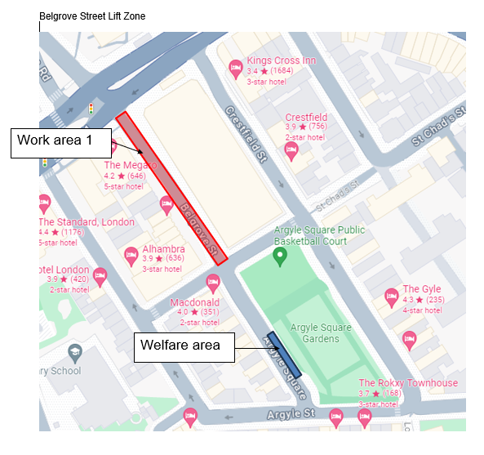  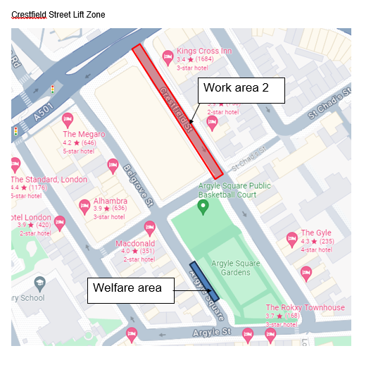  Welfare in Argile Square will be required for these extended hours
Please detail mitigation for any works outside of the approved working hours to address impact on neighbouring residents | We will ensure early delivery lorries and cranes are controlled on arrival  TMs to ensure lorries and attendance vehicles needed for the work will be parked in the lift zone situated in Belgrove St or Crestfield St. Only Traffic management install, early acceptance of large deliveries, Lift Zone fencing and Mobile Crane set up / dismantle will be carried out either side of the main working hours of 8:00 – 17:00hrs to avoid disturbance to residents (as detailed above).  Engines will be turned off when plant is not in use. No music radios in cabs will be permitted to be playing loud. (TMs to control)  Letters will be issued to the local residents and businesses to inform of the planned works and to offer the opportunity to engage with site before the works commence.
Liaison | Please provide a copy of the letter and or/email sent to all those initially consulted on the CMP/residents and business likely to be affected by this extension. This must have been sent before your application to extend hours is made.  If a letter is not provided, please note that we will automatically reject your application.  Following any approved by the Council a letter should be sent to all those to advise the date the extended works will commence.
Any consent granted: | Any extension granted is temporary and continuously under review. This extension can be withdrawn by the Council following review at any time.
Please note – This form is only for extended hours to enable construction works which cannot be heard at the boundary. A revised CMP will be required to be submitted through formal channels and a Section 61 notice will be required if you intend to undertake noisy construction works outside of approved hours.
Once complete please email planning.obligations@camden.gov.uk and allow up to 10 days for a response.

