Background

50 Lambs Conduit Street is a residential and commercial property consisting of 3 flats at first, second and third floor levels over a basement and ground floor commercial premises which has additional single storey rear additions.

The main building is of solid brickwork construction with a pitched slate covered roof of timber construction with perimeter box gutters behind parapet and party walls. The outrigger /rear addition has a mansard roof with a flat asphalt covered crown. The 2No. single storey rear addition flat roofs are also asphalt covered concealed behind brick parapet walls. The floors are with suspended timber upper floors and a solid basement floor. Windows to the front and rear are single glazed timber sliding sashes, there is one small casement window. There are timber framed glazed shopfronts with timber glazed doors either side of a central timber panelled communal flat entrance door recessed into a geometric tiled porch area.

To the west elevation at basement level there is a small courtyard which is bound by brick enclosing party walls.

Our Clients (The Governing Body of Rugby School) are in the process of making Energy Efficiency adaptations improving the thermal efficiency of their properties by taking natural “passive” measures to reduce energy usage. This approach follows the recommendations in Camden’s Planning Guidance “Energy Efficiency and Adaptation” as part of an ongoing cycle of Planned Preventative Maintenance Works over the Estate carried out on an annual basis at which point the properties are repaired and redecorated. Externally energy efficiency measures including insulating roofs and replacing windows and shopfront glazing will be completed as part of these works. It is understood that as window and shopfront replacement will either be in the case of the shopfront by retaining the existing frames and if respect of the windows, replacement of the individual sashes and not the entire box frames or if required for replacement in their entirety will essentially be on a like for like replacement basis in matching materials and arrangement, then Planning Permission will not be required and for this reason has not been referred to within the application.

It is also our understanding that Planning Permission would not be required for the installation of mechanical extract fan grilles/flues sited to the rear elevation but would be for the front elevation, hence the inclusion of. Where possible mechanical ventilation with heat recovery will be installed as again recommended in Camden’s Guidance Notes referred to above.

The attached photographs show the elevations of the main building and the rear additions.

Relevant Policies & Guidance

National Planning Policy Framework (2021)
London Plan (2021)
LB Camden Local Plan (2017) D2 Heritage
Supplementary Guidance -Design (2021) & Bloomsbury Conservation Area Appraisal and Management Strategy (2011)
Camden Planning : Energy Efficiency and Adaptation

Pre- Application Advice

Several calls were made to Camden’s Planning Services using the ‘call back’ facility in order to establish whether Planning Permission was required in order to make the following alterations.

We have also earlier this year installed railings and edge protection on another property on an adjacent street (3/5 Rugby Street) where we submitted and obtained Planning consent for the installation (Planning ref: 2023/1775/P) as demonstrated in the photo below.

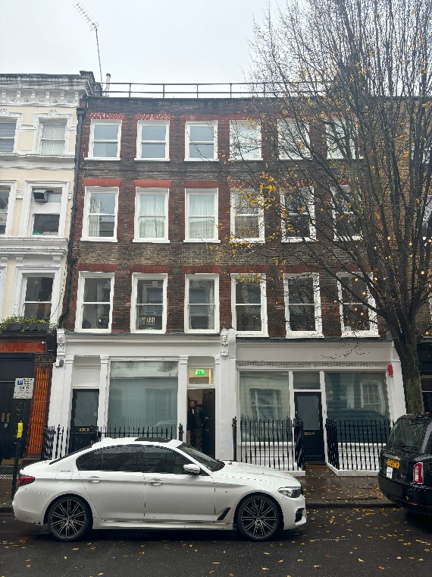

Proposals

The following outlines the proposed works requiring Planning Approval:

- Installation of fall arrest edge protection to the main and rear addition roofs
- Mechanical heat recovery extract ventilation
- Installation of flat roof insulation to the third floor mansard crown and the single storey rear additions and new waterproof coverings.

Design

Having completed a roof access risk assessment of the property, it has been proposed in accordance with the safety hierarchy that it will be necessary to eliminate the risk of falls from the main roof when access is required for maintenance of the roof and box gutters by installing permanent edge protection to the main roof. Due to the nature and layout of the roof structures, it will be necessary to install the edge protection into the perimeter parapet walls. The edge protection will be a black powder coated steel handrail constructed from circular tube sections (approximately 40mm diameter) set at a height of 1100mm above the roof deck with a further additional intermediate guarding/rail set midpoint between the parapet coping and the top rail. The edge protection to the main roof is considered essential to allow the safe maintenance of the roof structure in order for health and safety legislation compliance. The design of the railings are simple and unobtrusive and as such to meet Building Regulation standards in respect of the height of the railings and the spacing of the additional rail. The railings will be powder coated black to enhance their appearance.

In order to combat the increased risk of condensation and mould growth in the flats resulting from the installation of energy efficient, draughtproofed, double glazed timber sash windows and in order to improve the internal living environment in the flats, it is proposed to install single room heat recovery extract ventilation in the kitchens and bathrooms. The bathrooms face the front elevation and so there will be three fan extract flues terminating to the front elevation (one for each flat) and three to the rear to serve the kitchens (which are situated to the rear). The flue projects from the wall by approximately 150mm is buff coloured plastic and is 100mm diameter. The air bricks will be removed and the voids infilled with matching brickwork. The new windows being installed will incorporate trickle ventilation.

The flat roof insulation will be laid on top of the existing asphalt coverings and will raise the level of the roof by approximately 80mm in the case of the single storey rear additions that are already partially insulated but not to current regulations (the thickness of the insulation board) and 140mm to the mansard roof rear addition flat roof section. The insulation is overlaid with a cold liquid applied seamless waterproof membrane which is grey in colour. The raising of the roof level will not be visible from ground level as the roofs are concealed behind the parapet walls.

Access Assessment

The proposals do not change the access into or within the property in any way. The proposed works are of repair, safety and energy efficiency improvement only.

Summary

The proposals described are considered insignificant and will not have any detrimental impact to the character and architectural significance of the property or the surrounding properties and Conservation Area and will allow The Governing Body of Rugby School to improve the energy efficiency and living conditions within this property as well as provide a safe working environment for maintenance at roof level.

Photos

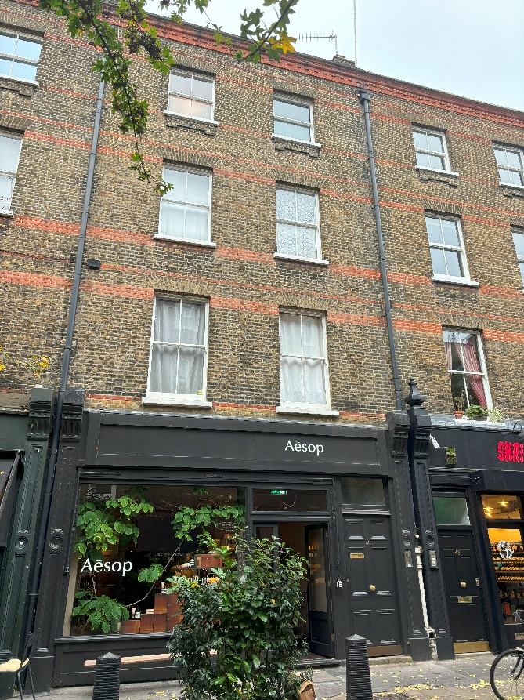

- Front elevation

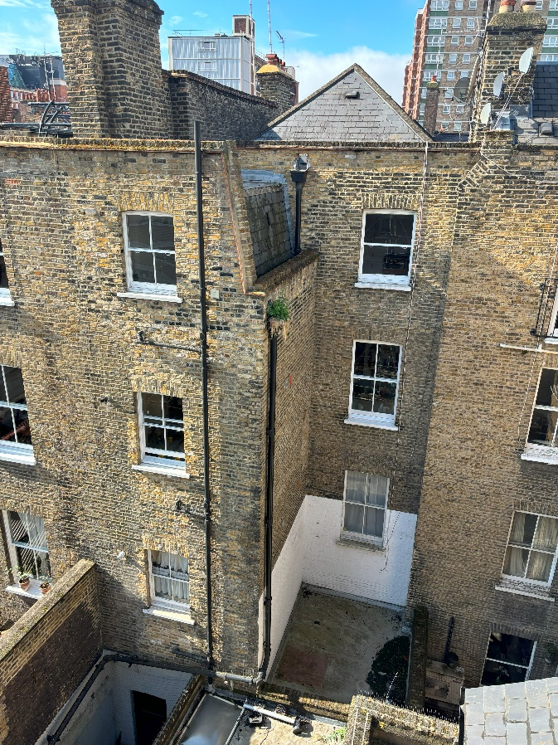

- Rear elevation - photo taken from roof level at 15 Rugby Street.

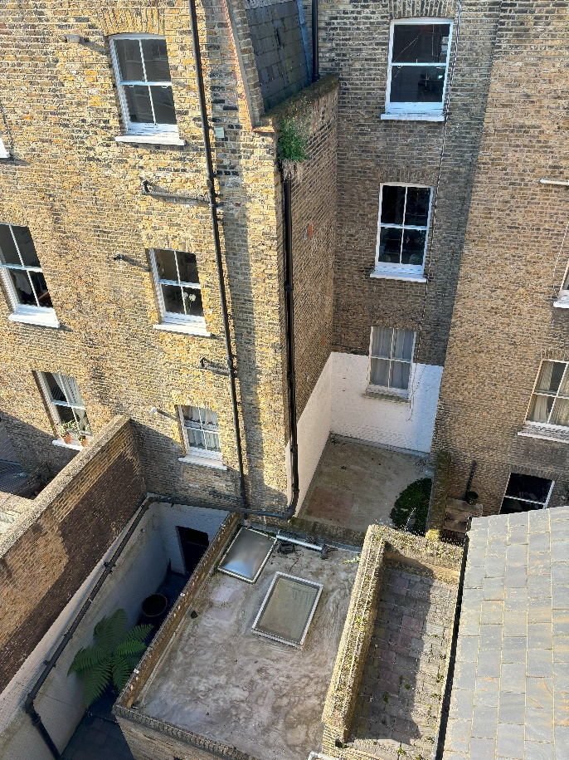

- Main rear elevation and single storey rear addition flat roof areas - photo taken from roof level at 15 Rugby Street

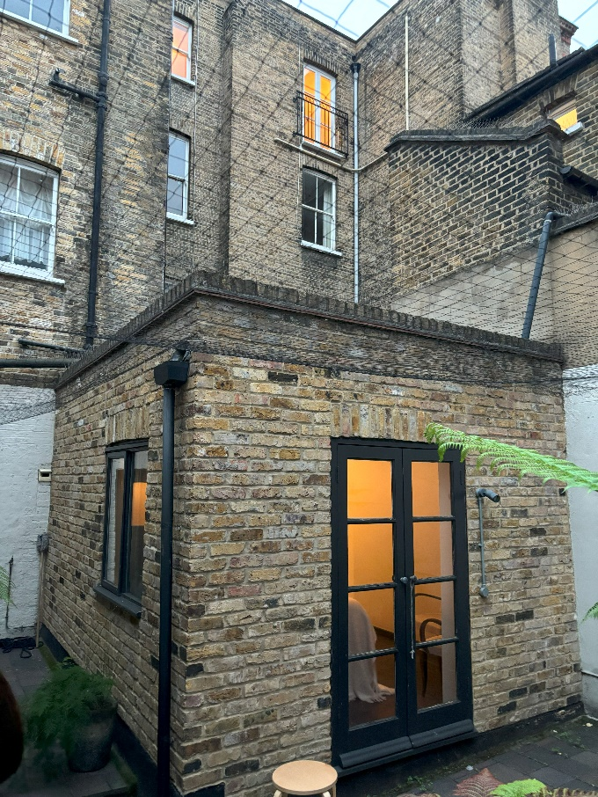

- Single Storey rear addition.

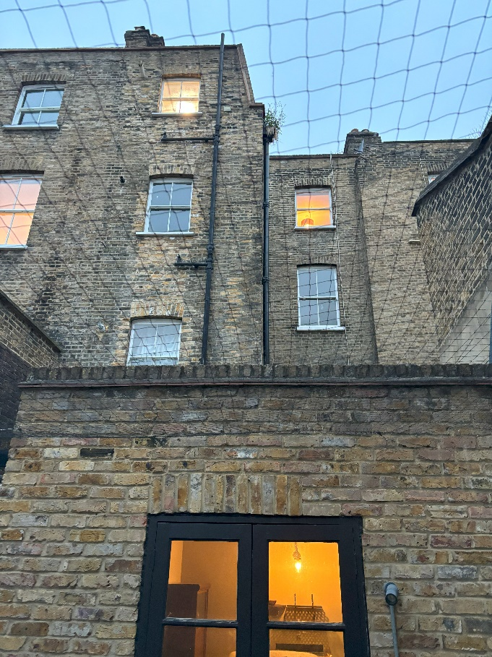

- Rear elevation and single storey rear addition

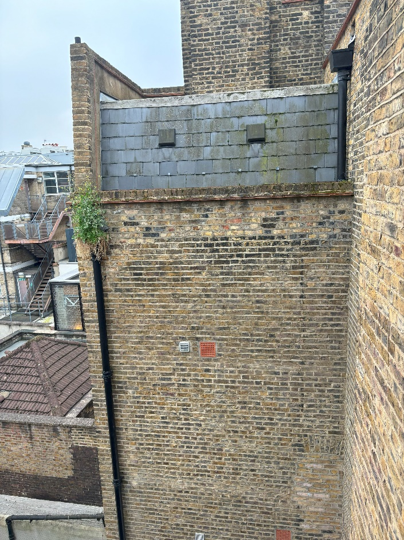

- North elevation - Outrigger / mansard roof

