REDINGTON FROGNAL
NEIGHBOURHOOD FORUM
5 February 2025

Dear Adam,

2024/5582/P: 18 Platt’s Lane - objection

Number 18 Platt’s Lane is a significant local property in a prominent position. It was designed by CHB Quennell, the architect who was responsible, in large measure, for shaping the unique beauty of this garden suburb.

The building is a non-designated heritage asset, for which the Neighbourhood Forum requests incorporation in Camden’s Local List, along with all other non-designated heritage assets in the Conservation Area, when the Local List is next updated.

It is recognised as a positive contributor to the conservation area, being part of the group of buildings at 4-34 Platt’s Lane, which all contribute positively.

However, the building’s status as a positive contributor is in danger of being eroded as a result of various unsympathetic extensions to the rear / side and the roof. These, together with the current front / side extension proposal, have destroyed the symmetry with its neighbour at number 20 Platt’s Lane. It should additionally be noted that the off-street car park and the closely boarded boundary fence are responsible for significant harm to the setting of the building. Such harm is noted in the Redington Frognal Conservation Area Character Appraisal and Management Plan, as detailed on pages 20, 21 and 45-46.

The result of such unsympathetic additions is clearly apparent at 1 Platt’s Lane and any further extension to number 18 risks creating a similar situation (albeit not as extreme), where the building‘s status is put in jeopardy.

Extended Quennell house at 1 Platt’s Lane
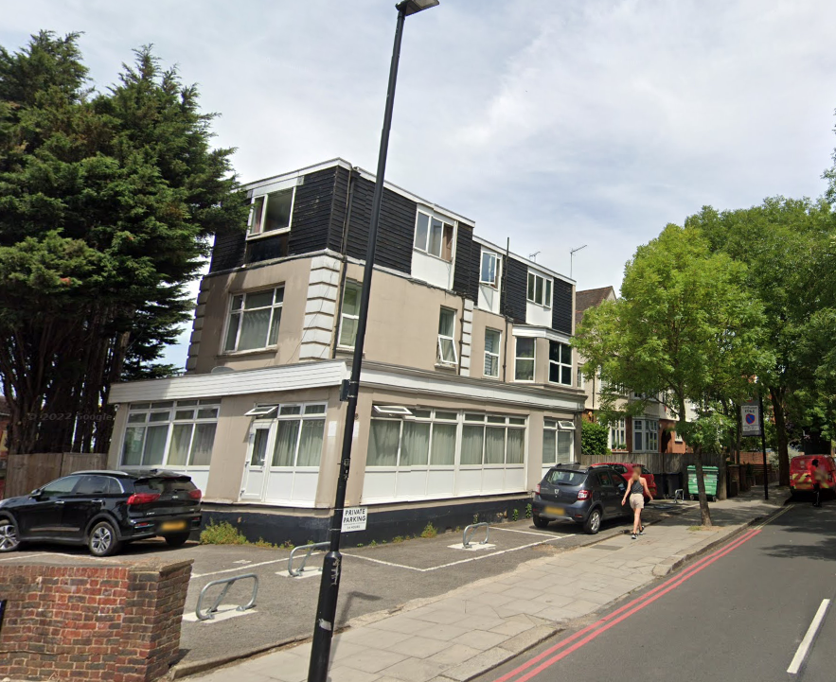
The Neighbourhood Forum therefore requests that this application, for a further extension to this already extended building, is refused.

Yours sincerely,

Nancy Mayo

Secretary
Redington Frognal Neighbourhood Forum
https://www.redfrogforum.org
REDINGTON FROGNAL
NEIGHBOURHOOD FORUM

