Dear Sir/Madam,

DISPLAY OF SHROUD WITH 1:1 REPLICA OF BUILDING FAÇADE AND ADVERTISEMENT BANNER TO APPROXIMATELY 10% OF THE FRONT ELEVATION FOR A TEMPORARY PERIOD OF 9 MONTHS

59-61 CAMDEN HIGH STREET, CAMDEN, LONDON, NW1 7JL

Please accept this covering letter as an accompaniment to this advertisement consent application to display a shroud with a replica of the building façade and associated advertisement banner to the front elevation at 59-61 Camden High Street.

Introduction

This application seeks temporary consent to display a banner at 59-61 Camden High Street, London, NW17JL. The consent is sought for the temporary period of 9 months, whilst the proposed redevelopment of this building is still undergoing.

The proposed banner will be displayed on a fully working engineered temporary scaffold. The scaffold installation is essential for the proposed refurbishment work to take place.

This submission follows the grant of advertisement consent on 19th June 2024 (Ref: 2024/1911/A) for “Display of shroud with 1:1 replica of building facade and advertisement banner to approximately 10% of the front elevation for a temporary period of 9 months’’.

The works have been delayed due to installation of scaffolding commencing in mid-December 2024, resulting in a 6-month delay from the original installation date specified. This was unforeseen and caused by factors beyond the developer’s control, such as contractors or logistical challenges. Consequently, the works remain incomplete, and the presence of scaffolding continues to be essential for their safe and effective completion.

We would like to request an extension of time on the consent to account for the shrouding of the scaffold during the period in which works are actively being carried out. The request for this limited extension of time does not raise any problems beyond those considered on the original granting of the consent. This is only a short extension, made necessary by the delay in the start of the construction works.

The Site

The application site is located on the west side of Camden High Street close to the junction with Miller Street and comprises a three-storey building. The ground floor of the site is in commercial use, whilst the upper two storeys are in residential use. There has recently been a resolution to grant planning permission for the conversion of the application site from 4 flats to 8 flats. Scaffolding will be legally required to be erected in order to implement that permission.

The immediate surroundings are largely characterised by a range of retail/commercial uses at ground floor level and small units of residential accommodation/storage spaces above. The site is located within the Camden Town Conservation Area and is identified as a positive contributor to the area. It is also within the Camden Town ‘Town Centre’ as designated by the Camden Local Plan (2017).

The site is located within an area where controlled parking measures are in place. The site is within an area with a Public Transport Accessibility Rating (PTAL) of 6(b), indicating very good access to public transport. The site is also located within flood zone 1, indicating a low risk of flooding.

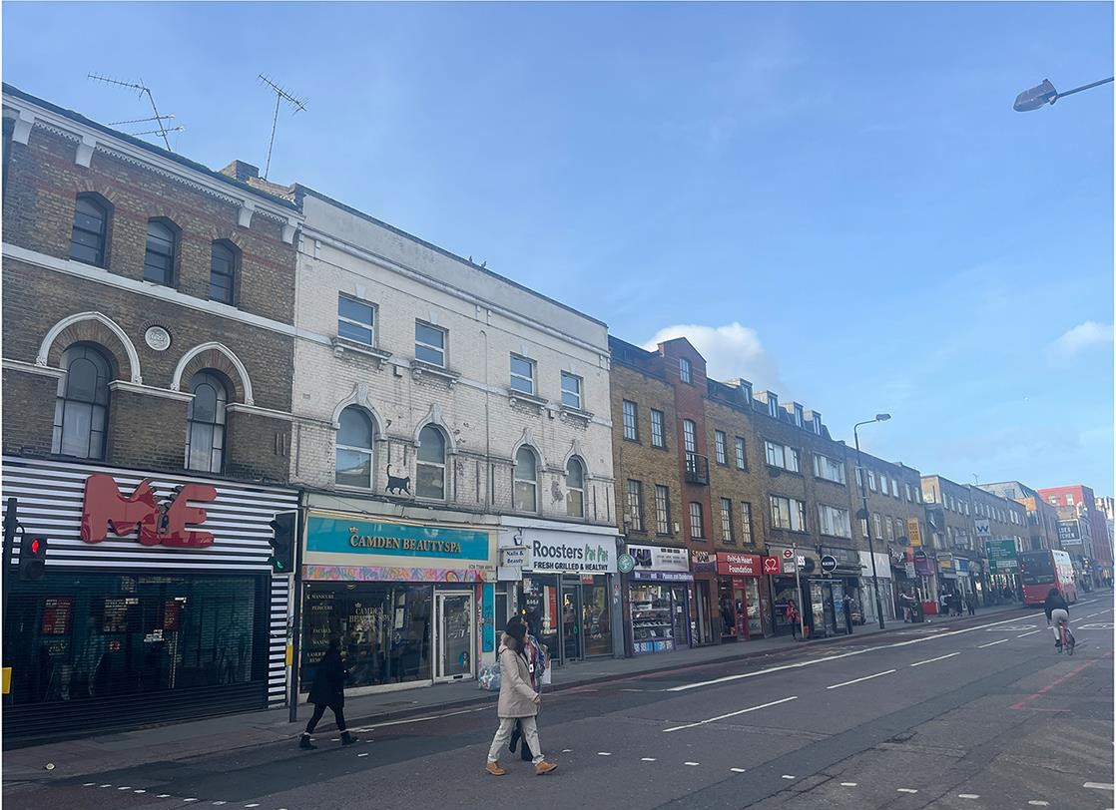
Figure 1 – Existing application site

Planning History

2023/4561/P - Conversion of property from 4 flats (3 x 2 bedroom flats and 1 x 1 bedroom flat) to 8 flats (2 x 2 bedroom flats, and 6 x 1 bedroom flats). Erection of front mansard roof extension above existing second floor and erection of second floor rear extension. Creation of roof terraces to rear first and second floors, along with associated external works.

2022/2149/P - Conversion of property from 4 flats (3 x 2 bedroom flats and 1 x 1 bedroom flat) to 7 flats (2 x 2 bedroom flats, and 5 x 1 bedroom flat). Erection of front mansard roof extension above existing second floor and creation of roof terraces to rear first floor level, along with associated external works. Council resolved to grant subject to a section 106 legal agreement 13/06/2023.

2020/2434/P - Conversion of property from 4 flats to 8 flats including erection of rear extension at second and third floor incorporating mansard roof and erection of front mansard roof extension above existing second floor including rear roof terraces at first floor level. Refused 14/04/2021 and appeal dismissed 06/12/2021.

2019/1225/P - Use of 1st and 2nd floors as 4 self-contained flats (Class C3) including a 2-bed flat and a 3-bed flat at first floor; and a 1-bed flat and a 2-bed flat at second floor. Certificate of Lawfulness Granted 08/04/2019.

P9601171R1 - Change of use of the first floor from offices to one, one bedroom flat and one, two- bedroom flat. Granted 09/08/1996.

34865R1 - Change of use of the southern half of the ground floor and the whole of the first and second floors from retail to offices. Granted 08/11/1982.

The Proposal

This application seeks advertisement consent for the erection of a non-illuminated shroud with a 1:1 replica image of the host building to vastly improve the appearance of the site during the period of works. It is proposed that the non-illuminated advertisement space will be provided to the front elevation at a ratio of 10% which is considered appropriate in the context of the site and surroundings.

The proposed shroud would be retained during the period of works. The advertisement would be removed upon completion of the works within a period expected to be no longer than 9 months from the submission of the application.

Legislative Provision

Regulation 3 of The Town and Country Planning (Control of Advertisements) (England) Regulations2007 (as amended) requires that local planning authorities control the display of advertisements in the interests of amenity and public safety, considering the provisions of the development plan, in so far as they are material, and any other relevant factors. Therefore, unless the nature of the advertisement is in itself harmful to amenity or public safety, consent should not be refused.

Planning Policy

National Planning Policy

The National Planning Policy Framework (NPPF) sets out the Government’s planning policies for
England and how these are expected to be applied. Paragraph 141 of the NPPF states that:
"...A separate consent process within the planning system controls the display of advertisements, which should be operated in a way which is simple, efficient and effective. Advertisements should be subject to control only in the interests of amenity and public safety, taking account of cumulative impacts."

Local Planning Policy

For the purposes of this application, the adopted Development Plan for the London Borough of Camden comprises the London Plan (2021), the Camden Local Plan (2017) and the Camden Supplementary Planning Documents, specifically Advertisements (2018), Design (2019) and Amenity (2018).

The development plan sets out the local policy context. Camden’s Planning Guidance on advertisements specifically states that:

‘Shroud advertisements come in a range of forms but are generally largescale and can cover the entire elevation of a building. They can help to shield unsightly construction work, reducing visual impact. However, as a result of the scale and size of shroud advertisements their appearance can create a conflict with the surrounding environment and the street scene and, where the advertisement partially obscures a building, the visual appearance of the building itself.’

The guidance further provides a criteria-based assessment stating that shrouds on scaffolding will only be permitted where:

- The scaffolding covers the entire elevation of the building and the netting on the scaffolding depicts a true 1:1 image of the completed building which is undergoing construction work;

- The shroud does not exceed the height and length of the completed building (the 1:1 image should also not be extended where scaffolding stretches around a corner); and

- The advertisement must respect the architectural form and scale of the host building. Where shroud and banner advertisements are considered acceptable on listed buildings or in conservation areas, the advertisement on the shroud should not cover more than 10% of the shroud on each elevation and is not fragmented. The location of the advertisement on the shroud will depend on the character of the local built form and the nature of views within it.

Policy D4 of the Local Plan further sets out that advertisements must preserve and enhance the character of their setting and host building. Furthermore, they must respect the form, fabric, design and scale of their setting. Ultimately, the policy highlights that advertisements that preserve/ enhance the amenity of the area, heritage assets and conservations areas will be supported.

Planning Assessment

Principle

In town centre locations, there are no development plan or national planning policies that restrict the display of advertisements in principle.

Amenity

National and local planning policy acknowledges that shroud advertisements help to shield unsightly construction work, thus reducing visual impact. However, shroud screens are inevitably of a scale that could be perceived to cause harm in alternative ways, simply by virtue of the area they would typically cover.

The character and appearance of the immediate area is predominantly commercial and is dominated by a range of buildings and the traffic-dominated character of the town centre where the application site sits. Most notably, this creates a large-scale, busy and dynamic environment.
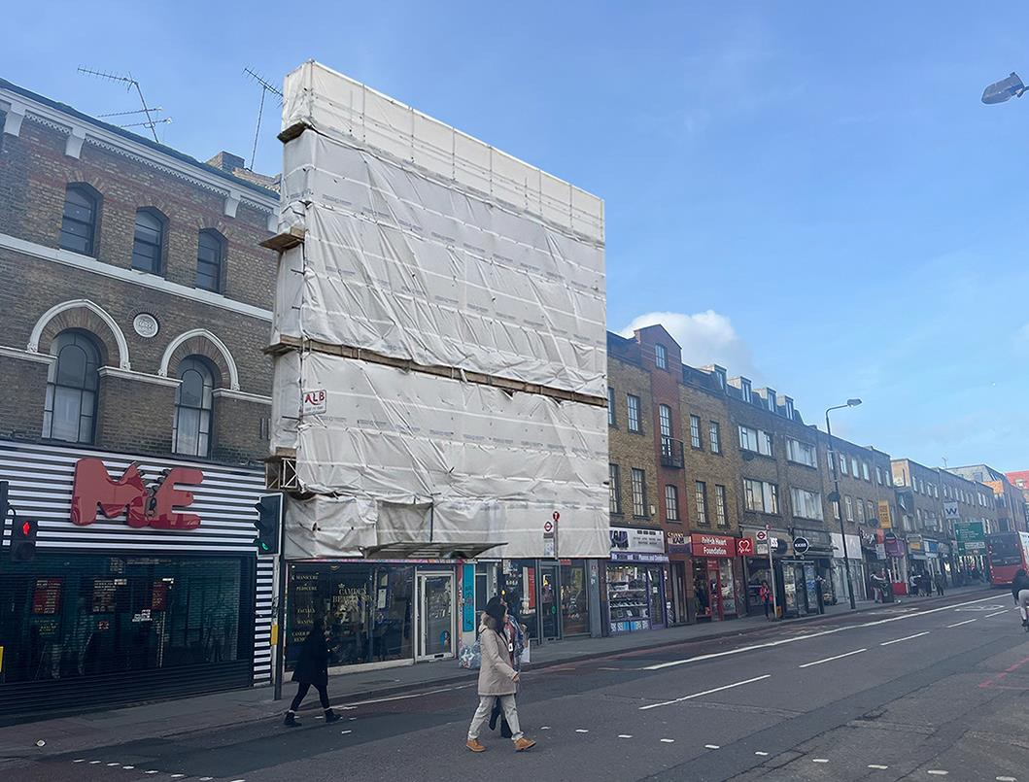
Figure 2 – Application site with scaffold
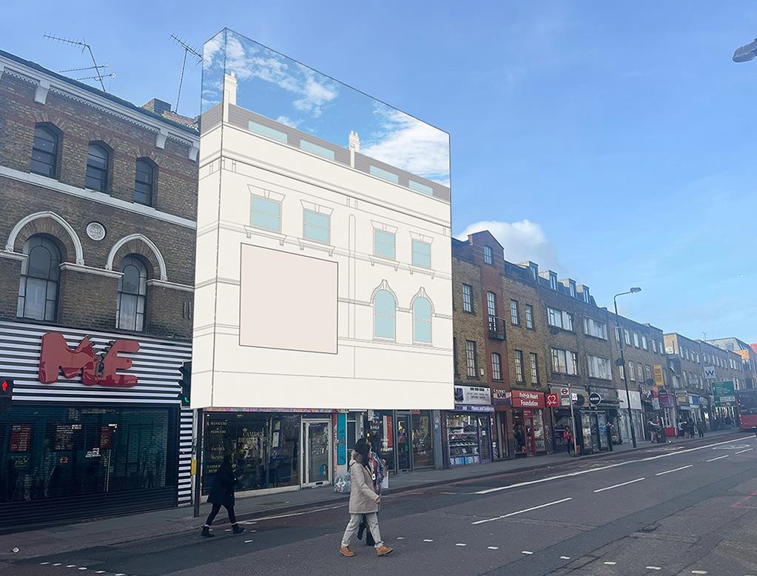
Figure 3 – Application site with proposed shroud

The proposal seeks to encase the scaffolding with a high-quality replicated image of the existing building, noting the positive impact it has on the streetscape. The scale and positioning of the proposed advertisement space has been meticulously designed and considered to ensure the key features of the façade will be replicated on the shroud and the advertisement space will remain subservient to the main building.

Heritage Impacts

Case law dictates that decision makers are required to give great weight to any harm to the significance of a heritage asset and how this should be applied is set out in section 16 of the National Planning Policy Framework. This refers to the historic environment and requires the decision maker to consider whether the proposal sustains and enhances the significance of the heritage asset, making a balanced judgement having regard to the scale of harm or loss and the significance of the heritage asset. In respect of the proposal considered in its own right, its relationship with the conservation area will be entirely positive.

Policy D2 of the Local Plan further relates specifically to heritage and requires proposals to sustain and enhance the significance of heritage assets, making a balanced judgement having regard to the scale of harm and the significance of the heritage asset. As the application site lies within the Camden Town Conservation Area and is cited as a positive contributor to the character of the area, the significance of this heritage asset is acknowledged, and the proposal seeks to ensure that the visual impact and historic significance of the building and wider streetscape is protected.

The shroud enhances the quality of its host building during a period of construction works and thus, the townscape quality of the area. There will be no effect on the setting of any listed buildings and the proposed development is therefore considered acceptable with regard to its impact on the conservation area.

Notwithstanding the above, the shroud is intended to protect the character of the area during a time of refurbishment works where the site would otherwise have appeared as an incongruous part of the street scene. This is highlighted at Figures 2 and 3, which highlight the visual benefit of the shroud against the scaffold and demonstrates how the proposal seeks to protect and retain the character of the host building. By proxy therefore, this ensures the setting of the conservation area is maintained and most pertinently, this is an application for a temporary period of 9 months only while the works take place.

Public Safety/Highway Impacts

The character and appearance of the high street is predominantly commercial and is subject to intense traffic flows.

With this in mind, it is unlikely that a non-illuminated advertisement of this scale would cause harm to public safety or contribute to any adverse highway impacts. The non-illuminated nature of this proposal coupled with the subservient scale of the advertisement space ensures that the impact on

public safety and highways is limited and no grounds therefore exist that would warrant a refusal on these grounds.

Summary

The proposal is for the display of a shroud to the front of the building with a 1:1 replica of the building's façade for a temporary period of 9 months so the works to the building can be fully implemented. An advertisement panel will be sensitively located on the shroud to ensure architectural features are maintained and for the reasons outlined above, the proposal is considered appropriate in the context of the site and surroundings.

The proposal is acceptable with regard to public safety and visual amenity and therefore accords with the principles of both national and local planning policy. It is therefore respectfully requested that consent is granted.

I trust the commentary above is clear but if you require any points of clarification of have any questions, please do not hesitate to contact me.

Yours sincerely

Infinity Outdoor

