

|  |  |
| --- | --- |
| David Fowler  Regeneration and Planning  London Borough of **Camden** 2nd Floor,  5 Pancras Square | Design Out Crime Office  North West DOCO Office,  Ruislip Police Station,  The Oaks,  Ruislip,  HA4 7LE  Telephone: 0208 7333703 Email: DOCOMailbox.NW@met.pnn.police.uk www.met.police.uk  Your ref: 2023/5240/P  Our ref: NW 7547  (24/01/2025) |

Good morning,

Thank you for allowing me to comment on the **Redevelopment of Euston Tower comprising retention of parts of the existing building (including central core, basement and foundations) and erection of a new building incorporating these retained elements, to provide a 32-storey mixed-use building providing offices and research and development floorspace (Class E(g)) and office, retail, café and restaurant space (Class E) and Enterprise Space (Class E/F) at ground and first floors, and associated external terraces; public realm enhancements, including new landscaping and provision of new publicly accessible steps and ramp; short and long stay cycle storage; servicing; refuse storage; plant and other ancillary and associated work.**

I have had previous meetings with the architects in relation to this proposed development.

The site falls within the policing ward of Regents Park. The top reported crimes for this ward for the month of November 2024 (taken from the police UK website) are theft from the person, violence and sexual offences, antisocial behaviour and other theft. Other crimes of note within this area are public order, criminal damage, robbery and drugs.

I have had previous meetings in regards to this development from the architect.

Please refer to Appendix A for illustration of crime figures and local as well as national planning policy

**I do not object to the proposal but also have the following comments and recommendations:**

There are several concerns for this proposed development which I have raised during the previous meetings, it is believed that this can be achieved.

* Separation of public realm, commercial and office/lab space will be key (within the building). There should be no areas of crossover that could lead to potential conflict.
* Landscaping to provide clear access routes with excellent lines of sight. Visibility lowers the fear of crime. There should be no opportunities for concealment which could increase the risk of robbery, burglary and theft. Concealment also includes the stashing of weapons, drugs and other illicit items. Management of this area will be key and include both security and maintenance patrols.
* Lighting will also be important within this development and externally should meet BS 5489-1 2020. Any lighting need to complement the existing or any proposed CCTV system

Other considerations:

* Compartmentation will be key to mitigating the risk of anti-social behaviour and acquisitive/opportunistic crime. Drugs are also a key issue for the borough of Camden and the development must not become a kindly habitat for gangs to enter and take control. It is noted that this area has the added benefit of a security team that patrols the environs and actively monitors CCTV.
* With the possibility of lab space it must be acknowledged that (dependant on the company and lab usage) protests may occur. Consider an area for this to be facilitated which will have the least impact upon other buildings/businesses as well as road users and pedestrians.
* With the large amount of landscaping around the tower and the numerous areas which are public/semi-public including under crofts it will be down to the security teams to manage this space. It should not fall to local policing resources to tackle issues potentially created in this area.

**It is strongly recommended that this location have security rated products to mitigate against the risk of theft and other forms of acquisitive crime to provide some protection for residents that will be housed at this location.**

I am happy to make further recommendations for this development through consultation with the applicant.

**I strongly recommend that the following conditions be placed upon this application.**

1. **Prior to construction proof that the plans can achieve secured by design accreditation must be submitted to the design out crime officer and local planning office.**
2. **For the site to achieve a secured by design accreditation to silver award and to maintain this standard through the life of the development.**

Further consultation is required in the pursuit of achieving SBD certification for the development. If yourself or the applicant wishes to discuss any of my recommendations further then please feel free to contact me. The advice I have provided has been taken from the following guides:

<https://www.securedbydesign.com/images/HOMES_GUIDE_2023_web.pdf>

<https://www.securedbydesign.com/images/COMMERCIAL_GUIDE_2023_web.pdf>

The advice has been adjusted taking into consideration crime statistics and analysis of the area. Further consultation is required in the pursuit of achieving SBD certification for the development.

Kind regards

Aran

Appendix A

Camden planning response template – NPFF and Camden local plan references

**Section 17 of the Crime and Disorder Act 1988**

“It shall be the duty of each Authority to which this section applies to exercise its various functions with due regard to the likely effect of the exercise of those functions on and the need to do all it reasonably can to prevent Crime and Disorder in it’s area”, as clarified by PINS953.

The NPPF and Camden’s own local guidance can support this proposal:

Section 91 of the NPPF states:

*Planning policies and decisions should aim to achieve healthy, inclusive and safe places which*..

b) *are safe and accessible, so that crime and disorder, and the fear of crime, do not undermine the quality of life or community cohesion – for example through the use of clear and legible pedestrian routes, and high quality public space, which encourage the active and continual use of public areas*;…..”

Section 127 of the NPPF further adds:

*Planning policies and decisions should ensure that developments*..

f) *create places that are safe, inclusive and accessible and which promote health and well-being, with a high standard of amenity for existing and future users, and where crime and disorder, and the fear of crime, do not undermine the quality of life or community cohesion and resilience* …..”

Taken from the Camden Supplementary Guide to Design (January 2021 revision)

* *The Council requires that developments demonstrate that they have been designed to contribute to community safety and security.*
* *Security features must be fully considered and incorporated at an early stage in the design process.*
* *Designing-against crime features, safe access and security measures must complement other design considerations and be considered as part of a holistic approach to designing and maintaining safer environments for all.*
* *Better designed environments support safer and healthier communities.*
* *Consideration will be given to the impact of measures on the surrounding area to ensure that there is not displacement of activity into surrounding neighbourhoods.*
* *Safer environments support healthier communities.*

In accordance with Local Plan Policy C5 Safety and Security, the Council will require applicants to demonstrate that all impacts of their proposal on crime and community safety have been considered and addressed. Applicants should be able to demonstrate that they have consulted Met Police Designing Out Crime Officer (details of which can be found at [www.securedbydesign.com](https://eur02.safelinks.protection.outlook.com/?url=http%3A%2F%2Fwww.securedbydesign.com%2F&data=04%7C01%7CAran.L.Johnston%40met.police.uk%7C79a74e93e9434dff94a008d8c9b313e2%7Cf3ee2a7e72354d28ab42617c4c17f0c1%7C0%7C0%7C637481118250278966%7CUnknown%7CTWFpbGZsb3d8eyJWIjoiMC4wLjAwMDAiLCJQIjoiV2luMzIiLCJBTiI6Ik1haWwiLCJXVCI6Mn0%3D%7C1000&sdata=QSRH3WSaqCK1abR8Il3mGJ9n4rJlSayhGDDce5to%2FnE%3D&reserved=0)) and that proposals take into account the advice given and achieve Secured by Design certification, where appropriate.

**Policy C5 Safety and security (From the Camden Local Plan)**

*The Council will aim to make Camden a safer place. We will:*

1. *work with our partners including the Camden Community Safety Partnership to tackle crime, fear of crime and antisocial behaviour;*
2. *Require developments to demonstrate that they have incorporated design principles which contribute to community safety and security, particularly in wards with relatively high levels of crime, such as Holborn and Covent Garden, Camden Town with Primrose Hill and Bloomsbury;*
3. *Require appropriate security and community safety measures in buildings, spaces and the transport system;*
4. *Promote safer streets and public areas;*
5. *Address the cumulative impact of food, drink and entertainment uses, particularly in Camden Town, Central London and other centres and ensure Camden’s businesses and organisations providing food, drink and entertainment uses take responsibility for reducing the opportunities for crime through effective management and design; and*
6. *Promote the development of pedestrian friendly spaces.*

*We strongly encourage security features to be incorporated into a scheme from the beginning of the design process and complement other key design considerations. Internal security measures are preferred. Further information on designing safer environments is set out in our supplementary planning document Camden Planning Guidance on design.*

*It is important to take a proactive approach at an early stage to reduce risks and opportunities for crime and ASB to occur, rather than relying on reactive measures such as*

*CCTV, which should only be used as part of a package of measures to reduce crime. Incorporating designing out crime features into a development should complement other key design considerations and high quality architecture and design should still be achieved.*

*Considering good design early in the design process will lead to a better quality development overall.*

*The design of streets, public areas and the spaces between buildings needs to be accessible, safe and uncluttered. Careful consideration needs to be given to the design and location of any street furniture or equipment in order to ensure that they do not obscure public views or create spaces that would encourage antisocial behaviour. The use of the site and layout should also be carefully considered as these can also have a major impact on community safety.*

From the Camden local plan;

*“ Camden’s food, drink and licensed entertainment premises contribute to the attractiveness and vibrancy of the borough but, where there is a concentration of late night activity, there can also be problems such as noise and disturbance, littering, antisocial behaviour, crime and violence. The cumulative impact of these uses will therefore be assessed in line with our town centre policies, particularly Policy TC4 Town centre uses and Policy A1 Managing the impact of development. The Council will also take into consideration any concerns raised from stakeholders within adjoining areas beyond Camden’s boundaries. Alcohol related crime and late night disorder have been identified as significant issues, particularly within Camden Town and the Seven Dials area of Central*

*London. Camden’s Statement of Licensing Policy sets out the Council’s approach to licensing and special licensing policies apply to these areas.”*

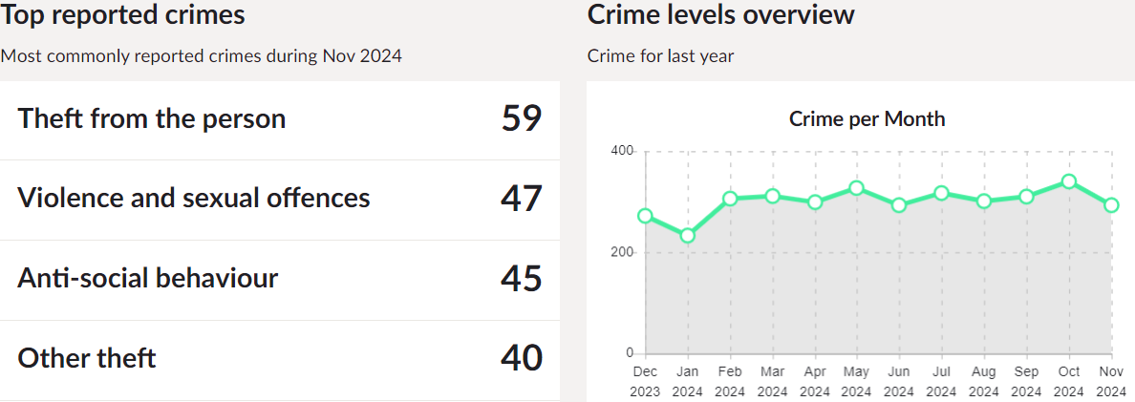

*Line graph showing the number of crimes over the last twelve (12) months for Regents Park ward.*

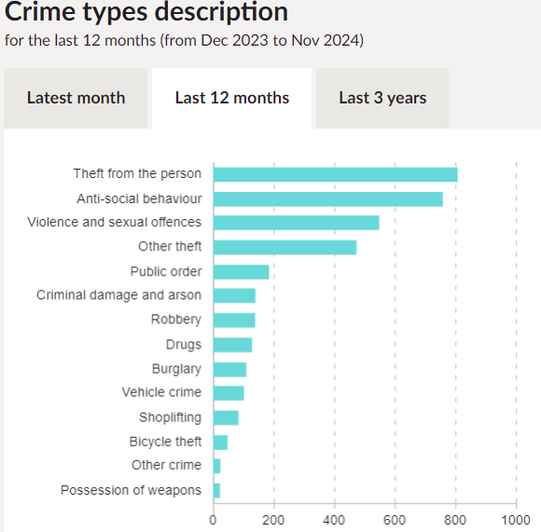

*Bar chart indicating the types of recorded crimes over the last twelve (12) months on Regents Park ward*

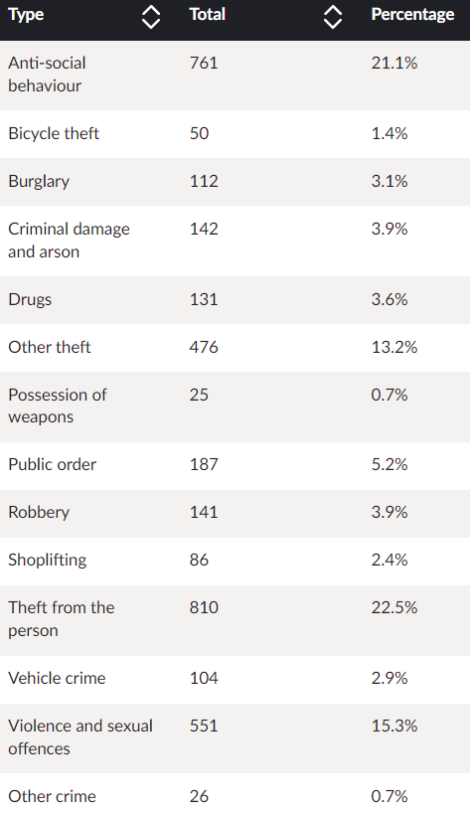

*Number of crimes on Regents Park ward over the last twelve (12) months*

**The primary objective of an efficient Police Service is the prevention of crime**

Crime Prevention advice can be found on the Metropolitan Police Service Website –

http://content.met.police.uk/site/crimeprevention

(Crime figures obtained from www.police.uk and are as most recent as available)

*‘Crime prevention advice is given freely without the intention of creating a contract. Neither does the Metropolitan Police Service take any legal responsibility for the advice given. You must abide by the fire and safety regulations and if you are in any doubt consult the Fire Prevention Officer and the Council’s Building Control Officers.’*