DECISION

Planning (Listed Building and Conservation Areas) Act 1990

Listed Building Consent Refused and Warning of Enforcement Action to be Taken

Address:
111 Frognal
London
NW3 6XR

Proposal:
Variation of condition 2 (approved drawings) and removal of condition 4 (details drawings) of Listed Building Consent ref: 2019/6100/L dated 03/03/2020, which itself was varied by 2021/3075/L dated 18/10/2021 for the erection of basement room beneath garden, erection of single storey rear extension at upper ground level and reinstatement of historic gabled rear elevation; replacement front dormer windows; internal and external refurbishment (summary); Namely, changes to internal layouts, amendment to front dormer window, reduction to approved swimming pool, inclusion of timber and mesh balustrades and lime render finish, and introduction of a electric charging port in the front landscaped area.
Drawing Nos: Cover Letter dated 8 Feb 2024; Heritage Appraisal dated June 2024; P2.LG; P2.UG; E1.CC rev 13; S1.DD rev 13; S3.GG rev 13; P1.P rev 13; LP rev 04; SP.LG rev 4 and SP.UG rev 4; KHW1; HWTD; HNBW; HLFW; HKW2; HKW2D; HRSW; PD1; PD2; RSD1; RSD2; RSD3; RAD; LRG; Cover letter dated 17 June 2024; Cover Letter dated 14 October 2024;

The Council has considered your application and decided to refuse listed building consent for the following reason(s):

Reason(s) for Refusal

1 | The development, by reason of the cumulative impact of the increase in ridge height, raising of the eaves height, resulting increase in height of the rear additions, repositioning of the front roof slope and the scale, location and design of the front dormers, harm the special character and historical significance of the Grade II listed building, and the character and appearance of the wider conservation area, contrary to policies D1 (Design) and D2 (Heritage) of the Camden Local Plan and policies DH1 (Design) and DH2 (Conservation areas and listed buildings) of the Hampstead Neighbourhood Plan 2018.
2 | The development, by reason of the alterations to the front elevation, harm the special character and historical significance of the Grade II listed building, and the character and appearance of the wider conservation area, contrary to policies D1 (Design) and D2 (Heritage) of the Camden Local Plan and policies DH1 (Design) and DH2 (Conservation areas and listed buildings) of the Hampstead Neighbourhood Plan 2018.

Informative(s):

If you intend to submit an appeal that you would like examined by inquiry then you must notify the Local Planning Authority and Planning Inspectorate (inquiryappeals@planninginspectorate.gov.uk) at least 10 days before submitting the appeal. Further details are on GOV.UK.

In dealing with the application, the Council has sought to work with the applicant in a positive and proactive way in accordance with the National Planning Policy Framework. The council publishes its adopted policies online, along with detailed Camden Planning Guidance. It also provides advice on the website for submitting applications and offers a pre-application advice service.

You can find advice about your rights of appeal at:

http://www.planningportal.gov.uk/planning/appeals/guidance/guidancecontent

Yours faithfully

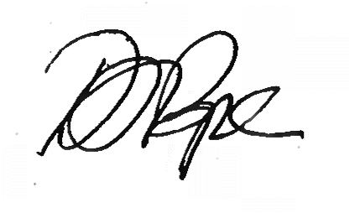
Daniel Pope
Chief Planning Officer

