DECISION

Town and Country Planning Act 1990 (as amended)

Householder Application Refused and Warning of Enforcement Action to be Taken

Address:
22 Elaine Grove
London
NW5 4QG

Proposal:
Retrospective application for roof extension with rear door to flat roof
Drawing Nos: KRC/2022/11/001;

The Council has considered your application and decided to refuse planning permission for the following reason(s):

Reason(s) for Refusal

1 | The existing dormer, by reason of its size, bulk and mass, would appear as an incongruous addition harming the appearance of the host property and the uniformity and symmetry of the terrace and would be detrimental to the character and appearance of the locally listed building and adjacent locally listed buildings, contrary to Policies D1 (Design) and D2 (Heritage) of the London Borough of Camden Local Plan 2017.
2 | The existing dormer would allow for use of the roof as a roof terrace, resulting in a loss of privacy to the adjacent neighbours and the rear neighbours on Mansfield Road contrary to policy A1 (Amenity) of the Camden Local Plan 2017.

Informative(s):

If you intend to submit an appeal that you would like examined by inquiry then you must notify the Local Planning Authority and Planning Inspectorate (inquiryappeals@planninginspectorate.gov.uk) at least 10 days before submitting the appeal. Further details are on GOV.UK.

In dealing with the application, the Council has sought to work with the applicant in a positive and proactive way in accordance with the National Planning Policy Framework. The council publishes its adopted policies online, along with detailed Camden Planning Guidance. It also provides advice on the website for submitting applications and offers a pre-application advice service.

ENFORCEMENT ACTION TO BE TAKEN

The Council has authorised the Planning Department to instruct the Borough Solicitor to issue an Enforcement Notice alleging breach of planning control.

You can find advice about your rights of appeal at:

https://www.gov.uk/appeal-householder-planning-decision.

If you submit an appeal against this decision you are now eligible to use the new submission form (Before you start - Appeal a planning decision - GOV.UK).

Yours faithfully

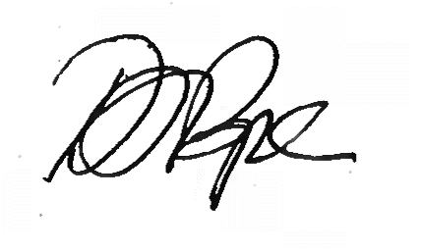
Daniel Pope
Chief Planning Officer

