Document title: | Piling Condition No. 28 Documents (ref: 2023/2510/P)
Site Address: | Selkirk House, 1 Museum Street and West Central Street, WC1A 1JR
Client | Simten

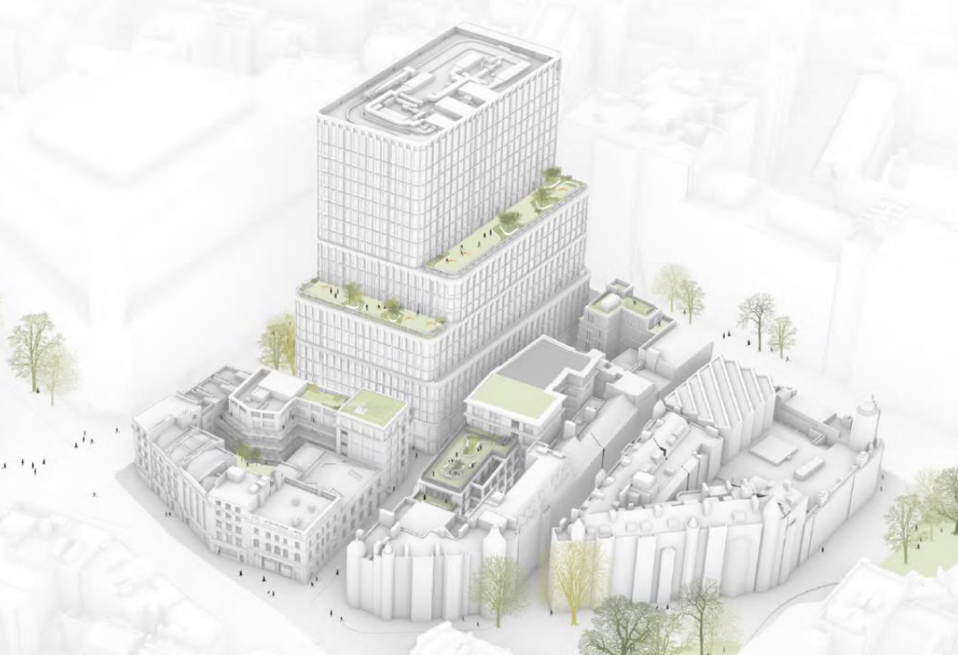

 | Contents
1.1  1.2  1.3 | 1MS & WCS - Proposed Sub-structure drawings  Demolition Drawings- Selkirk House  Demolition Drawings- West Central Street Buildings  These include details of below ground works at 1 Museum Street, 10-12 Museum Street, 35-41 New Oxford Street and 16A-18 West Central Street.
2 | Ground Movement and Damage Impact Assessment  Identifies and accommodates London Underground (LU) structures and tunnels. Details of any changes in loading to LU's infrastructure considering sequence of temporary and permanent works. Provides staged ground movement impact assessment arising from temporary works and permanent works during demolition and construction stages to be undertaken. Accommodates ground movement arising from the development construction thereof.
3 | Tension Pile Design Report  This document includes the detailed design of the tension piles
4 | Basement Construction Plan  This document includes the detailed method of the basement construction and sequencing
5 | Piling Method Statement and Risk Assessments  This document includes the detailed method of the piling works

Part of Planning Condition 28 | Document / drawing references submitted to address part of the condition
1. Provide details of below ground works at 1 Museum Street, 10-12 Museum Street, 35-41 New Oxford Street and 16A-18 West Central Street. | 1.1 1MS & WCS - Proposed Sub-Structure Drawings  1.2 Demolition Drawings- Selkirk House  1.3 Demolition Drawings- West Central Street Buildings
2. Identify and accommodate London Underground (LU) structures and tunnels. | 2. Ground Movement and Damage Impact Assessment
3. Details of any changes in loading to LU's infrastructure considering sequence of temporary and permanent works. | 2. Ground Movement and Damage Impact Assessment
4. Provide staged ground movement impact assessment arising from temporary works and permanent works during demolition and construction stages to be undertaken. | 2. Ground Movement and Damage Impact Assessment
5. Accommodate ground movement arising from the development construction thereof. | 2. Ground Movement and Damage Impact Assessment
6. Provide risk assessment and method statement for the proposed demolition and construction works including temporary works, use of mobile cranes as well as tower cranes. | 3. Tension Piles Design Report  4. Basement Construction Plan  5. Piling Method Statement and Risk Assessments

