SCHEDULE OF WORKS FOR A DISABLED FACILITIES GRANT

REQUIRED AT: Flat D, 7 St George’s Terrace,
London NW1 8XH

CLIENT: Mr. Dimitar Novakov

LANDLORD: Clarion Housing Association

CONTACT TEL. NO: 07918 106578

AGENT AND ALL CORRESPONDANCE TO COMCARE

All sub-items are to be priced as unnecessarily grouped prices are unacceptable.
Where applicable the tenderer is to affix details/quantities in all gaps provided with the description.

Item | Work Description | Unit | Cost
1 | Provision of Level Access Showering Facilities.
1.1 | Strip out and properly dispose of the existing bath  Upon removal, cap-off all redundant drainage and service pipe work below floor level.  Make good all disturbed areas. | Item
1.2 | Construct full height boxing, with treated softwood and Aquaboard over, to shower controls wall for WHB services to run to rear, and ensure firm fixing points for shower seat and grabrails. Also construct half height boxing for shower waste pump behind shower seat position, reinforced for shower seat fixing and with a large white uPVC access panel for pump maintenance. | Item
1.3 | Provide and fit a level access showering facilities by provision of an Impey Radiate Low level acces Tray of dimensions of 700mm wide by 1300mm long.  Position as shown in the drawing, ensuring that the connected to a suitably placed floor drain and that the installation is properly connected to the dwellings existing foul water drainage system. | Item
1.4 | This facility may require a pumped waste water system and contractors should price here for a quiet action pump (Whale instant match pump) be installed, if deemed necessary, sited within boxing per above item,  Gravity waste is always a preferable option. | Item
1.5 | Provide and firmly secure in place, including ceiling supports, a L-shaped shower curtain rail, complete with 2no. weighted, heavy duty shower curtains, to hang 5mm above the floor when wet  Ensure that the curtains fully enclose the new wet floor area. Include for a spanning track and half length curtain behind shower seat to protect shelf over half height boxing. | Item
1.6 | All shower walls including all new boarding inside the shower area to be appropriately tanked, to Contractor design, beneath tiling to ensure suitable substrate for tiling thereon, resistant to moisture. | Item
1.7 | Provide and properly install, as per manufacturer’s instructions, a thermostatically controlled shower unit e.g. Mira Advance with an anti-scald and temperature cut off at 43⁰C.  The unit shall be accompanied with a care package of an extended hose (1.5m), riser bar (1m) and soap dish for use by the client. Allow for easy use by the client in a seated position. Position per OT diagram show below. Contractors are to allow for the routing of all pipework and electrical wiring within the full and half height boxings.  Include for all necessary electrical connections and upgrading at the consumer box, to comply with current NIC regulations.  Include for a limescale inhibitor. | Item
1.8 | Remove all existing tiling throughout the room, and allow to re-tile to full height to the areas as shown in the drawings, around the shower area & service riser, and to half height behind WHB, including for white plastic tile trim at edges of any boxings and surfaces where tiling stops. White tiles have been allowed for. | Item
1.9 | Supply and install Impey Elevate shower screens to suit the 700 x 1300mm shower area, as shown on drawings. | Item
1.10 | Remove all existing flooring. Provide and properly install, as per manufacturer’s instructions, Altro Aquarius flooring to the whole of the room. Cove 100mm to all walls and properly dress into the floor drain. To run under WC pan– no cutting around allowed. Colour TBC with the client | Item
1.11 | Supply and install a new Dimplex FX20IPX4 downflow heater and provide new fused spur connection, install per manufacturers instructions, location TBC with Contractors electrician. | Item
1.12 | Remove all wallpaper to untiled areas and re-skim throughout as necessary for a smooth and level surface, sealed with mist coat. Allow for 2 coats of mould-resistant emulsion paint to all walls, upon completion. Colour to client’s choice. Allow to redecorate ceiling with 2 coats of white emulsion paint | Item
1.13 | Supply and securely fit 2 No 460mm, ribbed plastic grab rails, vertical and horizontal grabrails in the shower area. Position per OT diagram shown below | 2no.
1.14 | Provide and securely fit a wall mounted, fold down shower seat with legs, arms and padded seat. Utilise AKW Model 04230P – Grey model, Position as shown on drawing, finished seat height 482mm | Item
1.15 | Where possible, if there is existing ducting and an exhaust grille in place, allow to supply and install a new, low voltage, axial or centrifugal mechanical extract fan as required, which complies with current electrical regulations. To ceiling location over WC/shower seat position. Ensure that the unit has a suitable over run and leave in proper working order. NOTE this item to be omitted if not possible to install | Item
1.16 | No works are required to the existing ceiling lights which appears steamproof (TBC with Contractors electrician) | Item
1.17 | Remove and dispose of existing WHB including pedestal and taps and supply and install a new 550mm width wall hung WHB, with mixer tap including waste kit, plug and new bottle trap with 75mm deep water seal and make all service connections, including an allowance for any required pipework | Item
1.18 | Remove and dispose of existing WC and supply and install a new raised height (height TBC with OT prior to works) WC including seat and lid, including flush kit and lever flush, and make all service connections | Item
2.0 | General
2.1 | On completion of the works remove all tradesmans’ refuse and leave in a clean and tidy condition at the end of every working day.
2.2 | All works to be carried out in a proper workmanlike manner using materials of British Standard where possible.
2.3 | All relevant Building Regulation consents must be obtained by the contractor from the relevant authority.
2.4 | Contractors must provide a NIC Certificate for all electrical works.
Any questions regarding specialist equipment shall be discussed with the Occupational Therapist of the London Borough of Camden Social Services Department.
Occupational Therapist Felice Maambira, ph no. 07723 444382

2.6 | Contractors must visit the site to ascertain the full extent of the works before submitting their quotation. The tenant should be contacted before the visits are made.
2.7 | VAT the works should be exempt from VAT. The contractor must obtain the necessary exemption certificate directly with the applicant
2.8 | “Left” and “right” are stated throughout as if standing in the doorway of the bathroom and looking into the room.

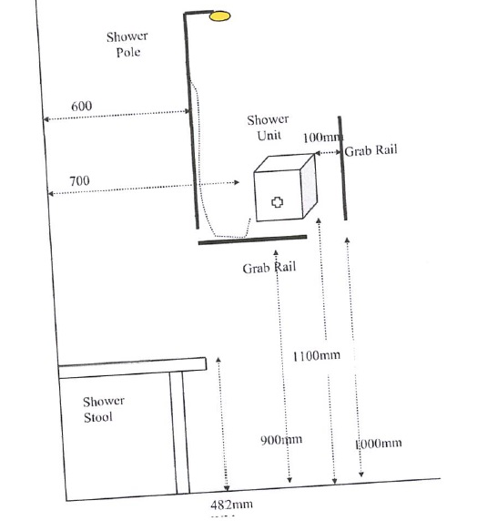

OT Shower Controls Diagram

