REDINGTON FROGNAL
NEIGHBOURHOOD FORUM

1 December, 2024
Dear Mr. Nicholls,
226 Finchley Road, application 2024/5022/P - object
The Neighbourhood Forum wishes to note that this application for off-street parking relates to a location with a PTAL rating of 6a and that it is in extremely close proximity to the 13 and 113 bus routes, Finchley Road and Frognal Overground, Finchley Road Underground and various coach routes with stops on Finchley Road.
https://tfl.gov.uk/info-for/urban-planning-and-construction/planning-with-webcat/webcat?Input=NW3+6DH&PlaceHolderText=eg.+NW1+6XE+or+530273,+179613&type=Ptal&zoomLevel=15
The pavement here has high footfall and is used by parents and children accessing many local schools, as well as pedestrians en route to Camden Art Centre, JW3 cultural centre, public transport links and the O2 shopping centre.
Vehicles driving over the footway to access off-street parking has been identified as intimidatory and a barrier to pedestrian journeys, during surveys conducted by Hampstead Transport Partnership.
The harm and cumulative harm to the Conservation Area that is caused by the proliferation of off-street parking on this eastern stretch of Finchley Road would be ameliorated by the restoration of some of the original boundary treatments.
Poor streetscape caused by off-street parking
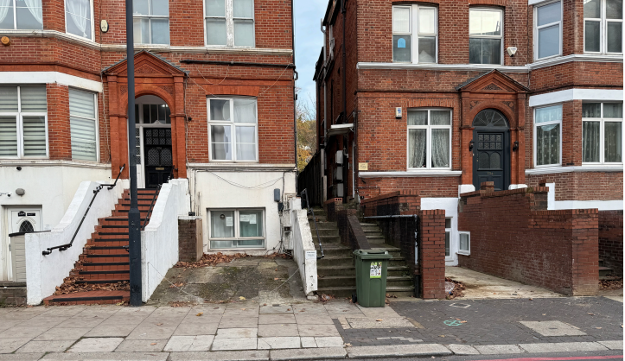
The encouragement of increased vehicle movements is also contrary to the TfL-led research, Healthy Streets for All:
https://content.tfl.gov.uk/healthy-streets-for-london.pdf
The Neighbourhood Forum therefore wishes to object to this application for off-street parking.

Yours sincerely,
Nancy Mayo
Secretary

Redington Frognal Neighbourhood Forum
https://www.redfrogforum.org
REDINGTON FROGNAL
NEIGHBOURHOOD FORUM

