93 Hampton Road
Hampton Hill
Hampton
London
TW12 1JQ
Tel: +44 (0)20 8943 3609
michael@mbaplanning.com

Michael Burroughs BA MRTPI FRSA
Planning Consultant

Planning Department
London Borough of Camden
2nd Floor, 5 Pancras Square
c/o Town Hall, Judd Street
London
WC1H 9JE

Dear Sir

Camden: 102 Frognal: Discharge of conditions.

This letter accompanies a retrospective Householder application for approval of materials required by planning consent 2023/4996/P, approved by appeal 3338596 on 19 September 2024. The fee will be paid by the applicant when notified.

Plans
The application is accompanied by Plans 0510 MAT300 (front elevation); 301 (side) and 302 (rear). The proposed materials and their locations are noted on these plans.

Background
Work commenced on it as soon as the consent issued, relying on the well-established exception to the Whitley principle (Whitley and Sons v. Secretary of State for Wales [1992] 64 P. & C. R.296). This provides that works undertaken prior to formal approval may lawfully commence a development where the application is made before the expiry of the relevant planning permission, if the works undertaken accord with the submitted details and approval is subsequently granted.

This consented scheme was an extension to a recently built side extension 22/5138/P, previously granted consent by appeal 3324781 on 14 September 2023. The existing and proposed front elevation below distinguishes the consented and built extension (with the 4 garage doors) and the consented extension subject of this application (22/5138/P, red lined) that is part built. Note that the consented 23/4996/ extension is behind an existing 2m brick garden wall – the ground floor window is faintly shown because it is behind the wall.

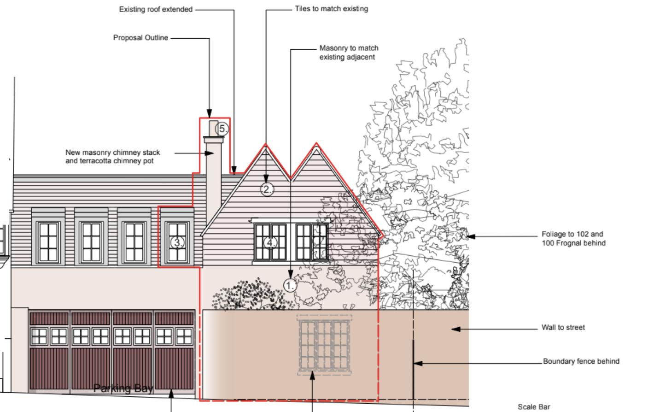

Materials
The materials subject of this application match the materials used in the completed side extension ref 22/5138 (which had no materials condition) and most had been previously approved by the Council in respect of the earlier extension consent ref.

The materials consents subsequent to 20/3418 were:
- 22/1574 granted on 27 May 2022 for replacement of single glazed timber framed windows with double glazed timber sashes on the front and rear of the (main) house.
- 22/3053 granted on 12 July 2022 for details of joinery, railings and bricks pursuant to conditions 4 a+b and 5 of consent 20/3418 for the earlier iteration of the side extension;
Heritage Issues
As the extension has recently been granted consent on appeal and the materials match those approved for use (and being used) in a previous extension scheme, the proposed materials will have a neutral effect on the Conservation Area and the surrounding listed buildings, as the appeal inspector noted.

We look forward to discussing this application with the case officer.

Yours faithfully

Mike Burroughs

