DESIGN & HERITAGE PLANNING STATEMENT
Ref: 29 Spencer Rise NW5 1AR 24 Oct 2024

This statement is submitted by Fixated Ltd in support of the planning application for the roof extension at 29 Spencer Rise. The statement provides a description of the site and its surroundings, design, layout, planning and policy considerations. This statement is written in accordance and in full conformity with the requirements set for planning applications as amended in the Town and Country Planning (general Development Procedure) Order 2016.

1. CONTEXT
29 Spencer Rise is a mid-terraced house located in the Dartmouth Park Conservation area. It is unclear when No 29 was built but we believe most of Spencer Rise was constructed during the 1870s and was initially composed of two storey houses along its entire length. There have been a variety of single and two storey extensions within Spencer Rise and the precedent for roof extension has been well established. There is little consistency within the street with a number of properties benefitting from mansard roof extensions, a number with more shallow pitched roofs with dormer windows front/rear and a number of ‘butterfly’ roofs.

2. RELEVANT PLANNING POLICY
National Planning Policy Framework (2019)

The London Plan (2016)

The London Plan Intend to Publish version (2019)

Camden Local Plan (2017)
H6 – Housing choice and mix
H7 – Large and small homes
A1 - Managing the impact of development
D1 - Design
D2 – Heritage

Camden Planning Guidance 2018-2020
CPG Design
CPG Home improvements
CPG Amenity

Dartmouth Park Conservation Area Appraisal and Management Statement (DPCAAMS) (2009) Dartmouth Park Neighbourhood Plan (2020)
H1 – Meeting housing need
DC1 – Enhancing the sense of place
DC2 – Heritage assets
DC3 – Requirement for good design
DC4 – Small residential extensions

3. RECENT PLANNING HISTORY ON 27 SPENCER RISE
NA

4. RECENT APPROVED PLANNING APPLICATIONS ON SPENCER RISE
NA

5. DESIGN RATIONAL
The low profile conservation style velux windows are well established on Spencer Rise and a number of properties have been granted consent with similar roof windows in recent years. The proposed velux windows at No 29 would not deviate from this. The proposed velux windows would not detract from the conservation area.

6. AERIAL VIEW

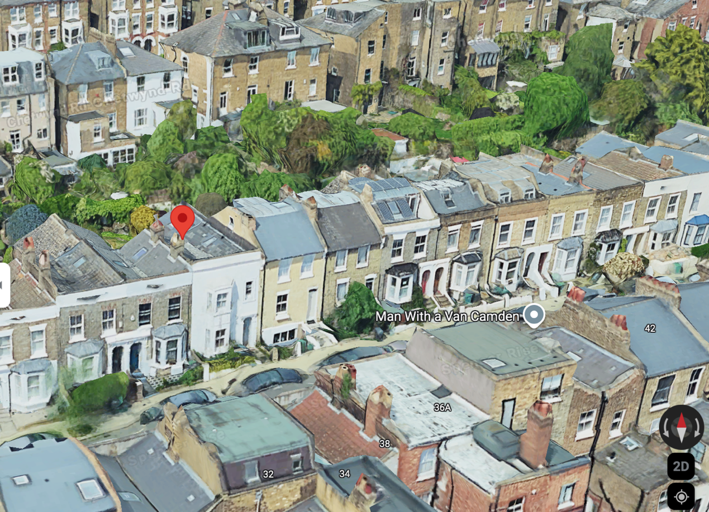
NO 29

7. TREES/SHRUBS
No trees of shrubs are to be affected by the proposed works.

8. PARKING
Existing parking arrangements are to remain unchanged.

9. IMPACT ON NEIGHBOURING PROPERTIES
There will be no impact to the outlooks or amenity spaces of the neighbouring properties.

10. ACCESS
Existing access to the property is to remain unchanged.

11. CONCLUSION
The proposed conservation style, low profile, velux windows will not adversely affect the conservation. The proposed roof light on the flat roof will not be visible from the public realm. In line with a number of similar approved planning applications, we would recommend for approval.

