DESIGN & HERITAGE PLANNING STATEMENT
Ref: 27 Spencer Rise NW5 1AR 24 Oct 2024

This statement is submitted by Fixated Ltd in support of the planning application for the roof extension at 27 Spencer Rise. The statement provides a description of the site and its surroundings, design, layout, planning and policy considerations. This statement is written in accordance and in full conformity with the requirements set for planning applications as amended in the Town and Country Planning (general Development Procedure) Order 2016.

1. CONTEXT
27 Spencer Rise is a mid-terraced house located in the Dartmouth Park Conservation area. It is unclear when No 27 was built but we believe most of Spencer Rise was constructed during the 1870s and was initially composed of two storey houses along its entire length. There have been a variety of single and two storey extensions within Spencer Rise and the precedent for roof extension has been well established. There is little consistency within the street with a number of properties benefitting from mansard roof extensions, a number with more shallow pitched roofs with dormer windows front/rear and a number of ‘butterfly’ roofs.

In particular it should be noted that the host property is sandwiched between a terrace of 5 properties all with matching parapets, brick finish, single story bay windows and adjoined front entrance features. It is likely these properties were built at the same time. To the other side of the host property (no 29) there is little consistency but predominantly the properties on this side have pitched roofs, many with dormer windows. The host property bears little relation to either adjoining property.

2. RELEVANT PLANNING POLICY
National Planning Policy Framework (2019)

The London Plan (2016)

The London Plan Intend to Publish version (2019)

Camden Local Plan (2017)
H6 – Housing choice and mix
H7 – Large and small homes
A1 - Managing the impact of development
D1 - Design
D2 – Heritage

Camden Planning Guidance 2018-2020
CPG Design
CPG Home improvements
CPG Amenity

Dartmouth Park Conservation Area Appraisal and Management Statement (DPCAAMS) (2009) Dartmouth Park Neighbourhood Plan (2020)
H1 – Meeting housing need
DC1 – Enhancing the sense of place
DC2 – Heritage assets
DC3 – Requirement for good design
DC4 – Small residential extensions

3. RECENT PLANNING HISTORY ON 27 SPENCER RISE
2004/3614/P (GRANTED)
The erection of a roof extension and ground floor rear extension.
(not implemented)

2006/3199/P (GRANTED)
Certificate of Proposed Lawfulness for single -storey rear and side extension at ground floor level dwelling house (Class C3

4. RECENT APPROVED PLANNING APPLICATIONS ON SPENCER RISE

2022/5290/P. 45 - 47 Spencer Rise London Camden NW5 1AR
Erection of mansard roof extensions and ground floor rear side return
extensions at no's 45 and 47

2023/0330/P. 34 Spencer Rise London NW5 1AP
Erection of mansard roof extension

2022/1286/P. 41 & 43 Spencer Rise London Camden NW5 1AR
Erection of mansard roof extensions

2020/3547/P. 49 Spencer Rise, NW5 1AR
Erection of mansard roof extension

5. DESIGN RATIONAL
5.1 The proposed roof extension will be finished in natural slate to match the existing terrace.

5.2 The proposed pitch of the roof is to mimic the adjoining properties of No 29 and beyond.

Whilst a traditional 70 degree mansard roof with a 70-90cm set back was considered, the resulting projection of the raised parapet wall beyond the roof/parapet of No 29 would look incongruous within the terrace. It should be noted that the proposed shallower pitch, rather than a mansard pitch, will inevitably result in reduced internal space within the new 2nd floor level. However, on balance it was felt that this would result in a more acceptable design.

5.3 The proposed roof extension will not be visible from the public realm.

5.4 In line with many similar extensions on Spencer Rise, the proposed roof will have zinc/lead clad double dormers to the front and a single dormer to the rear.

5.5 The existing chimneys between No 27 and No 25 are to be raised to accommodate the new roof. The pots/crown detailing are to match the existing.
This reflects similar applications on Spencer Rise.

5.6 The rear ‘butterfly’ walls are to be retained with a contrasting slate finish.

5.7 Existing render to the front of the property is to be removed at 1st floor level and the brick work repaired/repointed. This will return the property to its original state, with a positive enhancement to the conservation area.

5.8 The existing glazing to the ground floor rear wrap around extension rear and roof is to be replaced with allum frame glazing.
There has been some water ingress and general deterioration of the existing wood frame windows. Neither of these elements are part of the original property and are not visible from the public realm.

5.9 The proposed roof extension closely follows a previous approved planning application 2004/3614/P (now lapsed)

5.10 A new extended sunken courtyard to the rear garden will greatly enhance the outlook from the rear of the property and will closely reflect the sunken courtyard at No 25.

6. AERIAL VIEW

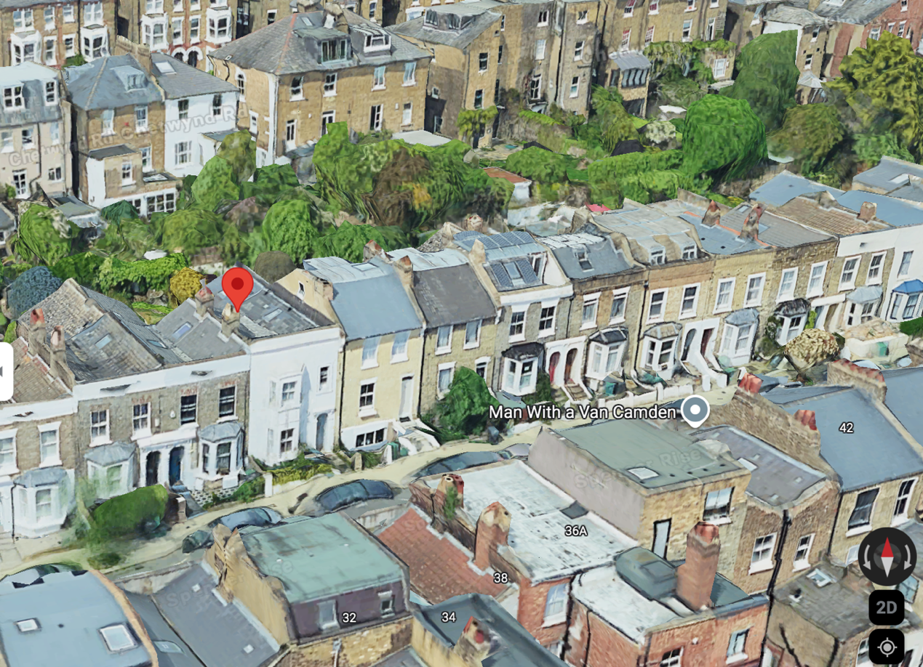

7. TREES/SHRUBS
No trees of shrubs are to be affected by the proposed works.

8. PARKING
Existing parking arrangements are to remain unchanged.

9. IMPACT ON NEIGHBOURING PROPERTIES
There will be no impact to the outlooks or amenity spaces of the neighbouring properties.

10. ACCESS
Existing access to the property is to remain unchanged.

11. CONCLUSION
The proposed roof extension to the property follows a long standing precedent within Spencer Rise with approximately 30% of the street having benefitted from similar extension.
The design rational of the proposed shallower pitched roof, rather than a more traditional mansard roof, has been clearly explained and sits comfortably within the terrace and the adjoining properties.

With an eclectic and hotchpotch range of roofs on Spencer Rise, there is little continuity within the street. No 27 sits apart from both adjoining properties.

The proposed roof extension will provide some much need space for this family home and we would recommend for approval.

12. PHOTO MONTAGE

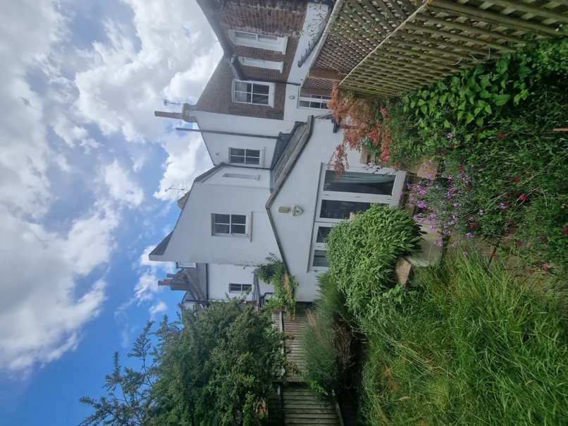 Rear

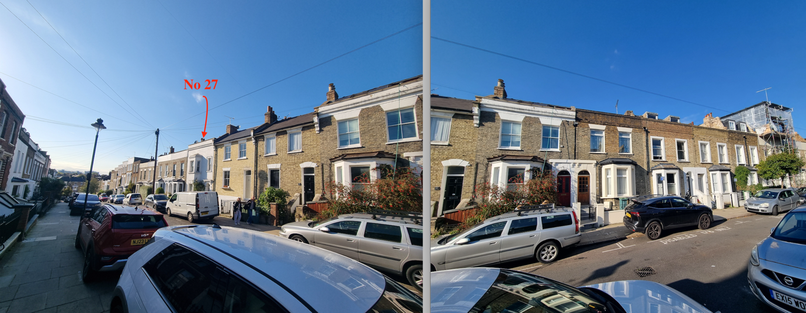Front

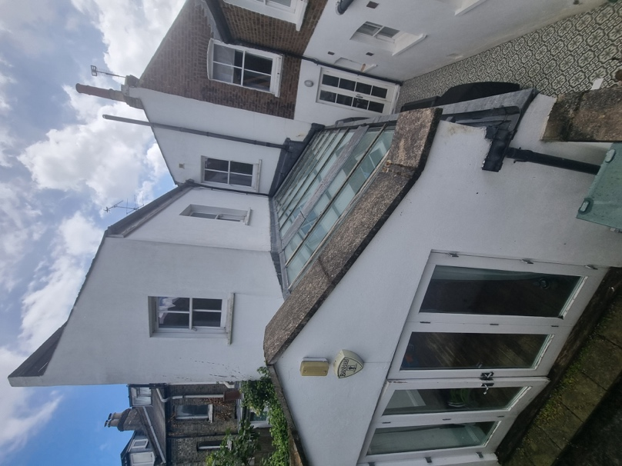 Wrap around rear extension

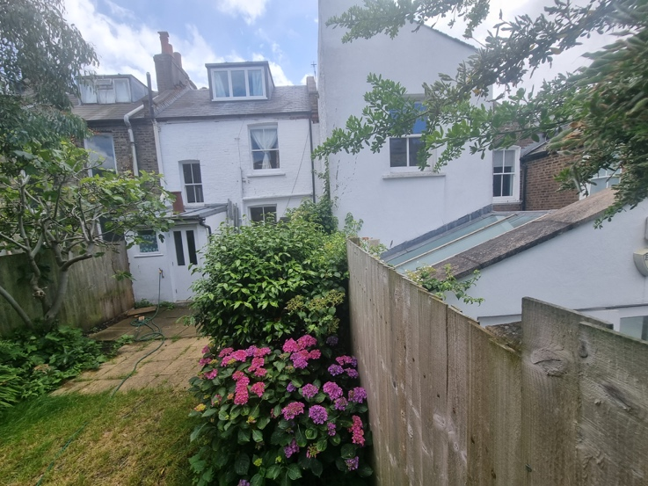 Rear No 29

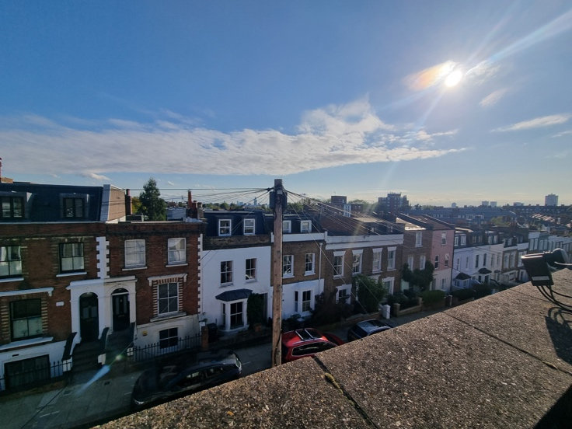 View from existing roof

