REDINGTON FROGNAL
NEIGHBOURHOOD FORUM

19 October 2024
Dear Mr. Nicholls,

2024/4205/P: Flat 1, 36 Platt’s Lane – objection

The Neighbourhood Forum wishes to object to the proposed loss of natural soft surface in the absence of any significant mitigation measures.

Policies SD 2, SD 4, SD 5, BGI 1 and BGI 2 of the Neighbourhood Plan are all relevant and, in particular, SD 4 vii, SD 4 vii, SD 5 iii, , SD 5 vii, BGI 1 I, ii, iii. Iv, v, vii, BGI 2 i, ii, iii, iv, v.

The proposed sedum roof will do very little to enhance biodiversity and, instead, the planting selection should be in compliance with the guidance set out in section 6.2.4 of the Neighbourhood Plan.

It should be noted that the proposed loss of garden is in very close proximity to the lost Boundary Stream, which flows directly beneath Platt’s Lane. The screenshot below, showing the path of the lost Boundary Stream, is from Arup’s Google Earth Pro map of Redington Frognal Underground Rivers.

Path of the Lost Boundary Stream along Platt’s Lane
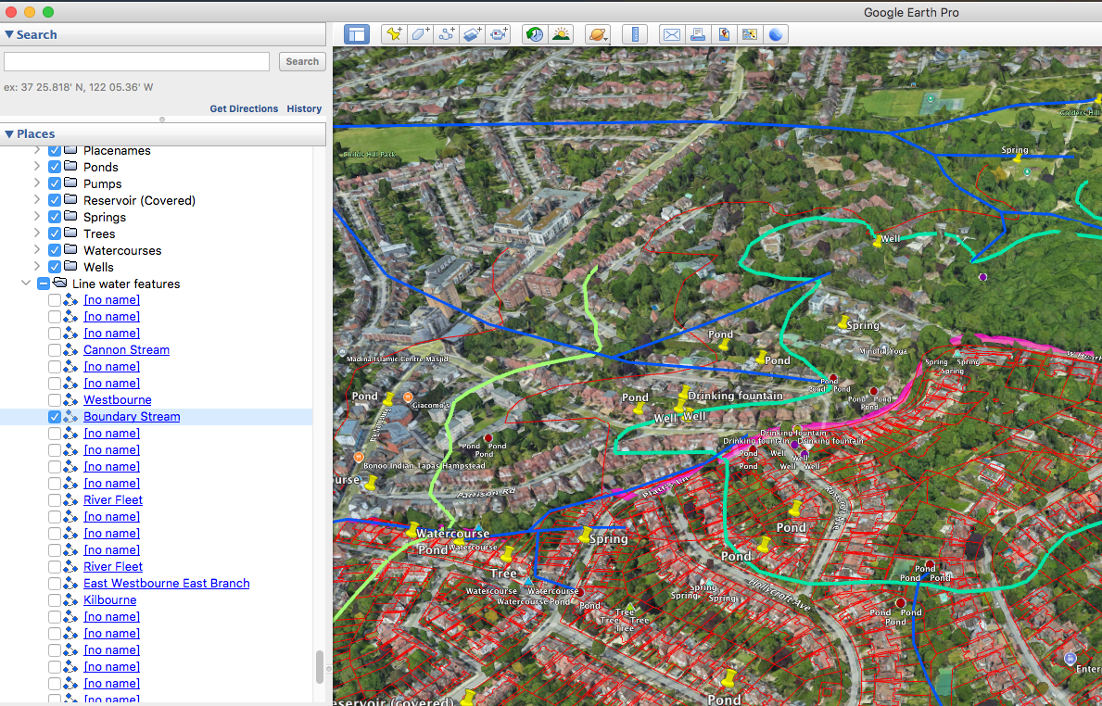

The Arup maps can be found at:
https://www.redfrogforum.org/wp-content/uploads/2018/11/RF_GoogleEarth_snapshot_1600.jpg
and accessed via the attached KMZ Google Earth file.

Surface water flooding occurs downstream in Platt’s Lane towards the junction with Finchley Road:
https://www.redfrogforum.org/wp-content/uploads/2020/03/89-Environment-Agency-RedFrog-surface-water-flood-risk-north.pdf

As it stands, the application is not in conformity with the Neighbourhood Plan. If significant mitigation measures were to be proposed, the application could potentially become acceptable.

Yours sincerely,

Nancy Mayo

Secretary
Redington Frognal Neighbourhood Forum
https://www.redfrogforum.org

REDINGTON FROGNAL
NEIGHBOURHOOD FORUM

