**2024/3560/T – Map 5 of 7 – T73-79**

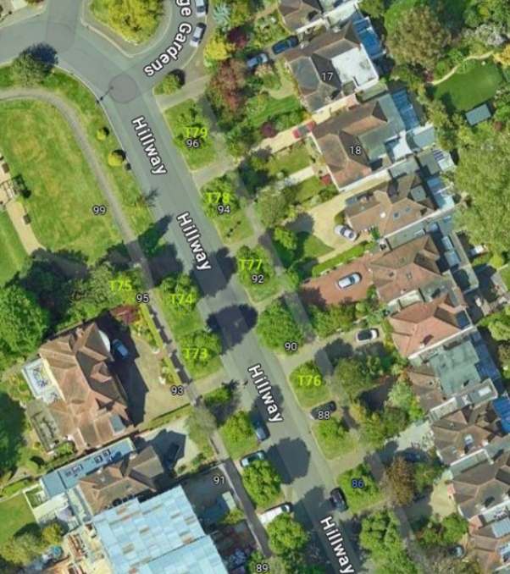

|  |  |  |  |
| --- | --- | --- | --- |
| **Tree number** | **Location** | **Operation** | **App ref** |
| T73 | OS 97 Hillway | Re-pollard back to previous most recent pollard points. Remove all epicormic growth. | 2024/3560/T |
| T74 | OS 99 Hillway | As above | 2024/3560/T |
| T75 | SO 99 Hillway | As above | 2024/3560/T |
| T76 | OS 92 Hillway | As above | 2024/3560/T |
| T77 | OS 96 Hillway | As above | 2024/3560/T |
| T78 | OS 18 Holly Lodge Gardens | As above | 2024/3560/T |
| T79 | OS 17 Holly Lodge Gardens | As above | 2024/3560/T |