**2024/3560/T – Map 4 of 7 – T28-T36**

Exclude T32, which is on TPO ref 2024/3608/T

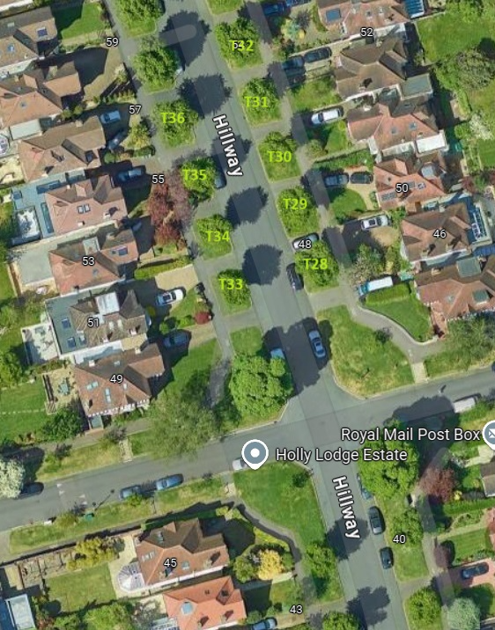

|  |  |  |  |
| --- | --- | --- | --- |
| **Tree number** | **Location** | **Operation** | **App ref** |
| T28 | OS 46 Hillway | Re-pollard back to previous most recent pollard points. Remove all epicormic growth. | 2024/3560/T |
| T29 | OS 48 Hillway | As above | 2024/3560/T |
| T30 | OS 50 Hillway | As above | 2024/3560/T |
| T31 | OS 52 Hillway | As above | 2024/3560/T |
| T32 | OS 54 Hillway | As above | 2024/3608/T |
| T33 | OS 51 Hillway | As above | 2024/3560/T |
| T34 | OS 53 Hillway | As above | 2024/3560/T |
| T35 | OS 55 Hillway | As above | 2024/3560/T |
| T36 | OS 57 Hillway | As above | 2024/3560/T |