**2024/3560/T – Map 2 of 7 - T9-T19**

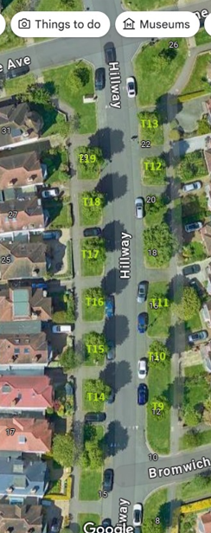

|  |  |  |  |
| --- | --- | --- | --- |
| **Tree number** | **Location** | **Operation** | **App ref** |
| T9 | OS 10 Hillway | Re-pollard back to previous most recent pollard points. Remove all epicormic growth. | 2024/3560/T |
| T10 | OS 12 Hillway | As above | 2024/3560/T |
| T11 | OS 16 Hillway | As above | 2024/3560/T |
| T12 | OS 22 Hillway | As above | 2024/3560/T |
| T13 | OS 24 Hillway | As above | 2024/3560/T |
| T14 | OS 19 Hillway | As above | 2024/3560/T |
| T15 | OS 21 Hillway | As above | 2024/3560/T |
| T16 | OS 23 Hillway | As above | 2024/3560/T |
| T17 | OS 25 Hillway | As above | 2024/3560/T |
| T18 | OS 27 Hillway | As above | 2024/3560/T |
| T19 | OS 29 Hillway | As above | 2024/3560/T |