**2024/3560/T – Map 1 of 7 - T1-T8**

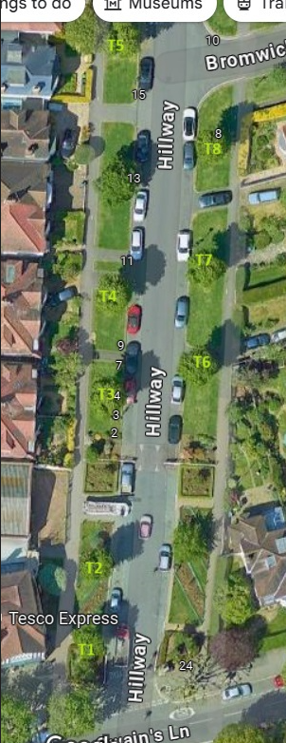

|  |  |  |  |
| --- | --- | --- | --- |
| **Tree number** | **Location** | **Operation** | **App ref** |
| T1 | SO 25 Swain’s Lane | Re-pollard back to previous most recent pollard points. Remove all epicormic growth. | 2024/3560/T |
| T2 | OPP 27 Swain’s Lane on Hillway | As above | 2024/3560/T |
| T3 | OS 3 Hillway | As above | 2024/3560/T |
| T4 | OS 7 Hillway | As above | 2024/3560/T |
| T5 | OS 15 Hillway | As above | 2024/3560/T |
| T6 | OS 2 Hillway | As above | 2024/3560/T |
| T7 | OS 4 Hillway | As above | 2024/3560/T |
| T8 | OS 8 Hillway | As above | 2024/3560/T |