**DESIGN & ACCESS STATEMENT**

**Site Address: Flat 4, Salamander Court, 135 York Way, London. N7 9LG.**

**Introduction**

The proposed site is located in the London Borough of Camden.

The Flat is located on the first floor of a building which comprises of residential flats over 2 main elements; a 4 storey 19th century building with London stock brick with stucco base and quoins which faces York Way and a modern 7 storey rear extension which extends over the top of the original building. The flat is in the original building.

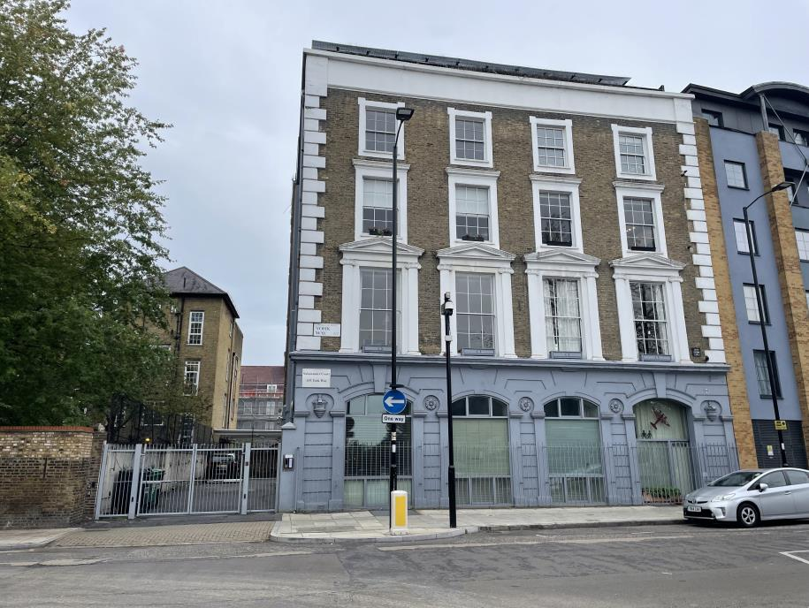

*View of front of building on York* ***Way***

**Description of Development**

The replacement of rotting wooden Juliet balcony doors and frame with UVPC to match the design and proportions of the existing doors on the south side of the building facing the playground of Brecknock Road School.

The existing doors were installed just 7 years ago replacing the previous rotting doors. The fact that the current doors have failed in a very short period clearly indicates that prevailing conditions are not conducive to wooden construction and UVPC would be potentially more durable.

*View of the original doors from the south side parking area*

**Site**

The site is located in a predominantly residential area supported by local shops towards the junction with Camden Road and beyond Brecknock Road. It shares its south and rear boundary with Brecknock School, and its ancillary buildings and playground.

The subject building and surrounding buildings are predominately used as residential accommodation with various new housing developments undertaken in the area.

**Access**

The existing building has a principal entrance to the left hand side of the building on York way. The proposed works would have no impact on access.

**Landscaping**

No landscaping works are proposed in the respect of the application.