Reply to queries from Campbell Reith Basement Impact Assessment Audit (CR ref: 14006-89 September 2024)
Query No. | Query Reference | Query | Response
1 | 4.4 & 4.14 | Confirmation of the elevations of the surrounding properties and the extent of the void below the ground floor level is requested. | 4.4- The extent of the void and the relative differences in ground levels are shown in the elevation drawings 31222/P/005-10.  The elevation of the property Well Mount to the southeast is approximately 2m lower than No. 30 Grove Place. This was stated in Q13 of the Land stability Screening. It can be argued that due to the lower level of Well Mount, ground movement impact is likely to the negligible, therefore the assessment is conservative.  4.14 The void underneath the existing ground floor is noted on section 1 of the Croft BIA. The propping will remain as noted on appendix E of the Croft BIA
2 | 4.6 | Clarification is requested for some of the responses given to the screening stages. | 4.6 - The gradient of the hillside taken from OS 1 25 00 survey ranges from approximately 1 in 9 to 1 in 12 or from about 5⁰ to 6⁰.  4.6 it is agreed that the Claygate Member is a secondary A aquifer. However, the material is of low permeability being predominantly a clay or a silt.  4.6 In MGC BIA Section 5 of groundwater screening has been amended to refer to Croft groundwater levels in design.  The site is not underlain by the Bagshot Beds See info from BGS (and Arup report). The geological boundary is topographically above the site  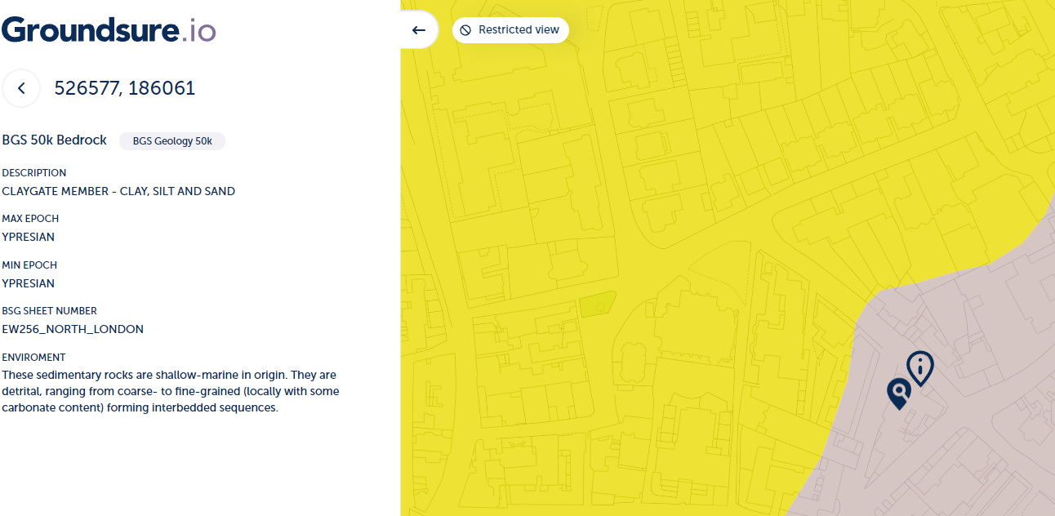
3 | 4.7 | Further justification for the ground model adopted in the BIA is requested. | The Bagshot Member lies to the northwest of the site not at the site itself. Furthermore, the description of the material is consistent with the Claygate Member. As stated in the MGC BIA an adjacent borehole at a similar level also indicated the presence of the London Clay Formation at a similar level (ref Section 5.3.2). The ground model is considered as accurate as the data allows.
4 | 4.9 | Consideration should be given to the likelihood of groundwater ingress during basement construction, potential stability and hydrogeological impacts and any mitigation requirements. | It is anticipated that groundwater flow if present will be slow due to the clay or silt nature of the material encountered.  The presence of groundwater will be accounted for in the detailed design stage.
5 | 4.11 | Confirmation of the impact the proposed basement will have on the proportions of hardstanding is requested and should be presented consistently. | This has been updated on the Croft BIA. No change in hardstanding surfaces is noted.
6 | 4.13 | Geotechnical parameters to be reviewed in line with the comments made in Section 4. | Ka 0.46 and kp 2.3 in MGC BIA No other changes are proposed  Croft BIA updated to reflect values noted in MGC BIA
7 | 4.16 | Comments and requests for clarification relating to the Ground Movement Assessment have been discussed in Section 4 and require a response. The building damage assessment may require subsequent revision. | XDISP has not been used in the assessment  The hard layer has been increased to 10m. The excavation gm curves are based on the PDISP contours  The ground movement is a summation of different forces. There is both heave and settlement and based on the input parameters from the ground model and loads. The inputs from soil removal and loads are included in the PDSIP analysis for the drained analysis  PDISP input and output now provided  The cross sections already show ground movements for adjacent buildings. Plan view Figures 6.1 and 6.2 in MGC BIA have been annotated to show this as well.  The loads provided by the structural engineer are included in the GMA
8 | 4.17 | Further consideration of the movement monitoring trigger level values is requested following review of the Ground Movement Assessment. | A revision for the movement monitoring was carried out to increase the depth to the hard layer within the London Clay. The trigger levels were reviewed according to the updated ground movement results and no revisions were requested as trigger levels are tighter than suggested movement recorded.

