

**Planning Statement**

**55, Marchmont Street, London WC1N 1AP**

# Change of use – Conversion of costa coffee to Tapas

**Restaurant (Class E) with associated internal and external alterations, including to shop front, and advertisement signage**

**Written and prepared by Planning by Design on Behalf of KT&TT LTD**

## 1. Introduction

Planning By Design (the agent) has been instructed to act on behalf of KT&TT LTD (the applicant) to submit a planning application to Camden Council (the Local Planning Authority) for the proposed change of use – conversion of costa coffee to Tapas Restaurant (class E) with associated internal and external alterations, including to shop front, and advertisement signageat 55, Marchmont Street, London WC1N 1AP (the site).

In support of this application, the following planning statement has been constructed to demonstrate the suitability of this site for this proposal and evaluate its accordance with national and local planning policy along with supplementary design guidance.

## 2. Site Context

The site is located within the ground and basement floors of 55 Marchmont Street, London WC1N 1AP, which occupies a mid-terrace property on the western side of Marchmont Street, within a mixed use (commercial and residential) area. The space is currently registered as Costa Coffee café and shop; however, it is currently vacant.

The site is located within the established development boundary, as per the local plan policies map.

**As per the council policy map, the site is associated with the following designations:**

* Grade II Listed Building
* Bloomsbury Conservation Area
* Marchmont Street – Leigh Street Local Plan Centre
* Local Plan Central London Area
* Protected Views and Vistas:

o Blackheath Point to St Paul's Cathedral

o Greenwich Park Wolfe statue to St Paul's Cathedral o Primrose Hill summit to St Paul's Cathedral

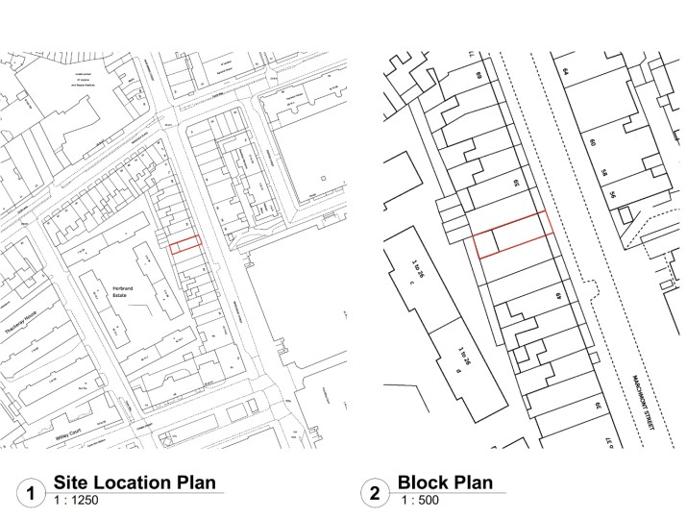

Fig.1 - Site Location Plan

## 3. Planning History

* 2014/3981/L – Listed Building Consent for installation of retractable awning – Granted
* 2014/3872/P - Full Planning Permission for installation of a retractable awning Granted

There is also precedent within the local area for such uses being accepted by the council in the locality.

## Proposed Development

Planning permission is sought for the proposed – conversion of costa coffee to Tapas Restaurant (use class E) with associated internal and external alterations, including to shop front, and advertisement signageat 55, Marchmont Street, London WC1N 1AP. The business will operate under the name “Vavi.” The predominant use will be well curated sit in dining experience for customers, whereby a breakfast, lunch and dinner sitting will be available to customers.

As part of the proposal there will be minor, attractive alterations to the shop frontage with regard to the external elevations. These will include a none illuminated fascia sign with metal letters, which will be powder coated in bronze, with thickness of 3mm, which represents a modest projection. There will be a White LED strip light, adjacent to this and luminance levels will not exceed 200 cd/m2, above the fascia will be faux, fire-retardant green plants, which will be securely fixed.

The existing shopfront wooden frame to be painted with exterior paint, colour: Brompton Road No 205, by Midlands, and vinyl will be added to the glazing. The existing retractable awning will also be repainted to match shopfront colour and the fabric and skirt of this will be replaced in a colour to match the shopfront.

Within the front patio area, the existing damaged floor tiles will be replaced with appropriate tiles which match the existing, and there will be freestanding outdoor furniture and freestanding planters located in this area.

Aside from the above, alterations primarily relate to an internal fit-out, which will include the addition of a commercial kitchen/ bar, furniture, redecoration, all of which will support the new enterprise at the site. There will also be a bar area and furniture added to the rear patio.

Further information and the design and specific layout of the proposal can be found within the accompanying planning drawings.

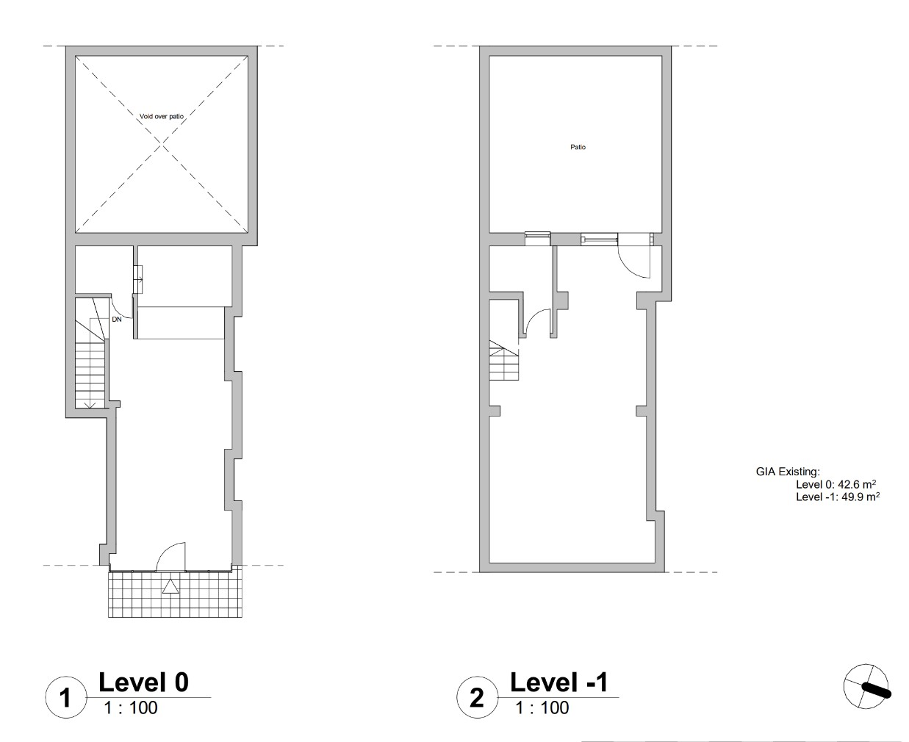

Fig. 2- Existing Floor Plans

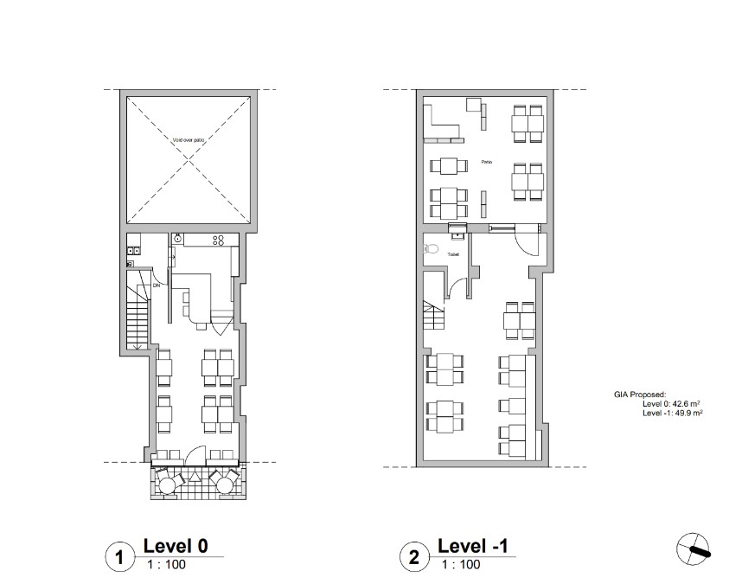

Fig. 3 – Proposed Floor Plans

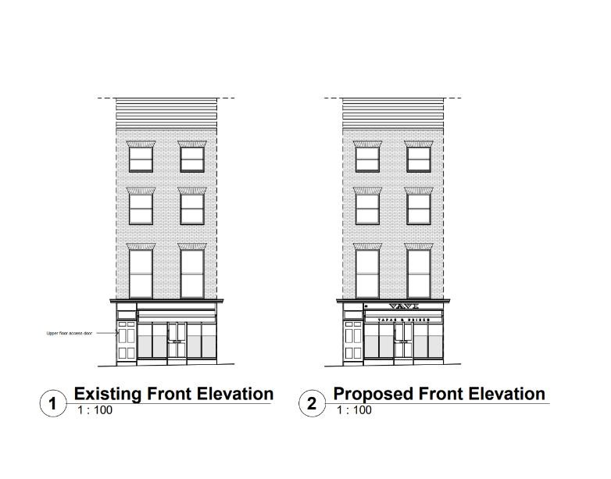

Fig.4 – Existing and Proposed Elevations

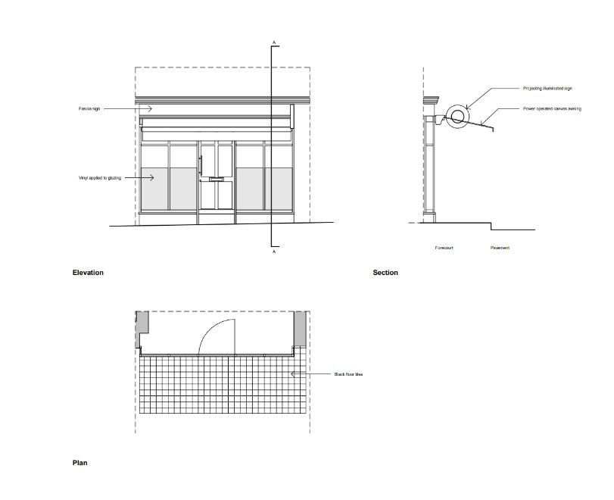

Fig. 5- Existing Shopfront

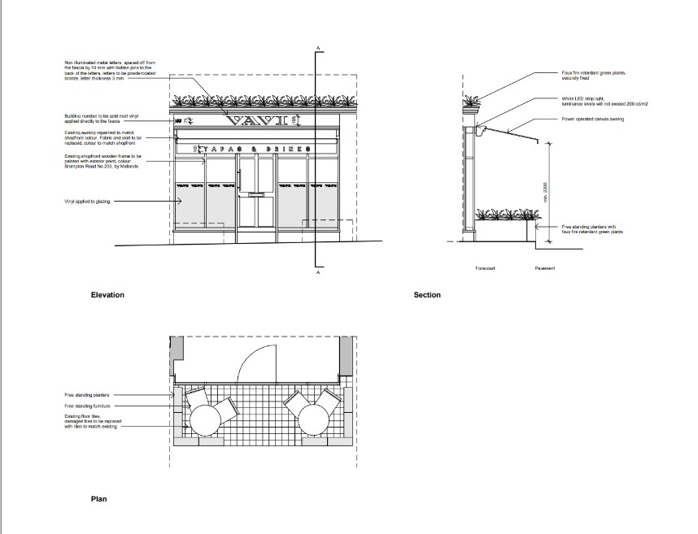

Fig.6 – Proposed Shop Front

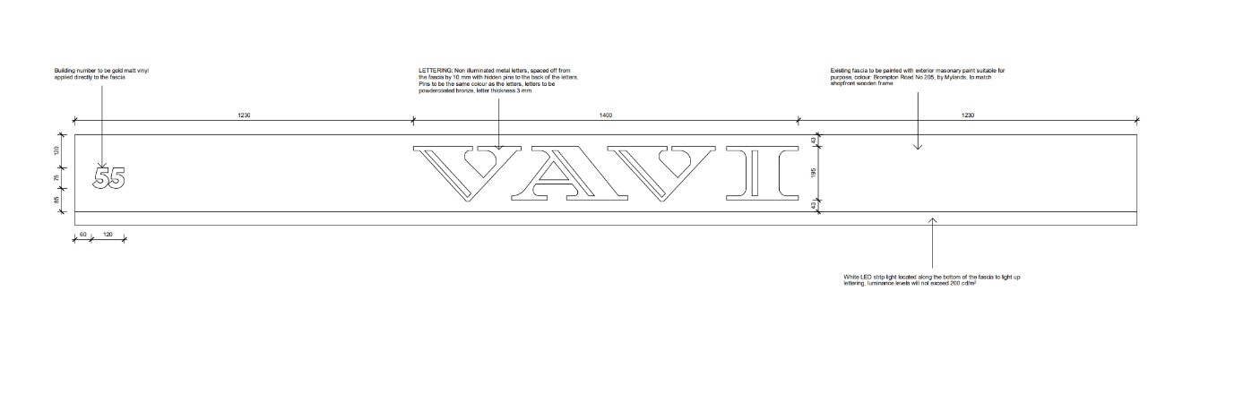

Fig.7 – Proposed Fascia Signage

### 4. Planning Policy Documents

The following policy and guidance documents are recognized as primary considerations for the decision of the associated application at the site location

* National Planning Policy Framework 2023.
* National Planning Practice Guidance.
* The London Plan 2021
* Camden Local Plan 2017

**Specific relevant policies:**

National Planning Policy Framework 2023

* Section 2: Achieving sustainable development.
* Section 12: Achieving well-designed and beautiful places.
* Section 16: Conserving and enhancing the historic environment.

The London Plan 2021

* Policy D3 – Optimising site capacity through the design-led approach
* Policy D4 - Delivering good design.
* Policy D8 - Public realm.
* Policy D14 – Noise
* Policy T4 – Assessing and Mitigating Transport Impacts
* Policy T5 - Cycling
* Policy T6 - Car Parking
* Policy HC1 – Heritage conservation and growth.

Camden Local Plan

* Policy G1 Delivery and location of growth
* Policy C3 Cultural and leisure facilities
* Policy A1 Managing the impact of development
* Policy A4 Noise and Vibration
* Policy TC2 Camden’s centres and other shopping areas
* Policy TC4 Town Centre Uses
* Policy D1 Design
* Policy D2 Heritage
* Policy D3 Shopfronts
* Policy D4 Advertisements
* Policy T1 Prioritising walking, cycling and public transport
* Policy T2 Parking and car free development
* Policy DM1 Delivery and monitoring

Supplementary Planning Documents

* Camden Planning Guidance: Advertisements March 2018
* Conservation Area character appraisal
* Access for All CPG - March 2019
* Amenity - January 2021
* Community uses, leisure and pubs - January 2021
* Design - January 2021
* Town centers and retail - January 2021
* Transport - January 2021

### 5. Assessment

The following section evaluates the proposed development in accordance with the relevant policies and Council’s supplementary design guidance to demonstrate why the proposal should be considered as acceptable in principle and in strict accordance with National, London and Councils development criteria.

The main considerations of this application are the potential impact of the proposal on parking and highways, the character and amenity of the surrounding neighbouring properties, impact on heritage assets and the design and impact on the visual character of the local area. This will be discussed within regards to the guidelines and policies set out below:

Principle of Development

The proposal is for a small-scale Tapas Restaurant to be located at the site, which is within a central mixed-use area within a neighbourhood centre, where, as will be discussed further below the proposal is wholly appropriate and suitable to site and the character of the surrounding area, which includes the Conservation Area and Listed Building.

Policy TC4 seeks to ensure that the development of central uses does not cause harm to the character, function, vitality and viability of a centre, and that development does not harm shopping provision in centres. Policy TC2 (a) and (b) which aim to promote a successful and vibrant centre, to protect and enhance the role and unique character of Camden’s centres, and to provide for and maintain a range of shops including food, drink and entertainment uses to provide variety, vibrancy and choice. TC2 point (d) also states *“d. support and protect Camden’s Neighbourhood Centres, markets and areas of specialist shopping, local shops.”* It also states for neighbourhood centres that *“The Council will seek to retain convenience shopping for local residents in Camden’s Neighbourhood Centres and will ensure that development in them does not harm the function, character or success of that centre.”* Restaurant, nightclub or drinking establishment uses are not afforded any specific policy protection; however, the supporting text to Policy TC4 recognises the importance of restaurants, bars and entertainment venues to the borough’s image as a dynamic and attractive place. It goes on to note that Camden Town has a particular concentration of such uses, and the important part they play in the night-time economy of Camden and of London, socially, economically and in terms of job provision. However, it also notes the conflicts that can arise due to the borough’s densely developed, mixed use nature, with much night-time activity occurring close to places where people live. Policy TC4 therefore seeks to ensure that the development of shopping, services, food, drink, entertainment, and other centre uses do not cause harm to the character, function, vitality and viability of a centre, the local area, or the amenity of neighbours. The appendices of the Local Plan note *“Neighbourhood Centres will be considered suitable locations for food and drink uses of a small scale (generally less than 100sqm) that serve a local catchment, provided they do not harm the surrounding area.”* Of which the proposal, due to its small scale, complies with policy TC4. Due to its smaller scale and the fact it’s a use typical to such areas in London, it will not compromise the on-going operations of businesses in the area or infringe upon surrounding uses locally; As such, the proposal can be considered acceptable in land use terms.

The proposal, will also contribute to the mix of uses within the locality, contributing to a vibrant and dynamic economy in line with policy G1, and it presents a suitable use to the area it is located within. This would help to support the long-term sustainability of the day and night-time economy of this part of Camden and London as a whole. It will also be employment-led and provide local jobs in line with policy.

As will be discussed further below, the proposed use would be in keeping with the area, and not cause detrimental harm to neighbouring occupiers or visual amenity or the area or historical site.The proposed use would therefore not present a demonstrable harmful use within its locality and there would be no extra traffic as a result of the proposal as the site is located in setting with good access to public transport and possible active travel to and from the site.

The proposal can thereby be considered acceptable in principle according with Local, National, London policies and guidance subject to other policies of the local development plan which will be discussed below:

Visual Impact and Character

Section 66 of the Planning (Listed Buildings and Conservation Areas) Act 1990 sets out that special regard must be given to the preservation of a listed building, its setting or its features of special architectural or historic interest. Section 72 of the same Act sets out that special regard must be given to preserving or enhancing the character and appearance of a conservation area. Policy D1 seeks to secure high quality design in all development by requiring development to respond to local character and context, be highly sustainable in design and construction, integrate well to the surrounding streets and townscape, comprise high quality architecture, and be accessible for all. Policy D2 requires development to preserve, and where appropriate, enhance Camden’s rich and diverse heritage assets and their settings, including conservation areas and listed buildings. Camden’s Local Plan is supported by CPG (Design). Policy D3 and D4 of the London Plan also seek to ensure shopfronts and advertising is suitable, alongside the associated SPD.

The property is a Grade II listed, mixed-use building located inside a Conservation Area, within a centre location. As discussed, the proposed internal and external alterations, as well as the proposed signage are well designed and will be attractive, and modest in scale, which have been sensitively designed and respect the special historical interest of the property and wider conservation area. As such, the proposed use will not harm the visual amenity or historic fabric of the property or the character surrounding area.

The building itself already hosts signage and a similar business usage, and there is other comparable businesses and advertisements existing locally within the Conservation Area, ensuring the proposal will be in keeping with the character of the area. The proposal is also sympathetically designed to not cause visual intrusion by virtue of significant light pollution into nearby properties or the public realm and avoids flashing illumination; The resultant works will thus be complimentary to the site and wider area, in which similar signage already exists.

Therefore, the proposal will not be unduly prominent in this location, and it is not considered to cause harm to the appearance or historic fabric of the Listed Building, the setting of the Conservation Area; This will also ensure the public realm or character of the area is not negatively impacted.

Therefore, the policies of the development plan will be complied with, as well as the above noted SPD guidance, London and National policies. Heritage considerations are further discussed within the accompanying Heritage Impact statement, which concluded the impact of the proposal upon heritage assets is neutral and can be considered less than harmful and will not cause enough of an impact to warrant a refusal in this.

Impact on Neighbouring Amenity

Policies A1 and A4 and the Amenity CPG are all relevant with regards to the impact on the amenity of residential properties in the area, requiring careful consideration of the impacts of development on light, outlook, privacy and noise. The thrust of the policies is that the quality of life of current and future occupiers should be protected and development which causes an unacceptable level of harm to amenity should be refused.

The applicant wishes to use the site as a small-scale Tapas Restaurant, which is not expected to affect neighbouring amenity in a detrimental manner. All operations will be as follows:

* Staff levels per shift: One Chef, one bartender and one waiting staff to start with, depending on occupancy levels, these will be increased to satisfy needs.
* The business will operate 7 days a week from 11am-11pm
* Expected number of customers per day: 100 +
* Opening Hours: Depending on the permit, but we aim to serve 3 shifts/day; breakfast, lunch and dinner, closing as late as possible, around 23:30.
* Extractor fans are already in place, on the ground floor kitchen to the rear. The current extraction infrastructure will be used. The Tapas Restaurant will aim to minimise cooking and serve predominantly food in small plates such as, eg. Cheese or Meat platers, salads, sandwiches, bread and spreads, etc. The applicants intend to keep the cooking to a minimum to ensure minimal disruption from noise, fumes or odours as a result of the business operation.
* Healthy options will be available upon the menu; The applicant would also of course be willing to comply and sign up to operate in compliance with Healthy Catering Commitment if requested.
* Noise willbe kept to a minimum. Any music would be kept at an ambient level. There would be no extra noise or inconvenience expected to any neighbours, if required a NIA report can be submitted to accompany the application.
* Customer will be able to be wait to be seated inside the site, within bar and service area, avoiding overcrowding outside the premise.
* Waste management: the business will dispose of waste in accordance with the council's guidelines with the bins provided.
* As will be discussed below, regarding customer parking, the proposal is a car free development, with multiple public transport nodes available locally.
* Delivery parking: Loading Bay in front/ and rear of the shop.

The proposal is a small-scale enterprise, and its ambiance will be more towards a relaxed, civilised environment than a loud, party atmosphere; the location of the site within the basement and ground floor will also provide some level of noise barrier to surrounding occupiers. It is unlikely the neighbouring amenity will be disrupted by any noise disturbances or overcrowding of customers on the street or that the proposed use could be considered an overbearing or out of character use in the locality. As such, the proposal would not cause a detrimental impact to amenity and is therefore compliant with polices of the Local, National and London Plans and supplementary guidance.

Highway and Accessibility Matters

Policy T2 of the Local Plan states that the Council will limit the availability of parking and require all new developments in the borough to be car-free.

There is no expected infringement upon local amenity due to parking concerns, even by deliveries at the site. The proposal also does not offer customer parking. Due to the sites’ sustainable location, it is easily accessible via active travel and public transport; It has a high PTAL rating of 6b meaning all public transport modes in London are currently available: National Rail, London Overground, Tube, DLR, Tram, Buses. The site is in close proximity to Russel Square Underground Station as well as multiple others, Kings Cross Train Station, and several bus routes.

The site is also within active travel distance to other workplaces and residences, customers can therefore access the site via walking or bicycle and will be able to use the public bicycle parking racks located along Marchmont Street – consequently reducing their carbon footprint and improving the quality of the air in the region. The tapas restaurant’s ground floor will also be inclusive and accessible, and removable ramp can also be used to ensure this if required; The external pavement is also wide enough to support safe wheelchair access.

The proposal therefore complies within local planning policies related to sustainable transport.

Public Safety

Given the nature of the immediate context as well as the size and position of the signage, the signage scheme is considered unlikely to have an unacceptable impact upon highway safety or result in any significant adverse effects on pedestrian safety within the public realm.

#### 6. Planning Balance

**Economically**, the proposal will generate significant benefits by stimulating the local economy through job creation, both directly within the restaurant and indirectly through the use of **local suppliers** and **fitters** during the construction and operational phases. This proposal will bring a vacant site back into use and add **economic vibrancy** to the area by enhancing footfall, supporting local businesses, and ensuring the site’s long-term commercial viability.

**Environmentally**, the proposal demonstrates a strong commitment to **good design principles** and **heritage protection**, ensuring that no harm will come to any surrounding **heritage assets**. Additionally, the use of the premises as a restaurant poses no risk to **public environmental health**, with appropriate mitigation measures in place to manage waste and emissions. The proposal does not foreseeably result in any adverse impact on **neighbouring amenity**, given its modest scale and careful consideration of operational hours and noise management.

**Socially**, the scheme contributes to **social sustainability** by introducing a new, vibrant use that encourages **community interaction** and enhances the **diversity of uses** within the area. The tapas restaurant will help to foster a **sense of place**, bringing people together and promoting social inclusion, while also contributing positively to the **vitality, viability, and vibrancy** of Camden as a key leisure destination.

On balance, and in light of current policy, any perceived harm is minimal and clearly outweighed by the significant economic, social, and environmental benefits of the proposal, which align with sustainable development principles and support a positive planning outcome.

#### 7. Conclusion

Overall, permission is sought for the use of the site as a Tapas Restaurant under use class E, with some associated internal and external alterations, including signage to support this. The proposal presents an appropriate use with alterations that will not lead to any adverse impact to the surrounding area or historic site. The proposal is in line with local and national planning policy and guidance.

The proposal will deliver significant social and economic benefits to the applicants, and the local community, while not resulting in any detrimental harm to the surrounding area, neighbouring occupiers, or local existing uses.

We kindly request that the Council supports this application. Should the Council have any further questions in relation to this proposal, do not hesitate to contact Planning by Design.