DECISION

Town and Country Planning Act 1990 (as amended)

Full Planning Permission Refused and Warning of Enforcement Action to be Taken

Address:
Flat A
190 Fordwych Road
London
NW2 3NX

Proposal:
Erection of a single storey rear outbuilding. Retrospective.
Drawing Nos:

The Council has considered your application and decided to refuse planning permission for the following reason(s):

Reason(s) for Refusal

1 | The rear outbuilding, by virtue of its height, depth and location adjacent to neighbouring habitable windows, is an overbearing structure creating a harmful sense of enclosure and loss of daylight/sunlight, detrimental to the amenity of neighbouring occupiers, contrary to policy A1 (Managing the impact of development) of the Camden Local Plan 2017.

Informative(s):

If you intend to submit an appeal that you would like examined by inquiry then you must notify the Local Planning Authority and Planning Inspectorate (inquiryappeals@planninginspectorate.gov.uk) at least 10 days before submitting the appeal. Further details are on GOV.UK.

ENFORCEMENT ACTION TO BE TAKEN

The Director of Culture and Environment will instruct the Borough Solicitor to issue an Enforcement Notice alleging a breach of planning control.

In dealing with the application, the Council has sought to work with the applicant in a positive and proactive way in accordance with paragraph 38 of the National Planning Policy Framework 2021.

ENFORCEMENT ACTION TO BE TAKEN

The Council has authorised the Planning Department to instruct the Borough Solicitor to issue an Enforcement Notice alleging breach of planning control.

You can find advice about your rights of appeal at:

https://www.gov.uk/appeal-planning-decision.

If you submit an appeal against this decision you are now eligible to use the new submission form (Before you start - Appeal a planning decision - GOV.UK).

Yours faithfully

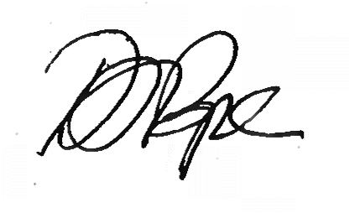
Daniel Pope
Chief Planning Officer

