Dear Adam,

Thank you for consulting us on Flooding and Drainage for the case listed below.. Apologies for the delay in returning our comments back to you. **Further information is required.** Please see below for details.

*Case reference: 2024/2872/P*

*Site Address: Mulberry House 12 A Church Row London Camden NW3 6UU*

*Proposal: Extensions to the east facade at ground floor and to the north and west facades at ground and first floor, as well as a roof extension, single storey basement, reconstructed garden room and relocated garage*

**Flood Risk**

In reference to the Strategic Flood Risk Assessment (2024), it is noted that the proposal includes a basement with proposed use of a games room (which could potentially be turned into a habitable room) in an area at risk of flooding. Below is a list of considerations on why the site is in a location of elevated flood risk:

* Adjacent to the application site, Frognal Gardens was a previously flooded street in 1975,(not directly adjacent but Frognal Road was also flooded in 2002),
* A portion of the Mulberry House site is located within the Local Flood Risk Zone (Frognal),
* There is also a limited potential for groundwater flooding to occur (with consideration that the proposal includes a basement) and,
* The area of the application site has experienced sewer flooding incidents.

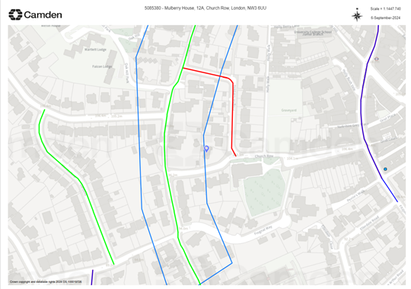

The Applicant has submitted a Basement Impact Assessment (BIA) as well as a site specific Flood Risk Assessment (FRA) and Drainage Strategy.

There is no proposed external basement access, there is no proposed external threshold.

**Inconsistency of the FRA**

It should be reminded that any reference to the Strategic Flood Risk Assessment should be to the [updated 2024](https://url.uk.m.mimecastprotect.com/s/6B4tCn5lpcVVLK6c9fYCJrATa?domain=camden.gov.uk) version.

The statement provided in section 6.10.3 is incorrect, based on the SFRA (2024), NW3 6 has 21-40 sewer incidents in total, and should be viewed as Medium in the Summary Table 3 instead.

Noted - this has been updated and reflected in the amended FRA. However please note that maps such as the ‘Flood Hazard Rating 1 in 100 year storm’ from the SFRA dated 2014 are not included in the 2024 revision, therefore cannot be updated but due to their relevance remain in the FRA.

**Drainage**

There is a decrease in hardstanding area of 107m2 which equates to roughly 22% decrease, mainly from the removal of the swimming pool and an increase in grassed area.

The Applicant has stated that the Greenfield Runoff rate of 1.41l/s is not considered feasible due to the required attenuation, approximately 30m³, and proposed that a 50% betterment be provided on the existing ‘brownfield’ runoff rates, equating to 8.7l/s.

There are two green roofs proposed, including one on the external Garden Room and one on the Garage Roof but we were unable to locate any information on the depth of the substrate which we would expect to be at least 150mm for storage. Other SuDS components such as basins, ponds, rainwater harvesting, are stated to not be feasible due to site constraints.  There is no justification for the omission of blue roofs and a lack of clarity on the constraints which would prevent rainwater harvesting.

Utilisation of green roofs, particularly for attenuation purposes, were omitted for modelling large storm events (1 in 100 year + 40% CC) under the assumption that the green roof would be fully saturated, whilst also ensuring a robust design. Exact details of green roof build ups would not typically be readily available at RIBA Stage 2, however, for the purposes of this response assume substrate is at least 150mm.

The 14m³ attenuation was derived from estimating the required attenuation through Innovyze storage estimation software using a known discharge rate, whilst the 13.66m³ was derived from analysis of a detailed Innovyze model during the 1 in 100 year + CC storm event, ensuring no flooding. We understand the confusion and have therefore updated the report to reflect the attenuation volume of 13.66m³.

The attenuation volume required to accommodate for a 1 in 100 year +40% CC storm event is estimated at 14m3. In Appendix A – Drainage Strategy, it appears that the total volume of surface water attenuation is 13.66m3 (calculated from the below-ground geo-cellular storage of 12.5m3, and the Proposed Filter Drain volume is of 1.16m3).The capacity is just under that required for a 50% betterment and whilst a green roof has been proposed there is no consideration of a blue roof. **Clear justification should be provided as to why the greenfield rate has not been met and all options including blue roof should be considered.**

The greenfield runoff rate was not considered feasible due to the estimated required attenuation volume of 30m³. Current attenuation indicates a volume of 13.66m³, therefore an increase of 140% would likely require significant excavation whilst encompassing much of the rear garden.

Blue roofs are not considered feasible due to the initial cost and structural impact of additional loading versus the storage benefits, given the relative area where this is achievable against total area of the site. Furthermore, green roofs are being proposed in various locations which provide water quality and biodiversity value, in addition to other SuDS features such as filter drains and below ground attenuation.

The proposal has considered mitigation measures on the remaining risk of flooding in the event of an exceedance, where the drainage and design layout, its levels(sloping), convey surface water away from the building and/or prevent it from entering accessing the building. On the eastern side where there is a slope descending from the Garden Room to the main building, mitigation measures such as a filter drain and a surface water slot rain are proposed.

Basement drainage outlets shall be fitted with non-return valves to prevent the backflow of storm and foul water. As there are no toilets, bathroom or kitchen proposed in the basement (which could result in habitable rooms or result in the property becoming uninhabitable after a flood event), this is considered acceptable.

I could not locate any information on water efficiency. It should be reminded that Camden Local Plan Policy CC3 require development to incorporate water efficiency measures. Residential developments will be expected to meet the requirement of 110 litres per person per day (including 5 litres for external water use).

Overall,  **further information is required on water efficiency, potential for blue roofs and depth of green roof substrate and inconsistencies to be rectified in the final version**. If it is recommended for approval, then mitigation measures outlined in the FRA should be conditioned and / or a condition may be applied to prevent basement rooms being used as bedrooms or subdivided to make a self contained unit.

We are utilising rainwater butts for irrigation purposes and exploring the idea of integrating a rainwater harvesting system within the proposed below ground attenuation. However, this is being developed as the design progresses

See above for rationale to blue roofs and green roof build up. Discrepancies as noted above within the FRA have been updated.

Regards,

Katherine and Chin Chin

*Katherine Frost*

*Senior Sustainability Officer (Planning)*

*Chin Chin LAM*

*Sustainability Officer (Planning)*