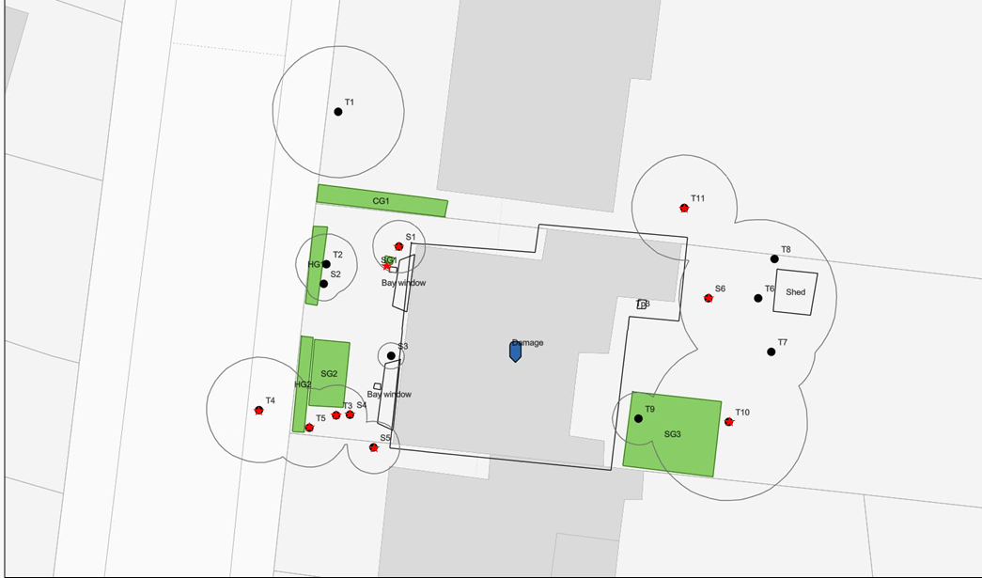

6 Dartmouth Park Avenue, London, NW5 1JN