SimonPryceArboriculture

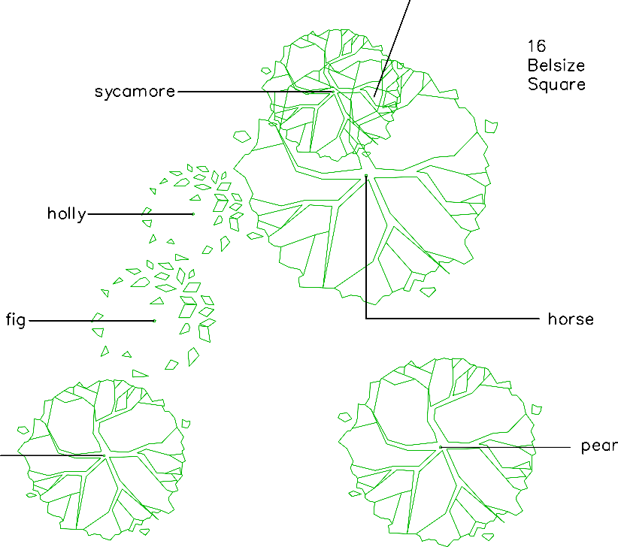

30WoodfieldRoad, Radlett,

Herts, WD78JD

01923467600

07710224906

[info@simonpryce.co.uk](mailto:info@simonpryce.co.uk) [www.simonpryce.co.uk](http://www.simonpryce.co.uk/)

Client: 23LancasterGroveResidents' Association

Site:

23LancasterGrove,London, NW34EX

Title:

Treesurvey

Date: 30thJuly2024

Ref: 24033

Scale: 1:200atA4

Originaldrawing: SimonPryceon OSbaseplan

Rev:

Notes:

2024OrdnanceSurvey