Construction Management Plan
Incorporating Traffic Management Plan and Environmental Management Plan

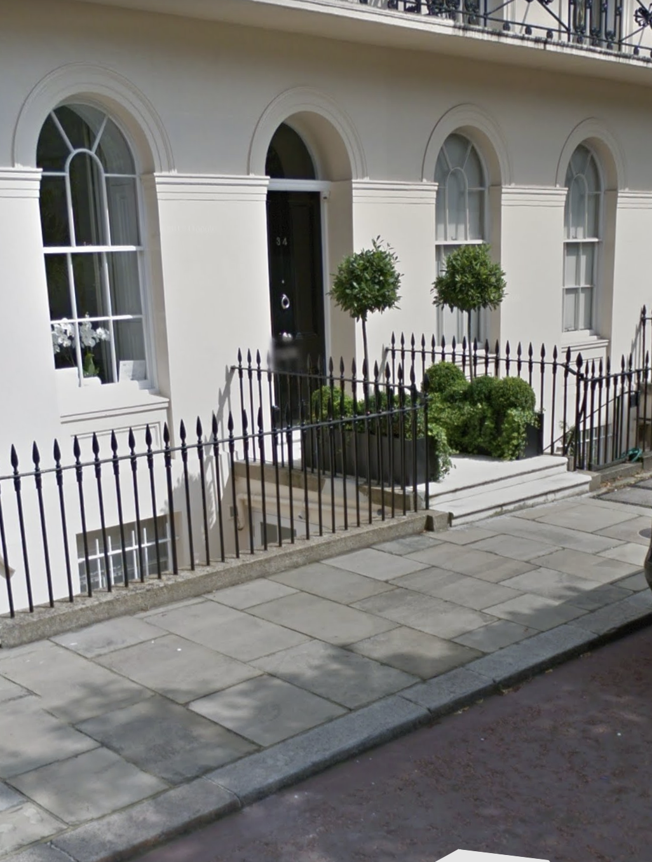

34 Chester Terrace, NW1 4ND

Prepared by Emerson Willis Ltd

Table of Contents
- Introduction
- Protective Measures
- Demolition, Alteration and Rebuilding
- Traffic Management and Site Traffic
- Environmental Management
- Waste Management
- Emerson Willis Policies
- Noise and Vibration Plan

- Introduction

1.0 Introduction
The purpose of the Construction Management Plan (CMP) is to address the detailed procedures, sequencing and construction methodology anticipated by the Project Team engaged in the planning, liaison, and construction of the Project. The plan outlines proposals on traffic and environmental management measures to be adopted during construction and provides supplementary information to the Environmental Statement on construction related issues.
It is also designed to be a live document, which will eventually address how any planning conditions imposed on the project will be managed or discharged by the construction teams. All revised publications will be issued to London Borough of Camden for their review prior to implementation.
It is not to be confused with a Construction Phase (Health and Safety) Plan which will provide the Contractor with a mechanism to comply with its legal responsibilities when acting as Principal Contractor in respect to the Construction (Design & Management) Regulations 2015.
The CMP incorporates 3 main elements:
- Background and description of the construction works.
- Traffic management considerations
- Environmental management considerations

1 Revision Record

ISSUE No | DATE | SECTION N^{O} | SUBJECT | AUTHORISED

2.00 Protective Measures

2.00 Protective Measures

- Pre-Construction Phase
- Detailed Survey and Documentation:
  - Structural Survey: Conduct a comprehensive structural survey of the historic building and surrounding properties to assess their current condition.
  - Heritage Survey: Document all architectural and historical elements of the heritage asset, including photographs, drawings, and written descriptions.
- Risk Assessment and Management Plan:
  - Risk Assessment: Identify potential risks associated with the basement construction, including structural damage, vibrations, and water ingress.
  - Management Plan: Develop a risk management plan outlining measures to mitigate identified risks. Include contingency plans for unforeseen issues.
- Permissions and Consultations:
  - Planning Permission: Obtain necessary planning permissions from local authorities, ensuring compliance with heritage conservation regulations.
  - Consultation: Engage with heritage consultants, structural engineers, and conservation officers to review and approve plans.
- Engineering and Design Plans:
  - Structural Design: Design a structural support system for the new basement that minimizes impact on the existing building fabric. This may include underpinning, piling, or diaphragm walls.
  - Temporary Works Design: Plan temporary supports and bracing to stabilize the structure during excavation and construction.
- Construction Phase
- Protective Measures:
  - Monitoring Systems: Install monitoring systems to continuously track the movement, vibration, and structural integrity of the heritage asset and adjacent buildings.
  - Physical Barriers: Erect protective barriers around sensitive areas to prevent accidental damage.
  - Environmental Controls: Implement dust suppression, noise reduction, and vibration control measures to minimize environmental impact.
- Excavation and Support:
  - Sequential Excavation: Excavate the basement in small, controlled sections to prevent large-scale destabilization. Use temporary supports as needed.
  - Underpinning: Carefully underpin the existing foundations to transfer the load away from the excavation area. Ensure that underpinning is done in a sequence that maintains stability.
  - Shoring and Bracing: Install shoring and bracing systems to support the walls and floors of the heritage asset during basement formation.
- Waterproofing and Drainage:
  - Waterproof Membrane: Apply a waterproof membrane to the new basement walls and floor to prevent water ingress.
  - Drainage System: Install an effective drainage system to manage groundwater and prevent hydrostatic pressure buildup.
- Structural Integration:
  - Load Transfer: Ensure that the new basement structure is properly integrated with the existing building to allow for load transfer without causing stress or damage to the historic fabric.
  - Settlement Monitoring: Monitor settlement during and after construction to detect and address any issues promptly.
- Supporting Work Before Construction Begins
- Legal and Administrative Tasks:
  - Ensure all legal and administrative tasks are completed, including securing necessary permits and approvals.
- Engagement and Communication:
  - Maintain open communication with all stakeholders, including neighbors, local authorities, and heritage bodies.
- Site Preparation:
  - Clear the site of any obstacles and prepare for safe access and working conditions.

3.00 Demolition, alterations to basement level of grade one listed town house, 34 Chester Terrace, NW1 4ND

3.0 Demolition, alterations to basement level of grade one listed town house, 34 Chester Terrace, NW1 4ND
3.1. Site location
The proposed site is located on Chester Terrace as shown on Figure 1. The Property is located approximately 60m from Cumberland Place and 110m from Outer Circle with the closest rail station being Regent’s Park Underground train station. The site is located on a quiet residential street surrounded by residential properties.
Figure 1 - Site location Plan

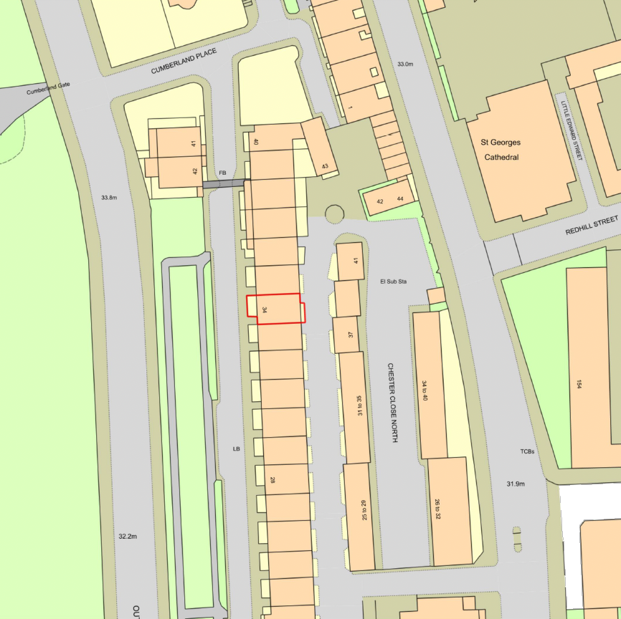

3.2. Project Description
Project Overview: The project involves refurbishing the basement of the existing residential property located at 34 Chester Terrace, London NW1 4ND. This property consists of a Basement, Ground, First, Second, Third floors, and a roof Terrace with a shallow pitch roof. The primary objectives of this project are to enhance the basement space, improve functionality, and upgrade certain structural and mechanical elements.
Scope of Work:
- Window Replacement: The existing metal doors will be replaced with windows to improve natural lighting and aesthetics.
- Space Reconfiguration: Partial removal of existing walls between vault areas will be carried out to create a more open and versatile layout. This will involve support and steel works.
- Floor Level Adjustment: The existing floor level in the boot room will be lowered to align with the original vault floor level, with the vault floor to be lowered by 2.1 m to improving accessibility and space utilization.
- Mechanical and Plumbing Works: The project includes relocating the boiler, pressure pump, water tanks, and other related equipment to optimize the basement's functionality.
Project Context: The property is part of a row of terrace houses, with neighbouring residential accommodations on both sides. To the rear of the property, there is access to a private road known as Chester Close North.
Project Phases: The project can be broadly categorized into the following phases:
- Demolition
- Groundworks
- Window replacement
- Mechanical and plumbing works
Quality Standards: All project activities will adhere to premium quality standards to ensure the final result is a high-quality dwelling that meets or exceeds the expectations of the property's occupants.

3.3 Project Details
3.3.1 Details of Client, Contractors and Consultants
PRINCIPLE CONTRACTOR

Emerson Willis Ltd
Bretts Farm
Aveley
Essex
RM15 4XD

Tel No: 01708 861044

CLIENT

Antonio & Tomas
34 Chester Terrace
London
NW1 4ND

ARCHITECT

Dovetail Architects
5th Floor
Unex Tower
Stratford
London

Tel: 02031413601

STRUCTURAL ENGINEER

TBC

QUANTITY SURVEYOR

TBC

3.3.2 Organisation Chart

Gary Hurley
Contracts manager
David Norton
Director

Site Agent/Manager
TBC

Site Engineer

Works Manager/Foreman

Quantity Surveyor

Health & Safety Chain of Command

MESH Consult.
H&S
Consultant

Site Agent
TBC

Site Workers

Amanda Norman
H&S Assistant

Gary Hurley
Contracts Manager

David Norton
Director

3.4 Programme
The construction duration is expected to take approximately 52 weeks from the commencement of the works on site.
3.5 Working Hours
Standard Working Hours:
- Construction activities will be conducted during the following standard working hours:
  - Monday to Friday: 8:00 am to 6:00 pm
  - Saturday: 8:00 am to 1:00 pm
- The site will remain closed on Sundays and Bank Holidays, as stipulated by The London Borough of Camden's permitted hours.
Limited Road Closure and Deliveries:
- To minimize disruptions to the community, no road closures or deliveries will occur outside of the specified window: 9:30 am to 3:30 pm.
Extended Working Hours Policy:
- Under certain exceptional circumstances, there may be a need to extend the standard working hours. These situations will be planned well in advance to minimize inconvenience.
- An example of when extended hours may be necessary is during the pouring of foundations and basement walls.
- Whenever extended working hours are required, we will provide prior notification to The London Borough of Camden at least four weeks in advance of the occasion. This proactive approach ensures that all relevant parties are informed and prepared.
Approval Procedure:
- For any extended working hours beyond the standard schedule, we will follow the established procedures of The London Borough of Camden to seek the necessary approvals. This ensures compliance with local regulations and community expectations.
No Early Morning or Late Evening Work:
- To respect the peace and quiet of the neighbourhood, no road closure or deliveries will be scheduled before 9:30 am or after 3:30 pm.

3.6 Pre-Start Survey
Survey Objectives:
- Before the commencement of construction works, a comprehensive Pre-Start Survey will be conducted. The primary objectives of this survey are as follows:
  - To document the existing environment, including structures and infrastructure, to serve as a baseline reference.
  - To identify potential hazards, constraints, or conditions that may affect the construction process.
  - To ensure compliance with safety standards, regulations, and project requirements.
Survey Scope:
- The Pre-Start Survey will encompass the following aspects of the project site and its immediate surroundings:
  - Existing structures, including buildings (interior and exterior), walls, and fences.
  - Infrastructure elements, such as footpaths, roads, kerb lines, lighting columns, street furniture, and road signs.
  - Property boundaries and access points.

3.7 Construction Site Compounds and Accommodation, Welfare and Storage
Enhancing Construction Site Facilities and Traffic Management
Objective: We aim to optimize our construction site setup to streamline deliveries while ensuring the safety and convenience of the public.
Temporary Structure License and Welfare Facilities
We intend to secure a Temporary Structure License, specifically for hoarding, to enhance accessibility for deliveries and machinery during the project's duration. Additionally, we plan to house our welfare facilities within the construction site for the convenience of our workforce.
Hoarding and Compound Installation
Our proposal includes the installation of a hoarding at the property's front and the creation of a designated compound within Chester Terrace's roadway. Importantly, this arrangement will keep the pavement free and accessible for public use.
Waste Management and Material Storage
We will establish a dedicated waste disposal area for general rubbish and the storage of construction materials. To protect the existing road surface, this area will be fortified with a combination of a damp-proof membrane (DPM) and 18mm OSB boarding. In addition, perimeter red lights will be incorporated into the hoarding/compound to enhance safety during low-light conditions.
Security Measures
To safeguard the construction site and compound, we will install temporary CCTV surveillance for the duration of the project. This added security measure will help monitor the premises and deter potential unauthorized access.
By implementing these enhancements, we aim to create a construction site environment that maximizes efficiency, safety, and public convenience.

4.0 Traffic Management and Site Traffic

4.0 Traffic Management and Site Traffic
Entrance and Access:
- The primary entrance to the proposed site is accessible via Outer Circle, leading into Cumberland Place, followed by a right turn into Chester Terrace, which is a one-way street. It is essential that all vehicles adhere to this prescribed route to minimize traffic congestion and disruption.

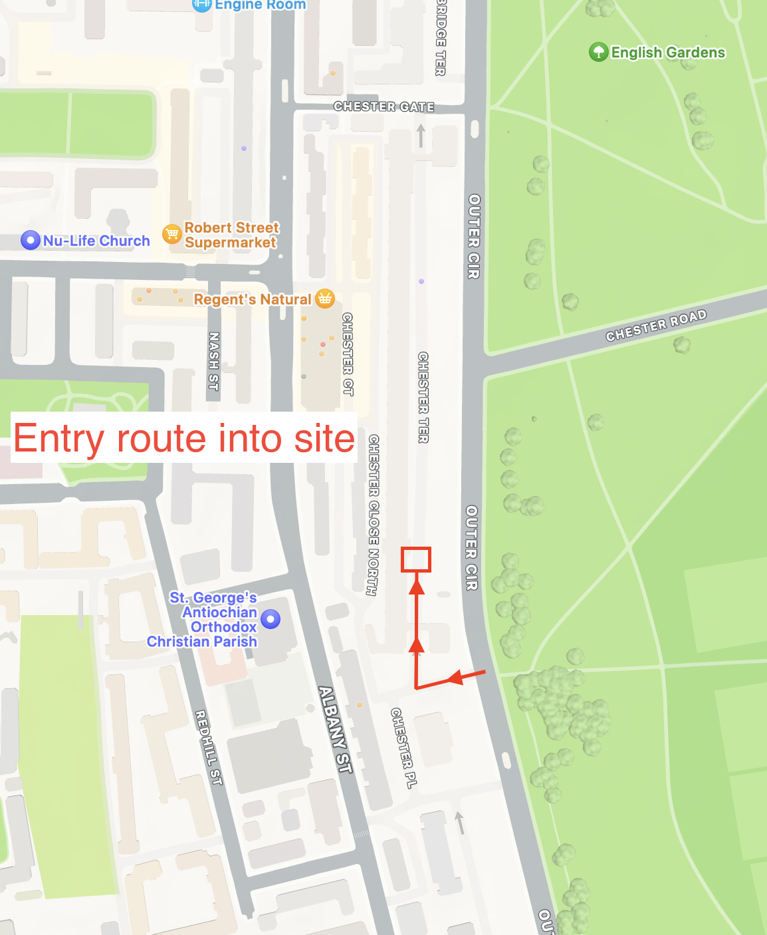
Trade Permits for Businesses:
- Businesses involved in the project are required to obtain trade permits, which grant them permission to park in designated resident parking spaces while working on the project. These permits are valid until 5:30 pm each day.

Deliveries Management:
- All deliveries to the site will be meticulously managed by the Site Foreman to ensure efficient logistics and prevent congestion in adjacent roads and access routes.
- No road closures or deliveries will be scheduled before 9:30 am or after 3:30 pm to avoid peak commuter traffic hours.
- Upon arrival, all delivery vehicles will be promptly offloaded, and their contents will be transported to our designated storage area. This process will be coordinated in advance by the Site Foreman.
- Delivery drivers will be instructed to contact the site approximately one hour before their scheduled arrival. This proactive approach allows us to prepare for the delivery, ensuring it can be received swiftly and safely, minimizing disruptions to the surrounding community.
- Delivery vehicles will be guided into our site by trained traffic Marshalls/Banksmen to maintain smooth traffic flow and enhance safety.
Traffic Timing for Minimal Disruption:
- To minimize disruption to the surrounding community and commuter traffic, we propose that all deliveries take place exclusively between 9:30 am and 3:30 pm. This timing strategy ensures that deliveries do not coincide with peak traffic hours.
Exiting the Site:
- Upon completing their tasks, vehicles exiting the site will follow the prescribed route, exiting via Chester Terrace, leading to Chester Gate. From Chester Gate, vehicles will make a right turn toward Outer Circle, where they can choose to turn left or right based on their intended destination.
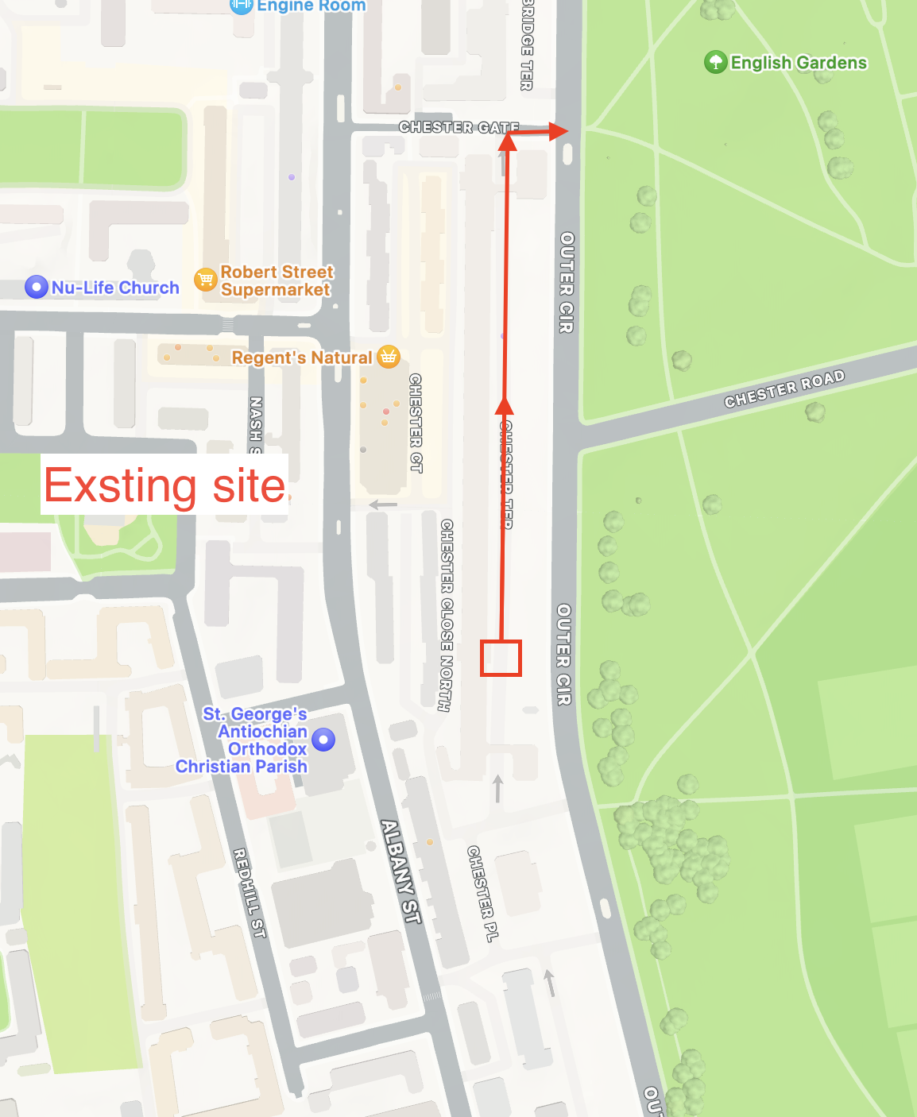
4.1 Foundation Construction
Introduction: The foundation construction phase is a critical component of the project, ensuring the structural integrity and stability of the building. This section outlines the equipment, procedures, and logistics involved in this phase.
Excavation and Underpinning:
- To commence the main construction works, (TBC by structural engineer) we would employ a 0.75-ton electric excavator. This equipment will enable us to perform the underpinning works meticulously in accordance with the structural design.
- All excavated materials will be efficiently offloaded onto a conveyor belt system. This conveyor belt will transport waste materials to the designated waste area.
- Regular clearing of the designated waste area will be conducted to maintain control over the volume of stored waste materials.
Materials Management:
- To ensure an organized and clutter-free construction site, we will carefully plan the delivery of reinforcement and materials required for foundation formation. Deliveries will align with the sequencing of works to prevent excess materials within the designated storage area. This proactive approach prevents space and manoeuvrability issues on the site.
- During the foundation pouring phase, our concrete lorry will reverse up to the site hoarding and remain stationary until the delivery is completed.
- To prevent the transfer of debris onto public roads, all vehicles will undergo a thorough washdown and cleaning process before leaving the site.
Delivery of Other Materials:
- In addition to foundation materials, various other materials, including PVC drainage pipework, precast concrete manhole rings, ducts, chambers, kerbs, and gullies, will be delivered to the site over this period.
- It is important to note that these materials will also adhere to the sequencing of our works and will not be stored on site. This practice ensures a clutter-free and efficient workspace.

4.2 All Phases of Construction
Pedestrian Traffic:
- In addition to vehicular traffic, it's important to note that pedestrian traffic to the construction site will include daily arrivals of workers who use public transport. The safety and convenience of both workers and pedestrians are a top priority throughout all phases of construction.
Vehicle Types and Deliveries:
- Deliveries throughout the project will primarily involve vehicles such as 7m rigid vehicles and flatbed trucks. On occasion, smaller deliveries, including packages, will be made using vans and other light goods vehicles. It's essential to ensure that deliveries are managed efficiently without causing disruptions to the surrounding area.
Delivery Timeframes:
- To minimize disruptions to the local community, no road closures or deliveries will be scheduled before 9:30 am or after 3:30 pm. This timeframe aligns with the project's commitment to respecting the community's daily routines and traffic patterns.
Notification for Abnormal Loads:
- In the case of deliveries involving abnormal loads, we are committed to proactive communication with local residents who may be affected. This communication will occur at least one week before the commencement of any deliveries involving abnormal loads.
- The notifications will include the following essential information:
  - Name and contact information of the Construction Site Manager.
  - Commencement date for deliveries involving abnormal loads.
  - Duration of the delivery period.
  - Estimated times of deliveries.
  - If applicable, a request for residents to keep the highway clear of parked cars during the delivery period.

4.3 Maintenance of Off-site Roads
Mud and Silt Prevention:
- There is a potential for delivery vehicles and other site traffic to carry mud and silt onto the public roads when leaving the site. To mitigate this, a strict protocol will be in place to ensure all vehicles are washed down before leaving the site.
- The washing process will be supervised by the Site Foreman/Banksman, who will be the sole personnel authorized to approve vehicles for departure. This process is designed to minimize the risk of road contamination.
- Within our site boundaries, cleanliness will be maintained at all times by our dedicated on-site labourer.
Efficient Water Management:
- The wash water from vehicle cleaning will be directed into a sealed settlement tank located below the washing area. This tank will be equipped for water recirculation to minimize water wastage.
- Periodic removal of sludge from the settlement tank and replenishment of washing water will be scheduled. All waste materials will be transported off-site to ensure responsible waste management.
Road Sweeper Deployment:
- As a further measure to prevent mud and silt from being carried onto Chester Terrace, a road sweeper may be deployed on the access road leading to the site. This equipment will ensure the continuous cleanliness of the access road, reducing the risk of debris being transferred onto public roads.
Environmental Considerations:
- To address potential environmental concerns, all measures will be taken to prevent the discharge of contaminants into the surrounding environment. This includes the proper handling and disposal of waste materials and adherence to local environmental regulations.

Responsibilities:
- The Site Foreman/Banksman will play a central role in overseeing the vehicle washdown process and approving vehicles for departure.
- Our on-site labourer will be responsible for maintaining cleanliness within our site boundaries.
- Coordination with an environmental specialist, if necessary, will ensure compliance with environmental regulations and best practices.
4.4 Site Traffic and Pedestrian Management
Site Entrance and Traffic Flow:
- All vehicular traffic must pull up to the site hoarding entrance. Upon arrival, a designated Banksman will record vehicle details and direct deliveries to report to the reception office. In the reception office, an assigned site staff member will guide the driver to the appropriate area for unloading materials.
- A clearly marked segregation barrier will establish a dedicated pedestrian route leading all pedestrians to the site offices. This ensures the safe separation of vehicular and pedestrian traffic within the construction site.
Operatives Identification and Induction:
- To enhance site security and safety, all operatives are required to identify themselves and provide proof of identity upon arrival. Individuals who have not undergone the necessary site induction will not be permitted to proceed beyond the site office area until they have completed the induction process.
Site Register and Attendance Recording:
- To maintain an accurate record of personnel on-site at any given time, all individuals, including operatives, are required to sign in using the Site Register. This register serves as a crucial means of recording attendance.
- The attendance record is of particular importance in emergency situations such as fires or other emergencies. It enables the site management to account for all personnel on-site and facilitates an organized evacuation if necessary.

4.4.1 Pedestrian Access
Main Access Gates and Hours:
- Access to our construction site will be granted through the main access gates, which will be integrated into our hoarding, defining the site compound. Access will be permitted between the hours of 9:30 am and 3:30 pm.
Valid Induction Requirement:
- Only individuals with a valid site induction will be allowed entry onto the construction site. Those without a valid induction will need to be escorted to the site office, located within the building, where they will receive the necessary induction training.
Pedestrian Routes and Safety Measures:
- Whenever feasible, we will establish designated pedestrian routes to separate pedestrians from site traffic. These routes will enhance safety and ensure a clear separation between pedestrians and moving vehicles.
- At suitable locations, clearly marked crossing points will be designated to provide pedestrians with a well-defined and safe path for crossing the construction site. These crossing points will prioritize pedestrian safety by offering clear lines of vision for pedestrians.
Pedestrian Access Within the Site Compound:
- Pedestrian access will be established throughout the site compound area, providing pedestrians with a safe and convenient way to navigate within the construction site.
Daily Inspection and Maintenance:
- We are committed to safety and will conduct daily inspections of pedestrian barriers and signage within the construction site. Regular checks will help ensure the integrity and effectiveness of safety measures.
4.4.2 Site Traffic and Pedestrian Rules
These site-specific traffic and pedestrian rules complement the general site rules and are designed to ensure the safety and orderly conduct of all personnel on the construction site:

For General Site Operatives:
- All operatives are required to complete the site induction process before commencing work on the site.
- It is mandatory for all operatives to wear appropriate Personal Protective Equipment (PPE) at all times while on the construction site.
- Operatives are expected to utilize designated pedestrian access routes for their movement within the site.

4.4.4 Visitors and Landowners
For the safety and security of all individuals visiting the construction site, the following procedures are in place:
1. Escort to Site Office:
- All visitors, including landowners and external parties, will be greeted and escorted to the site office located within the site compound. This ensures that visitors are properly informed and guided during their time on-site.
2. Hazard Awareness and Site Access:
- Upon arrival at the site office, visitors will receive a briefing on any potential hazards present on the construction site. This information is essential for their safety.
- Visitors will be escorted onto the construction site by designated personnel. This ensures that they are accompanied by individuals familiar with the site and its safety protocols.
3. Temporary PPE Issuance:
- Visitors will be provided with temporary Personal Protective Equipment (PPE) as necessary. This includes safety gear such as helmets, high-visibility vests, and any other required items.
- The issuance of temporary PPE is a critical safety measure to protect visitors while they are on the construction site.
4. Visitor Sign-In Register:
- All visitors are required to sign in using the visitor sign-in register, which will be located at the site office. This register serves as a record of visitor presence on the site.
- Signing in is essential for accountability and security purposes.

4.5 Community Relations and Communication
Importance of Communication:
- Effective and transparent communication with stakeholders is of paramount importance. It ensures that all potentially affected parties are well-informed and engaged throughout the construction process.
Responsibility for Stakeholder Management:
- The Project Manager and the Contract Administrator are jointly responsible for managing and coordinating stakeholder interactions and communications during construction. Stakeholders may include local residents, elected representatives, schools, businesses, public transport providers, and emergency services.
Proactive Communication Approach:
- Communication efforts will be proactive and multifaceted. Prior to and during construction, we will establish contact with stakeholders to provide project overviews and introduce points of contact for addressing any concerns or inquiries.
Regular Newsletters and Letter Drops:
- We will maintain an ongoing dialogue with London Borough of Camden (LBC) to ensure they are continuously updated on project developments and any related issues.
- As part of our planning process, Emerson Willis Ltd will produce newsletters aimed at introducing the project to potentially affected individuals and parties. These newsletters will be distributed during both the construction and operational phases of the facility.
Engagement with Local Residents:
- Engagement with local residents and affected parties will be ongoing to provide comprehensive information on the proposed construction works.
- Updates on the construction program and project milestones will be communicated to keep stakeholders informed and engaged.
- Any concerns or inquiries from the community will be actively addressed to foster a positive and collaborative relationship.

4.7 Service Interruptions
Notification of Planned Service Interruptions:
- To minimize inconvenience to affected properties, we are committed to providing timely and transparent communication regarding any planned service interruptions. These interruptions may include services such as water, electricity, and telecommunications.
Advanced Notification:
- We will ensure that affected properties are informed of any planned service interruptions well in advance. Specifically, we will provide a minimum of 7 days' notice to all affected properties before the scheduled interruption.
Communication Channels:
- Notifications will be conveyed through various communication channels, including written notices, email, or other suitable means of communication. We will make every effort to reach out to property owners, residents, or relevant parties to ensure they are aware of the upcoming interruption.
Information Provided:
- The notifications will include essential information such as the date and time of the planned interruption, the expected duration of the interruption, and the reason for the interruption (e.g., maintenance, upgrades, repairs).
Mitigation Measures:
- Whenever possible, we will also provide information on any mitigation measures that may be available during the interruption. This may include alternative sources of essential services or temporary solutions to minimize inconvenience.
Accessibility for Inquiries:
- We will designate a point of contact or helpline for inquiries and concerns related to the planned service interruptions. Property owners and residents can reach out to this contact for additional information or assistance.

4.8 Community Relations
Ongoing Liaison:
- The Project Manager/Manager will maintain continuous communication with the client and neighbouring parties throughout the construction process.
- Our commitment is to address any concerns or complaints efficiently and effectively, fostering positive working relationships among all parties involved.
Complaint Resolution:
- Any complaints received will be promptly investigated, and appropriate actions will be taken to resolve them. The progress of complaint resolutions will be regularly reviewed during progress meetings.
- Details of all complaints and the remedial measures implemented will be documented and forwarded to the relevant authority for transparency and accountability.
Operative Awareness:
- During site induction, all operatives employed on the site will be informed about the significance of maintaining good relations with the community.
- Operatives will be educated on the importance of respectful behaviour and adherence to site rules and regulations to minimize disturbances and promote a positive image of the construction project.
Considerate Constructors Scheme:
- The construction site will actively participate in and sign up for the Considerate Constructors Scheme.
- This commitment demonstrates our dedication to uphold high standards of community engagement, safety, and environmental responsibility throughout the construction process.

4.9 Noise and Vibration
Construction Hours:
- Construction activities are scheduled to occur within the hours of 8:00 am to 6:00 pm from Monday to Friday. The site will remain closed on Saturdays and Sundays to minimize disruptions to the community.
Extended Working Hours:
- In exceptional circumstances where construction work must exceed the standard hours, detailed planning will be undertaken well in advance.
- London Borough of Camden (LBC) will be informed of such situations at least 4 weeks before the occasion. For instance, the pouring of concrete foundations for the basement structure may require extended hours.
- Prior to any work that exceeds standard hours, permission will be sought from WCC to ensure compliance with local regulations.
Managing Noise Impact:
- We recognize that some construction activities may result in temporary noise emissions. To mitigate the impact on the local community, effective communication between our site management team and local residents will be maintained.
- Correct timing and the use of noise-reducing measures, such as silencing equipment, will be employed to minimize disruptions caused by noise emissions.
Basement Excavation Works:
- For basement excavation works, comprehensive Risk Assessments and Method Statements (RAMS) will be developed and provided.
- These RAMS will outline specific measures to manage noise and vibration during excavation activities to ensure that they are carried out with minimal impact on the surrounding area.
4.10 Dust and Air Quality
Dust Control and Air Quality Management
Recognizing the Impact:
- Dust can be a nuisance and has the potential to harm human health, damage machinery, harm plants, and negatively affect animals.
- We are committed to preventing unnecessary dust emissions and maintaining good air quality on and around the construction site.
Minimizing Dust:
- All construction activities will be conducted with a focus on minimizing dust generation.
- Preventative measures such as dust suppression techniques, watering of surfaces, and the use of appropriate equipment and tools will be employed to reduce dust emissions.
Site Cleanliness:
- Littering on the site will not be tolerated. All site personnel will be responsible for maintaining a clean and orderly work environment.
- Adequate waste disposal facilities and practices will be implemented to ensure that debris and waste materials do not contribute to dust pollution.
Vehicle Emission Control:
- All vehicles and equipment on-site will adhere to strict emission control measures.
- Engines of vehicles will not be left running unnecessarily to prevent both exhaust emissions and excessive noise.
- Low emission vehicles and machinery fitted with catalysts, diesel particulate filters, or similar devices will be used wherever possible to minimize environmental impact.
Routine Maintenance:
- Vehicles will be well-maintained, and routine servicing will be conducted in accordance with the manufacturer’s recommendations.
- Comprehensive records will be maintained to track all servicing and maintenance activities to ensure the safe and efficient operation of equipment.

4.11 Liaison between Parties on Site
Promoting Effective Communication and Collaboration
Cooperation for Health & Safety:
- Cooperation among contractors for health and safety purposes is paramount. We will maintain regular contact, provide relevant information, and host on-site meetings to facilitate discussions regarding the construction program, interface management, overlap coordination, and items requiring special attention.

Continuous Liaison:
- Liaison activities will occur consistently throughout the project to ensure smooth operations and safety. These activities will encompass the following key elements:
a) Client Progress/Review Meetings: Regular meetings with the client will be conducted to review project progress and address any concerns or updates.
b) 2-Weekly Safety Planning Meetings: Bi-weekly safety planning meetings will be organized to focus on safety measures, updates, and proactive planning to enhance safety on the site.
c) Sub-contractor Progress/Programme Meetings: Meetings with sub-contractors will be held to discuss progress, project timelines, and coordination among various teams.
d) Stakeholder Engagement: We will engage with identified stakeholders, including Emergency Services, Local Authorities, residents, schools, and others as necessary. This ensures that everyone is informed, and their concerns are addressed.
e) Sub-contractors’ Supervisors’ Meeting Agenda (HSE 05): Sub-contractor supervisors will participate in meetings with a dedicated agenda focusing on health, safety, and environmental considerations.
f) Periodic Review Meetings with LBC: Every six weeks, we will organize meetings with London Borough of Camden (LBC) to review the progress and maintenance of our Construction Management Plan (CMP) and Environmental Management Plan.

5.00 Environmental Management

5.0 Environmental Management Systems
5.1 Identification of Environmental Risks
Initial Assessment:
- Before the commencement of site works, the Project Team will convene to identify potential environmental issues that may arise during the Project's entire lifecycle, covering the design, construction, and commissioning phases up to handover to operations staff.
- These assessments will encompass on-site and off-site concerns.
Environmental Risk Register:
- Each identified issue will be meticulously documented in an Environmental Risk Register.
5.2 Environmental Risk Assessment
Comprehensive Assessment:
- The Project Team will conduct a thorough assessment of each identified environmental risk. This assessment will provide a precise definition of the risk, potential impacts it may have, and the consequences associated with the occurrence of the risk.
- The results of this assessment will be recorded in the Environmental Risk Register.
5.3 Mitigation Planning and Implementation
Tailored Mitigation Measures:
- Mitigation measures will be devised based on the individual assessments of risks. These measures may range from design modifications aimed at eliminating the risk to on-site precautions implemented to manage the risk and prevent adverse consequences.
- The agreed-upon mitigation measures will be meticulously documented in the Environmental Risk Register.
- Specific mitigation measures mandated by planning conditions will also be addressed comprehensively.

5.4 Monitoring, Recording, and Continuous Improvement
Environmental Risk Register as Management Tool:
- The Environmental Risk Register will serve as the central management tool for handling environmental issues throughout the Project's lifecycle.
- Regular reviews will be conducted to assess the effectiveness of the implemented mitigation measures. These reviews will be based on collected monitoring data and maintained records.
- Results of these reviews will be communicated to the Project Team to facilitate necessary adjustments and improvements.
- Best practices and innovative methods will be actively sought and shared among the team through the coordination of the Company Environmental Manager to enhance overall environmental standards on the Project.
5.5 Environmental Policy
Our Commitment: At Emerson Willis Ltd (EWL), we are unwavering in our commitment to maintaining high environmental standards across our operations. Our focus includes reducing waste, preventing pollution, and improving our environmental impact. To achieve this, we pledge to:
Environmental Management System:
- Establish and uphold an Environmental Management System that aligns with the requirements of BS EN ISO 14001:2015.
Compliance with Legislation:
- Comply with all current and future environmental legislation, corporate standards, and other relevant requirements to which EWL subscribes. This includes but is not limited to the Control of Pollution Act 1989, Environmental Protection Act 1990, and BS EN ISO 9001:2015.
Continuous Improvement:
- Provide a framework for reviewing and setting our environmental objectives, targets, management programs, and policy. This framework will drive ongoing improvements in our environmental performance.
Sustainable Design Influence:
- Actively engage in project design discussions to propose and implement solutions that reduce our environmental impact.

Responsible Procurement:
- Consider environmental factors during material selection and procurement, leveraging our influence whenever possible to promote sustainable choices.
Site-Specific Environmental Plans:
- Assess each site's unique characteristics and develop specific environmental management plans. These plans will address concerns such as noise, dust, odour, waste, emergency situations, and community issues. We are dedicated to controlling hazardous substances responsibly.
Performance Monitoring:
- Develop and implement a system to monitor the performance of our company vehicles and track the energy consumption of our buildings.
Collaboration for Improvement:
- Collaborate closely with our suppliers and subcontractors to drive improvements in both parties' environmental performance.
5.6 Environmental Site Rules
1) Storage of Hazardous Materials:
- Store diesel, fuel, oil, and chemicals only in designated storage areas. Empty or partially full containers should be returned to these areas.
2) Diesel Handling:
- Exercise extreme care during diesel deliveries and refuelling to prevent spillages.
3) Water Discharge:
- Do not discharge any water, whether surface water or other types, into drains or manholes unless authorized by EWL.
4) Noise Management:
- Notify the Site Manager of any activities likely to generate excessive noise before proceeding.
5) Radios:
- Radios are not allowed on site to minimize noise.
6) Waste Management:
- Do not allow waste to accumulate. Dispose of waste in the provided skips.
7) Litter Control:
- No littering on or outside of the site boundary is permitted.
8) Specialist Waste:
- Dispose of specialist waste like glue pots and paint tins in designated bins or arrange for their removal by the subcontractor on site.
9) Material Separation:
- Use dedicated skips provided for specific materials (e.g., metal, masonry, timber) exclusively. Do not mix materials.
10) Waste Documentation:
- Provide copies of Waste Carrier Licenses, Disposal Facility Licenses, and Waste Transfer Notes for all waste leaving the site to EWL.
11) No Burning of Waste:
- Burning of waste is strictly prohibited.
12) Dust Control:
- Ensure all equipment (e.g., disc cutters, chasers, skill saws) have dust bags or dust extraction equipment to prevent atmospheric pollution from dust.
13) Spill Response:
- In the event of any spillage (e.g., diesel, petrol, paint, glue), immediately inform the Site Manager for instructions on cleaning up and following emergency procedures.
14) Toolbox Talks:
- Conduct monthly Toolbox Talks to educate workers about environmental issues and how they relate to their work.
15) Seek Guidance:
- If you have any queries or doubts, please contact EWL Site Management.
Note: EWL encourages the use of non-hazardous and environmentally friendly materials whenever possible.
5.7 Energy Use
Energy will be utilized during construction for the following purposes:
- Fuel for vehicles and machinery used on the site.
- Transporting materials/waste to and from the site.
- Electricity for lighting and heating.
To minimize emissions, all vehicles will undergo regular servicing and inspections before being allowed on-site. vehicles should be switched off when not in use.
Given that most work will occur during daylight hours, electricity consumption for lighting and heating in the construction site offices and working areas is expected to be minimal. Staff will be encouraged to adopt an 'energy conservation' policy by turning off lighting and heating when not needed. Posters highlighting energy wastage will be displayed, and energy consumption will be monitored in the occupied offices on-site.
The Project Manager/Deputy Project Manager will consider the use of infrared detectors for security lighting or low-energy spotlights to further reduce energy consumption.
5.8 Natural Resources
Whenever possible, natural resources will be locally sourced to reduce transportation impact. However, due to the specialized requirements of certain aspects of the project, local sourcing may not always be feasible. Mitigation measures will be in place to minimize wastage, including the extraction or reuse of aggregates (where available and meeting relevant specifications). The primary objective is to conserve natural resources whenever possible.

5.9 Monitoring Proposals
Contact names and telephone numbers for 'out of hours' emergencies related to the site will be made available and prominently displayed on the hoarding.
Emerson Willis will implement procedures to protect the site from fire hazards. A Site Fire Safety Coordinator will be appointed to assess the degree of fire risk and formulate a Site Fire Safety Plan. This plan will be regularly updated as the works progress and will include the following components:
- A Hot Work Permit regime.
- Installation of site firefighting equipment, such as establishing fire points and installing and maintaining fire extinguishers.
- Implementation of an evacuation alarm system.
- Guidelines for material storage and waste control.
- Ensuring adequate Fire Brigade access to the site.
5.10 Cumulative Impact
As a fundamental part of our work ethic, we are committed to ensuring that our construction activities have minimal disruption to the daily routines of all personnel affected by our work. To achieve this goal, we have established several key principles:
- Scheduled Deliveries and Road Closures: We understand the importance of keeping the surrounding area as undisturbed as possible. Therefore, we have implemented a policy that strictly prohibits road closures or deliveries to the construction site before 9:30 am and after 3:30 pm. This timeframe is chosen to avoid peak traffic hours and minimize inconvenience to local residents and businesses.
- Continuous Communication with Residents: Effective communication with residents is essential. We are dedicated to maintaining open lines of communication with local residents throughout the construction process. Our team will regularly liaise with the community to address concerns and ensure their satisfaction.
- Neighbouring Site Collaboration: Before commencing any work on our site, our Site Foreman and Project Manager will proactively visit the neighbouring site to introduce ourselves and establish a cooperative relationship. By working together, we aim to minimize disruptions to the community and coordinate our efforts effectively.

6.00 Waste Management

6.00 Waste Management
Effective waste management on site is paramount to minimize pollution and contamination. Our approach to waste management includes the following measures:
- Closed Skip Containers: Waste will be contained in closed skip containers to prevent spillage and littering.
- Non-Dumping/Littering Policy: Strict policies against dumping or littering on site will be enforced.
- Waste Segregation: Waste materials will be segregated to ensure proper disposal and recycling.
- Regular Site Clean-up: Routine clean-up of site will prevent waste build-up and maintain a clean environment.
- Careful Handling and Transportation: All waste materials will be handled and transported with care to avoid damage to raw materials.
- Efficient Ordering: Material orders will be planned efficiently to avoid over-purchasing and waste generation.
Licensed Waste Carriers will be engaged to transport waste off-site, and Waste Transfer Notes will be obtained for all waste, ensuring compliance with Duty of Care requirements.
6.1 Hazardous Substance Management
Sub-contractors will be required to submit COSHH Assessments, which will be reviewed by Emerson Willis Ltd. COSHH Assessments will include the following information:
- Identification of the substance
- Description of how it is used.
- Number and type of employees exposed to the risk.
- Hazard classification
- Routes of entry to the body
- Steps to minimize the risk.
- Health surveillance requirements
- Information, instruction, and training requirements
- First aid measures
- Storage and disposal recommendations
- Risk level assessment
Sub-contractors will be responsible for updating COSHH Assessments in response to changes in work procedure, legislation, equipment, or other reasons. A register of hazardous substances will be maintained on-site, and hazardous substances will be stored and handled to prevent environmental contamination.

6.2 Management of Wastes
- Hazardous waste, including oil, oil filters, chemicals, paint, and empty aerosols, will be stored separately in designated containers as required by law.
- Used batteries will not be left on-site and will be disposed of as hazardous waste.
- Burning of waste materials on-site is strictly prohibited, as it requires a Waste Exemption License.
- Excavated or generated waste on-site will be transported to licensed disposal facilities or waste exempt sites.
- Waste Carriers must possess a Waste Carrier License in compliance with the law.
- Trucks will not be overloaded, and access routes will be kept clean to prevent littering and environmental contamination.
6.3 Washing Out of Concrete Delivery Trucks / Concrete Mixers
- Concrete delivery trucks will not be washed out near waterways or drains leading to waterways to prevent cement, which is alkaline and harmful to fish, from entering water systems.
- Concrete delivery trucks will be washed out only in designated areas, located far from waterways.
- Tools contaminated with wet concrete will not be washed in waterways.
6.4 Spillage Response
In case of incidents like silt, oil, concrete, grout, cement, and chemical contamination of nearby waterways or land, follow these response procedures:
- Identify the cause of the incident and take immediate action to prevent it from worsening. Stop or reduce the flow of diesel, engine oil, hydraulic oil, or chemicals.
- Contain the incident using appropriate materials such as sand, absorbent pads, or containment bunds.
- Report the incident immediately to site management, providing details about the nature, cause, and location of the incident. The site management team will involve other relevant authorities and specialist clean-up contractors as necessary.
- Contaminated ground should be excavated and disposed of as hazardous waste to prevent further environmental harm.

6.6 Vegetation
- Avoid land and vegetation pollution by preventing spills of fuels, oils, paints, chemicals, or waste materials.
- Protect existing vegetation that will remain after the project's completion when unloading and manoeuvring.
- Do not damage, disturb, or remove any vegetation unless it is explicitly required in a Method Statement.
- Access to the site and areas within the site should only be via designated routes to minimize environmental impact.
- Ensure that all project activities are confined within the site boundary.
6.7 Archaeological and Historic Finds
In the event of discovering archaeological or historic artifacts or features such as bones, coins, broken pottery, burned or blackened materials, brick or tile fragments, skeletons, timber joists, post holes, brick or stone foundations, in-filled ditches, or objects of potential historical significance, it is imperative to adhere to the following protocols:
- Immediately halt any ongoing work and promptly inform site management of the discovery.
- Under no circumstances should any object be removed from the site, ensuring its preservation for further investigation.
- Safeguard the find by installing appropriate fencing or barriers to prevent any disturbance or damage.
- When requested, provide assistance and cooperation to qualified archaeologists or specialists involved in the assessment and documentation of the discovery.

6.8 Noise
To minimize noise pollution and ensure a responsible approach to noise management, follow these guidelines:
- Confirm that all equipment is equipped with properly functioning silencers or mufflers. Notify site management if any issues arise with these noise-reducing devices.
- Avoid unnecessary idling or running machinery and other vehicles, as this can lead to undue noise and environmental disturbance.

7.00 Emerson Willis Policies

7.00 Emerson Willis Policies

7.1 Quality Policy

In order to provide clear guidelines on how we manage quality throughout Emerson Willis Ltd (EWL), we have developed a Quality Management System (QMS) which is designed to meet the requirements of BS EN ISO 9001:2000 and provides a framework for commitment to statute and other requirements, including amongst others, the Health & Safety at Work etc Act 1992 and The Environmental Protection Act 1990.

Through regular communication with our employees, clients and supply chain on quality issues, and by acting on their feedback, as well as review of this policy and the implementation of the QMS at management review meetings, we are able to continuously improve on what we do, which is to the benefit of everyone involved.

To achieve this, we shall ensure that our aim is communicated throughout the business and that objectives and targets are established, monitored and measured for all divisions and departments.

The continuous improvement of our processes and people is fundamental to our success, and support Emerson Willis Ltd’s Mission Statement, which is “To promote best practice to create superior value for our clients and employees”.

Emerson Willis Ltd will make every effort to provide safe places of work at all times.

We consider that Safety, Health & Welfare are as important as production.

It is the responsibility of management to do all that is practicable to promote good health, safety and welfare practices and prevent accidents. This responsibility extends to all of our activities.

7.2 Site health and safety rules

- All persons having any business on site must attend an induction and receive and understand a copy of the site rules.
- All persons, whether operatives or visitors, must report to the site office and sign in before entering the site, and sign out on leaving the site.
- All persons on site must wear a safety helmet, protective footwear and high visibility clothing at all times (the site offices and welfare facilities are excluded from this rule).
- Trainers will not be permitted at any time. Visitors shall be made aware regarding protective footwear but may be exempt if agreed and accompanied by site management.
- The correct task specific personal protective equipment must be worn at all times, e.g. gloves, goggles, masks, ear defenders etc.
- Unauthorised personnel must not alter scaffolding.
- No one is to operate vehicles or machinery, including fitting abrasive wheels and erecting or dismantling scaffolding, unless they are suitably qualified, e.g. CITB or similar and authorised in writing by EWL.
- Defective vehicles or machinery must not be used at any time and the defect(s) should be brought to the attention of the site management immediately.
- No person under the influence of drugs or alcohol will be permitted to remain on site.
- Welfare facilities are to be kept clean and tidy at all times.
- Warning signs must be obeyed at all times.
- All accidents and dangerous occurrences must be reported to the site office, and all injuries entered in the accident book.
- Operatives using any equipment producing a naked flame or sparks must have within arm’s reach a suitable fire extinguisher. The operative must also be in the possession of a Hot Works Permit.
- A Permit to Work is required for any person entering a confined space. A permit to dig is required every time before breaking the ground surface.
- Only certificated and authorised personnel will be allowed to sling loads or direct cranes.
- All excavators and reversing vehicles must be supervised by a banksman.
- It is incumbent upon all operatives to work in a safe manner and not to endanger themselves or other persons by their actions.
- Portable electric tools and equipment shall only operate at 110-volt power or lower. Wherever possible use RCD protection.
- No radios on site.
- All materials used on site which have a hazard symbol on the container/bag, must have a COSHH Assessment sheet, which should form part of the sub-contractors Method Statement. We encourage all sub-contractors to use where possible, materials that are, non-hazardous and friendly to the environment.
- The sites F10 form will be on display in the site office for the duration of the works and an asbestos register kept on site available for viewing by all attendees to site.
- Where needed, temporary lighting will be installed for the period of time that permanent fittings are yet to be installed.

6.3 Selection Procedures

Prior to appointment, Trade-Contractors will be interviewed to ensure they are competent and are able to and will make adequate provisions for Health & Safety. The Trade-Contractors order will make reference to such provisions.

At this time each Trade-Contractor will be made aware of their duties under the CDM Regulations and will be made aware of the Health and Safety Plan. If necessary, the Trade-Contractors will provide individual Method Statements, Risk Assessments and COSHH assessments.

Prior to placement of an order for the delivery of materials, suppliers will provide all appropriate product data sheets, to enable assessments to be made.

Responsibility for the co-ordination of Trade-Contractors will be the Contract Surveyor. All responsibilities, duties and attendance will be allocated prior to commencement and Trade-Contractors made aware that they will be under direct control of our Site Manager. This will be in addition to procedure for selection.

Trade-Contractors will be formally tied into the contract programme and conditions. Direction and control of Trade-Contractors will be via our Site Foreman and Contract Surveyor.

No machinery will be supplied for common use.

Only equipment that holds a valid test and maintenance certificate is to be issued to site.

Trained personnel only to operate the equipment.

a) Sub-contractors, Designers

In accordance with the CDM Regulations 2015, arrangements will only be made for sub-contractors to carry out or manage construction work if EWL are satisfied that the sub-contractor has the appropriate competence and has or will allocate adequate resources to enable him to comply with the relevant statutory provisions.

It is the policy of EWL to employ those who are included on our database of approved organisations. This is kept up to date through regular feedback from a number of sources, including Site Management. Those organisations not on our approved register will be assessed in accordance with EWL’s Procurement and Supply Chain Process. The purpose of this procedure is to ensure that only organisations that are competent and make adequate provision for Health & Safety are selected.

The competence of sub-contractors is assessed by evaluating their response to our Health & Safety Questionnaire. For Supply Chain Partners further evaluation is provided by audits covering Commercial and Health and Safety issues. This response to the questionnaire or audit is taken into consideration, together with details of their past performance and pre-appointment interview.

b) Suppliers of Materials

The buying department/site will ensure that when placing orders for materials, the manufacturers/suppliers are instructed to forward to site the relevant safety data sheets and Health & Safety information to support their products.

c) Machinery

Machinery supplied for use will be suitably selected, inspected and recorded, used and maintained, with operator training provided when necessary. This will be in accordance with CITB Construction Site Safety Notes (GE700). Relevant maintenance certificates and operator training records will be provided prior to starting on site.

7.4 Risk Assessments

Risk assessments will, in accordance with the management of Health & Safety at Work Regulations 1992; be carried out for all appropriate activities.

COSHH Assessments will, in accordance with the Control of Substances Hazardous to Health Regulations 2002 (COSHH), also be carried out.

Each person upon entering the site will be requested to sign in at the site office where they will be instructed on any hazardous operation in progress.

All persons will be given a site induction and information sheet which will be signed, and a copy retained and when specifically required our site foreman will inform/instruct via ‘toolbox talks’. The site induction will not only identify potential hazards and risks it will advise on site rules, access routes, first aid point, welfare facilities and emergency muster point.

All non-hazardous waste is to be placed into skips, which will be removed by an authorised haulers to licensed tips. In the event that any hazardous materials are discovered, a specialist contractor appropriate for such disposal will undertake removal.

Emerson Willis Ltd also operates under the Construction Confederation System of Waste Carriage and Disposal.

Any works using a hot flame shall be restricted by a Hot Work Permit procedure.
Any works to the Residents Heating System will also require a Permit to Work.

Operatives shall familiarise themselves daily with the emergency procedures and escape routes relevant to each area in which they are working. The emergency escape route shall be maintained at all times. The works shall be carried out so as not to compromise the usage of these areas.

7.5 Emergency Procedures

In the event of an accident or dangerous occurrence, the Site Manager shall, if appropriate, ensure that first aid is administered and that the appropriate emergency services are contacted. This will be undertaken via the Site Manager’s mobile telephone.

The nearest Accident & Emergency Department is Located At:
University College Hospital
235 Euston Road
London
NW1 2BH
(Call 999 in the event of an Emergency)

The Director responsible for Health & Safety shall be informed of any notifiable accident or dangerous occurrence. The Director will ensure the appropriate notification is sent to the H.S.E. Copies of forms AC/001 (Site Accident Report Form) and AC/002 (Reporting of Injuries, Diseases and Dangerous Occurrences Form) are enclosed within Appendix E.

In the event of a fire or any other occurrence, which requires the evacuation of the site, all those on site shall proceed to the assembly point in the front car parking area (see site set up plan).

The person in charge of the First Aid box is to be confirmed but will be a Registered First Aider.

The First Aid box will be located in the site office and be accessible at all times.

In the event of an emergency out-of-hours the following may be contacted:

- David Norton (Director) - 07958390798

7.6 Welfare and safety responsibilities

Adequate and suitable toilets, washing facilities, rest rooms and changing rooms will be provided at the earliest possible time. The welfare arrangements will:

- be easily and safely accessible.

- be kept clean and orderly.

- be adequately ventilated and lit.

- have a place to store normal and work clothing and to dry it when wet.

- have facilities for rest in a non-smoking atmosphere.

- have a supply of drinking water (clearly marked) and cups.

- have facilities for boiling water and heating food.

- have facilities for eating food etc.

- have facilities that will be safely maintained.

- have separate toilet, washing and changing facilities for male and female staff, or a lockable door.

- not be used for storage of materials.

- portable facilities will be provided only as an interim measure and for remote or short-term work.

- running water for washing and flushing will be provided as soon as possible. Wash hand basins with water, soap, nailbrushes when working with lead, and towels or dryers will be provided.

- showers will be provided where work is particularly dirty e.g. during work in contaminated ground.

- specialist decontamination facilities shall be established where identified as necessary for activities such as asbestos removal.

7.7 Project health and safety goals

The Health & Safety standards to which this project will be carried out will be in accordance with Emerson Willis Ltd (EWL) Health & Safety Policy, procedures, and safe working practices, e.g. Construction Site Safety Notes (CITB GE 700), proforma, assessments etc. Any standards referred to in the pre-tender Health & Safety Plan and all relevant statutory provisions e.g. Acts, Regulations etc., together with ACOP’s and guidance notes, will be complied with as a minimum.

As a company Emerson Willis Ltd is committed to executing its works without injury or harm to any persons affected by its activities.

Annual Corporate Health & Safety Objectives are prepared and published for Emerson Willis Ltd. They are displayed on notice boards, and a copy of the current objectives are detailed overleaf.

The project team has identified the following goals for achievement throughout the construction cycle.

7.8 Arrangement for monitoring

Monitoring of the Health & Safety Plan and site operations will be carried out on a day-to-day basis by the Site Management. Weekly site safety inspections will be carried out and recorded by site staff on a rota basis. Any items requiring attention will be actioned appropriately.

EWL’s Safety Managers will also carry out regular audits/inspections, generally at 4-weekly intervals, or more frequently if considered necessary. The results will be recorded on a site safety inspection report, or in the minutes of safety meetings, with actions as appropriate.

In addition, Health & Safety audits will be performed at regular intervals throughout the contract.

Regular site management control meetings with sub-contractors will be held with Health & Safety as a prominent item on the agenda.

Site standards actually achieved will be compared with those set for the project at monthly safety planning meetings.

Investigations will be carried out by site staff, or the relevant Manager, of all incidents and complaints, (whether causing injury, loss, or ‘near miss’) and details forwarded to EWL’s Health & Safety Manager. Contractor selection procedures and the management of certain trades will be reviewed regularly by Senior Management.

Records of accidents/incidents, direct employee and sub-contract personnel will be recorded. These reports are to be submitted to the office for central processing.

Sub-contractor performance with regard to Health & Safety is monitored and recorded during and upon completion of the works. This information is entered onto sub-contractor’s records, used as part of future selection processes, and contributes to the further improvement of Health & Safety performance through the application of lessons learnt.

A schedule of Method Statements/Risk Assessments (HSE 08) is to be prepared and maintained throughout the construction period identifying the time by which individual Method Statements complete with Risk Assessments are required.

Detailed Method Statements must be prepared for all activities, and they shall address Risk Assessment, Control Measures, COSHH, Manual Handling and PPE.

The review of individual Method Statements will be recorded on Method Statement Evaluation Sheet (HSE 09) and the cover sheet of EWL authorised Method Statements signed accordingly (if applicable). All Method Statements must be formally authorised by a Senior Manager who has not been involved in the initial production.

The EWL Manager/Supervisor responsible for the activity, whether performed by EWL or a sub-contractor, is responsible for ensuring that operatives understand and comply with the Method Statement.

Any changes in method must be approved and re-authorised before being acted upon.

To assist in the preparation of the Health & Safety file, the Principal Designer shall, when first developed, be provided with a copy of the Construction Phase Health & Safety Plan.

The Principal Designer will thereafter be provided with any additional information as it becomes necessary throughout the Construction Phase. This will take place at regular site meetings and will include any additional information required as a result of any significant changes during the course of the contract, design or otherwise.

Our site representative will have regular and close contact with the Principal Designer and will verbally discuss and liaise with them wherever possible, however all queries, responses and instruction will be recorded in our site instruction pads which will note the location, query, date and signatures.

Copies will be forwarded to Emerson Willis Ltd office and a copy retained on site. Confirmation will then follow if required from our office.

All site query/instruction pads are numbered sequentially for ease of recording.

8.00 Noise and Vibration Management Plan

8.00 Construction Noise and Vibration Management Plan

Objective
This management plan defines the measures to control and limit noise emissions and vibration levels, at residential properties and other sensitive receptors in the vicinity of the Project.
We will discuss and agree with the Local Authority whether to seek their formal consent in accordance with Section 61 of Control of Pollution Act 1974 to the proposed methods of work and to the steps proposed in order to minimise noise. Notwithstanding this, we will discuss in detail and agree the proposed noise and vibration control measures with the Local Authority.
General Requirements – Noise
Best Practicable Means (BPM) of noise control will be applied during construction works to minimise noise (including vibration) at neighbouring residential properties and other sensitive receptors arising from construction activities.
The general principles of noise management are given below:
Control at source:
● Equipment – noise emissions limits for equipment brought to site.
● Equipment – method of directly controlling noise e.g. by retrofitting controls to machinery.
● Equipment - indirect method of controlling noise e.g. acoustic screens.
Control across site by:
● Administrative and legislative control,
● Control of working hours,
● Control of delivery areas and times,
● Careful choice of compound location,
● Physically screening site,
● Control of noise via Contract specification of limits,
● Noise Monitoring, to check compliance with noise level limits, cessation of works until alternative method is found.
● Many of the activities which generate noise can be mitigated to some degree by careful operation of machinery and use of tools. This may best be addressed by toolbox talks and site inductions.

Best Practicable Means
BPM are defined in Section 72 of the Control of Pollution Act 1974 and Section 79 of the Environmental Protection Act 1990 as those measures which are:
“reasonably practicable having regard among other things to local conditions and circumstances, to the current state of technical knowledge and to financial implications”.
- BPM as identified above, including.
- Noise and vibration control at source: for example the selection of quiet and low vibration equipment, review of construction methodology to consider quieter methods, location of equipment on site, control of working hours, the provision of acoustic enclosures and the use of less intrusive audible warnings such as broadband vehicle reversing alarms.
- Screening: for example local screening of equipment or perimeter hoarding; and
- Where, despite the implementation of BPM, the noise exposure exceeds the criteria defined in this Construction Noise and Vibration Management Plan, or where there are residents who would still be affect (eg shift workers, young mothers, the elderly, sick or disabled residents)
Noise and Vibration Control Measures
In addition to specific requirements of the Local Authority, we will be required to adopt the following more specific measures:
Control measures
Without prejudice to the other requirements of this section, we shall comply with the following requirements:
● Vehicles will be maintained in a good and effective working order and operated in a manner to minimise noise emissions
● HGV and site vehicles will be equipped with broadband, non-tonal reversing alarms;
● Compressor, generator and engine compartment doors will be kept closed and turned off when not in use.
● All pneumatic tools will be fitted with silencers/mufflers.
● Care would be taken when unloading vehicles to avoid un-necessary noise.
● Reduce the speed of vehicle movements.
● Drop heights will be minimised when loading vehicles with rubble.
● Vehicles should be prohibited from waiting within the site with their engines running or alternatively, located in waiting areas away from sensitive receptors.
● Local hoarding, screens or barriers should be erected to shield particularly noisy activities.
● Temporary noise screens will be used to reduce noise from particularly noisy activities and the height of perimeter hoarding will be extended where this would assist in reducing noise disturbance at sensitive receptors; and
● Hours of operation will be strictly enforced and any deviations other than those previously identified will be with the consent of the local authority.
Notifications
Occupiers of adjacent properties will be informed by us up to 2 weeks in advance of the works taking place, including the duration and likely noise and vibration effects. In the case of work required in response to an emergency, the Local Authority and local residents will be advised as soon as reasonably practicable that emergency work is taking place. Potentially affected residents will also be notified of the number for us.
Noise and vibration monitoring
A regular programme of noise and vibration monitoring shall be implemented.
We will submit the proposed method, the frequency and the location of monitoring site to the Planning Authority for agreement prior to commencing works. Noise baseline levels will be agreed prior to commencement of construction.
Notwithstanding general advice on best practicable means as outlined above for those construction activities which have shown to have the highest potential to give rise to temporary significant adverse effects, the mitigation measures detailed below will be required.

Summary
This reports gives details of a noise and vibration construction management plan to be implemented us prior to and during the construction of the Project.
The location of noise sensitive receptors is identified where there is the potential for disturbance from either noise and or vibration during construction.
The principles of noise management are outlined for which we shall comply.
Best Practicable Means (BPM) of noise control are outlined and will be applied by us during construction works to minimise noise (including vibration) at neighbouring residential properties and other sensitive receptors arising from construction activities.
Specific mitigation measures should be implemented by us during those construction activities identified as having the highest potential to cause disturbance from either noise and or vibration.

