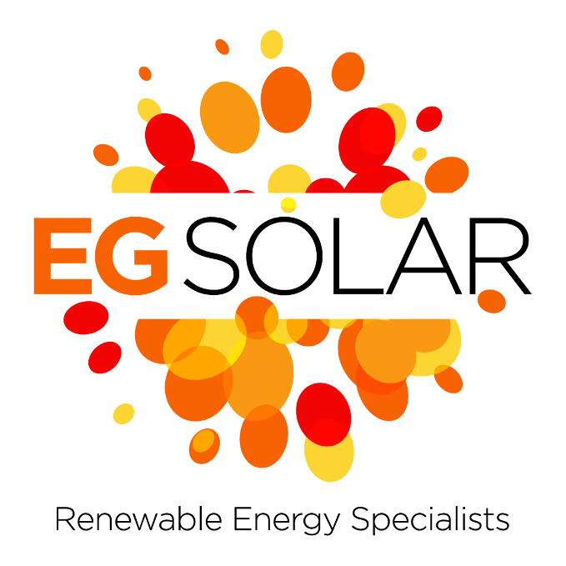

**SOLAR PV MAINTENANCE & CLEANING DIRECTIVE**

Regular Inspections: Schedule routine inspections of the entire solar PV system at least twice a year. These inspections should be conducted by qualified technicians who can identify any potential issues such as loose connections, damaged panels, or debris accumulation.

**Cleaning Schedule:** Develop a cleaning schedule based on the local climate conditions. In areas with high levels of dust, pollen, or pollution, more frequent cleaning may be necessary. Generally, cleaning every 12 months is recommended.

**Cleaning Methods**: Use appropriate cleaning methods to avoid damaging the solar panels. This typically involves using a soft brush or sponge with a mild detergent and water. Avoid abrasive materials or harsh chemicals that could scratch or degrade the panels.

**Safety Procedures**: Ensure that all safety procedures are followed during cleaning and maintenance activities. This includes using proper personal protective equipment (PPE) such as gloves and safety glasses, as well as following any relevant OSHA guidelines for working at heights.

Debris Removal: Regularly remove any debris such as leaves, branches, or bird droppings from the surface of the solar panels. Accumulated debris can reduce the efficiency of the panels by blocking sunlight and creating hot spots.

**Inverter Maintenance**: Check the inverters regularly for any signs of damage or malfunction. Clean the air intake and exhaust vents to prevent overheating, and inspect the wiring connections for tightness and corrosion.

Electrical Testing: Conduct regular electrical testing to ensure that the system is operating safely and efficiently. This may include checking voltage levels, testing for ground faults, and verifying proper functioning of protective devices such as breakers and fuses.

**Monitoring System**: Implement a remote monitoring system to track the performance of the solar PV system in real-time. This can help identify issues early on and facilitate proactive maintenance.

**Record Keeping**: Maintain detailed records of all maintenance activities, including dates, observations, and any corrective actions taken. This documentation can be valuable for tracking the performance of the system over time and identifying trends or recurring issues.

**Professional Services:** For more complex maintenance tasks or repairs, enlist the services of qualified professionals with experience in solar PV systems. This may include certified electricians, solar technicians, or specialized maintenance contractors.

By following this maintenance and cleaning strategy, you can ensure that your large solar PV system remains in optimal condition, maximizing its energy production and lifespan while minimizing downtime and repair costs.

* A cherry picker should be used be used to access the roof
* Where fall restraint is adopted an approved rescue plan must be in place
* All operatives to be harnessed with lanyard
* Once on the roof all operatives must connect to the man safe system at all times
* Oversized crawl board are to be placed over skylights local to the working area
* No lone working is permitted
* At least one operative must have IPAF (or approved equivalent)
* Walking on solar panels While it may be physically possible to walk on solar panels, it's not recommended due to the risk of damage, particularly microcracks that can impede panel performance
* All operatives are to have valid working at heights qualifications

T: 01322 479957

E: info@elco-group.co.uk

W: www.egsolar.co.uk

Unit C6, Spectrum Business Estate, Anthony’s Way, Medway City Estate, Rochester, Kent, ME2 4NP