# 1 1.0 Introduction

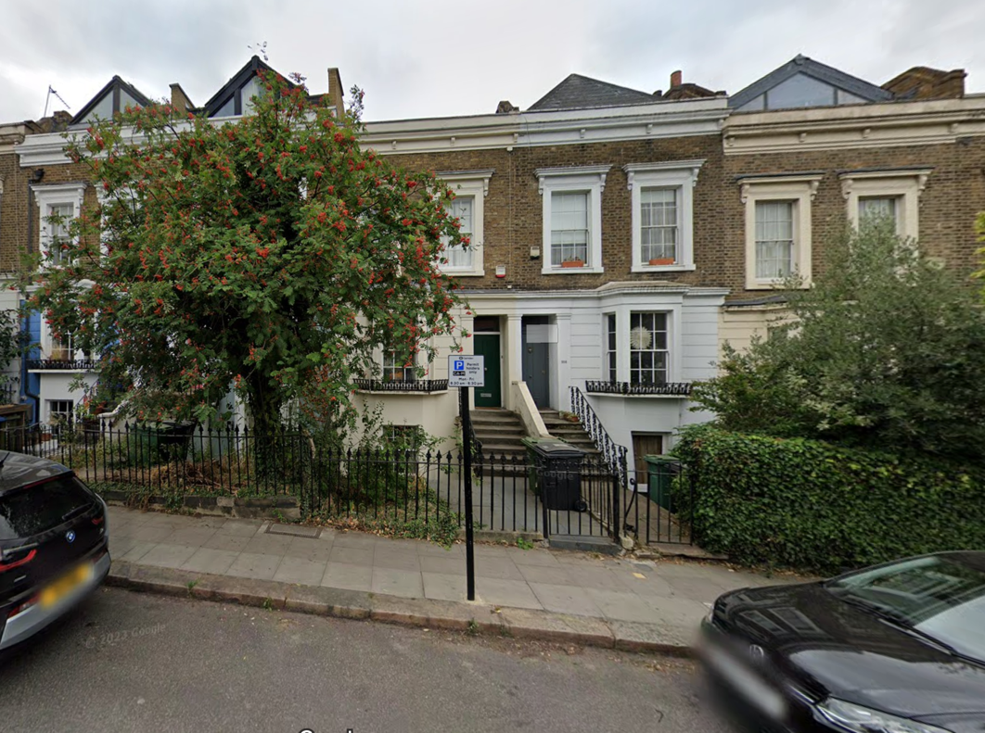

This Heritage and Design and Access statement has been complied as an explanation of the proposed alterations at 168 Leighton Road, London NW5 2RE and it should be read in conjunction with the planning application for the erection of a roof extension.

The purpose of this statement is to demonstrate that the proposal will enhance the property in context with the neighbouring properties and the proposed development will not conflict with relevant planning policies, or have any negative impact on the neighbouring properties or character of the local area.

The property is sited within a Conservation Area and is not classed as a statutory listed building.

168 LEIGHTON ROAD, LONDON NW5 2RE

DESIGN & ACCESS STATEMENT / HERITAGE STATEMENT

AUGUST 2024

Figure 1 - Front View of 168 Leighton Road

# 2.0 The Site

Figure 2 - Site Location Map (Not to Scale)

The application site is a 19th Century mid-terraced single-family dwelling located on the south side of Leighton Road. The property is over three storeys and has a large garden at lower ground floor level. The property is sited in the middle of twenty-three terraced houses (no. 142 -186) all of a similar style and proportion.

Fourteen of the twenty-three houses in the terrace have been altered at the roof level. This work includes the erection of a roof extension with new front and rear large windows to match the neighbouring properties along the terrace.

The use as a single dwelling will not be affected by the proposal. No changes are proposed to the existing access via the front door serving the house and rear door to the garden.

168 LEIGHTON ROAD, LONDON NW5 2RE

DESIGN & ACCESS STATEMENT / HERITAGE STATEMENT

AUGUST 2024

# 3.0 The Proposal

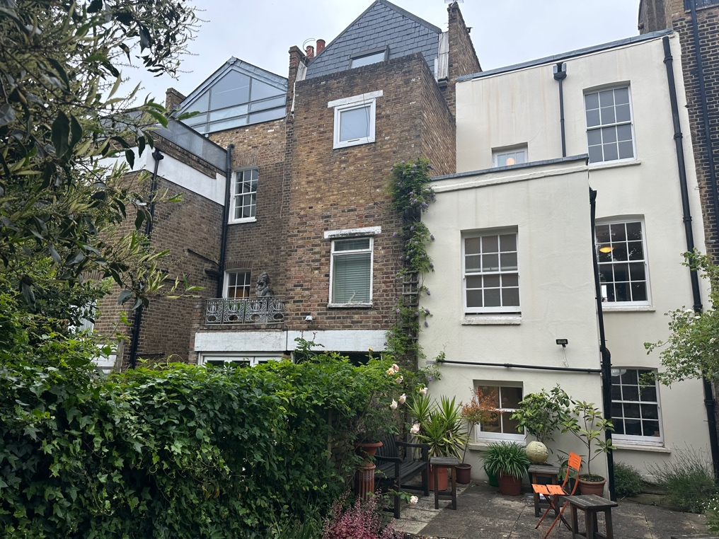The proposal consists of building a loft extension with a gable set back from front elevation visible from street level as in a similar fashion as various properties within the terrace such as 164, 170, 172, and 180 Leighton Road. The main roof is to be taken down and a new pitched roof build between raised party walls. The glazed gable is set back from the street facade. The rear gable elevation will be vertical tile finish, similar to that of 166 Leighton Road. Figures 3 & 4 show neighbouring properties with similar loft extensions.

The existing staircase is extended to provide access to the loft floor, where a new master bedroom and bathroom will be provided.

Figure 3 - 164 & 166 Leighton Road Rear Elevations

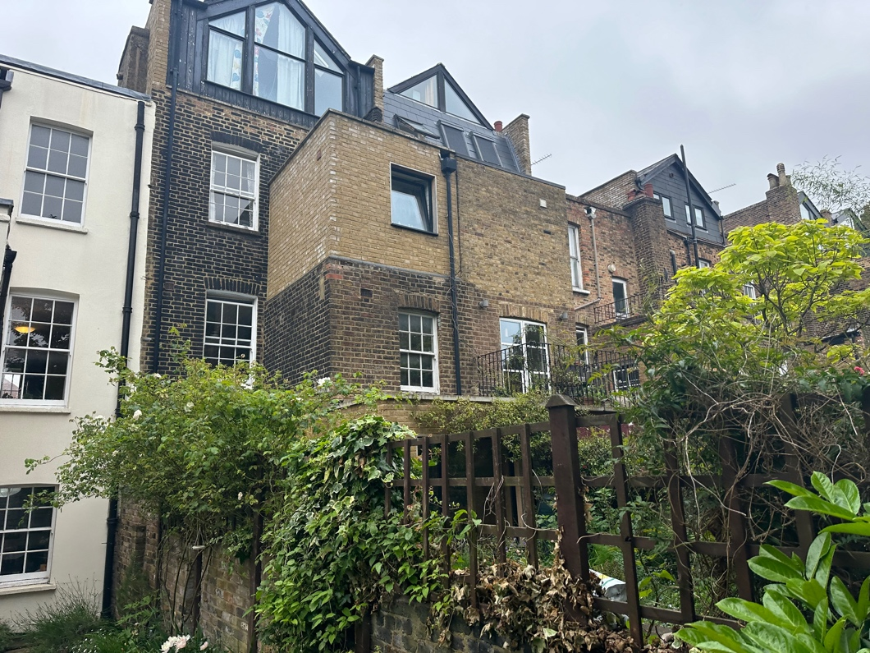

168 LEIGHTON ROAD, LONDON NW5 2RE

DESIGN & ACCESS STATEMENT

AUGUST 2024

Figure 4 - 170 - 176 Leighton Road Rear Elevation

168 LEIGHTON ROAD, LONDON NW5 2RE

DESIGN & ACCESS STATEMENT

AUGUST 2024

# The Design

The proposed roof extension would be finished to match the existing surrounding materials in order to preserve or enhance the appearance of the building and the character of the area in accordance with policies of the devolvement plan and policies.

The roof extension will be with a pitched roof with front glazed gable wall and a rear tiled gable wall with two windows. The new windows in the loft will be dark stained or painted with external dark grey frames with double glazing. New loft with black slate roof and black timber fascia similar to the adjoining properties.

The proposed alterations respond to their local context in a sympathetic manner that do not detract from or harm the character of the existing building or area. Several similar roof conversions were undertaken locally along the same street and elsewhere in the Camden Borough to building of the same type -which all contribute to the current character of the area. The scale and design of the roof conversion ensures that no unacceptable sense of enclosure of loss of privacy results to neighbouring properties. The design enables the owners to enjoy secure, energy efficient and modernized accommodation adjusted to suit the needs of modern life. The thermal improvement works associated with the proposal will improve heat loss of the whole property.

Figure 5 & 6 - Proposed Front and Rear Elevation of 168 Leighton Road

168 LEIGHTON ROAD, LONDON NW5 2RE

DESIGN & ACCESS STATEMENT

AUGUST 2024

168 LEIGHTON ROAD, LONDON NW5 2RE

DESIGN & ACCESS STATEMENT

AUGUST 2024