CMP REQUEST FOR EXTENSION OF HOURS FORM
APPLICATION FOR EXTENSION OF WORKING HOURS AS SET OUT WITHIN THE CONSTRUCTION MANAGEMENT PLAN SECURED VIA A SECTION 106 LEGAL AGREEMENT
Site address: | Belgrove House, Belgrove St, London WC1H 8AA
Planning reference number: | 2020/3881/P
Revision number and approval date of current CMP. | Belgrove House Belgrove Street 2020/3881/P CMP Rev G (rev 9). 17/11/23

I/WE HEREBY MAKE APPLICATION for a temporary extension to the hours as controlled in the approved CMP as outlined above.
Signed |  | Date of the application | 20/06/2024
Print Name | Paul Coomber | Position | Senior Construction Manager

COMPULSORY INFORMATION

Name and Registered Office address of applicant | Mace  155, Moorgate, London, EC2M 6HB
Name, address and telephone number of main contractor | Mace  155, Moorgate, London, EC2M 6HB  0203 522 3550
Please outline the reasons for this request. | To carry out below ground and above ground including demolition of the Kings Cross Station East Box structure in Euston Road. Works need to be carried out at night due to lane closures and footpath diversions in Euston Road. It has been stipulated by TFL that because this is a red route anything that affect Euston Road must be dine at night.
Current approved working hours (as set out in the CMP) | 08.00-18.00 Monday – Friday.  08:00-13:00 Saturday.
Proposed amended working hours (date and times for the proposed working hours) | 29/07/24 – 14/10/24 Inclusive  Night works – Mon-Fri 19:00 – 07:00hrs  Sat – 19:00 – 7:00hrs  Sun – 07:00 – 07:00hrs
Please provide a brief description of all the activities that will take place outside of the approved hours with justification (i.e. staggered working hours and how they comply with a). This should include the precise times, shift patterns, number of staff on site. | Setting up and dismantling traffic management either side of each shift.  Hoarding and scaffold works  Kerb realignment works to junctions at Belgrove St & Crestfield St.  Removing material from below ground and loading into lorries / skips positioned in Euston Rd  Pouring concrete using mobile concrete pumps from street level,  Removing cladding panels using powered hand tools, gutting out glass panels and demolishing the steel structure using excavator with munching attachment.  All waste will be loaded into lorries positioned in Euston Road.  Paving works once structure has been removed  Welfare / office units will be used by site operatives in these time periods.  30 Operatives + 2 traffic marshals + Traffic management operatives
Please provide a map showing nearby residential receptors. | 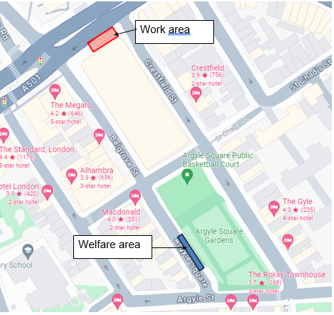
Please detail mitigation for any works outside of the approved working hours to address impact on neighbouring residents | We will ensure delivery lorries are controlled and dispersed evenly over the period.  TMs to ensure lorries are parked in the pit lane on Euston Road avoid disturbance to residents. Attendance vehicles needed for the work will be parked north end of Belgrove St & Crestfield St.  Acoustics barriers to minimise noise pollution from small plant will be used. (this will not be possible for large plant carrying out demolition).  Letters will be issued to the local residents and businesses to inform of the planned works and to offer the opportunity to engage with site before the works commence.
Liaison | Please provide a copy of the letter and or/email sent to all those initially consulted on the CMP/residents and business likely to be affected by this extension. This must have been sent before your application to extend hours is made.  If a letter is not provided, please note that we will automatically reject your application.  Following any approved by the Council a letter should be sent to all those to advise the date the extended works will commence.
Any consent granted: | Any extension granted is temporary and continuously under review. This extension can be withdrawn by the Council following review at any time.
Please note – This form is only for extended hours to enable construction works which cannot be heard at the boundary. A revised CMP will be required to be submitted through formal channels and a Section 61 notice will be required if you intend to undertake noisy construction works outside of approved hours.
Once complete please email planning.obligations@camden.gov.uk and allow up to 10 days for a response.

