|  |  |  |  |  |
| --- | --- | --- | --- | --- |
| **Address:** | **Minerva House and Telephone Exchange**  **1-4 North Crescent and 5 North Crescent**  **London**  **WC1E 7PH** | | | **3&4** |
| **Application Number(s):** | 2021/3704/P & 2021/4679/L | **Officer: Nathaniel Young** | |
| **Ward:** | Bloomsbury |  | |
| **Date Received:** | **29/10/2021** | | | |
| **Proposal:**  **2021/3704/P: Demolition of existing mansard; refurbishment and reconfiguration of the existing buildings; including the erection of a part 2 and part 3-storey extension with plant equipment above; demolition works associated with internal and external alterations to provide additional office accommodation; landscaping works and other associated works.** | | | | |
| **Background Papers, Supporting Documents and Drawing Numbers:**  **Existing and proposed drawings:** A300-MCO-XX-XX-DR-A-06101 P01, A300-MCO-XX-XX-DR-A-06102 P01, A300-MCO-ZZ-B0-DR-A-06119 P01, A300-MCO-ZZ-00-DR-A-06120 P01, A300-MCO-ZZ-01-DR-A-06121 P01, A300-MCO-ZZ-02-DR-A-06122 P01, A300-MCO-ZZ-03-DR-A-06123 P01, A300-MCO-ZZ-04-DR-A-06124 P01, A300-MCO-ZZ-05-DR-A-06125 P03, A300-MCO-ZZ-R0-DR-A-06126 P03, A300-MCO-ZZ-GF-DR-A-05110 P01, A300-MCO-ZZ-01-DR-A-05111 P01, A300-MCO-ZZ-02-DR-A-05112 P01, A300-MCO-ZZ-03-DR-A-05113 P01, A300-MCO-ZZ-04-DR-A-05114 P01, A300-MCO-ZZ-R0-DR-A-05115 P01, A300-MCO-ZZ-B0-DR-A-05109 P01, A300-MCO-ZZ-GF-DR-A-05150 P01, A300-MCO-ZZ-01-DR-A-05151 P01, A300-MCO-ZZ-02-DR-A-05152 P01, A300-MCO-ZZ-03-DR-A-05153 P01, A300-MCO-ZZ-04-DR-A-05154 P01, A300-MCO-ZZ-R0-DR-A-05155 P01, A300-MCO-ZZ-B0-DR-A-05149 P01, A300-MCO-XX-XX-DR-A-06200 P02, A300-MCO-ZZ-XX-DR-A-06201 P02, A300-MCO-ZZ-XX-DR-A-06202 P02, A300-MCO-MH-XX-DR-A-06203 P02, A300-MCO-TE-XX-DR-A-06204 P02, A300-MCO-ZZ-XX-DR-A-05210 P01, A300-MCO-MH-XX-DR-A-05211 P01, A300-MCO-ZZ-XX-DR-A-05212 P01, A300-MCO-TE-ZZ-DR-A-05213 P01, A300-MCO-ZZ-XX-DR-A-05250 P02, A300-MCO-ZZ-XX-DR-A-05251 P02, A300-MCO-MH-XX-DR-A-05252 P01, A300-MCO-TE-ZZ-DR-A-05253 P01, A300-MCO-TE-XX-DR-A-06301 P01, A300-MCO-TE-XX-DR-A-06302 P01, A300-MCO-MH-XX-DR-A-06303 P01, A300-MCO-XX-XX-DR-A-06304 P01, A300-MCO-TE-ZZ-DR-A-06305 P01, A300-MCO-MH-XX-DR-A-06306 P01, A300-MCO-TE-XX-DR-A-05310 P01, A300-MCO-TE-XX-DR-A-05311 P01, A300-MCO-MH-XX-DR-A-05312 P01, A300-MCO-MH-XX-DR-A-05313 P01, A300-MCO-TE-XX-DR-A-05350 P01, A300-MCO-TE-XX-DR-A-05351 P01, A300-MCO-MH-XX-DR-A-05352 P01, A300-MCO-MH-XX-DR-A-05353 P01, A300-MCO-TE-ZZ-DR-A-06401 P01, A300-MCO-TE-ZZ-DR-A-06402 P01, A300-MCO-MH-ZZ-DR-A-06403 P01,  **DAS:** A300-MCO-XX-XX-RP-A-14001 P01, A300-MCO-XX-XX-RP-A-14002 P01, A300-MCO-XX-XX-RP-A-14003 P01, A300-MCO-XX-XX-RP-A-14004 P01, A300-MCO-XX-XX-RP-A-14005 P01, A300-MCO-XX-XX-RP-A-14006 P01, A300-MCO-XX-XX-RP-A-14007 P01, A300-MCO-XX-XX-RP-A-14008 P01, A300-MCO-XX-XX-RP-A-14009 P01, A300-MCO-XX-XX-RP-A-14010 P01, A300-MCO-XX-XX-RP-A-14011 P01, A300-MCO-XX-XX-RP-A-14012 P01, A300-MCO-XX-XX-RP-A-14013 P01, A300-MCO-XX-XX-RP-A-14014 P01, A300-MCO-XX-XX-RP-A-14015 P01, A300-MCO-XX-XX-RP-A-14016 P01, A300-MCO-XX-XX-RP-A-14017 P01, A300-MCO-XX-XX-RP-A-14018 P01, A300-MCO-XX-XX-RP-A-14019 P01, A300-MCO-XX-XX-RP-A-14020 P01, A300-MCO-XX-XX-RP-A-14021 P01, A300-MCO-XX-XX-RP-A-14022 P01, A300-MCO-XX-XX-RP-A-14023 P01, A300-MCO-XX-XX-RP-A-14024 P01, A300-MCO-XX-XX-RP-A-14025 P01, A300-MCO-XX-XX-RP-A-14026 P01, A300-MCO-XX-XX-RP-A-14027 P01, A300-MCO-XX-XX-RP-A-14028 P01  **Supporting Documents:** Planning Statement (prepared by DP9 Ltd), Design and Access Statement (prepared by Morris + Company); Preliminary Ecological Appraisal - 2112-07gg v4 (prepared by Eight Associates), Townscape; Heritage and Visual Impact Assessment’ (prepared by KM Heritage & AVR London); Schedule of Listed Building Works (prepared by Morris & Co. & KM Heritage); Structural Planning Report (prepared by Heyne Tillet Steel) including. Ground Movement and Basement Impact Assessment; Acoustic Report (prepared by Temple Group); Air Quality Assessment (prepared by AQ Consultants); Archaeological Assessment (prepared by MOLA); Construction Management Plan (prepared by Real Pm); Contaminated Land Assessment (prepared by Geotech); Daylight & Sunlight Assessment (prepared by Avison Young); Delivery and Servicing Management Plan (prepared by Momentum Transport); Energy Statement (prepared by Thornton Reynolds); Sustainability Statement including BREEAM (prepared by Eight Associates); CC1 Policy Response (prepared by Eight Associates); Whole of Life Carbon Assessment (prepared by Eight Associates); Flood Risk Assessment and SUDS Strategy (prepared by HTS London); Transport Assessment & Travel Plan (prepared by Momentum Transport); Security Needs Assessment (prepared by QCIC); Fire Statement (prepared by OFR); Housing Report/viability (prepared by DS2); Employment and Training Strategy & Regeneration Strategy (prepared by Volterra); SuDS Strategy (prepared by HTS); Statement of Community Involvement (prepared by Kanda); and Bat Assessment Report issue no.1 (prepared by Eight Associates). | | | | |
| **RECOMMENDATION SUMMARY: Grant Conditional Planning Permission Subject to a Section 106 Legal Agreement** | | | | |
| **Proposal:**  **2021/4679/L: Partial demolition of boundary wall parapet and flat roof (rear roof level); erection of one storey roof extension connected with extension above Telephone Exchange (rear section only, existing pitched roof at front to be retained); windows to be replaced to match existing style; with double glazed units; alterations to ground floor rear upstand; portal openings in party wall to be created (to connect to Telephone Exchange internally); and various other internal and external works.** | | | | |
| **Background Papers, Supporting Documents and Drawing Numbers:**  **Existing and proposed drawings:** A300-MCO-XX-XX-DR-A-06101 P01, A300-MCO-XX-XX-DR-A-06102 P01, A300-MCO-ZZ-B0-DR-A-06119 P01, A300-MCO-ZZ-00-DR-A-06120 P01, A300-MCO-ZZ-01-DR-A-06121 P01, A300-MCO-ZZ-02-DR-A-06122 P01, A300-MCO-ZZ-03-DR-A-06123 P01, A300-MCO-ZZ-04-DR-A-06124 P01, A300-MCO-ZZ-05-DR-A-06125 P03, A300-MCO-ZZ-R0-DR-A-06126 P03, A300-MCO-ZZ-GF-DR-A-05110 P01, A300-MCO-ZZ-01-DR-A-05111 P01, A300-MCO-ZZ-02-DR-A-05112 P01, A300-MCO-ZZ-03-DR-A-05113 P01, A300-MCO-ZZ-04-DR-A-05114 P01, A300-MCO-ZZ-R0-DR-A-05115 P01, A300-MCO-ZZ-B0-DR-A-05109 P01, A300-MCO-ZZ-GF-DR-A-05150 P01, A300-MCO-ZZ-01-DR-A-05151 P01, A300-MCO-ZZ-02-DR-A-05152 P01, A300-MCO-ZZ-03-DR-A-05153 P01, A300-MCO-ZZ-04-DR-A-05154 P01, A300-MCO-ZZ-R0-DR-A-05155 P01, A300-MCO-ZZ-B0-DR-A-05149 P01, A300-MCO-XX-XX-DR-A-06200 P02, A300-MCO-ZZ-XX-DR-A-06201 P02, A300-MCO-ZZ-XX-DR-A-06202 P02, A300-MCO-MH-XX-DR-A-06203 P02, A300-MCO-TE-XX-DR-A-06204 P02, A300-MCO-ZZ-XX-DR-A-05210 P01, A300-MCO-MH-XX-DR-A-05211 P01, A300-MCO-ZZ-XX-DR-A-05212 P01, A300-MCO-TE-ZZ-DR-A-05213 P01, A300-MCO-ZZ-XX-DR-A-05250 P02, A300-MCO-ZZ-XX-DR-A-05251 P02, A300-MCO-MH-XX-DR-A-05252 P01, A300-MCO-TE-ZZ-DR-A-05253 P01, A300-MCO-TE-XX-DR-A-06301 P01, A300-MCO-TE-XX-DR-A-06302 P01, A300-MCO-MH-XX-DR-A-06303 P01, A300-MCO-XX-XX-DR-A-06304 P01, A300-MCO-TE-ZZ-DR-A-06305 P01, A300-MCO-MH-XX-DR-A-06306 P01, A300-MCO-TE-XX-DR-A-05310 P01, A300-MCO-TE-XX-DR-A-05311 P01, A300-MCO-MH-XX-DR-A-05312 P01, A300-MCO-MH-XX-DR-A-05313 P01, A300-MCO-TE-XX-DR-A-05350 P01, A300-MCO-TE-XX-DR-A-05351 P01, A300-MCO-MH-XX-DR-A-05352 P01, A300-MCO-MH-XX-DR-A-05353 P01, A300-MCO-TE-ZZ-DR-A-06401 P01, A300-MCO-TE-ZZ-DR-A-06402 P01, A300-MCO-MH-ZZ-DR-A-06403 P01,  **DAS:** A300-MCO-XX-XX-RP-A-14001 P01, A300-MCO-XX-XX-RP-A-14002 P01, A300-MCO-XX-XX-RP-A-14003 P01, A300-MCO-XX-XX-RP-A-14004 P01, A300- MCO-XX-XX-RP-A-14005 P01, A300-MCO-XX-XX-RP-A-14006 P01, A300-MCO-XX-XX-RP-A-14007 P01, A300-MCO-XX-XX-RP-A-14008 P01, A300-MCO-XX-XX-RP-A-14009 P01, A300-MCO-XX-XX-RP-A-14010 P01, A300-MCO-XX-XX-RP-A-14011 P01, A300-MCO-XX-XX-RP-A-14012 P01, A300-MCO-XX-XX-RP-A-14013 P01, A300-MCO-XX-XX-RP-A-14014 P01, A300-MCO-XX-XX-RP-A-14015 P01, A300-MCO-XX-XX-RP-A-14016 P01, A300-MCO-XX-XX-RP-A-14017 P01, A300-MCO-XX-XX-RP-A-14018 P01, A300-MCO-XX-XX-RP-A-14019 P01, A300-MCO-XX-XX-RP-A-14020 P01, A300-MCO-XX-XX-RP-A-14021 P01, A300-MCO-XX-XX-RP-A-14022 P01, A300-MCO-XX-XX-RP-A-14023 P01, A300-MCO-XX-XX-RP-A-14024 P01, A300-MCO-XX-XX-RP-A-14025 P01, A300-MCO-XX-XX-RP-A-14026 P01, A300-MCO-XX-XX-RP-A-14027 P01, A300-MCO-XX-XX-RP-A-14028 P01  **Supporting Documents:** Planning Statement (prepared by DP9 Ltd), Design and Access Statement (prepared by Morris + Company); Preliminary Ecological Appraisal - 2112-07gg v4 (prepared by Eight Associates), Townscape; Heritage and Visual Impact Assessment’ (prepared by KM Heritage & AVR London); Schedule of Listed Building Works (prepared by Morris & Co. & KM Heritage); Structural Planning Report (prepared by Heyne Tillet Steel) including. Ground Movement and Basement Impact Assessment; Acoustic Report (prepared by Temple Group); Air Quality Assessment (prepared by AQ Consultants); Archaeological Assessment (prepared by MOLA); Construction Management Plan (prepared by Real Pm); Contaminated Land Assessment (prepared by Geotech); Daylight & Sunlight Assessment (prepared by Avison Young); Delivery and Servicing Management Plan (prepared by Momentum Transport); Energy Statement (prepared by Thornton Reynolds); Sustainability Statement including BREEAM (prepared by Eight Associates); CC1 Policy Response (prepared by Eight Associates); Whole of Life Carbon Assessment (prepared by Eight Associates); Flood Risk Assessment and SUDS Strategy (prepared by HTS London); Transport Assessment & Travel Plan (prepared by Momentum Transport); Security Needs Assessment (prepared by QCIC); Fire Statement (prepared by OFR); Housing Report/viability (prepared by DS2); Employment and Training Strategy & Regeneration Strategy (prepared by Volterra); SuDS Strategy (prepared by HTS); Statement of Community Involvement (prepared by Kanda); and Bat Assessment Report issue no.1 (prepared by Eight Associates). | | | | |
| **RECOMMENDATION SUMMARY: Grant Listed Building Consent Subject to a Section 106 Legal Agreement** | | | | |
| **Applicant:** | | | **Agent:** | |
| Schroders UK Real Estate Fund  London | | | DP9  100 Pall Mall  London  SW1 5NQ | |

**ANALYSIS INFORMATION**

|  |  |  |
| --- | --- | --- |
| **Land Use Details:** | | |
|  | Use Class | Floorspace (GIA sqm) |
| Existing | Class E Office | 5,514 sqm |
| Proposed | Class E Office | 8,217 sqm |
|  |  | Uplift 2,703 sqm |

|  |  |  |  |  |
| --- | --- | --- | --- | --- |
| **Parking Details:** | | | | |
|  | Car Parking Spaces (General) | Car Parking Spaces (Disabled) | Cycle Parking Spaces (Long stay) | Cycle Parking Spaces (Short stay) |
| Existing | 0 | 0 | 0 | 0 |
| Proposed | 0 | 0 | 141 | 14 |

**EXECUTIVE SUMMARY**

1. The application site comprises Minerva House and Telephone Exchange, it is located in North Crescent on the northern side of Chenies Street between its junction with Tottenham Court Road to the west and Huntley Street to the east. Minerva House is a Grade II Listed Building, and although the Telephone Exchange is not afforded a statutory listing it is considered a positive contributor within the Bloomsbury Conservation Area.
2. Both properties are office buildings and have an overall combined GIA of 5,514sqm. The proposals are for the extension, refurbishment and intensification of the office use. The refurbishment to provide high quality, flexible office space and the intensification of the existing employment use within the Central Activities Zone would be in accordance with both local and national policies. With an uplift of 2,703sqm GIA, the development is required to provide on-site residential housing by policy H2. The applicant's financial viability assessment concludes that the scheme would be in a significant financial deficit (£6.3 million). This has been audited by BPS who agree with this conclusion. The applicant has agreed to contribute £2,027,250.00 as a payment in lieu (PIL) to the Council despite this significant financial deficit, along with a number of other economic, employment and training benefits and contributions, including an offer of affordable workspace. They are taking a long-term view on the proposal and wish to make the upfront payment rather than having a viability review imposed.
3. The existing buildings make a positive contribution to the character and appearance of the Bloomsbury Conservation Area. The existing mansard (front) above the Telephone Exchange would be demolished and a part 2 (to the front), part 3 (to the rear) storey extension would be built above both buildings. Various internal refurbishment works would be carried out to modernise the underperforming and poorly laid out buildings (for their existing purpose). The internal works combine the buildings into a single Grade A office space while retaining each building’s individual character and historic fabric. All significant internal works are considered to be reversible and would not cause undue harm to the character and special interest of the buildings. The proposals would be sympathetic and of a high standard of design quality and materiality which would preserve and enhance the character and appearance of the buildings and their contribution to the character of the conservation area. The proposals would also preserve the setting and significance of nearby listed buildings.
4. The development would not result in undue harm to neighbouring amenity, nor to the local transport network or infrastructure subject to the recommended conditions and S106 obligations. The development would also provide a sustainable development which meets local and regional energy and sustainability policies.
5. As such, it is recommended that planning permission is granted subject to conditions and a Section 106 legal agreement.

**OFFICERS’ REPORT**

**Reason for Referral to Committee: The application is a major development which involves an uplift in non-residential floorspace of over 500sqm [clause 3ii]**

1. **SITE**

1.1 The application site is situated in the southern part of Camden Borough near Goodge Street station. It is located in North Crescent on the northern side of Chenies Street between its junction with Tottenham Court Road to the west and Huntley Street to the east.

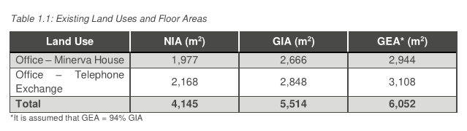1.2 The two buildings located on the site are Minerva House and Telephone Exchange. When viewed from Chenies Street, Telephone Exchange is centrally located within North Crescent and Minerva House sits to the left. Both properties are office buildings and have an overall combined GIA of 5,514sqm.

1.3 The surrounding area is characterised by a mixture of uses. To the west of the site lie ground floor retail units on Tottenham Court Road with office space on the floors above. Further office space lies to the north along Alfred Mews with residential uses to the east along Huntley Street. Alfred Mews is a narrow, commercial back passage mostly used for servicing purposes for the neighbouring Heal’s building and subject buildings. Views from Tottenham Court Road into the passage and of the rear of the subject buildings are highly restricted. The Eisenhower Centre, a deep level shelter constructed in 1942, lies to the south of the site. This structure is referenced within the Bloomsbury Conservation Area Appraisal and Management Strategy as a building of social and historic interest.

1.4 The site lies within the Bloomsbury Conservation Area and the Alfred Place/Tottenham Court Road sub area. Minerva House is a Grade II Listed Building, and although Telephone Exchange is not afforded a statutory listing it is considered a positive contributor within the Conservation Area.

1.5 The site has a PTAL (Public Transport Accessibility Level) rating of 6b, the highest possible rating. In addition to nearby bus stops, Goodge Street Underground Station is located less than a 100m walk to the east of the site. Indeed, within a 13-minute walk are the Underground Stations at Warren Street, Euston, Tottenham Court Road and Russell Square.

1.6 In terms of scale, both buildings comprise a lower ground, ground and three levels above. The surrounding buildings on Tottenham Court Road vary in height from 5 to 7 storeys. Along Chenies Street, opposite the site, building heights range from 4 to 7 storeys. Within this area, it can be seen that the fourth, fifth, or six storeys are characterised by setback mansard roofs.

1. **THE PROPOSAL**

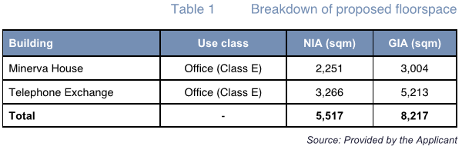2.1 The proposal is for a major office extension (Class E). No change of use is proposed. There would be an uplift in floorspace of 2,703 sqm GIA.

2.2 The existing mansard (front) above the Telephone Exchange would be demolished and a part 2 (to the front), part 3 (to the rear) storey extension would built above both buildings.

2.3 From the front (viewed from Chenies Street) Minerva House would appear no taller and the Telephone Exchange would appear one storey taller than what currently exists.

2.4 From the rear (viewed from Alfred Mews) there would be a more notable 3-storey build up above the rear wing of the Telephone Exchange and a 1-storey increase above Minerva House (rear only).

2.5 Various internal refurbishment works would be carried out to modernise the underperforming and poorly laid out buildings (for their purpose). The internal works combine the buildings into a single Grade A office space.

2.6 A listed building application has been submitted in respect of the works affecting Minerva House comprising:

External

* Partial demolition of boundary wall parapet and flat roof (rear roof level);
* Erection of one storey roof extension connected with extension above Telephone Exchange (rear section only, existing pitched roof at front to be retained);
* Windows to be replaced to match existing style; with double glazed units and anodized/PPC aluminium frames;
* Alterations to ground floor rear upstand;
* Facade to be cleaned and repaired where required;
* Balustrades to be repaired and replaced to match existing where required;
* Roof (front section/façade) to be repaired to match existing where required;
* Piers to be cleaned and repaired where required;
* Replacement of various entrance/exit/fire doors; and
* Removal of unused plant and water tanks.

Internal

* Portal openings in party wall to be created (to connect to Telephone Exchange internally);
* Removal of various retrofitted stairs and balustrades;
* Removal of retrofitted WCs;
* Removal of retrofitted lift and lift shaft and void infilled;
* Removal of various internal non-structural walls;
* Removal of various retrofitted platforms; and
* Removal and replacement of various cills and window surrounds.

2.7 The figures below are indicative only (not for approval) – they are extracts from the daylight/sunlight report to demonstrate the general massing of the proposal. The development has since improved, with a reduction in the height of the plant screening near the most affected residential properties (Mayne House and Chenies Street Chambers), amongst other minor improvements which were made during the course of the application process.

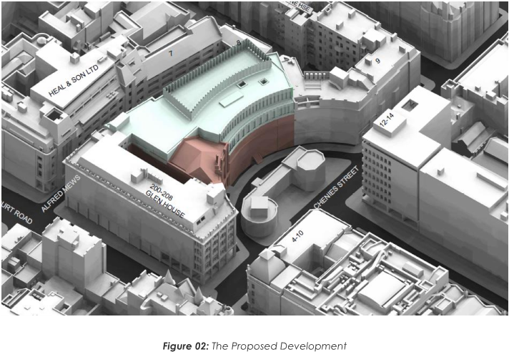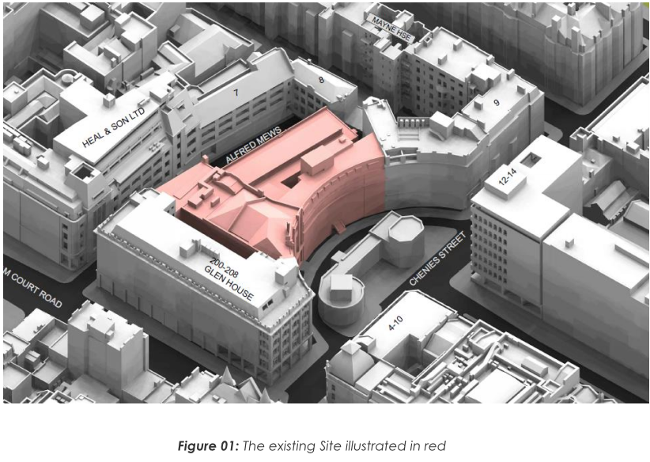

Revisions

2.8 The following revisions were made during the course of the application to respond to officer concerns / points raised in consultation:

* Addition of parapet wall to visually separate roofs of Nos. 1-4 and 5 North Crescent.
* UKPN have confirmed that the new previously proposed substation is no longer required. The new proposal is to reuse and upgrade the existing Minerva House substation. Therefore, the proposed substation in Telephone Exchange has been removed and the lower ground and ground floors have been redesigned. As a result, there has been a reduction in demolition to the Mews facade, existing openings have been retained but doors are to be replaced. This allows for better inclusive design and end of journey offering.
* Plant has been relocated from the roof to the basement to minimise the massing and street level impact at roof level. Due to this change additional ventilation is required. Louvres are required to the lower ground façade to Telephone Exchange and will be positioned within existing window openings.
* Modification to north portal between Minerva House and Telephone Exchange has shifted 700mm south on all floors. By avoiding the existing beam, there is a reduction in structural intervention to the listed building.
* Following contractor engagement on the buildability and waterproofing of the basement and due to the complexity of waterproofing an existing basement, the proposal is to replace the lower ground floor ground bearing slab with a new concrete slab.
* Modification to Minerva House ground floor window due to reduced reception space and increase in ground floor affordable workspace offering.
* Internally lining the existing wall of Telephone Exchange Mews on ground and first floors to achieve desired U-value and improve thermal performance.
* Modifications to shower and cycle store layouts in Telephone Exchange lower ground floor to allow for an improved sustainable transport experience.
* Reduced number of doors on fourth floor of Telephone Exchange terrace to enhance water tightness of the building envelope and reduce risk of water overflow at threshold.
* Reduced number of doors on third floor of Telephone Exchange terrace to enhance water tightness of the building envelope and reduce risk of water overflow at threshold.
* Modifications to extent of demolition due to design development. Internally increased floor demolition and modifications to party wall. Externally reduced demolition on Minerva House existing flat roof and Mews facade.
* Minor adjustments to risers on all floors in Minerva House and Telephone Exchange due to design development.
* Modification to cycle store door width to Telephone Exchange façade at lower ground floor, improving the access for cyclists.
* Redesign of Minerva House ground floor entrance door to sliding door to improve access.
* Following the residents’ consultation, the visibility of the plant screen has been reduced from the surrounding context by chamfering the east elevation and moving it in 550mm.
* Following the residents’ consultation and review of more appropriate contextual materials, there is a change of materiality on east facade to glazed brickwork.
* Rationalisation of northwest stair wall on fourth floor of Minerva House to allow natural light into the core and to avoid inaccessible floor space.
* Modification of northwest staircase on fifth floor of Minerva House to improve access onto a small area of the roof for maintenance.
* Modification to the position of the plant access door on the fifth floor of Telephone Exchange to suit changes to MEP equipment layout.
* Modification to width of glazed door to Minerva House façade at lower ground floor, adjusted to suit fire escape door requirements.

1. **RELEVANT HISTORY**

3.1 Minerva House (1-4 North Crescent)

2010/5776/L: Alterations to existing office building (Class B1) including replacement of windows and external alterations to rear elevation of the building. Granted 20/12/2010.

2010/5740/P: Alterations to existing office building (Class B1) including replacement of windows to rear elevation of the building. Granted 20/12/2010.

2010/4325/L: Internal and external alterations to existing office building (Class B1) including installation of roof mounted solar panels; erection of eight condenser units within light well to south-west elevation; repairs to chimney stack, roof, parapets, gutters, and facades and a new level access at ground floor level. Granted 15/10/2010.

2010/4322/P: Alterations to existing office building (Class B1) including installation of solar panels at roof level, erection of eight condenser units within light wells to south-west elevation and new level access at ground floor level. Granted 15/10/2010.

2011/0729/L: Alterations in association with replacement windows to southwest elevation of existing office building (Class B1). Granted 14/04/2011.

2011/0726/P: Replacement windows to southwest elevation of existing office building (Class B1). Granted 14/04/2011.

2011/4555/L: Internal alterations including the installation of secondary glazing units to the windows on the front elevation and four windows to the rear wall at 1st, 2nd and 3rd floor levels of existing office building (Class B1). Granted 04/11/2011.

2012/0137/L: Details of condition 2 (masonry and re-pointing works) of Listed Building Consent (2010/4325/L) dated 15/10/2010 for the internal and external alterations to existing office building (Class B1) including installation of roof mounted solar panels; erection of eight condenser units within light well to south-west elevation; repairs to chimney stack, roof, parapets, gutters, and facades and a new level access at ground floor level. Granted 10/04/2012.

2013/2959/L: Internal alterations to include alterations to partitions at ground floor level of office building (Class B1). Granted 12/06/2013.

2016/6225/L: Installation of 2 x AC units in the southwest lightwell at ground floor level and associated pipework Granted 20/12/2016.

2016/6004/P: Installation of 2 x AC units in the southwest lightwell at ground floor level. Granted 20/12/2016.

2016/6000/L: Installation of partition walls at ground, second and third floor levels. Granted 06/12/2016.

2016/1515/L: Internal alterations to include install / alterations to partitions at ground, 1st, 2nd and 3rd floors level of office building Granted 06/12/2016.

2019/6243/L: Replacement of damaged slates to part of the front facing roof pitch including new breather membrane and lead abutment flashing. Granted 31/03/2020.

3.2 Telephone Exchange (5 North Crescent)

PS9704463: Change of use of the whole building from Class D1 (health authority/ educational use) to use for office purposes (Class B1). Granted 01/08/1997.

2004/1263/P: Replacement of existing timber front entrance door with new glazed door to existing office building. Refused 12/05/2004.

2006/4744/A: Display of non-illuminated flag above the entrance door of the building. Refused 30/01/2007.

2010/4702/P: The erection of solar panels at main flat roof level, a new air-handling unit and four condensers at rear second floor flat roof level and the replacement of a condenser unit at rear/side ground level and new waterproof membrane to flat roof areas of office building (Class B1). Granted 27/10/2010.

2010/5593/P: Replacement of windows and installation of platform lift within front light well, and associated gate, to offices (Class B1). Granted 09/12/2010.

2013/2959/L: Internal alterations to include alterations to partitions at ground floor level of office building (Class B1). Granted 19/06/2013.

1. **CONSULTATION SUMMARY**

|  |  |
| --- | --- |
| **Date** | **Organisation** |
| 21st October 2020 | The project team had an introductory meeting with The Bloomsbury Conservation Area Advisory Committee (BCAAC) to present the proposals. |
| 23rd October 2020 | The project team emailed Bloomsbury Ward Councillors Adam Harrison and Rishi Madlani to introduce the proposals and offer a site tour. |
| 18th November 2020 | The project team had a further meeting with The BCAAC to present the proposals. |
| 11th February 2021 | The project team once again emailed Bloomsbury Ward Councillors Adam Harrison and Rishi Madlani to introduce the proposals and offer a site tour. |
| 21st June 2021 | A newsletter outlining the proposals for the site and detailing the virtual consultation was sent to an area around the site, which contained c.1519 addresses. |
| 21st June – 6th July | The consultation website was launched, with virtual exhibition boards and the opportunity to leave feedback. |
| June 2021 | Social media adverts were run to advertise the consultation. |
| 23rd June 2021 | The project team conducted a site tour with the BCAAC to discuss the proposals further. |
| 28th June 2021 | The project team emailed the Bloomsbury Association, The Fitzrovia Partnership BID, and BRAG (Bloomsbury Residents Action Group) as well as Ward Cllrs Madlani and Harrison to share details of consultation and offered an invitation to meet. |
| 1 July 2021 | The project team emailed a follow up to the Bloomsbury Association, The Fitzrovia Partnership BID, and Bloomsbury Residents Action Group to share details of consultation and offered an invitation to meet. |
| 2nd July 2021 | A follow-up newsletter outlining the proposals for the site and detailing the virtual consultation was sent to an area around the site, which contained c.1519 addresses. |

**Statutory Consultation**

**Local groups/stakeholders**

* 1. **Historic England:** No comment.
  2. **The Greater London Archaeological Advisory Service (GLAAS):** No Archaeological requirement.
  3. **TfL Crossrail Safeguarding:** No comment.
  4. **TfL Spatial Planning:** Tottenham Court Road forms part of the Strategic Road Network (SRN). TfL has a duty under the Traffic Management Act 2004 to ensure that any development does not have an adverse impact on the SRN, including temporary impacts during construction. The footway and carriageway on Tottenham Court Road should not be blocked during the development as it is a major bus corridor. Temporary obstructions should be kept to a minimum and should not encroach on the clear space needed to provide safe passage for pedestrians or bus passengers or obstruct the flow of traffic on Tottenham Court Road. All vehicles should only park/ stop at permitted locations and within the time periods permitted by existing on-street restrictions.
  5. **TfL London Underground and DLR:** No objection in principle. Recommend a condition is attached requiring the submission of detailed design, methods statements and load calculations.

*Officer response: Condition has been attached accordingly (Condition 15).*

* 1. **Bloomsbury CAAC:** Objection.
* Excessive massing above Telephone Exchange (particularly on Alfred Mews).
* Design does not fully integrate with host building.

*Officer response:*

1. *See section 7 (Design and Conservation). On Chenies Street, BCAAC’s comments regarding a two-storey extension being the upper limit at pre-application stage were noted. Only a single storey of office space is added from the North Crescent view above what has been established. On Alfred Mews, the proposed Mews scale reflects the buildings opposite.*
2. *See section 7 (Design and Conservation). It is considered that the design proposed integrates successfully with the host building and wider conservation area by demonstrating a contemporary reflection of the host building (celebratory rather than mimicry). The removal of the existing cornice and replacement with contemporary cornice highlights the transition between existing and new in a sensitive manner as well as retains the key proportions of ‘façade and roof.’* 
   1. **Bloomsbury Residents Action Group (BRAG):** Objection.
3. Loss of light.
4. Loss of privacy.
5. Loss of outlook.
6. Noise and vibration (caused by plant equipment).
7. Lack of consultation (original comment acknowledges they were offered a meeting which they did not take up).

*Officer response:*

1. *See section 8 (Impact on Neighbouring Amenity) – Light*
2. *See section 8 (Impact on Neighbouring Amenity) – Privacy*
3. *See section 8 (Impact on Neighbouring Amenity) – Outlook*
4. *See section 8 (Impact on Neighbouring Amenity) – Noise*
5. *The applicant’s team is not obligated to contact all residents for consultation, it is however noted that Kanda (developer’s team) contacted BRAG to offer a meeting and briefing on the proposals on 28th June 2021 - this offer to meet was not taken up (as acknowledged in the original objection comment). The Council has also carried out its consultation process in accordance with the Council’s Statement of Community Involvement.*
   1. **Chenies Street Chambers Leaseholder Association:** Objection.

* Loss of light.
* Inaccuracies with daylight/sunlight report.
* Insufficient consultation.
* Loss of privacy.
* Noise and disturbance (caused by plant equipment).
* Acoustic study inadequate.

*Officer response:*

1. *The daylight report indicates there will be no significant transgressions of BRE guidelines - see section 8 (Impact on Neighbouring Amenity) – Light*
2. *See section 8 (Impact on Neighbouring Amenity) – Light*
3. *The Council has carried out its consultation process in accordance with the Council’s Statement of Community Involvement. It is also understood that the developer has offered meetings with the residents of Chenies Street Chambers Leaseholder Association. In June, Avison Young the Daylight and Sunlight Consultant, ran through the daylight/sunlight report and discussed impacts on various properties at a consultation meeting arranged by the applicant. In addition, the architect went into one of the flats and prepared a visual of the proposal which was also presented.*
4. *See section 8 (Impact on Neighbouring Amenity) – Noise*
5. *See section 8 (Impact on Neighbouring Amenity) – Noise*

4.9 **Councillor Adam Harrison (Bloomsbury ward):** Objection.

* Detrimental impact to residential amenity.
* Overbearing nature of rooftop extension.
* Lack of contribution to affordable housing.

*Officer response:*

1. *See section 8 (Impact on Neighbouring Amenity)*
2. *See section 8 (Impact on Neighbouring Amenity)*
3. *See section 6 (Land Use)*

**Adjoining Occupiers**

Twelve site notices were displayed from the 29th September 2021 until the 23rd October 2021. A press advert was placed on the 30th September 2021 in the Ham and High.

The sites notices were then republished from the 6th October 2021 until the 30th October 2021. A press advert was also republished on the 6th October 2021.

Twenty-five responses were received (Flats 2, 9, 13, 15, 19, 24, 28, 29, 32 Chenies Street Chambers; Flats 2, 10, 12, 1 Huntley Street; Flats 26, 27, 35, 5 Huntley Street; Flats 45, 7 Huntley Street; and 3 Middle Lane) which raised the following issues:

1. Loss of light (to rear windows and garden)
2. Loss of privacy
3. Loss of outlook
4. Design and materials –in particular the flat occupiers at 1-9 Huntley Street object to the white glazed tiled east elevation which they feel would be overly stark and reflective of light/heat
5. Detrimental impact to building’s appearance
6. Excessive scale of extension
7. Noise (caused by plant)
8. Noise and disturbance (caused by construction work)
9. Noise and pollution (caused by increased traffic)
10. Increased parking pressures
11. Insufficient consultation (during application process and pre-app process)
12. Displacement of bats (bat survey needs carrying out)

*Officer response:*

1. *See section 8 (Impact on Neighbouring Amenity) – Light*
2. *See section 8 (Impact on Neighbouring Amenity) – Privacy*
3. *See section 8 (Impact on Neighbouring Amenity) – Outlook*
4. *See section 7.20 (Design and Conservation)*
5. *See section 7 (Design and Conservation)*
6. *See section 7 (Design and Conservation)*
7. *See section 8 (Impact on Neighbouring Amenity) – Noise*
8. *Such concerns would be considered within the Construction Management Plan (CMP). Noise from demolition and construction works is subject to control under the Control of Pollution Act 1974. Any building works that can be heard at the boundary of the site must be carried out only between 08.00 and 18.00 hours Monday to Friday and 08.00 to 13.00 on Saturday and not at all on Sundays and Public Holidays. If this is breached, residents are advised to report this to the Council’s noise team for investigation.*
9. *The development would be entirely car free. There would be no parking spaces on-site and no parking permits would be issued.*
10. *The development would be entirely car free. There would be no parking spaces on-site and no parking permits would be issued.*
11. *The consultation has been carried out in accordance with the Council’s statement of community involvement. The Council does not control how the applicant chooses to engage with local stakeholders. It is however understood various meetings were held/offered during the application process. Pre-application discussions are confidential, it is at the applicant’s discretion whether they choose to engage with local stakeholders at that stage of the development process.*
12. *Bat survey was carried out in response to comment. No evidence of significant bat activity/ roosting was found. See section 15 (Ecology)*

1. **POLICIES & GUIDANCE**
   1. **National Planning Policy Framework 2021**
   2. **National First Homes Policy (Written Ministerial Statement May 2021)**
   3. **The London Plan 2021**
   4. **Camden Local Plan 2017**

G1 Delivery and location of growth

H2 Maximising the supply of self-contained housing from mixed use schemes

H4 Maximising the supply of affordable housing

A1 Managing the impact of development

A2 Open space

A3 Biodiversity

A4 Noise and vibration

A5 Basements

C6 Access for all

D1 Design

D2 Heritage

E1 Economic development

E2 Employment premises and sites

T1 Prioritising walking, cycling and public transport

T2 Parking and car-free development

T4 Sustainable movement of goods and materials

CC1 Climate change mitigation

CC2 Adapting to climate change

CC3 Water and flooding

CC4 Air quality

CC5 Waste

DM1 Delivery and monitoring

* 1. **Supplementary Planning Guidance 2018-2021**

CPG Access for all

CPG Air quality

CPG Amenity

CPG Biodiversity

CPG Basements

CPG Design

CPG Developer contributions

CPG Employment sites and business premises

CPG Energy efficiency and adaptation

CPG Public open space

CPG Housing

CPG Transport

CPG Water and flooding

* 1. **Fitzrovia Area Action Plan 2014**
  2. **Site Allocations Local Plan (SALP) 2020 – Draft**

KQ1 Knowledge Quarter

Following approval by Cabinet in November 2019, the Council consulted on the draft Site Allocations Local Plan document. The process for preparing Local Plans includes a number of statutory stages including at least two formal rounds of public consultation. The first formal consultation on the Site Allocations Local Plan was carried out between 13 February and 27 March 2020. The second round of formal consultation is yet to be carried out.

* 1. **Planning Statement on the Intermediate Housing Strategy and First Homes (March 2022)**
  2. **Bloomsbury Conservation Area Appraisal and Management Strategy 2011**

5.10 **London Borough of Camden Housing Delivery Test - Action Plan August 2021**

**ASSESSMENT**

The principal considerations material to the determination of this application are considered in the following sections of this report:

|  |  |
| --- | --- |
| **6** | **Land Use** |
| **7** | **Design and Conservation** |
| **8** | **Impact on Neighbouring Amenity** |
| **9** | **Basement Development** |
| **10** | **Transport** |
| **11** | **Waste** |
| **12** | **Sustainability and Energy** |
| **13** | **Air Quality** |
| **14** | **Flood Risk & SuDS** |
| **15** | **Land Contamination** |
| **16** | **Open Space** |
| **17** | **Ecology** |
| **18** | **Planning Obligations** |
| **19** | **CIL** |
| **20** | **Conclusions** |
| **21** | **Recommendations** |
| **23** | **Legal Comments** |
| **24** | **Conditions and Informatives** |

**6 Land Use**

Provision of additional employment space

6.1 Policy G1 of the Local Plan promotes the most efficient use of land and buildings in the borough. The policy supports development which makes the best use of its site, taking into consideration quality of design, surroundings, sustainability, amenity, heritage, transport accessibility and any other considerations relevant to the site. The policy also expects a mix of uses where appropriate, in particular in the most accessible parts of the borough, including an element of self-contained housing where possible.

6.2 Policy E1 of the Local Plan seeks to create the conditions for economic growth in the borough by, amongst other aims: maintaining a stock of premises that are suitable for a variety of business activities; directing new office development to the Growth Areas and Central London; safeguarding existing employment sites and premises in the borough; and supporting proposals for the intensification of employment sites and premises where these provide additional employment and other benefits in line with Policy E2.

6.3 Policy E2 encourages the provision of employment premises and sites in the borough and seeks to protect premises or sites that are suitable for continued business use, in particular premises for small businesses, businesses and services that provide employment for Camden residents and those that support the functioning of the Central Activities Zone (CAZ) or the local economy.

6.4 The importance of office floorspace is recognised within the LBC Local Plan: “The high concentration of property, banking and service activities and large number of publishing and media businesses in the borough mean that a significant number of Camden’s jobs are in offices. The Camden Employment Land Review 2014 forecasts that the demand for offices will increase by 695,000sqm between 2014 and 2031. To meet this demand, the Council will direct new office development primarily to the growth areas and Central London.”

6.5 The London Office Policy Review (LOPR) offers a slightly more updated projection for additional office space needed in LBC, at 574,000sqm (GIA) required over the period 2016-2041.

6.6 A breakdown by use-class of the proposed floorspace at the Site is provided in the tables immediately below. As the table shows, 5,517sqm NIA of Class E office floorspace would be provided. This is an increase of 33% (NIA) relative to the existing Site.





6.7 For context, the LOPR forecasts that – based on forecast demand – LBC requires 574,000sqm of additional Gross Internal Area (GIA) office floorspace over the period 2016-2041. This means that the 2,703sqm GIA of additional office floorspace at the Proposed Development equates to 12% of one years’ provision (or 0.5% of the total target to 2041).

6.8 The proposed development would deliver an increase of 2,703sqm GIA office floorspace at site, increasing the onsite provision to 8,217sqm GIA. The site is located within the Central London Area in the Central Activities Zone, which the London Plan identifies as the Country’s most important strategic office location. The site also falls within the Knowledge Quarter Innovation District which is a cluster of world-class academic, cultural, research, scientific and media institutions and organisations.

6.9 Given the location of the site within the CAZ and the existing office use of the site, the increase in office floorspace is considered appropriate in this location, and the development would contribute towards a successful and inclusive economy in accordance with policies G1, E1 and E2 of the Local Plan, and London Plan policies GG1, GG2, E1 and SD4.

Employment and Training

6.10 The Council would secure a strong package of employment and training opportunities through a s106 legal agreement to ensure that local people were able to benefit during the construction phase of the scheme, and from any affordable workspace provided. These include:

* The applicant should work to CITB benchmarks for local employment when recruiting for construction-related jobs as per section 68 of the Employment sites and business premises CPG
* The applicant should advertise all construction vacancies and work placement opportunities exclusively with the King’s Cross Construction Skills Centre for a period of 1 week before marketing more widely.
* The applicant should provide a specified number (to be agreed) of construction work placement opportunities of not less than 2 weeks each, to be undertaken over the course of the development, to be recruited through the Council’s King’s Cross Construction Skills Centre, as per section 70 of the Employment sites and business premises CPG
* The build costs of the scheme are estimated at £34.4 million. The applicant must recruit 1 construction apprentice paid at least London Living Wage per £3million of build costs, and pay the council a support fee of £1,700 per apprentice as per section 65 of the Employment sites and business premises CPG (11 apprentices and £18,700 support fee in this instance). Recruitment of construction apprentices should be conducted through the Council’s King’s Cross Construction Skills Centre. Recruitment of non-construction apprentices should be conducted through the Council’s Inclusive Economy team.
* The applicant must also sign up to the Camden Local Procurement Code, as per section 71 of the Employment sites and business premises CPG; and
* The applicant must provide a local employment, skills and local supply plan setting out their plan for delivering the above requirements in advance of commencing on site, as per section 63 of the Employment sites and business premises CPG.
* Construction Work Experience Placements - The applicant should provide **5 construction work placement opportunities** (this is one placement per 500sq m of non-residential floorspace) of not less than 2 weeks each, to be undertaken over the course of the development, to be recruited through the Council’s King’s Cross Construction Skills Centre, as per section 69 of the Employment sites and business premises CPG.
* End use apprenticeships -provision of a rolling programme of **3 end use apprenticeships per year for 5 years**.

Employment and training contribution

6.11 A Section 106 contribution is to be used by the Inclusive Economy Service to support employment and training activities and local procurement initiatives (should there be a net increase of floorspace of 1000sqm or more). This contribution would be calculated as follows:

* Net increase in floorspace (sqm GIA) 2703sqm / 12sqm [space requirement per full time employee] = 225 full time jobs created.
* Full time jobs created 225  x 21% [% of Camden residents who work in Camden] = 47 jobs for Camden Residents.
* 47 x 35% [% of employees requiring training] = 16 employees who need training
* 16 x £3,995 [£ per employee requiring training] = **£63,920.00** employment and training contribution.

Direct Employment

6.12 The proposal would also result in an increase of direct employment, which is a welcome benefit. An estimate for gross direct employment supported at the Site is presented in Table 2 (below). Estimates are calculated by applying employment densities given by the HCA Employment Density Guide10 to the proposed commercial floorspace. Using this methodology, it is estimated that a total of 460 gross FTEs would be supported, corresponding to 495 jobs when accounting for part-time working patterns. Compared to the existing Site, the Proposed Development would provide an uplift of approximately 115 FTEs (125 jobs) – a 33% uplift.

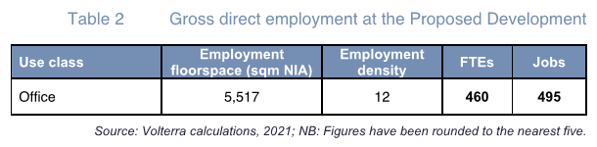

End use phase:

In order to ensure Camden residents are able to benefit from employment opportunities from the additional jobs provided by the development the Council would secure an end-use employment and training package as part of the Section 106 agreement:

* Supportthe [Good Work Camden](https://blog.wearefuturegov.com/good-work-camden-6c50698562f) programme, and promote amongst end use occupiers, including the following:
  + Advertise vacancies in partnership with Good Work Camden and its relevant local employment support providers to create pathways into knowledge economy jobs
  + Promote employee mentoring and volunteering within Camden
  + Commitment to attend job fairs to promote opportunities to local residents
  + Commitment to providing supported employment opportunities – e.g. supported internships.

Mixed use policy and residential accommodation

6.13 Policy H2 promotes a mix of uses in new developments, including a contribution to the supply of housing. In the Central London Area, where development involves additional floorspace of more than 200sqm (GIA), the Council requires 50% of the additional floorspace to be provided as self-contained housing. This is required to be provided on site, particularly where 1,000sqm (GIA) of additional floorspace or more is proposed. The proposed development would involve an uplift of 2,703sqm of office (class E) floorspace which generates a requirement for 1,352sqm of the overall uplift to be provided as self-contained residential housing.

6.14 The first part of Policy H2 provides a set of criteria which will be considered when determining whether self-contained housing is required as part of a mix of uses. These include:

a. the character of the development, the site and the area;

b. site size, and any constraints on developing the site for a mix of uses;

c. the priority the Local Plan gives to the jewellery sector in the Hatton Garden area;

d. whether self-contained housing would be compatible with the character and operational requirements of the proposed non-residential use and other nearby uses; and

e. whether the development is publicly funded or serves a public purpose.

6.15 The proposed development does not include any on-site housing. The applicant did explore the provision of housing on site at pre-application stage, but discounted it for the following reasons:

* The London Plan recognises that new residential development should not compromise the strategic function of the CAZ and offices and other functions.
* Headlease restrictions (from City of London who are the freeholder) that prohibit residential use on site. The lease as outlined explicitly states that “not without the consent in writing of the Landlord such not to be unreasonably withheld or delayed to use the Premises otherwise than as offices within B1 (Business) of the 1987 Order and purposes ancillary to such use provided that no part of the premises shall be used for residential purposes or as a hotel.”
* Minerva House is listed and due to the nature of the existing structure there is potentially extensive remodelling works to the structure to accommodate new flats which would have significant impacts to the Grade II listed building.
* The proposed development is not proposing major demolition and any residential development would need to work within the constraints of the existing building.
* There is limited existing level access and if residential was to be included there would be reduced accessibility in comparison to a standalone residential development. There is currently insufficient pavement on mews for a dedicated pedestrian entrance.
* The mews also provides a hostile environment for residential use accessed via a long approach past shuttered service entrances and other dead ‘back-of-house’ frontages associated with commercial uses (there being no existing residential in the whole of the mews currently) and manoeuvring heavy goods vehicles during the daytime.
* One most notable key internal consideration is the differing floor plate levels between the two adjacent buildings. Any unification to accommodate flats will require significant structural work across both sites.
* The floorplates would be inefficient, and the quality of the new flats would be reduced.
* There is no opportunity on site to include the amenity and play space requirements for residential dwellings. To incorporate amenity, extensive works would be required to the listed and significant facades.
* The residential units would be single aspect.
* There would be inefficient daylight to the new flats.
* There are differing regulatory requirements regarding fire safety between office and residential which provides further constraints.
* Secure by design implications between the commercial and residential units requiring multiple entry points and cores.
* The overall quality of the residential accommodation would be poor.
* Impacts at basement level by introducing residential elements such as requirements for cycle parking.
* Additional plant in addition to what is required for the office, would be required for the residential and due to the limited space within the basement, more extract and plant would be required to be located on the roof which in turn would impact upon the surroundings.

In addition to the physical constraints, providing residential development at this site will:

* Fragment ownership where the units are for sale. Different management structures for the commercial and residential elements are required, even if the residential units are retained for rent.
* Increase costs associated with the need for separate entrances and servicing.
* Providing residential and office will create inefficiencies in the building itself, increasing service charges and creating opportunity costs.

6.16 Residential floorspace could theoretically be incorporated on site, and as such Policy H2 would apply (the scheme is not exempt from providing housing). It is however recognised that due to the reasons above that on-site housing would be difficult to achieve in this instance. Introducing residential would decrease the level of office floorspace (including affordable office) provided and may also compromise the office floorplate. The principle of this would likely be a concern for office tenants, and it would likely cause amenity issues in terms of any potential service programme for the building, reducing the attractiveness of the office space and likely making the development unviable (see below).

6.17 The second part of policy H2 considers whether housing should be provided on-site or off-site, or as a payment in lieu (PIL) and states that the following additional criteria will be considered:

f. the need to add to community safety by providing an active street frontage and natural surveillance;

g. the extent of any additional floorspace needed for an existing user;

h. the impact of a mix of uses on the efficiency and overall quantum of development;

i. the economics and financial viability of the development including any particular costs associated with it, having regard to any distinctive viability characteristics of particular sectors such as build-to-let housing; and

j. whether an alternative approach could better meet the objectives of this policy and the Local Plan.

6.18 In this case, the key issues relate to criteria (h) to (i) and in particular the economics and financial viability of the development. The developer raised concerns as to the impact on economic feasibility of the overall development if a proportion of the floorspace is provided as residential. A Financial Viability Assessment (FVA) has been submitted with the application to demonstrate the viability of the scheme which shows that the office-only scheme is not viable.

6.19 The FVA has been audited by BPS, the Council’s independent viability consultants. BPS conclude that the scheme would be in deficit, with the office scheme producing a deficit of £6.3m and therefore cannot theoretically provide any housing/affordable housing contribution. A mixed-use scheme would most likely lead to an even larger deficit and compromise the design and layout of the office building. Notwithstanding this, the applicant has recognised the need for housing in the London Borough of Camden and has offered a housing contribution despite the scheme being in deficit. When questioned why the developer is willing to proceed with the proposals given the office-led scheme is still shown to be in deficit, they confirmed they are willing to take the risk on future value growth as the deficit may reduce over time. The provision of an upfront payment would be in lieu of a viability review.

6.20 The applicant’s team (DP9, DS2 and Allisop) have reviewed the potential options of how housing could be provided. Having considered all available options, it was concluded that a financial payment in lieu of £2,027,250 made directly to Camden Housing team would be the most appropriate as it is the only practical and available option in line with the borough’s sequential test.

6.21 The PIL was calculated as per the Council’s Housing CPG:

* Total addition to floorspace proposed = 2,703 sqm GIA
* Self-contained housing floorspace target 2,703 sqm x 0.5 =1,351.5
* On-site addition to self-contained housing floorspace = 0 sqm GIA
* Self-contained housing shortfall (=target in this scenario) = 1,351.5
* Total payment in lieu of self-contained housing (shortfall GIA x £1,500psqm)

= **£2,027,250**

6.22 This compliant payment would be secured via S106 legal agreement.

6.23 As to whether the residential requirement should be provided off-site, given there is no surplus in the scheme, officers agree there is no potential for the developer to acquire an alternative property to provide the residential element. This has been demonstrated by a search for appropriate sites undertaken by the applicant which found that all the sites considered were either constrained in terms of development opportunity or were in existing (non-residential) use that was afforded policy protection, such as offices. The difficulty of finding additional sites to provide off site housing is also noted in the Housing CPG (para 5.28) “in recent years opportunities to acquire potential delivery sites at relatively low costs have diminished, and it has no longer been possible for developments to meet initial off-site targets in full”.

Provision of affordable workspace

6.24 Policy (E2(f)) requires the inclusion of "floorspace suitable for start-ups, small and medium-sized enterprises, such as managed affordable workspace where viable". Para 5.40 of the Local Plan states “where premises or sites are suitable for continued business use, the Council will consider higher intensity redevelopment schemes which improve functional efficiency, maintain or, preferably, increase the amount of employment floorspace and number of jobs and provide other priority uses".

6.25 CPG employment sites and business premises (January 2021) states that the Council will seek to secure an element of affordable SME workspace from large scale employment developments with a floorspace of 1,000 sqm (GIA) or more. Paragraph 37 of the CPG defines affordability as 20% of floorspace at 50% of market values. Paragraph 38 of the CPG states that the Council will also consider alternative suggestions for providing affordable workspace.

6.26 The uplift would exceed 1,000 sqm (GIA) and as such provision of affordable workspace is required. The DS2 FVA appraisal includes 10% of the uplift in workspace as affordable workspace which equates to 1,477 sq ft NIA. A 25% discount to this space was applied. BPS recognise that there is “no specific affordability requirements for affordable workspace in Camden”. They consider the valuation to be appropriate on the basis that the space will be provided at a 25% discount. On this basis, the Applicant is proposing to provide a 10% provision on the net uplift at a 50% discount for a period of 10 years. Given the scheme is in a significant deficit, the offer is considered acceptable and appropriately prioritises meeting a 50% discount (as opposed to 20% of the uplift in floorspace).

First Homes

6.27 The national First Homes policy has now come into effect for developments that trigger an affordable housing contribution. First Homes are a new type of discount housing for sale. National policy indicates that First Homes should form 25% of the affordable housing sought in a development, and that where a payment in lieu (PIL) is sought in place of affordable housing, 25% of the value should be used to deliver First Homes. However, the Council has adopted a Planning Statement on the Intermediate Housing Strategy and First Homes, which indicates that First Homes in Camden would not be affordable to median income residents, and consequently First Homes will not be sought in the borough. Having regard to the national and local policies relating to First Homes, any funds arising from PIL and deferred affordable housing contributions are expected to contribute to the Council's preferred affordable housing types identified by Local Plan Policy H4 and CPG Housing 2021, namely social-affordable housing and intermediate rented housing.

Conclusion

7.28 Given the location of the site within the CAZ and Knowledge Quarter and the existing office use of the site, the refurbishment and intensification of office use is considered appropriate in this location, and the development would contribute towards a successful and inclusive economy. Although no market or affordable housing is provided due to a lack of viability, the applicant will appropriately make a policy compliant financial payment in lieu of £2,027,250 while also offering to provide affordable workspace (a 10% provision on the net uplift at a 50% discount for a period of 10 years). On this basis, the development accords with the Camden Local Plan and the London Plan and is acceptable in this regard.

**7 Design and Conservation**

7.1 The Council’s design policies are aimed at achieving the highest standard of design in all developments, including where alterations and extensions are proposed. Policy D1 of the Local Plan requires development to be of the highest architectural and urban design quality, which improves the function, appearance and character of the area; and Policy D2 states that the Council will preserve, and where appropriate, enhance Camden’s rich and diverse heritage assets and their settings, including conservation areas and listed buildings. Camden’s Local Plan is supported by CPG (Design) and the Bloomsbury Conservation Area Statement.

Site

7.2 The site comprises of two office buildings facing North Crescent, originally built in 1912. Both buildings currently consist of a lower ground, ground + three levels, with an overall GIA of approximately 5,514sqm. Minerva House (west) is a Grade II listed building designed by George Vernon. Telephone Exchange is not listed, but is highlighted as a building of significance to the Bloomsbury Conservation Area. Due to the setback nature and Eisenhower Centre at the front, public views of the proposal are limited to Chenies Street and Alfred Place from the south and along Alfred Mews to the north, whilst glimpsed views are possible from both sides from Tottenham Court Road.

Site context

7.3 The site is located in the Bloomsbury Conservation Area. The adopted conservation area appraisal (2011) identifies 5 North Crescent, 11 Chenies St, Fitzroy House and the Eisenhower Centre as making positive contributions to the area. Bloomsbury is noted for its formally planned arrangement of streets and the contrasting leafy squares. There are a range of building types evident across the conservation area, although the predominant type is the terraced townhouse. Roofs are commonly defined by parapets, giving strong and consistent roof lines; the most widespread roof forms are butterfly roofs behind parapets or mansards where there is habitable attic space.

Overview

7.4 The proposal seeks to retain and enhance the existing buildings, working with many of their existing qualities whilst making additions and modifications where necessary. The design principles of the proposal are centred on a sustainability agenda, having being considered through a Whole Life Carbon Assessment to assess embodied and in-use carbon.

7.5 The proposal involves the removal of the non-original mansard to Telephone Exchange along with the unsightly rooftop plant and core. This is replaced with a new 3rd floor, and one additional storey added across Telephone Exchange on the southern frontage, extending to the west above the rear of Minerva House and to the north so that the frontage of Telephone Exchange to Alfred Mews becomes 5 storeys. This additional 4th floor is set back at the south in order to reduce overall massing and establish subservience to existing façades. To the north, the top 2 floors are set back from Alfred Mews. Above this a plant area is shaped to respond to the crescent to the south and set well in from the building edges.

7.6 Internally the approach is to restore Minerva House to its original form as much as possible, removing much of the poorly considered recent interior. Within Telephone Exchange, much of the existing structure is retained, including all structural floors. The core (lifts, stair, servicing) is located in the existing lightwell to facilitate this. To provide access to both Minerva House and Telephone Exchange, portals in the party wall are provided. This delivers an efficient floorplate, also enabling Minerva House floors to be restored via the removal of a retrofitted core and WCs. Each office floor benefits from clear views to the north and south whilst ensuring good daylighting throughout. Other internal changes use methods such as ‘soft core’ construction and design for disassembly with bolted steel connections, thereby employing a circular strategy. This enables future modification with little demolition and waste, or ‘asset reversal’ should that be desired.

Height

7.7 The existing height of Minerva House is 4 storeys above ground with a basement beneath. The existing height of Telephone Exchange is 4 storeys above a semi submerged lower ground floor facing south, and 2 storeys facing on to Albert Mews on the northern edge. The surrounding buildings on Tottenham Court Road vary in height from five to seven storeys, whereas the buildings on Chenies Street opposite the site range from four to seven storeys. Frequently the fourth, fifth or sixth storeys are set back. On Albert Mews, the neighbouring building at the eastern end is 3 storeys with 4 storey no.8 Alfred Mews opposite.

7.8 In this context, the proposed 5 storey height to Minerva House and the proposed 5 storey height with setback upper levels to Telephone Exchange are considered to be appropriately scaled to sit comfortably.

*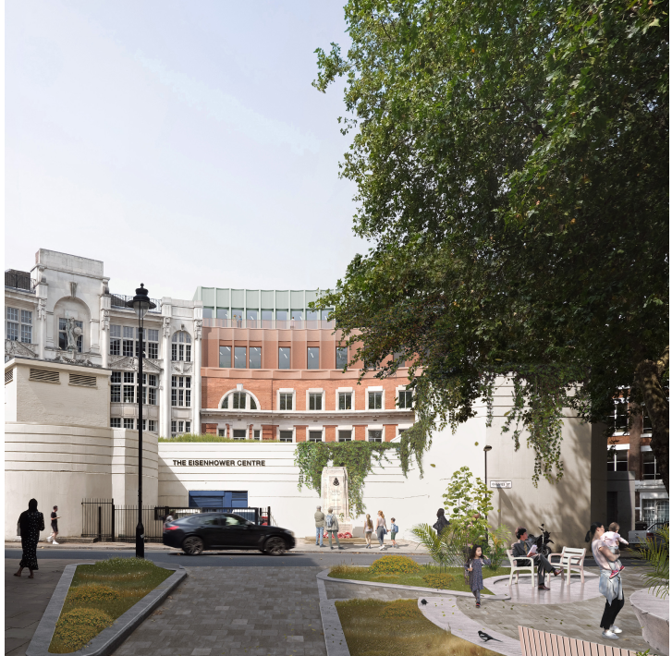Proposed front elevation*

Street level

7.10 The proposals create a ground level that is accessible and flexible in its arrangement. At present, Telephone Exchange does not provide universal access. Therefore, by laterally connecting the two adjacent buildings universal southern access can be provided. The design provides both ramp and stair access in the form of an amphitheatre stair which incorporates seating, exhibition space, biophilic design and a ‘stage for the new.’ An open plan arrangement is proposed to enable potential semi-public uses such as exhibitions and pop-up cafe spaces, whilst reducing impact of the secure line of a commercial reception. The creation of activity at ground level will positively address the street and improve the sense of overlooking that benefits security along the crescent.

Architecture

7.11 The proposals are based on the sustainable efficiency of any additions employing modular and lightweight construction where possible. Reflecting the surrounding context, as the building rises, a lighter ‘roof’ expression of set-backs and muted materials is utilised.

7.12 The alterations to the North Crescent façade to Minerva House are limited to replacement of glazing and doors within the existing fabric. These are considered to be sensitively handled and improve on the existing condition, particularly around accessibility. To the north, high level existing railings are removed and a new 4th floor created which broadly matches the height of the western neighbour. This has been detailed with a language of piers and lintels and openings aligned to the existing windows beneath.

7.13 Facing on to North Crescent, the proposals for Telephone Exchange build on the elegant proportions and heights of elements evident in the existing classically inspired architecture beneath. The new 3rd floor, replacing the existing non-original mansard, follows the curve of the brickwork beneath with punched windows that align with those existing below. Detail is added through a scalloped profile to the new frontage. Elements, such as the expressed lintel above the windows and horizontal banding of smooth finish GRC subtly reference features within the existing building. Above this, the new 4th floor is set back to reduce impact and provide a generous terrace for outdoor amenity. The south facing façade of this floor is also scalloped, however at this level a finer grain of texture is introduced to differentiate this as a roof element.

7.14 The northern façade to Telephone Exchange facing onto Alfred Mews also utilises the existing façade to inform the extension. The new elements consider the openings, lintels and piers of the existing to form a complimentary response. The expression here is much more utilitarian and functional in comparison to the Crescent side. By using this strategy, each character retains its own expression and language, carefully responding to the existing façade. The new 2nd floor is closest in character to the existing ground and first floors. Above this, the building steps back from the existing façade line with two further levels that follow the façade arrangement below and includes the piers and expressed lintels found in the existing building, but in a more contemporary aesthetic and material.

7.15 Above the 4th floor, a new level of external plant is proposed. This is screened in a complimentary finish, and well set back from all sides. To the south facing elevation, the enclosure follows a crescent form that reflects the building below and reduces visual impact from the street.

Materials

7.16 The lower frontage of Minerva House facing on to Alfred Mews is to be improved through new sensitively proportioned glazing frames and repairs to existing brickwork where required. Above this a light grey textured GRC frontage that provides a restrained addition viewed obliquely from the street. As elsewhere within the new elements, the external materials have been selected to be lightweight, and therefore efficient in material usage and impact on existing structure.

7.17 For the frontage of the Telephone Exchange fronting on to North Crescent the replacement 3rd floor is clad in curved GRC panels in a lightly textured red finish to reflect the existing brickwork below. The new 4th floor is clad in green coloured vertical ribs picking up the colouration of copper roofing that is found frequently in the locality.

7.18 Similar to the crescent, the extension of the Mews façade has been developed as a combination of bespoke GRC panels that achieve the piers and lintels with aluminium accent details. The proposed form utilises a shallow façade depth in response to its North facing orientation. The new 2nd floor is coloured to relate to the existing brickwork, which will be cleaned and repaired where required, whilst the upper levels will be green as per the upper level of the southern façade. Again, scalloped profiles are used throughout at varying scales. The existing, non-original, windows are to be replaced with efficient and well-proportioned aluminium framed double glazing throughout with openable sections to provide natural ventilation.

7.19 The plant screen to the top of Telephone Exchange will not be visible in critical views, however, follows the language found beneath. The scallop frequency of the bespoke aluminium panels respond to the building below. Therefore, on the crescent, the scallop is of a larger, calmer format. Contrastingly, the mews side utilises a high frequency scallop to mimic the details below and reflect its industrial history.

7.20 Concern has been raised by residents of 1-9 Huntley Street, Bloomsbury Terrace or ‘Mayne House’ (east of the site) regarding the design of the east elevation of the 3-storey extension and the potential impact to their visual amenity. The applicant relocated the plant equipment away from the east elevation to address concerns and has also been in discussion with residents about the detailed design options for this element of the scheme. The current proposal which shows the façade being treated with a white glazed brick has evolved from the discussions although does not resolve the residents’ concerns. Whilst officers feel the proposed design and material is not fundamentally objectionable as currently indicated, the applicant and residents have confirmed that they are still in active discussion about alternative options which might further mitigate the concerns of residents. In view of this a condition is proposed which allows for the submission of final details of this element of the scheme. The condition requires the applicant to engage with local residents in working up the final detailed design of the east elevation of the development.

Views

7.21 The impact of the proposals have been considered from a number of vantage points.

7.22 From Tottenham Court Road, the site is glimpsed to the northern elevation along Alfred Mews. The additional 2nd floor on Telephone Exchange will be the most noticeable change, however this will be within the general height of buildings within the Mews. The recessed upper floors to both buildings will be less visible and recessed to the viewer as they are well set back from the frontage.

7.23 Once within the Mews, the increase in height is more apparent, however considered to be appropriate and comfortable within the existing setting. The narrowness of the space allows only oblique views at street level which reduces the opportunity to recognise the taller façade elements beyond.

7.24 The proposed alterations to the south are primarily visible from the west and south. Views from the east are limited by existing tree canopies and the curve of the crescent. As seen from the west on Tottenham Court Road, the proposals improve the perception of the buildings through the removal of the mansard and unfortunate rooftop structure. The unified crescent is more pleasing to the eye and gives an appropriate scale to the roofscape as seen over the top of the Eisenhower Centre.

7.25 Any views from the south looking north up Alfred Place will be partially obstructed by the significant trees along this street. As per the western view, the proposal is considered to improve these views by removal of the existing rooftop elements and improved balance in the proportion in the visible scale of the roof seen against the height of the building.

7.26 It is considered that whilst some loss of original fabric would result from works to the listed building, the removal of later additions such as the retrofitted core and WCs have allowed its significance to be better revealed internally. Furthermore the roof extensions and other additions to Minerva House and Telephone Exchange have been designed sensitively, and revised where necessary during the course of the application, so as to respect the existing architecture of both these buildings. It is therefore considered that assessed as a whole there has not been any overall harm arising from the scheme to the relevant heritage assets. However, should for any reason a different judgement be reached with regard to the historic building interventions and potential sources of harm, it is considered that any such harm caused to the conservation area or listed building(s) could only be likely to be at the low end of the scale under the ‘less than substantial harm’ category, and therefore, would be outweighed by the public benefits the development brings forward which would include a £2 million contribution towards housing in the borough, affordable workspace and a wider employment and training package.

Certificate of Immunity from Listing (COIL)

7.27 This application was originally scheduled to be heard at planning committee on 4th August 2022, but was withdrawn from the agenda at the meeting because an application was made for listing of 5 North Crescent and 11 Chenies Street.

7.28 In response, the applicant also applied for Certificates of Immunity from Listing for both properties. Historic England have carried out their assessment and have confirmed that they do not intend to list either property and will be granting Certificates of Immunity from listing for 5 North Crescent and 11 Chenies Street (this may already have occurred by the time this case is presented at planning committee).

Conclusion

7.28 Subject to the recommended conditions, the proposals would be sympathetic and of a high standard of design quality and materiality which would preserve the character and appearance of the buildings and their contribution to the character of the conservation area. The proposals would preserve the special architectural and historic interest of the listed building (Minerva House) also cause no significant harm to the setting and significance of nearby listed buildings.

7.29 Special regard has been attached to the desirability of preserving the listed building and its features of special architectural or historic interest, under s.66 of the Planning (Listed Buildings and Conservation Areas) Act 1990 as amended by the Enterprise and Regulatory Reform Act (ERR) 2013.

7.30 Special attention has also been paid to the desirability of preserving or enhancing the character or appearance of the conservation area s.72 of the Planning (Listed Buildings and Conservation Areas) Act 1990 as amended by the Enterprise and Regulatory Reform Act 2013.

**8 Impact on Neighbouring Residential Amenity**

8.1 Policies A1 and A4 of the Local Plan seek to protect the amenity of Camden’s residents by ensuring the impact of development is fully considered and would not harm the amenity of neighbouring residents. This includes privacy, outlook, noise, daylight and sunlight.

Light

*Chenies Street Chambers*

8.2 The Applicant has undertaken a daylight and sunlight assessment in accordance with the BRE guidelines ‘Site layout planning for daylight and sunlight 2022’. In relation to Chenies Street Chambers, as set out in the submitted report, a total of 96 windows serving 78 rooms have been assessed for daylight within this property. The VSC (Vertical Sky Component - daylight) analysis has found that all 96 windows will meet the BRE’s daylight criteria. 74 of the 78 rooms will meet the NSL (No Skyline) assessment.

8.4 Of the four rooms that will fall below the NSL target, three will experience minor impacts, with percentage alterations of between 20.3% and 24.4%. It is unlikely that these would amount to perceptible losses in daylight amenity, considering the windows will meet the VSC criteria. Any perceptible loss that may occur, would be minor in nature.

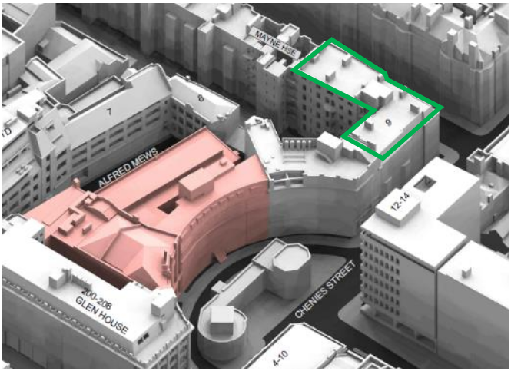8.5 Just one room that falls below the NSL target (R1/70, which appears to be a less sensitive bedroom) will experience a 33% change in NSL, falling from 78% to 52% of the room area. The window serving this room will not experience a change in VSC of more than 20% it’s former value (suggesting it will not be perceptible and meeting the recommended VSC criteria). This window will also retain a VSC of 20% absolute terms, which is considered common in a city centre site such as this. For example, an obstruction angle of c. 40 degrees (which equates to a VSC of 18%) is acknowledged as common in historic city centre locations by the BRE in Appendix F, paragraph F4 of the guidelines. Therefore, whilst it is possible there may be a perceptible change in light to this room, any change is likely to be small. In consideration of this, it has been concluded that the property will not experience a material alteration in light as a result of the Proposed Development.

Chenies Street Chambers (highlighted in green)

*Mayne House/ Bloomsbury Terrace*

8.6 Based upon architectural floor plans obtained for this property (and external observation), all windows facing the Site serve either non-habitable bathrooms or circulation spaces or serve secondary bedrooms. All flats in this development are dual aspect with the main living spaces remaining unaffected by the development.

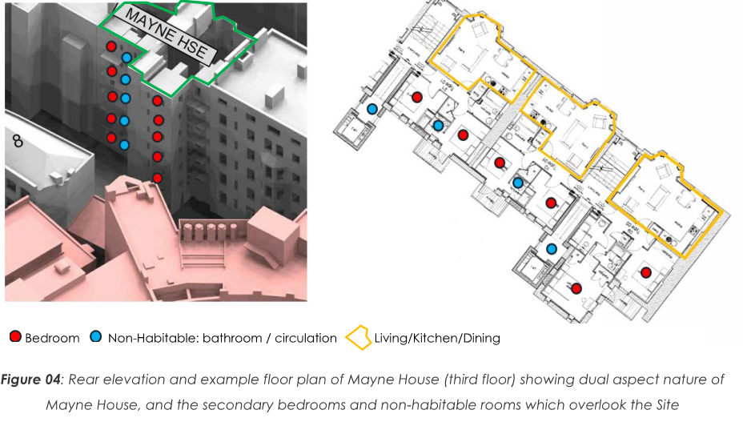

8.7 Alterations in light to bedrooms are considered less significant than losses to living rooms, kitchens, or dining rooms, as set out in the BRE Guidelines (see BRE paragraph 2.2.8: ‘Bedrooms should be analysed although they are less important’).

8.8 Of the 59-bedroom windows assessed for VSC, analysis found that 50 windows will experience negligible alterations in sky visibility (VSC), either achieving a VSC in excess of 27%, or alterations of less than 20%.

8.9 Where there are large percentage changes in NSL (Daylight Distribution) they are to secondary bedrooms that have very low existing levels, which are therefore susceptible to fairly low level changes in usable light equating to seemingly larger changes in percentage terms. However, in this case it’s almost certainly a case of already poorly lit secondary bedrooms in the existing context which rely on electric light (based upon the existing NSL analysis), getting a little darker. As stated above, the principal rooms (living/dining etc. facing onto Huntley Street) will not be affected.

*Adequacy of daylight/sunlight report (response to objection comment)*

8.10 Certain objection comments received raised concern over the adequacy of the submitted daylight/sunlight report. Officers are satisfied with the submitted daylight/sunlight report. All technical analysis undertaken by Avison Young was based upon a 3D, laser scan measured survey model produced by an independent survey firm, MSA Surveys. This accurately captured all windows in this property which face the proposed site. Using this data set, Avison Young ran VSC (Vertical Sky Component) daylight, and APSH (Annual Probable Sunlight Hours) sunlight assessments, each of which is calculated at the window – the room layouts are not relevant for these calculations.

8.11 Room layouts are used for the second daylight test – the NSL (No Sky Line) assessment. The room layouts used by Avison Young are based upon floor plans obtained from public records. Avison Young did not gain access to this property prior to undertaking their study, as this is not a usual requirement for a Daylight/Sunlight assessment, due mainly to the fact the VSC and APSH assessments are calculated at the windows.

8.12 Avison Young’s analysis found that of the 96 windows tested for VSC, all (100%) will meet the BRE criteria. The majority of windows will also meet the APSH criteria, with a small number of windows falling below the APSH target criteria, largely influenced by their location and orientation, which afford low levels of sun hours in the existing scenario. The minor losses caused by the proposal are not considered by Avison Young to be significant or unusual.

8.13 Whilst it is acknowledged some of the labelling of floors may not mirror the actual floor labelling, all windows have been assessed, and it will not alter the conclusions of Avison Young’s report. Where rooms labelled as ‘unknown’ may be living spaces, the results have been included in the report. The VSC and APSH results will not change.

8.14 Avison Young do not refer to ADF in relation to this building in their report. ADF is however run as standard in Avison Youngs technical appendices. Where Avison Young have referred to ADF (Average Daylight Factor) in relation to 1-9 Huntley Street in their report, it is purely as an additional supporting narrative to the VSC and NSL daylight tests. Avison Young also clearly state that ADF is not recommended by the BRE when assessing neighbouring properties, and that it was run due to the fact floor plans had being obtained. Reliance on the ADF analysis here is not required nor suggested. It does however confirm that the ADF values as a result of the development would not be significantly affected.

8.15 In summary, the VSC and APSH analysis indicates that any loss of daylight amenity to this building will either meet the BRE criteria or be minor (not significant) in nature.

*Daylight/sunlight conclusion*

8.16 Overall, the results of the daylight and sunlight analysis indicate that the majority of windows and rooms tested within the neighbouring properties will satisfy the recommended BRE Guidelines values for sky visibility (VSC) and daylight distribution (NSL). In addition, many of those that fall below the recommended BRE values either represent minor deviations; relate to less sensitive bedroom or non-habitable/secondary spaces (including ‘non-habitable’ small galley kitchens of less than 13 sq m); or arise due to the inherent design constraints of the buildings concerned.

8.17 Whilst there will be some isolated windows in Mayne House which will experience some perceptible alterations in daylight and sunlight amenity, the losses are in the majority of cases minor in nature and only affecting bedrooms which are considered less sensitive rooms. The main living spaces in these properties will remain wholly unaffected.

8.18 The daylight and sunlight impact to Chenies Street Chambers is also limited. Where there are isolated impacts that fall below the baseline BRE target criteria, they are considered to be minor in nature, with the majority of windows and rooms meeting the BRE’s target criteria.

Outlook

8.19 Outlook is the visual amenity enjoyed by occupants when looking out of their windows or from their garden. How pleasant an outlook is depends on what is being viewed. For example, an outlook onto amenity space is more pleasant than an outlook across a servicing yard. Any unpleasant features should be screened if possible.

8.20 The front windows of the nearest residential properties (Chenies Street Chambers and Mayne House) which contain the main living spaces of the flats would remain unaffected by the proposal. The rear windows currently look out towards the back of Fitzroy House, the rear of the Telephone Exchange, Alfred Mews (a service passage) and an oblique view of the back of the Heal’s building.

8.21 Neighbouring properties are not entitled to specific private views (such as of the Heal’s Building etc), loss of such views are not a material planning consideration. The only views protected in Camden are strategic views from Primrose Hill and Parliament Hill towards St Paul’s Cathedral or views which can be said to contribute to the public appreciation of conservation areas or other designated heritage assets (not a private view out of a rear residential window towards the back of an office building).

8.22 The proposal is of a sufficient distance and limited scale as to not result in an overbearing or dominating effect to the enjoyment of the neighbouring residential properties. Appropriate design efforts have been made to reduce the solidity of the east façade and give it more visual interest without causing a privacy issue. If more glazing was introduced to break up the massing of the flank elevation, then it would likely result in overlooking issues.

8.23 Views from various floors and angles have been considered from Chenies Street Chambers and Mayne House in detail and were presented to residents by the applicant as part of their application consultation. The visual analysis is considered to demonstrate that acceptable outlook levels would be retained (see examples below).

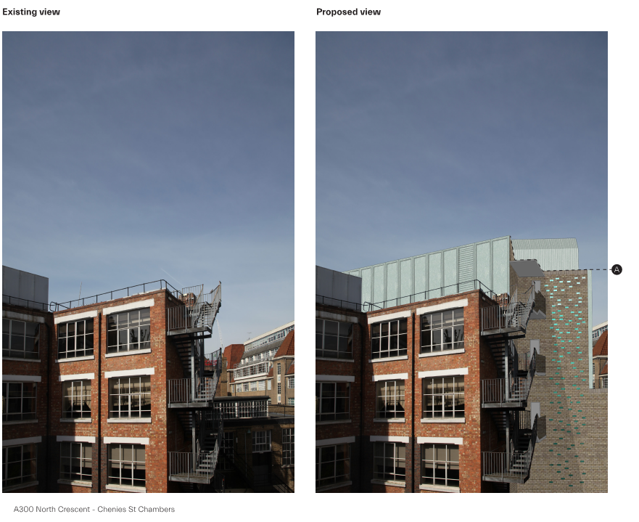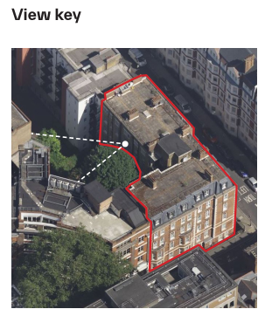*Chenies Street Chambers outlook*

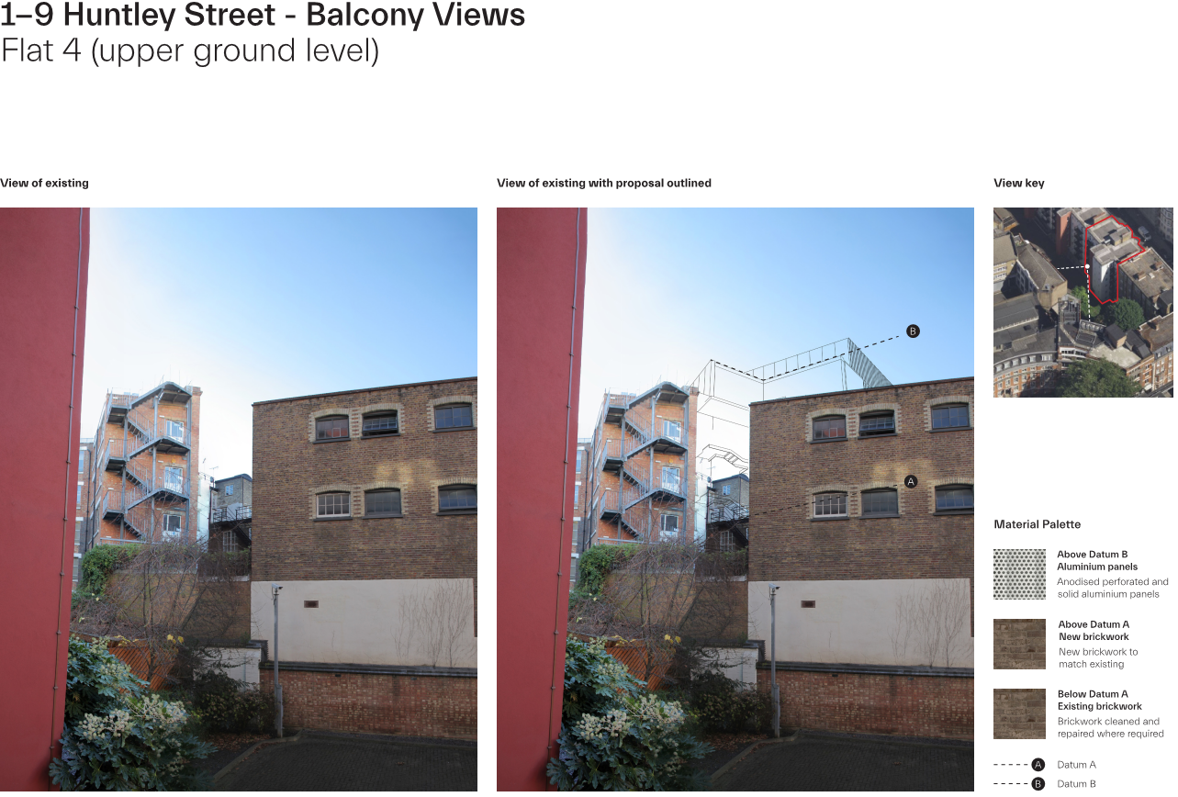

*Mayne House outlook*

Privacy

8.24 The design of the proposed development has actively considered the East façade which is in the closest proximity to the neighbouring residential properties. The proposal does not include any windows or other glazing on this façade to ensure that overlooking does not occur.

8.25 The new terraces would be located more than 18m from the residential windows which is the minimum distance recommended in Camden’s Design CPG for directly overlooking neighbouring windows. They would also face North (as opposed to East towards the nearest residential windows). As such, the proposals would not materially increase perceived overlooking or result in a loss of privacy to neighbouring flats.

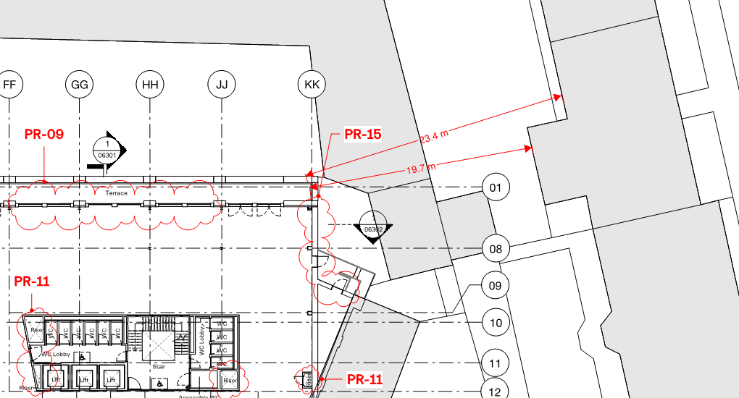

*Third floor proposed plan*

Noise and disturbance

8.26 The proposals include the installation of the following plant (roof and basement):

• 2 Office Air Handling Units – Office hours operation only,

• 1 Chiller – Office hours operation only,

• 1 Heat Pump – Operating 24/7

• 2 DX Units – Operating 24/7

• 1 Basement Air Handling Unit – Operating 24/7

• 1 Smoke Extractor Fan – Operating 24/7

• Tenants plant area – Operation 24/7

8.27 There is an allowance for Tenant’s plant at the North-West Boundary of the Telephone Exchange. The proposed plant will be screened at the edge of the roof boundary. The east part of the screen is proposed the be a solid barrier with a minimum height of 3.15 metres, relative to a maximum plant height of 2.63 metres, the remainder of the screen will be made of 500mm acoustic louver with a minimum height of 3.15 metres.

8.28 Appropriate noise guidelines have been followed within the report such as Noise Policy Statement for England, National Planning Policy Framework (NPPF), Planning Practice Guidance on Noise, Camden Council’s Local Plan, version June 2017 and BS 4142:2014.

8.29 The assessment indicates that, with suitable attenuators in place on the proposed chiller and AHU1 on Telephone exchange, the rating level of the plant is likely to comply with the Camden Council criteria of 10dB below the lowest existing background sound level LA90,15mins. Where specific plant selection is not available a noise level recommendation has been made and therefore are acceptable in environmental health terms for noise and vibration (as confirmed by the Council’s environmental health officer).

8.20 The proposals would introduce new terraces to the rear of the site at 3rd floor level and to the front at 4th floor level for use by office staff. Due to the size of the external spaces and the potential numbers of staff they could accommodate, it is proposed to restrict their hours of use to no later than 9pm (condition 10) to ensure they didn’t result in excessive noise disturbance.

8.31 The proposals are therefore acceptable in Environmental Health terms subject to conditions securing plant noise standards and anti-vibration measures (conditions 7 and 8) and terrace hours of use (condition 10).

Amenity Conclusion

8.32 The proposed development would not have a significant effect on the daylight and sunlight amenity levels within the residential properties facing the application site. There would be very limited impact on neighbouring outlook, and the proposals would not cause harm by way of loss of privacy or noise disturbance subject to the suggested conditions. As such, the proposals are considered to accord with policies A1 and A4 of the Local Plan.

**9 Basement Development**

9.1 The Council’s approach to basement development is set out in Local Plan policy A5. This requires evidence of the impact of basement schemes in the form of a Basement Impact Assessment to be carried out by appropriately qualified professionals. Basement Impact Assessments must include geotechnical, structural engineering, and hydrological investigations and modelling to ensure that basement developments do not harm the built and natural environment or local amenity. Basement Impact Assessments must be prepared according the specifications set out in our supplementary planning document Camden Planning Guidance on basements and the Camden Geological, Hydrogeological and Geological Study (ARUP 2010).

9.2 The proposed redevelopment works involves the partial demolition of the rear section of the Telephone Exchange, the construction of a three-storey extension up to the fourth floor; and deepening of the existing basement at site. The basement would not be enlarged in plan form and as such accords with the size criteria set out in Policy A5.

9.3 The Basement Impact Assessment has been carried out by Card Geotechnics Limited (CGL) and the individuals concerned in its production have suitable qualifications. Screening and Scoping assessments were presented and supported by desk study information.

9.4 The site is at low risk from flooding from all the sources, and the proposed development will not result in an increase in hardstanding areas. A SuDS Strategy has been presented to ensure that the surface water run-off will be managed in accordance with the Council’s guidance.

9.5 A site investigation has been undertaken indicating the basement will be constructed within the Lynch Hill Gravel Member. A construction method statement and ground movement assessment should be presented in a Basement Construction Plan (BCP) which confirm structural and temporary works proposals and the findings of an additional ground investigation.

9.6 Two different conceptual models are presented in the BIA and in the Geotechnical and Geoenvironmental Factual & Interpretative report. The conceptual model should be confirmed in the BCP once the additional ground investigation is complete.

9.7 The BIA states that groundwater is likely to be encountered during excavation works and means of dewatering/groundwater control are suggested. There will be no impact to the wider hydrogeological environment.

9.8 Subject to the submission of a satisfactory Basement Construction Plan it is confirmed that the BIA meets the requirements of Policy A5 of the Local Plan and CPG Basements. The submission of a Basement Construction Plan is to be secured via S106 legal agreement.

**10 Transport**

Introduction

10.1 The 1-4 and 5 North Crescent site comprises two existing buildings: Minerva House and the Telephone Exchange. The proposal would upgrade and enlarge the existing buildings. A Transport Assessment (TA), framework Delivery and Servicing Plan, framework Construction Management Plan (CMP) and a Travel Plan have been submitted in support of this application.

Trip generation

10.2 The applicant has assessed the uplift in trip generation by applying a generation rate for Office use – derived from TRICS software – to the uplift in floor space (about 45%).

10.3 The net impact of the development is an increase of 589 daily trips (81 in the AM peak and 75 in the PM peak) which is considered to be within acceptable limits.

Car parking

10.4 No car parking is proposed. Car-free development is to be secured via S106 legal agreement.

Cycle parking

10.5 Cycle parking should comply with CPG Transport and the London Cycling Design Standards (particularly Figure 8.1). Included in the requirements are that cycle parking should be:

* Close to the entrance of the property and avoiding obstacles such as stairs, multiple doors, narrow doorways (less than 1.2 metres wide) and tight corners;
* Conveniently located, with step-free access from outside and inside; and
* Any door to a cycle parking area should be automated – push button or pressure pad operated.

10.6 Cycle parking is proposed in accordance with the London Plan. It should be noted that CPG Transport Clause 8.6 States: ‘…The Council will also seek an additional 20% of spaces over and above the London Plan standard to support the expected future growth of cycling for those that live and work in Camden’.

10.7 The Proposed Development would provide a total of 14 short-stay, 141 long-stay cycle parking spaces as well as 94 lockers and 15 showers. In terms of numbers, this level of provision would satisfy the London Plan and Camden’s standards.

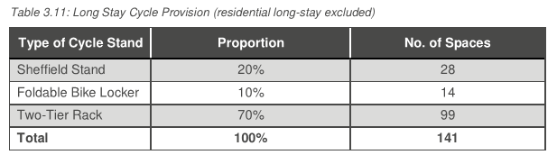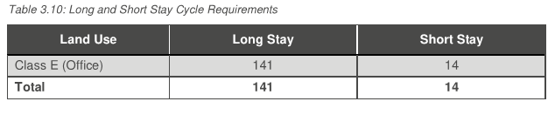

10.8 The TA states that it is proposed to locate Long-Stay cycle parking in the basement with access from North Crescent. Access to accessible spaces would be via Alfred Mews. A condition (12) is attached securing the provision of adequate cycle parking as well as lockers and showers.

Deliveries and servicing

10.9 A framework Delivery and Servicing Management Plan (FDSMP) has been submitted. The estimated number of deliveries is 12 per day. It is proposed to service the two buildings from the rear via Alfred Mews; vehicles up to 8m in length can enter and leave this area in a forward direction. The West End project has imposed restrictions on vehicular access to Tottenham Court Road. Vehicles would therefore need to arrive westbound from Torrington Place and turn left onto Tottenham Court Road, accessing the southbound stretch of the highway that is not part of the restricted access to buses and cyclists, in order to turn left onto Alfred Mews. To depart, vehicles would turn left back onto Tottenham Court Road before turning left again onto Chenies Street to access the surrounding highway network.

10.10 The FDSMP contains measures to control servicing activities including restricted delivery times for vehicles larger than 8m and a requirement for servicing from Alfred Mews. Whilst this is welcomed, there is likely to be a tendency for deliveries to be made to the North Crescent entrances. A Delivery and Servicing Management Plan is to be secured via s106 legal agreement to ensure servicing and deliveries are appropriately managed.

Managing and mitigating the impacts of construction

10.11 The proposed development would likely lead to a number of construction vehicle movements to and from the site. The Council’s primary concern is public safety in addition to ensuring that construction traffic does not create (or add to existing) traffic congestion. There is also the need to ensure that there is no cumulative impact with other developments in the area. The proposal is likely to lead to a variety of amenity issues for local people, such as noise, vibration, dust and air quality.

10.12 A framework CMP has been submitted in support of the planning application. While the information provided in the framework CMP is useful, a more detailed CMP would be required if planning permission is granted. The final CMP would be secured by S106 legal agreement and the full details would need to be submitted and approved by the Council’s Transport Planners prior to any works commencing on site, following further consultation with TfL, local residents, businesses and stakeholders, and the Camden Cycling Campaign; however, officers are satisfied that with careful management, the development can be completed safely whilst minimising disturbance to local residents, business and the road network. The Council would seek to secure a CMP, a CMP implementation support contribution of £28,520 and a Construction Impact Bond of £30,000 as section 106 planning obligation in accordance with Policy A1 of the Camden Local Plan.

10.13 The Council would expect construction vehicle movements to and from the site to be scheduled to avoid peak periods to minimise the impacts of construction on the transport network. This is particularly important due to the location of cycle and pedestrian routes adjacent to the site. The contractor would need to register the works with the Considerate Constructors’ Scheme. The contractor would also need to adhere to the CLOCS standard.

Travel planning

10.14 As detailed previously, there is a large number of predicted trips associated with the development, the majority of these associated with the office use. A draft workplace travel plan has been submitted in support of the planning application. This is welcomed as it demonstrates a commitment to encouraging and promoting trips by sustainable modes of transport.

10.15 A strategic workplace travel plan and associated monitoring and measures contribution of £9,762 is be secured as a section 106 planning obligation. The Travel Plan would be targeted towards the office, to encourage staff to make walking, cycling and travel by public transport the natural choice for day-to-day trips.

Highway works contribution

10.16 The carriageway and footway directly adjacent to the site on is likely to sustain significant damage as a result of the proposed demolition, excavation and construction works required. The Council would need to undertake remedial works to repair any such damage following completion of the proposed development.

10.17 A highways contribution of £61,168.35 is to be secured as a section 106 planning obligation. This would allow the Council to repave the carriageway adjacent to the site, provide new footways along the eastern and western frontage of the building and repair any other damage to the public highway in the general vicinity of the site. The highway works would be implemented by the Council’s highways contractor on completion of the development.

Pedestrian, Cycling and Environmental Improvements (PCE)

10.18 The Transport Statement suggests the development would introduce 589 new work trips to and from the area per day, and the Council aims to encourage walking and cycling as the primary mode of transport for short journeys. To support local Pedestrian, Cycling and Environmental schemes, a financial contribution of £135,000 shall be secured as a S106 planning obligation. This would be spent on improvements and upgrading of the existing cycle lanes in the area and improvements to the safety and visual amenity of the road.

**11 Waste**

11.1 Camden Local Plan policy CC5 (Waste) and Camden Planning Guidance (Design) are relevant with regards to waste and recycling storage and seek to ensure that appropriate storage for waste and recyclables is provided in all developments.

11.1 Waste is currently stored on-street to the rear of the development and is collected daily via Alfred Mews. Facilities Management moves the bins to Alfred Mews for loading prior to arrival.

11.2 Refuse and recycling bins would be provided at ground floor level within an identified storage area to the northern-eastern corner of the site. The storage area would accommodate 5 x 1100 litre bins and 3 x 240 litre bins, space would also remain to the rear of the site. The communal refuse store provides safe and convenient access to the occupants and is located on the ground floor. The store holds specifications are in accordance with Policy CC5 as well as the labelling and area requirements outlined in BREEAM New Construction 2018 credit Wst 03.

11.3 The provision and retention of the proposed refuse store shall be secured by condition (14).

**12 Energy and Sustainability**

Sustainability (BREEAM)

12.1 As this is a major application, an Energy and Sustainability Statement was submitted by the Applicant. This was assessed by the Council’s Sustainability Officer. All main targets are met and exceeded in accordance with Policies CC1 and CC2 of the Camden Local Plan 2017. Planning requirements for the new build non-residential extension is an Excellent BREEAM rating. The site reviewed currently achieves a score of 71.2%, which equates to an Excellent rating.

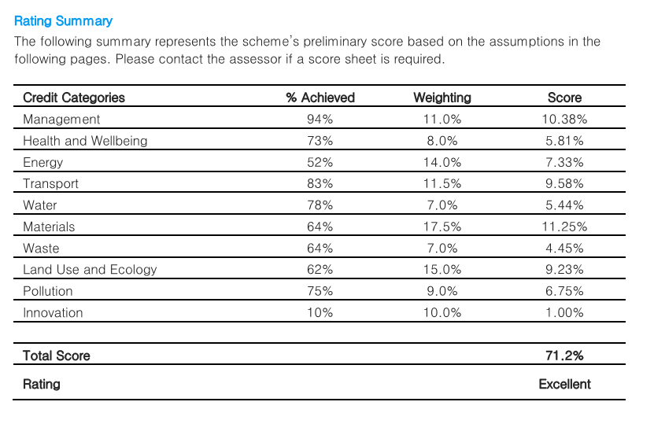

Energy (CO2 reduction beyond Part L 2013)

12.2 Energy Strategy The energy strategy for the scheme is detailed in the Energy Assessment report issued by Thornton Reynolds in June 2021. As shown in Table 1 (below), the new build element of Telephone Exchange will reduce carbon emissions by 22.12% and the refurbished development Minerva House will reduce emissions by a further 27.40% from the fabric energy efficiency measures described in the ‘Be Lean’ section using SAP 10.0 carbon dioxide emission factors, respectively. Total carbon emissions will be reduced by 56.84% and 64.29% over Building Regulations using draft SAP 10.0 carbon dioxide emission factors, respectively, with the further inclusion of a proposed communal air source heat pump and photovoltaic panels. Therefore, the scheme meets and exceeds the target of overall 35% carbon reduction over Part L building Regulations as set out in the London Plan Policy SI2. The scheme also meets and exceeds Policy CC3 requirements from the Camden Local Plan 2017.

12.3 The above targets will be secured via S106 legal agreement through an Energy and renewables plan and a Sustainability plan (BREEAM compliance).

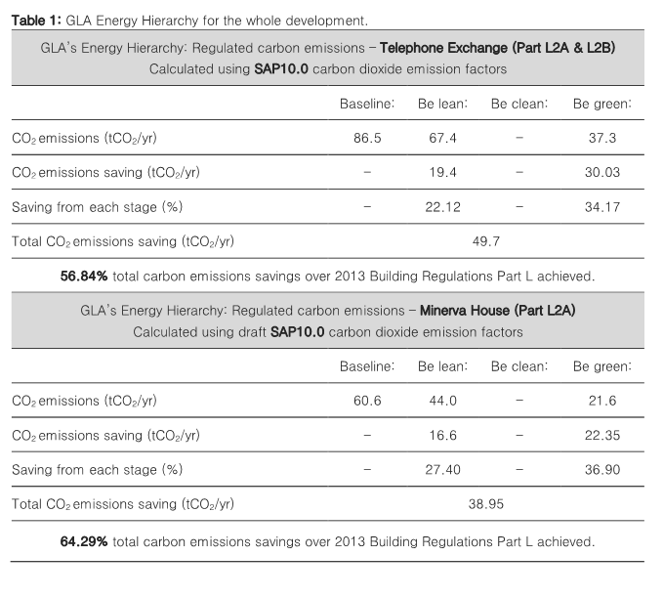

**13 Air Quality**

Air Quality

13.1 The whole of the Borough of Camden was declared an Air Quality Management Area (AQMA) in 2002 due to concern over the achievement of long-term NO2 AQS objective and short-term PM10 AQS objective. Camden’s Local Plan requires the submission of air quality assessments for developments that could cause harm to air quality. Mitigation measures are expected in developments located in areas of poor air quality.

13.2 The applicant has submitted an air quality assessment (AQA). The assessment has considered the impacts of the proposed development on local air quality in terms of dust and particulate matter emissions during construction, and emissions from road traffic generated by the completed and occupied development. It has also identified whether or not the proposed development is air quality neutral (as required by the London Plan). The assessment has been based on measurements made during 2019 to ensure a worst-case assessment that does not take into account temporary reductions in pollutant concentrations as a result of reduced activity levels during the Covid-19 pandemic.

*Construction Impacts*

13.3 The construction works have the potential to create dust. During construction it will therefore be necessary to apply a package of mitigation measures to minimise dust emissions. Appropriate measures have been recommended and, with these measures in place, it is expected that any residual effects will be ‘not significant’.

*Operational Impacts*

13.4 The proposed development is car-free and will not include any on-site combustion plant. The proposed development will not therefore have a significant effect on local air quality. The overall operational air quality effects of the development are judged to be ‘not significant’, and no additional mitigation has been proposed. The development is also judged to be air quality neutral.

*Conclusion*

13.5 Taking into account these conclusions, it is judged that the proposed development is consistent with Paragraph 180 of the NPPF, being appropriate for its location in terms of its effects on the local air quality environment. It is also consistent with Paragraph 181, as it will not affect compliance with relevant limit values or national objectives. The proposed development is compliant with Camden Council Local Plan as well as with Policy SI1 of the London Plan in the following ways:

• dust mitigation measures to implement on site during demolition and construction will be included within a Construction Management Plan, to ensure residual effects are not significant;

• it will not lead to further deterioration of existing poor air quality;

• it will not cause or extend any exceedances of legal air quality limits; and

• it is better than air quality neutral.

13.6 A condition (condition 20) is attached ensuring that the air quality and dust mitigation measures are carried out in accordance with the submitted details.

**14 Flood Risk and SuDS**

14.1 Policy CC3 states that the Council will seek to ensure that development does not increase flood risk and reduces the risk of flooding where possible. The Council will require development to:

a. incorporate water efficiency measures;

b. avoid harm to the water environment and improve water quality;

c. consider the impact of development in areas at risk of flooding (including drainage);

d. incorporate food resilient measures in areas prone to flooding;

e. utilise Sustainable Drainage Systems (SuDS) in line with the drainage hierarchy to achieve a greenfeld run-off rate where feasible; and

f. not locate vulnerable development in food-prone areas.

14.2 Where an assessment of flood risk is required, developments should consider surface water flooding in detail and groundwater flooding where applicable.

14.3 A Flood risk assessment and SuDS Strategy report has been prepared in accordance with local and national planning policy and guidance documents including the London Borough of Camden SFRA, the London Plan and the NPPF. The proposed development complies with local and national planning policy on food risk and sustainable drainage.

14.4 This report confirmed that the development site is at low risk from all sources of flooding. The suitability of different SuDS techniques was assessed in accordance with requirements set out in the London Plan. Surface water attenuation will be provided in the form of blue and blue green roofs. The areas that cannot be routed to blue roofs are proposed to discharge under gravity at an unattenuated rate to the sewer.

14.5 The runoff from the blue and blue-green roofs will be limited to 2.8 l/s, for a contributing area of 1,343m2. The peak surface water run-off rate from the site will be restricted to 25.5 l/s for the 1 in 100-year storm event with 40% climate change. For the whole site, the proposed sustainable drainage measures will provide a 76%betterment on the existing surface water run-off rates. This results in a significant reduction in peak run-off rates compared to the existing situation.

14.6 The development proposals meet the requirements of national and local planning policy from a food risk and drainage perspective. Conditions (17-19) are attached ensuring that the sustainable drainage systems are installed and maintained in accordance with the submitted details.

**15 Land Contamination**

15.1 The site is identified as having the potential for ground contamination. A Desk Study Report and Basement Impact Assessment, and a Geotechnical and Geoenvironmental factual and interpretive report has been submitted which has been assessed by the Council’s Contaminated Land Officer.

15.2 The submitted Desk Study was found to lack detail, however, in principle there is no objection to the proposal subject to conditions requiring the submission of further information on historical land use; the undertaking of a Supplementary Phase II Site investigation; the submission of a remediation method statement and a verification report. These conditions (condition 13 parts A-D) have been attached accordingly.

**16 Open Space**

16.1 Policy A2 of the Local Plan seeks to secure planning obligations to address the additional impact of proposed schemes on public open space taking into account the scale of the proposal, the number of future occupants and the land uses involved. The commercial development will lead to an increase demand for and use of public open spaces. For commercial development, the Council will seek 0.74sqm per worker. Where it is not feasible to deliver the full amount of public open space required, the Council will accept a financial payment in lieu of provision, which would be the case in this instance given the site constraints.

16.2 The commercial capital cost of the Open Space contribution is calculated as follows (which would be secured via S106 legal agreement):

|  |  |  |  |
| --- | --- | --- | --- |
| Additional floorspace | Type of floorspace  (Use Class/Sub-category and Sub-Sector) | Capital Cost (standard x amount of floorspace per worker x capital cost of greenspace works per sqm | = Total payment for capital costs |
| 2703 sqm | Class E (formerly B1a)/General/ Office – Density = 12 | 0.74 sqm x (2,703/12) x £200 | **£33,337** |

**17 Ecology**

17.1 A desk study and Phase 1 habitat survey were undertaken for Chenies Street in the London Borough of Camden, to review the ecology of the site to assist in a planning application for the site. The four key aims of a Preliminary Ecological Assessment (PEA) were fulfilled;

1. To identify likely ecological constraints associated with the site;

2. To identify mitigation which may be required;

3. To identify any additional surveys which may need to be undertaken; and,

4. To identify any ecological enhancement which can be carried out.

17.2 The site was found to have low ecological value, providing limited habitat for roosting bats and nesting birds. The development is expected to have negligible impact on statutory sites near to the development. Local Biodiversity Policy and compliance with EU & UK legislation for protected species is also reviewed and discussed.

17.3 Recommendations have been made in the Preliminary Ecological Appraisal - 2112-07gg v4 (prepared by Eight Associates) to mitigate any impact from the development and ensure that the site is enhanced for wildlife and a gain for biodiversity in line with national and local policy. It is considered that if all recommendations within this report are implemented, it is thought that the development will have minimal impact on the ecology of the site and zone of influence. A condition (condition 16) is attached requiring that all recommended ecological mitigation measures are implemented.

17.4 A Bat Assessment Report was also carried out by Eight Associates in response to a neighbour objection comment. This has been reviewed and accepted by the Council’s nature conservation officer. No evidence of bats was recorded during the PRA. A number of features with the potential to support roosting bats were identified on the roofs of Minerva House and the Telephone Exchange, and a large crack, also considered suitable for roosting bats is present on the north of the site, on the west façade of the wall adjoining Minerva House and The Telephone Exchange. As a result, Minerva House and The Telephone exchange were categorised as providing low to moderate potential to support

roosting bats whilst Fitzroy House was categorised as providing negligible potential to support roosting bats.

17.5 In line with the Bat Conservation Trust’s (BCT) Good Practice Guidelines 2, two subsequent bat emergence and re-entry surveys were undertaken on the features with bat roosting potential and no bats were observed roosting within these features. It is therefore considered that roosting bats are likely absent and subsequently unlikely that legislation affecting roosting bats will be triggered during construction. No further surveys are required for this species.

**18 Planning obligations**

18.1 The following contributions are required to mitigate the impact of the development upon the local area, including on local services. These heads of terms will mitigate any impact of the proposal on the infrastructure of the area.

|  |  |
| --- | --- |
| **Contribution** | **Amount (£)** |
| Housing PIL | £2,027,250 |
| CMP Implementation Support Contribution | £28,520 |
| CMP Impact Bond | £30,000 |
| Highways contribution | £61,168.35 |
| Strategic workplace travel plan and associated monitoring and measures contribution | £9,762 |
| Pedestrian, Cycling and Environmental Improvements | £135,000 |
| Open space | £33,337 |
| Apprentice support fee | £18,700 |
| Employment and training contribution | £63,920 |
| Carbon offset contribution | £67,844 |

**19** **Community Infrastructure Levy (CIL)**

19.1 The proposed development is liable for both Mayoral and Camden CIL. The development would have an uplift of 2,703sqm GIA (Class E office space). Based on the Mayor’s CIL2 and Camden’s CIL charging schedules and the information submitted the charges would be approximately £797,385.00

Mayor CIL2

Office - £185 sqm

Camden

Office - £110 sqm

• Camden CIL: £297,330.00

• Mayoral CIL: £500,055.00

• **Total CIL: £797,385.00**

19.2 The above is an estimate only and would be subject to the verification of the proposed floor area and calculations by the Council’s CIL team.

**20 Conclusion**

20.1 The proposed development is a well-considered scheme which would be in accordance with local and national policies.

20.2 With regard to land use, the proposals involve the refurbishment and intensification of the existing office function of the building, utilising unused land to the rear of the site to provide an uplift in floorspace with a flexible floorplate to cater for future changes in demand. The refurbishment to provide high quality, flexible office space and the intensification of the existing employment use within the Central Activities Zone would be in accordance with both local and national policies. Despite financially being in a deficit, the scheme would contribute £2,027,250 towards housing in the borough in accordance with the Council’s Housing CPG, along with a number of other economic, employment and training benefits and contributions, including an offer of affordable workspace.

20.3 The existing buildings make a positive contribution to the character and appearance of the Bloomsbury Conservation Area (one is Grade II listed). The proposed development would be sympathetic and of a high standard of design quality and materiality which would preserve and enhance the character and appearance of the buildings and their contribution to the character of the conservation area. The proposals would also preserve the setting and significance of nearby listed buildings.

20.4 The development would not result in undue harm to neighbouring amenity, nor to the local transport network or infrastructure subject to the recommended conditions and S106 obligations.

20.5 Paragraph 10 of the NPPF states that there is a presumption in favour of sustainable development, which should be a golden thread running through decision making. The dimensions of sustainable development are economic, social and environmental which should be sought jointly. The proposed development would result in benefits through all three strands of sustainable development without any adverse impacts significantly or demonstrably outweighing them. The proposal is considered to be a favourable sustainable development that is in accordance with relevant National and Regional Policy, the Camden Local Plan, Camden Planning Guidance and other supporting policy guidance for the reasons noted above.

**21 Recommendations**

21.1Approval of Planning Permission and Listed Building Consent is recommended subject to conditions and a Section 106 Legal Agreement with the following heads of terms**:**

* Housing PIL
* Affordable workspace
* Car free
* CMP and implementation fee
* CMP Impact bond
* Highways contribution
* PCE contribution
* Delivery and servicing management plan
* Strategic level travel plan and associate monitoring and measures contribution
* Energy and renewables plan (with carbon offsetting) – secure CO2 reduction beyond Part L 2013
* Sustainability plan (BREEAM compliance) – secure BREEAM excellent rating
* Carbon offset contribution
* Basement Construction Plan
* Employment and training contribution
* Employment plan including apprentices and a support fee
* Public open space contribution

**22 Legal Comments**

22.1 Members are referred to the note from the Legal Division at the start of the Agenda.

**23 Conditions and Informatives**

Full Planning Permission

|  |  |
| --- | --- |
| 1 | **Implementation**  This development must be begun not later than three years from the date of this permission.  Reason: In order to comply with the provisions of Section 91 of the Town and Country Planning Act 1990 (as amended). |
| 2 | **Approved drawings**  The development hereby permitted shall be carried out in accordance with the following approved plans:  Existing and proposed drawings: A300-MCO-XX-XX-DR-A-06101 P01, A300-MCO-XX-XX-DR-A-06102 P01, A300-MCO-ZZ-B0-DR-A-06119 P01, A300-MCO-ZZ-00-DR-A-06120 P01, A300-MCO-ZZ-01-DR-A-06121 P01, A300-MCO-ZZ-02-DR-A-06122 P01, A300-MCO-ZZ-03-DR-A-06123 P01, A300-MCO-ZZ-04-DR-A-06124 P01, A300-MCO-ZZ-05-DR-A-06125 P03, A300-MCO-ZZ-R0-DR-A-06126 P03,  A300-MCO-ZZ-GF-DR-A-05110 P01, A300-MCO-ZZ-01-DR-A-05111 P01, A300-MCO-ZZ-02-DR-A-05112 P01, A300-MCO-ZZ-03-DR-A-05113 P01, A300-MCO-ZZ-04-DR-A-05114 P01, A300-MCO-ZZ-R0-DR-A-05115 P01, A300-MCO-ZZ-B0-DR-A-05109 P01, A300-MCO-ZZ-GF-DR-A-05150 P01, A300-MCO-ZZ-01-DR-A-05151 P01, A300-MCO-ZZ-02-DR-A-05152 P01, A300-MCO-ZZ-03-DR-A-05153 P01, A300-MCO-ZZ-04-DR-A-05154 P01, A300-MCO-ZZ-R0-DR-A-05155 P01, A300-MCO-ZZ-B0-DR-A-05149 P01,  A300-MCO-XX-XX-DR-A-06200 P02, A300-MCO-ZZ-XX-DR-A-06201 P02, A300-MCO-ZZ-XX-DR-A-06202 P02, A300-MCO-MH-XX-DR-A-06203 P02, A300-MCO-TE-XX-DR-A-06204 P02, A300-MCO-ZZ-XX-DR-A-05210 P01, A300-MCO-MH-XX-DR-A-05211 P01, A300-MCO-ZZ-XX-DR-A-05212 P01, A300-MCO-TE-ZZ-DR-A-05213 P01, A300-MCO-ZZ-XX-DR-A-05250 P02, A300-MCO-ZZ-XX-DR-A-05251 P02, A300-MCO-MH-XX-DR-A-05252 P01, A300-MCO-TE-ZZ-DR-A-05253 P01, A300-MCO-TE-XX-DR-A-06301 P01, A300-MCO-TE-XX-DR-A-06302 P01, A300-MCO-MH-XX-DR-A-06303 P01, A300-MCO-XX-XX-DR-A-06304 P01, A300-MCO-TE-ZZ-DR-A-06305 P01, A300-MCO-MH-XX-DR-A-06306 P01, A300-MCO-TE-XX-DR-A-05310 P01, A300-MCO-TE-XX-DR-A-05311 P01, A300-MCO-MH-XX-DR-A-05312 P01, A300-MCO-MH-XX-DR-A-05313 P01, A300-MCO-TE-XX-DR-A-05350 P01, A300-MCO-TE-XX-DR-A-05351 P01, A300-MCO-MH-XX-DR-A-05352 P01, A300-MCO-MH-XX-DR-A-05353 P01, A300-MCO-TE-ZZ-DR-A-06401 P01, A300-MCO-TE-ZZ-DR-A-06402 P01, A300-MCO-MH-ZZ-DR-A-06403 P01,  DAS: A300-MCO-XX-XX-RP-A-14001 P01, A300-MCO-XX-XX-RP-A-14002 P01, A300-MCO-XX-XX-RP-A-14003 P01, A300-MCO-XX-XX-RP-A-14004 P01, A300-MCO-XX-XX-RP-A-14005 P01, A300-MCO-XX-XX-RP-A-14006 P01, A300-MCO-XX-XX-RP-A-14007 P01, A300-MCO-XX-XX-RP-A-14008 P01, A300-MCO-XX-XX-RP-A-14009 P01, A300-MCO-XX-XX-RP-A-14010 P01, A300-MCO-XX-XX-RP-A-14011 P01, A300-MCO-XX-XX-RP-A-14012 P01, A300-MCO-XX-XX-RP-A-14013 P01, A300-MCO-XX-XX-RP-A-14014 P01, A300-MCO-XX-XX-RP-A-14015 P01, A300-MCO-XX-XX-RP-A-14016 P01, A300-MCO-XX-XX-RP-A-14017 P01, A300-MCO-XX-XX-RP-A-14018 P01, A300-MCO-XX-XX-RP-A-14019 P01, A300-MCO-XX-XX-RP-A-14020 P01, A300-MCO-XX-XX-RP-A-14021 P01, A300-MCO-XX-XX-RP-A-14022 P01, A300-MCO-XX-XX-RP-A-14023 P01, A300-MCO-XX-XX-RP-A-14024 P01, A300-MCO-XX-XX-RP-A-14025 P01, A300-MCO-XX-XX-RP-A-14026 P01, A300-MCO-XX-XX-RP-A-14027 P01, A300-MCO-XX-XX-RP-A-14028 P01  Supporting Documents: Planning Statement (prepared by DP9 Ltd), Design and Access Statement (prepared by Morris + Company); Preliminary Ecological Appraisal - 2112-07gg v4 (prepared by Eight Associates), Townscape; Heritage and Visual Impact Assessment’ (prepared by KM Heritage & AVR London); Schedule of Listed Building Works (prepared by Morris & Co. & KM Heritage); Structural Planning Report (prepared by Heyne Tillet Steel) including. Ground Movement and Basement Impact Assessment; Acoustic Report (prepared by Temple Group); Air Quality Assessment (prepared by AQ Consultants); Archaeological Assessment (prepared by MOLA); Construction Management Plan (prepared by Real Pm); Contaminated Land Assessment (prepared by Geotech); Daylight & Sunlight Assessment (prepared by Avison Young); Delivery and Servicing Management Plan (prepared by Momentum Transport); Energy Statement (prepared by Thornton Reynolds); Sustainability Statement including BREEAM (prepared by Eight Associates); CC1 Policy Response (prepared by Eight Associates); Whole of Life Carbon Assessment (prepared by Eight Associates); Flood Risk Assessment and SUDS Strategy (prepared by HTS London); Transport Assessment & Travel Plan (prepared by Momentum Transport); Security Needs Assessment (prepared by QCIC); Fire Statement (prepared by OFR); Housing Report/viability (prepared by DS2); Employment and Training Strategy & Regeneration Strategy (prepared by Volterra); SuDS Strategy (prepared by HTS); Statement of Community Involvement (prepared by Kanda); and Bat Assessment Report issue no.1 (prepared by Eight Associates).  Reason: For the avoidance of doubt and in the interest of proper planning. |
| 3 | **Matching materials**  All new external work shall be carried out in materials that resemble, as closely as possible, in colour and texture those of the existing building, unless otherwise specified in the approved application.  Reason: To safeguard the appearance of the premises and the character of the immediate area in accordance with the requirements of policies D1 and D2 of the London Borough of Camden Local Plan 2017. |
| 4 | **Detailed drawings / samples**    Detailed drawings, or samples of materials as appropriate, in respect of the following, shall be submitted to and approved in writing by the local planning authority before the relevant part of the work is begun:    a) Details including plans, coloured elevations and sections at 1:20 of all new windows (including jambs, head and cill), ventilation grills, external doors, screening, balustrades, parapets, gates, planters and associated elements and lighting fixtures;  b) Manufacturer's specification details of all facing materials (to be submitted to the Local Planning Authority) and samples of those materials (to be provided on site). Samples of materials to be provided at a suitable size (e.g. 1x1m) and alongside all neighbouring materials;  c) Plan, coloured elevation and section drawings of a typical bay at a scale of 1:20;  d) Plan, coloured elevation and section drawings of a typical entrance bay at a scale of 1:20.    The relevant part of the works shall be carried out in accordance with the details thus approved and all approved samples shall be retained on site during the course of the works.    Reason: To safeguard the appearance of the premises and the character of the immediate area in accordance with the requirements of policies D1 and D2 of the Camden Local Plan 2017. |
| 5 | **External fixtures**    No lights, meter boxes, flues, vents or pipes, and no telecommunications equipment, alarm boxes, television aerials, satellite dishes or rooftop 'mansafe' rails shall be fixed or installed on the external face of the buildings, without the prior approval in writing of the local planning authority.    Reason: To safeguard the appearance of the premises and the character of the immediate area in accordance with the requirements of policies D1 and D2 of the Camden Local Plan 2017. |
| 6 | **Bat protection**  During any internal or external demolition of buildings or any site clearance, a precautionary measure is required that all contractors are aware of potential roosting bats and that external features such as roof tiles and other features which may support bats (i.e. areas with cracks or holes providing access routes for bats) should be removed by hand. There is a required formalisation of a protocol as to the steps to be taken in the event that a bat or bats is/are found during the demolition works. Should bats or their roosts be identified then works must cease and the applicant will be required to apply for, and obtain, a European Protected Species Licence and submit proof of this to the authority before work recommences. Additionally, they will be required to submit a mitigation and enhancement plan detailing features to be retained and added to site to maintain and replace roost and foraging features on the site.  Reason: In order to ensure the development safeguards protected and priority species in accordance with policy A3 of the Camden Local Plan 2017. |
| 7 | **Plant noise standards**  The external noise level emitted from plant, machinery or equipment at the development hereby approved shall be lower than the typical background noise level by at least 10dBA, by 15dBA where the source is tonal, as assessed according to BS4142:2014 at the nearest and/or most affected noise sensitive premises, with all machinery operating together at maximum capacity.  Reason: To safeguard the amenities of neighbouring noise sensitive receptors in accordance with the requirements of policies A1 and A4 of the London Borough of Camden Local Plan 2017. |
| 8 | **Anti-vibration measures**  Prior to use, machinery, plant or equipment and ducting at the development shall be mounted with proprietary anti-vibration isolators and fan motors shall be vibration isolated from the casing and adequately silenced and maintained as such.  Reason: To safeguard the amenities of the adjoining premises and the area generally in accordance with the requirements of policies A1 and A4 of the London Borough of Camden Local Plan 2017. |
| 9 | **Air source heat pump details**  Prior to commencement of above ground works (excluding demolition and site preparation works), details, drawings and data sheets showing the location, Seasonal Performance Factor of at least 2.5 and Be Green stage carbon saving of the air source heat pumps and associated equipment to be installed on the building, shall have been submitted to and approved by the Local Planning Authority in writing.  The measures shall include the installation of a meter to monitor the energy output from the approved renewable energy systems. A site-specific lifetime maintenance schedule for each system, including safe access arrangements, shall be provided.  The equipment shall be installed in full accordance with the details approved by the Local Planning Authority and permanently retained and maintained thereafter.    Reason: To ensure the development provides adequate on-site renewable energy facilities in accordance with the requirements of policy CC1 of the London Borough of Camden Local Plan 2017. |
| 10 | **Terrace hours of use**  The external terraces as shown on the approved drawings shall not be used outside the following times 08:00 to 21:00 Monday to Sunday.  Reason: To safeguard the amenities of the adjoining premises and the area generally in accordance with the requirements of policies D1, A1 and A4 of the London Borough of Camden Local Plan 2017. |
| 11 | **Noise breakout**  No music shall be played on the premises in such a way as to be audible within any adjoining premises or on the adjoining highway.  Reason: To safeguard the amenities of the adjoining premises and the area generally in accordance with the requirements of policies D1, A1 and A4 of the London Borough of Camden Local Plan 2017. |
| 12 | **Cycle parking**    Prior to first occupation of the development:    141 long-stay and 14 short-stay cycle parking spaces shall be provided for staff within the lower ground and ground floor cycle stores as shown on the approved drawing (including the provision of accessible spaces at ground floor level).    94 associated lockers and 15 showers shall be provided for within the lower ground and ground floor cycle stores as shown on the approved drawing (including the provision of accessible showers and lockers and ground floor level).    The cycle storage areas shall be provided in their entirety prior to the first occupation of the development, and permanently retained thereafter.    Reason: To ensure the development provides adequate cycle parking facilities in accordance with the requirements of policy T1 of the Camden Local Plan 2017 and table 6.3 of the London Plan 2021. |
| 13 | **Land contamination**  Part A:  No development shall commence until further information on historical land use is submitted to, and approved in writing by, the local planning authority. This is required in addition to the information provided within document: Desk Study and Basement Impact Assessment. CGL. Ref: CGL/09589A Rev 2, dated 3rd September 2021.  Part B:  No development shall commence until a Supplementary Phase II Site Investigation is undertaken and the findings are submitted to, and approved in writing by, the local planning authority. The Supplementary Phase II Site Investigation should assess all potential risks identified by the desktop study and should include a generic quantitative risk assessment and a revised conceptual site model. The assessment must encompass an assessment of risks posed by radon and by ground gas. All works must be carried out in compliance with CLRM (2020) and by a competent person. The Supplementary Phase II Site Investigation should compliment and further the assessment undertaken previously within document: Geotechnical and Geoenvironmental Factual and Interpretative Report. CGL. Ref: CGL/09589 Rev 0, dated 8th August 2021.  Part C:  No development shall commence until a remediation method statement (RMS) is submitted to and approved in writing by the local planning authority. This statement shall detail any required remediation works and shall be designed to mitigate any remaining risks identified in the approved quantitative risk assessment. This document should include a strategy for dealing with previously undiscovered contamination. All works must be carried out in compliance with CLRM (2020) and by a competent person.  Part D:  Following the completion of any remediation, a verification report demonstrating that the remediation as outlined in the RMS have been completed should be submitted to, and approved in writing, by the local planning authority. This report shall include (but may not be limited to): details of the remediation works carried out; results of any verification sampling, testing or monitoring including the analysis of any imported soil and waste management documentation. All works must be carried out in compliance with CLRM (2020) and by a competent person.  Reason: To ensure the risks from land contamination to the future users of the land and neighbouring land are minimised, together with those to controlled waters, property and ecological systems, and to ensure that the development can be carried out safely without unacceptable risks to workers, neighbours and other offsite receptors, in accordance with policies G1, D1, A1, and DM1 of the London Borough of Camden Local Plan 2017. |
| 14 | **Waste storage**  The ground floor refuse and recycling store shall be provided prior to the first occupation of the building and permanently retained thereafter.  Reason: To ensure that sufficient provision for the storage and collection of waste has been made in accordance with the requirements of policies A1 and CC5 of the Camden Local Plan 2017. |
| 15 | **TfL London Underground**  The development hereby permitted shall not be commenced until detailed design, method statements and load calculations (in consultation with London Underground), have been submitted to and approved in writing by the local planning authority which:  · provide foundation design and pile layout  · provide details of proposed basement design and temporary works  · accommodate the location of the existing London Underground structures and tunnels-provide  Method Statements / Risk Assessments / Safe Systems of Work relating to any works that could pose a risk to the operational railway for review and approval by TfL Engineers  · accommodate ground movement arising from the construction thereof - provide Ground Movement Assessment / Impact Assessment Report on TfL Operational Infrastructure  · no works to commence without prior written approval of TfL Engineers- communication and consultation with TfL Infrastructure Protection Engineers will be required throughout the design and construction phase  · and mitigate the effects of noise and vibration arising from the adjoining operations within the structures and tunnels.  The development shall thereafter be carried out in all respects in accordance with the approved design and method statements, and all structures and works comprised within the development hereby permitted which are required by the approved design statements in order to procure the matters mentioned in paragraphs of this condition shall be completed, in their entirety, before any part of the building hereby permitted is occupied.  Reason: To ensure that the development does not impact on existing London Underground transport infrastructure, in accordance with London Plan 2021, draft London Plan policy T3 and ‘Land for Industry and Transport’ Supplementary Planning Guidance 2012 |
| 16 | **Ecological compliance**  The development hereby approved shall be carried out strictly in accordance with all proposed nature conservation recommendations made in the Preliminary Ecological Appraisal - 2112-07gg v4 (prepared by Eight Associates), and all other related supporting documents hereby approved.  Reason: In order to secure appropriate features to conserve and enhance wildlife habitats and biodiversity measures within the development, in accordance with the requirements of the London Plan 2021 and Policies A3 and CC2 of the London Borough of Camden Local Plan 2017. |
| 17 | **SuDS compliance**  The development hereby approved shall be carried out strictly in accordance with In accordance with methodologies and recommendations of Flood risk assessment and drainage strategy prepared by Heyne Tillet Steel ref 2429 dated 22.12.2021, and all other related supporting documents hereby approved.  Reason: To reduce the rate of surface water run-off from the buildings and limit the impact on the storm-water drainage system in accordance with policies CC2 and CC3 of the London Borough of Camden Local Plan Policies and Policy SI 13 of the London Plan 2021. |
| 18 | **SuDS: Evidence of installation**  Prior to occupation, evidence that the system has been implemented in accordance with the approved details as part of the development shall be submitted to the Local Planning Authority and approved in writing. The systems shall thereafter be retained and maintained in accordance with the approved maintenance plan.  Reason: To reduce the rate of surface water run-off from the buildings and limit the impact on the storm-water drainage system in accordance with policies CC2 and CC3 of the London Borough of Camden Local Plan Policies and Policy SI 13 of the London Plan 2021. |
| 19 | **Blue / Green roof details**  Before the relevant part of the works commence, full details of all blue and green roofs shall be submitted to the Council for approval. Details of the green roofs provided shall include: species, planting density, substrate and a section at scale 1:20 showing that adequate depth is available in terms of the construction and long term viability of the green roof, as well as details of the maintenance programme for green roof.  The building shall not be occupied until the approved details have been implemented and these works shall be permanently retained and maintained thereafter.  Reason: In order to ensure the development undertakes reasonable measures to take account of biodiversity and the water environment in accordance with policies A3, CC2 and CC3 of the London Borough of Camden Local Plan 2017. |
| 20 | **Air quality compliance**  The development hereby approved shall be carried out strictly in accordance with In accordance with methodologies and recommendations of the Air Quality Assessment ref: J10/12245A/10/1/F2 (prepared by AQ Consultants) dated July 2021.  Reason: To safeguard the amenities of the adjoining occupiers, the area generally and contribution of developments to the air quality of the borough in accordance with the requirements of policies CC1, CC2 and CC4 of the Camden Local Plan 2017. |
| 21 | **Basement engineer appointment**  The development hereby approved shall not commence until such time as a suitably qualified chartered engineer with membership of the appropriate professional body has been appointed to inspect, approve and monitor the critical elements of both permanent and temporary basement construction works throughout their duration to ensure compliance with the design which has been checked and approved by a building control body. Details of the appointment and the appointee's responsibilities shall be submitted to and approved in writing by the local planning authority prior to the commencement of development. Any subsequent change or reappointment shall be confirmed forthwith for the duration of the construction works.  Reason: To safeguard the appearance and structural stability of neighbouring buildings and the character of the immediate area in accordance with the requirements of policies D1, D2 and A5 of the London Borough of Camden Local Plan 2017. |
| 22 | **BIA compliance**  The development hereby approved shall be carried out strictly in accordance with the methodologies, flood mitigation measures and recommendations of the Structural Planning Report (prepared by Heyne Tillet Steel) including. Ground Movement and Basement Impact Assessment, and all other related supporting documents hereby approved.  Reason: To safeguard the appearance and structural stability of neighbouring buildings and to reduce the rate of surface water run-off from the buildings and limit the impact on the storm-water drainage system in accordance with policies CC2, CC3 and A5 of the Camden Local Plan 2017. |
| 23 | **Non-road mobile machinery**  All non-road mobile machinery (any mobile machine, item of transportable industrial equipment, or vehicle - with or without bodywork) of net power between 37kW and 560kW used on the site for the entirety of the demolition and phases of the development hereby approved shall be required to meet Stage IIIA of EU Directive 97/68/EC. The site shall be registered on the NRMM register for the demolition and construction phases of the development.  Reason: To safeguard the amenities of the adjoining occupiers, the area generally and contribution of developments to the air quality of the borough in accordance with the requirements of policies CC1, CC2 and CC4 of the Camden Local Plan 2017. |
| 24 | **East elevation details**  Detailed drawings and samples of materials as appropriate, in respect of the east elevation of the 3-storey extension, shall be submitted to and approved in writing by the local planning authority before the relevant part of the work is begun, in line with the below:  a) Details including plans, illustrative visuals, coloured elevations and sections at 1:20 of the external finish and/or relief of the elevation;  b) Manufacturer's specification details of all facing materials and samples of those materials (to be provided on site or at other agreed location). Samples of materials to be provided at a suitable size (1x1m, up to 1 sample panel in total) alongside any  neighbouring materials;  c) Demonstration of engagement involving local residents in the consideration of options for the treatment of the east elevation.  The relevant part of the works shall be carried out in accordance with the details thus  approved and all approved handheld samples shall be retained on site during the course of the works.  Reason: To safeguard the appearance of the premises and the character of the  immediate area in accordance with the requirements of policies D1 and D2 of the  Camden Local Plan 2017. |
| 25 | **Fire escape use**  The eastern fire escape is to be used for emergency and maintenance purposes only and is not to be used as a terrace or any form of amenity space under any circumstances.  Reason: To safeguard the amenities of the adjoining premises and the area generally in accordance with the requirements of policies D1 and A1 of the London Borough of Camden Local Plan 2017. |

Listed Building Consent

|  |  |
| --- | --- |
| 1 | **Listed Building: Implementation**  The works hereby permitted shall be begun not later than the end of three years from the date of this consent.    Reason: In order to comply with the provisions of Section 18 of the Planning (Listed Buildings and Conservation Areas) Act 1990. |
| 2 | **Listed Building: New work to match original**  All new work and work of making good shall be carried out to match the existing adjacent work as closely as possible in materials and detailed execution.  Reason: In order to safeguard the special architectural and historic interest of the building in accordance with the requirements of policy D2 of the Camden Local Plan 2017. |
| 3 | **Listed Building: Approved drawings**  The development hereby permitted shall be carried out in accordance with the following approved plans:  Existing and proposed drawings: A300-MCO-XX-XX-DR-A-06101 P01, A300-MCO-XX-XX-DR-A-06102 P01, A300-MCO-ZZ-B0-DR-A-06119 P01, A300-MCO-ZZ-00-DR-A-06120 P01, A300-MCO-ZZ-01-DR-A-06121 P01, A300-MCO-ZZ-02-DR-A-06122 P01, A300-MCO-ZZ-03-DR-A-06123 P01, A300-MCO-ZZ-04-DR-A-06124 P01, A300-MCO-ZZ-05-DR-A-06125 P03, A300-MCO-ZZ-R0-DR-A-06126 P03,  A300-MCO-ZZ-GF-DR-A-05110 P01, A300-MCO-ZZ-01-DR-A-05111 P01, A300-MCO-ZZ-02-DR-A-05112 P01, A300-MCO-ZZ-03-DR-A-05113 P01, A300-MCO-ZZ-04-DR-A-05114 P01, A300-MCO-ZZ-R0-DR-A-05115 P01, A300-MCO-ZZ-B0-DR-A-05109 P01, A300-MCO-ZZ-GF-DR-A-05150 P01, A300-MCO-ZZ-01-DR-A-05151 P01, A300-MCO-ZZ-02-DR-A-05152 P01, A300-MCO-ZZ-03-DR-A-05153 P01, A300-MCO-ZZ-04-DR-A-05154 P01, A300-MCO-ZZ-R0-DR-A-05155 P01, A300-MCO-ZZ-B0-DR-A-05149 P01, A300-MCO-XX-XX-DR-A-06200 P02, A300-MCO-ZZ-XX-DR-A-06201 P02, A300-MCO-ZZ-XX-DR-A-06202 P02, A300-MCO-MH-XX-DR-A-06203 P02, A300-MCO-TE-XX-DR-A-06204 P02, A300-MCO-ZZ-XX-DR-A-05210 P01, A300-MCO-MH-XX-DR-A-05211 P01, A300-MCO-ZZ-XX-DR-A-05212 P01, A300-MCO-TE-ZZ-DR-A-05213 P01, A300-MCO-ZZ-XX-DR-A-05250 P02, A300-MCO-ZZ-XX-DR-A-05251 P02, A300-MCO-MH-XX-DR-A-05252 P01, A300-MCO-TE-ZZ-DR-A-05253 P01, A300-MCO-TE-XX-DR-A-06301 P01, A300-MCO-TE-XX-DR-A-06302 P01, A300-MCO-MH-XX-DR-A-06303 P01, A300-MCO-XX-XX-DR-A-06304 P01, A300-MCO-TE-ZZ-DR-A-06305 P01, A300-MCO-MH-XX-DR-A-06306 P01, A300-MCO-TE-XX-DR-A-05310 P01, A300-MCO-TE-XX-DR-A-05311 P01, A300-MCO-MH-XX-DR-A-05312 P01, A300-MCO-MH-XX-DR-A-05313 P01, A300-MCO-TE-XX-DR-A-05350 P01, A300-MCO-TE-XX-DR-A-05351 P01, A300-MCO-MH-XX-DR-A-05352 P01, A300-MCO-MH-XX-DR-A-05353 P01, A300-MCO-TE-ZZ-DR-A-06401 P01, A300-MCO-TE-ZZ-DR-A-06402 P01, A300-MCO-MH-ZZ-DR-A-06403 P01,  DAS: A300-MCO-XX-XX-RP-A-14001 P01, A300-MCO-XX-XX-RP-A-14002 P01, A300-MCO-XX-XX-RP-A-14003 P01, A300-MCO-XX-XX-RP-A-14004 P01, A300-MCO-XX-XX-RP-A-14005 P01, A300-MCO-XX-XX-RP-A-14006 P01, A300-MCO-XX-XX-RP-A-14007 P01, A300-MCO-XX-XX-RP-A-14008 P01, A300-MCO-XX-XX-RP-A-14009 P01, A300-MCO-XX-XX-RP-A-14010 P01, A300-MCO-XX-XX-RP-A-14011 P01, A300-MCO-XX-XX-RP-A-14012 P01, A300-MCO-XX-XX-RP-A-14013 P01, A300-MCO-XX-XX-RP-A-14014 P01, A300-MCO-XX-XX-RP-A-14015 P01, A300-MCO-XX-XX-RP-A-14016 P01, A300-MCO-XX-XX-RP-A-14017 P01, A300-MCO-XX-XX-RP-A-14018 P01, A300-MCO-XX-XX-RP-A-14019 P01, A300-MCO-XX-XX-RP-A-14020 P01, A300-MCO-XX-XX-RP-A-14021 P01, A300-MCO-XX-XX-RP-A-14022 P01, A300-MCO-XX-XX-RP-A-14023 P01, A300-MCO-XX-XX-RP-A-14024 P01, A300-MCO-XX-XX-RP-A-14025 P01, A300-MCO-XX-XX-RP-A-14026 P01, A300-MCO-XX-XX-RP-A-14027 P01, A300-MCO-XX-XX-RP-A-14028 P01  Supporting Documents: Planning Statement (prepared by DP9 Ltd), Design and Access Statement (prepared by Morris + Company); Preliminary Ecological Appraisal - 2112-07gg v4 (prepared by Eight Associates), Townscape; Heritage and Visual Impact Assessment’ (prepared by KM Heritage & AVR London); Schedule of Listed Building Works (prepared by Morris & Co. & KM Heritage); Structural Planning Report (prepared by Heyne Tillet Steel) including. Ground Movement and Basement Impact Assessment; Acoustic Report (prepared by Temple Group); Air Quality Assessment (prepared by AQ Consultants); Archaeological Assessment (prepared by MOLA); Construction Management Plan (prepared by Real Pm); Contaminated Land Assessment (prepared by Geotech); Daylight & Sunlight Assessment (prepared by Avison Young); Delivery and Servicing Management Plan (prepared by Momentum Transport); Energy Statement (prepared by Thornton Reynolds); Sustainability Statement including BREEAM (prepared by Eight Associates); CC1 Policy Response (prepared by Eight Associates); Whole of Life Carbon Assessment (prepared by Eight Associates); Flood Risk Assessment and SUDS Strategy (prepared by HTS London); Transport Assessment & Travel Plan (prepared by Momentum Transport); Security Needs Assessment (prepared by QCIC); Fire Statement (prepared by OFR); Housing Report/viability (prepared by DS2); Employment and Training Strategy & Regeneration Strategy (prepared by Volterra); SuDS Strategy (prepared by HTS); Statement of Community Involvement (prepared by Kanda); and Bat Assessment Report issue no.1 (prepared by Eight Associates).  Reason: In order to safeguard the special architectural and historic interest of the building in accordance with the requirements of policy D2 of the Camden Local Plan 2017. |

**Informatives (Planning Permission and Listed Building Consent)**

|  |  |
| --- | --- |
| 1 | Your attention is drawn to the fact that there is a separate legal agreement with the Council which relates to the development for which this permission is granted. Information/drawings relating to the discharge of matters covered by the Heads of Terms of the legal agreement should be marked for the attention of the Planning Obligations Officer, Sites Team, Camden Town Hall, Argyle Street, WC1H 8EQ. |
| 2 | This proposal may be liable for the Mayor of London's Community Infrastructure Levy (CIL) and the Camden CIL. Both CILs are collected by Camden Council after a liable scheme has started, and could be subject to surcharges for failure to assume liability or submit a commencement notice PRIOR to commencement. We issue formal CIL liability notices setting out how much you may have to pay once a liable party has been established. CIL payments will be subject to indexation in line with construction costs index. You can visit our planning website at www.camden.gov.uk/cil for more information, including guidance on your liability, charges, how to pay and who to contact for more advice. |
| 3 | Noise from demolition and construction works is subject to control under the Control of Pollution Act 1974. You must carry out any building works that can be heard at the boundary of the site only between 08.00 and 18.00 hours Monday to Friday and 08.00 to 13.00 on Saturday and not at all on Sundays and Public Holidays. You are advised to consult the Council's Noise and Licensing Enforcement Team, Camden Town Hall, Judd St, Kings Cross, London NW1 2QS (Tel. No. 020 7974 4444 or search for 'environmental health' on the Camden website or seek prior approval under Section 61 of the Act if you anticipate any difficulty in carrying out construction other than within the hours stated above. |
| 4 | Your proposals may be subject to control under the Party Wall etc Act 1996 which covers party wall matters, boundary walls and excavations near neighbouring buildings. You are advised to consult a suitably qualified and experienced Building Engineer. |
| 5 | Your proposals may be subject to control under the Building Regulations and/or the London Buildings Acts that cover aspects including fire and emergency escape, access and facilities for people with disabilities and sound insulation between dwellings. You are advised to consult the Council's Building Control Service, Camden Town Hall, Judd St, Kings Cross, London NW1 2QS (tel: 020-7974 6941). |
| 6 | This approval does not authorise the use of the public highway. Any requirement to use the public highway, such as for hoardings, temporary road closures and suspension of parking bays, will be subject to approval of relevant licence from the Council's Streetworks Authorisations & Compliance Team London Borough of Camden 5 Pancras Square c/o Town Hall, Judd Street London WC1H 9JE (Tel. No 020 7974 4444) . Licences and authorisations need to be sought in advance of proposed works. Where development is subject to a Construction Management Plan (through a requirement in a S106 agreement), no licence or authorisation will be granted until the Construction Management Plan is approved by the Council. |
| 7 | The applicant is advised to contact London Underground Infrastructure Protection in advance of preparation of final design and associated method statements, in particular with regard to: demolition; drainage; excavation; and construction methods;  This response is made as Railway Infrastructure Manager under the “Town and Country Planning (Development Management Procedure) Order 2015". It therefore relates only to railway engineering and safety matters. Other parts of TfL may have other comments in line with their own statutory responsibilities. |
| 8 | Mitigation measures to control construction-related air quality impacts should be secured within the Construction Management Plan as per the standard CMP Pro-Forma. The applicant will be required to complete the checklist and demonstrate that all mitigation measures relevant to the level of identified risk are being included. |
| 9 | Non-road mobile machinery (NRMM) is any mobile machine or vehicle that is not solely intended for carrying passengers or goods on the road. The Emissions requirements are only applicable to NRMM that is powered by diesel, including diesel hybrids. For information on the NRMM Low Emission Zone requirements and to register NRMM, please visit “<http://nrmm.london/>”. |
| 10 | You are advised that any works of alterations or upgrading not included on the approved drawings which are required to satisfy Building Regulations or Fire Certification may require a further application for listed building consent. |