REDINGTON FROGNAL
NEIGHBOURHOOD FORUM

23 July, 2024

Dear Brendan,

20 Redington Road: 2024/2871/P – very strong objection

Redington Frognal Neighbourhood Forum wishes to register a very strong objection to the demolition of the existing boundary treatment and to the proposed felling of 11 trees and two tree groups for the purpose of constructing a new gated boundary treatment.

The house at 20 Redington Road, also known as The Red Cottage, was designed and built in 1909 by CHB Quennell and George Washington Hart and is a non-designated heritage asset.

The existing boundary treatment, albeit with discreet metal railings which are concealed by mature trees, shrubs and hedging, contributes positively to the setting of this non-designated heritage asset, the Redington Frognal Conservation Area and to the garden suburb character of Redington Road.

It is noted that the Existing Street Elevation that accompanies the application (drawing D3_020) fails to depict the planting, which so positively enhances Redington Road. For clarity, this is shown below.

Existing hedge, character brick wall and discreet railings concealed by mature, dense vegetation
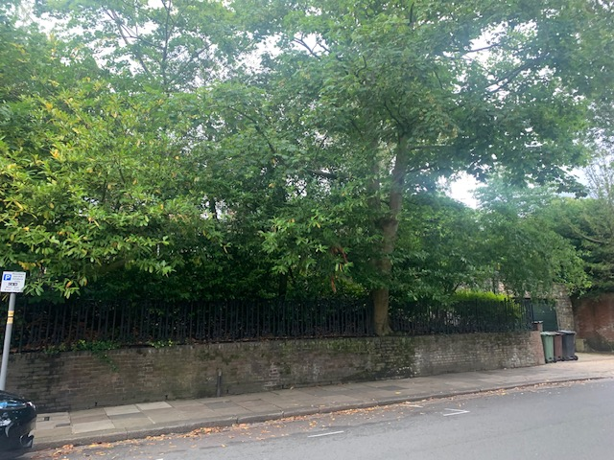

Densely vegetated front boundary treatments of holly, ivy, wild privet and yew, are key to the special interest and character of the Redington Frognal Conservation Area. The important contribution of such dense hedges to the verdant character of the local street scene, can be seen from the photos below of nearby front boundaries in Redington Road, Redington Gardens, Heath Drive, Ferncroft Avenue and Hollycroft Avenue.

Importance of densely vegetated front boundaries

Holly and Ivy Hedge in Redington Road and Redington Gardens
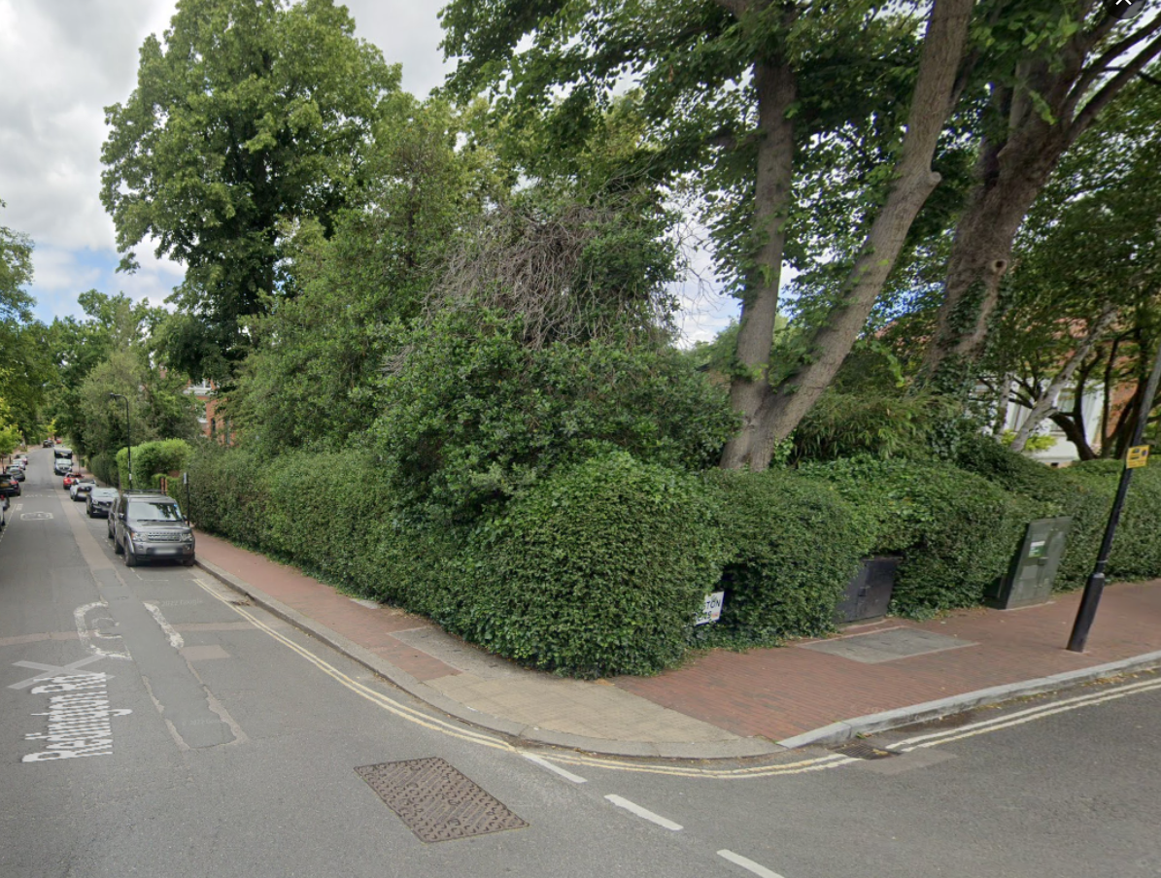

Ferncoft Avenue and Heath Drive
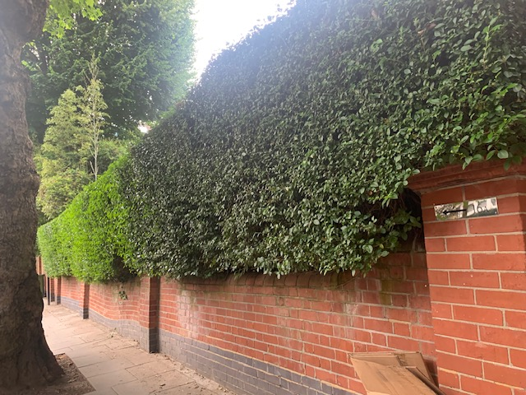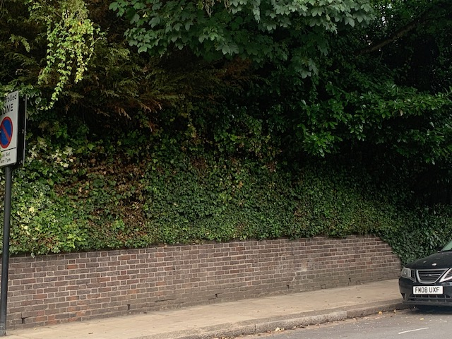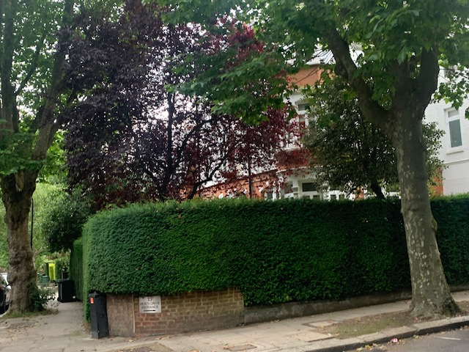

Hollycroft Avenue
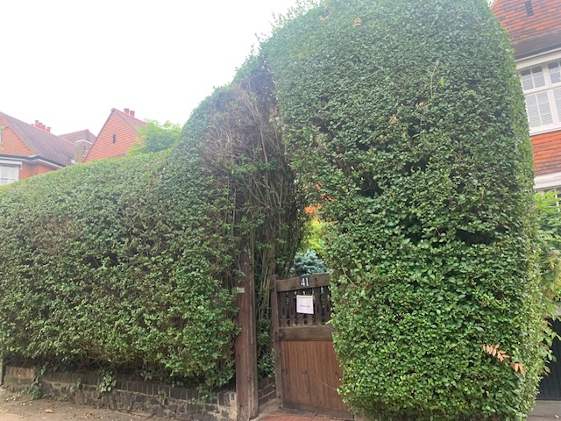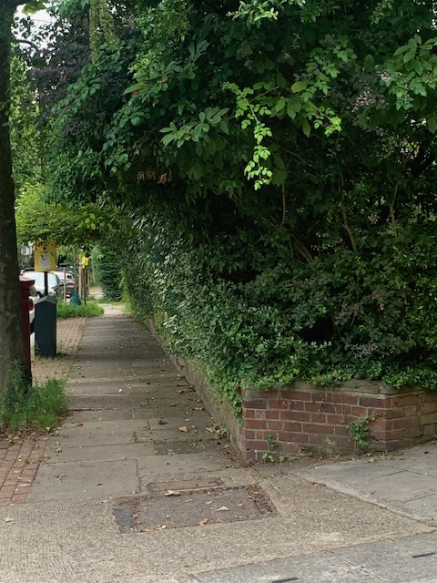

Demolition of existing brick wall and felling of trees and vegetation – objection

The demolition of the existing brick wall and trees and vegetation are in sharp conflict with Redington Frognal Neighbourhood Plan policies SD 1 vi, SD 2, SD 5 vii, SD 6, BGI 1, BGI 2, as well as section 3.4 of the Redington Frognal Conservation Area Character Appraisal and Management Plan.

Installation of metal gates and railings – objection

The Conservation Area is becoming blighted by the contagion of metal gates and railings. Such boundary treatments are not only inconsistent with an Edwardian conservation area but, in a recent Planning Inspectorate decision (APP/X5210/D/21/3289001), were noted as being alien to the street scene, harmful to the verdant, garden suburb character and to the open nature of the Redington Frognal street scene.

Furthermore, metal railings and gates are in conflict with Camden Local Plan Policy C5 and are noted as a key cause of harm to the Conservation Area (section 3.6 of the Redington Frognal Conservation Area Character Appraisal and Management Plan).

Felling of 11 trees and 2 tree groups – objection

Loss of trees and wooded areas are highlighted as another key cause of harm to the Copnservation Area (section 3.6 of the Redington Frognal Conservation Area Character Appraisal and Management Plan).

All trees are of importance to the Conservation Area character. In national Guidance on trees in conservation areas, it is stated under

"Individual, collective and wider impact"......."The authority is advised to also assess the particular importance of an individual tree, of groups of trees or of woodlands by reference to its or their characteristics including":
"Contribution to, and relationship with, the landscape; and
Contribution to the character or appearance of a conservation area."
https://www.gov.uk/guidance/tree-preservation-orders-and-trees-in-conservation-areas#making-tree-preservation-orders
Paragraph: 008 Reference ID: 36-008-20140306
Revision date: 06 03 2014

Thje proposed fellings are additionally contrary to Neighbourhood Plan policies BGI 1 and BGI 2.

New Garden Plan

It would be helpful to understand the changes in hard surface and natural soft surface if the areas of each were to be quantified in square metres, as exitsting and as proposed.

Appropriate planting to benefit native biodiversity (in accordance with policy BGI 1 i and ii) is set out in section 6.2.2 of the Neighbourhood Plan. .

Yours sincerely,
Nancy Mayo
Secretary
Redington Frognal Neighbourhood Forum
https://www.redfrogforum.org
REDINGTON FROGNAL
NEIGHBOURHOOD FORUM

