**Waste Management Plan**

**Euston Skills Centre**

**London Borough of Camden**



|  |  |
| --- | --- |
| **Document Status** |  |
| **Author / s** | **Mark Booth / Andrew Connor** |
| **Date of Origin** | **27.06.2023** |
| **Version** | **20230719** |

**Reason for this report**

LBC is currently working with HS2 and Mace Dragados jv to discharge the conditions attached to the planning permission, regarding Condition 5 Waste Management.

Condition 5 states:

“Prior to occupation of the site, details of the location, design and method of waste storage and removal including recycled materials for the CSC, are required and approved by the local planning authority in writing. The facility as approved shall be provided prior to the first occupation and permanently retained thereafter.”

Reason: To ensure that sufficient provision for the storage and collection of waste has been made in accordance with the requirements of policy CC5 of the Camden Local Plan.

*Policy CC5 Waste*

*The Council will seek to make Camden a low waste borough.*

*We will:*

*a. aim to reduce the amount of waste produced in the borough and increase recycling and the reuse of materials to meet the London Plan targets of 50% of household waste recycled/composted by 2020 and aspiring to achieve 60% by 2031;*

*b. deal with North London’s waste by working with our partner boroughs in North London to produce a Waste Plan, which will ensure that sufficient land is allocated to manage the amount of waste apportioned to the area in the London Plan;*

*c. safeguard Camden’s existing waste site at Regis Road unless a suitable compensatory waste site is provided that replaces the maximum throughput achievable at the existing site; and*

*d. make sure that developments include facilities for the storage and collection of waste and recycling*

**Summary**

The site is in the northern part of the former Maria Fidelis School and is adjacent to the HS2 Station worksite to the north.

The development, which has been approved under planning permission ref 2021/3796/P and is currently under construction, will provide a Construction Skills Centre (CSC)

The CSC will accommodate approximately 120 students and 30 staff members.

The development was granted planning permission subject to conditions and a Section 106 (S106) legal agreement (dated 10 December 2021). Condition 5 of the planning permission requires submission of details regarding waste management for the CSC prior to occupation of the development.

The objective of this Waste Management Plan (WMP) is to identify the activity and procedures for the Centre to comply with Camden’s waste management on operational buildings.

**Introduction**

This report has been produced by London Borough of Camden – CIP / College of North West London for Mace Dragados Joint Venture (MDJV) on behalf of High Speed 2 (HS2) Ltd, to support the discharge of a planning condition in relation to the CSC which is currently under construction at the site of the former Maria Fidelis School.

The development under construction will provide a Construction Skills Centre on behalf of London Borough of Camden (‘LBC’), for which a similar scheme was previously granted planning permission under LBC application reference 2019/3091/P.

The CSC and Site Accommodation building benefits from planning permission which was granted for a temporary 10 year period commencing 10 November 2022. Any buildings on the site shall be removed and land within the site shall revert to Class F1 use on expiry of this temporary period.

This Waste Management Plan is for the operational running of the Euston Construction Skills Centre. It sets out how the centre will manage the waste management on and offsite (ref: 2021/3796/P).

The Construction Skills Centre will be operated and managed by Camden Council in conjunction with their training provider the College of North West London, part of the United Colleges Group.

Below are a number of measures the Council and the College of North West London will put in place to mitigate certain risks.

The WMP includes the following key elements:

* Details of the responsible contact person, how a copy can be obtained and the teams / personnel to whom a copy of the WMP must be provided to;
* The segregation of waste streams and how to dispose of them;
* Expected waste generation and storage requirements;
* Collection points and frequency;
* Programme of document monitoring and review; and
* Documentation of any amendments.

The responsible contact person, is

Name - Andrew Connor

Position - Construction Operations Manager

Office Location - Euston Skills Centre

Contact Number - 02079745165

Camden’s central Facilities Management Schools Team is located in 5 Pancras square and the responsible person will be the FM property manager Marcin Woszczyk in the schools team, to set up all the agreed maintenance works and provide a reactive service which will be chargeable. The cleaner will move with service and again be chargeable.

A physical copy of the Waste Management Plan will be contained in the office and a digital copy will be held on the Administration folder online, and can be obtained from the personnel to whom a copy of the WMP must be provided

**Provision for recycling and re-use**

Camden’s policy is to encourage reduce, re-use and recycle waste materials where possible to reduce waste to incineration.

When considering waste reduction methods, the waste hierarchy pyramid provides a useful guide to the order in which waste reduction measures should be considered, from most effective to the least effective as shown in Figure 1.

*Figure 1 Waste hierarchy*

|  |
| --- |
| Image result for waste prevention pyramid |

Preventing the generation of waste is considered the most effective way of improving recycling rates, followed by reuse of materials, and then moving into recycling, recover and, eventually, disposal in landfill.

**Packaging**

The College of North West London and the Camden Building Management team should endeavour to collaborate with suppliers that display green initiatives when packing items including: Downsizing packaging; Using “green” packaging materials; Promoting recycling and reuse programs; Cooperating with vendor to standardise packaging; Encouraging and adopting returnable packaging methods; Minimising material uses and time to unpack; Using a recyclable pallet system; and saving energy in warehouses throughout the supply chain.

**Supply Chain**

The building management should provide a purchasing strategy that encourages green logistics, including: Using alternative fuelled vehicles; Grouping orders together, rather than in smaller batches; Collaborating with other tenants to consolidate loads; and Optimising reverse logistics to collect used products and packaging from customers for recycling, returning packaging and products to suppliers for reuse, and requiring suppliers to collect their packaging materials.

**Behaviour Change**

People often attach a low priority to pro-environmental behaviour. To encourage such behaviour and drive environmental performance, the tenant should address both the physical and the psychological environment. The goal should be to create an environment that guides decision making, and helps people act out those decisions.

Some examples on how this could be achieved are as follows:

Collect data to understand users’ experience of waste infrastructure and its effect on their behaviour; Reduce the amount of packaging, and increase the percentage of recyclable packaging; Redesign signage to make bins for different streams distinct;

Update labelling to be uniform; Locate bins for different streams where they are most needed (e.g. on walking routes); and remove bins not consistent with design.

Current Re-use, recycle and reduce activity at the existing Skills Centre which will be brought across to the new building include materials identified in Table 1.

*Table 1 - Materials*

|  |
| --- |
| **Metals – Recycled**  1. Copper  2. Aluminium  **Timber – Recycled**  1. Hardwood  2. Softwood  **Plastics – Recycled**  1 PET – Polyethylene Terephthalate  2 HDPE – High-Density Polyethylene  3 PVC – Polyvinyl Chloride  4 LDPE – Low-Density Polyethylene  5 PP – Polypropylene  6 PS – Polystyrene.  7 Other – Miscellaneous.  **Non-Recyclable**  Lime / Sand–mortar  Plaster / Plaster board  Tiles  Off cuts of wood  Brick  (All to be disposed of into the skip on the west of the site)  **New activity will include**  Waxed paper cups instead of plastic cups. |

**Provisions for removal of waste - Veolia**

The Skills Centre operating hours are 8am until 6pm Monday to Friday.

The Construction Skills Centre has two points of access for waste management related to the specific waste, these are shown in the figure below.

1. Out of hours access path directly to the lockable Bin Store on the east adjacent to the Exmouth Arms, 1 Starcross Street Euston London NW1 2HR for recycle and general waste Euro bins adjacent to the open space on Starcross Street.
2. Access point on the west, off North Gower Street Gate, at Hampstead Road. This is for access to the Skip.

*Figure 2 Collection points*

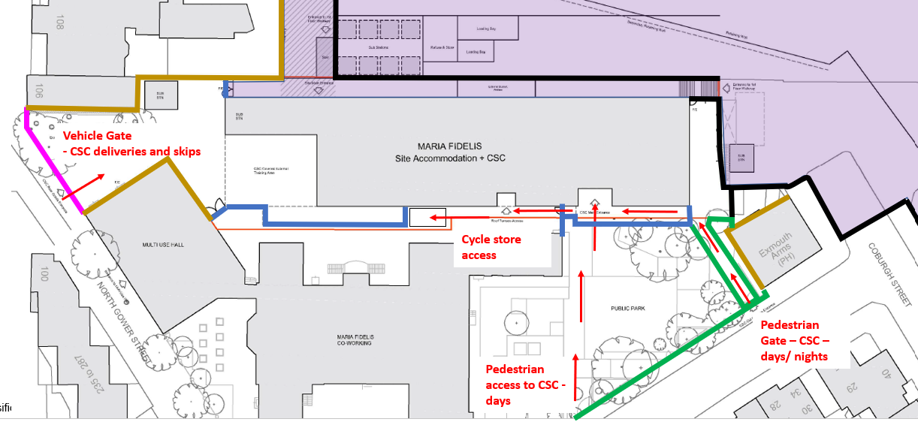

1

2

**Collection points and frequency**

Collectors should not have to move a bulk bin more than 10 metres from the point of storage to the collection vehicle;

The gradient of any path that the bulk bins must be moved on should ideally be no more than 1:20, with a width of at least 2 metres, and the surface should be smooth;

If the storage area is raised above the area where the collection vehicle parks, then a dropped kerb is needed to safely move the bin to level of the collection vehicle; and

The roadway the vehicle parks on should be able to accommodate the weight and size of a 26-tonne vehicle.

1. Euro Bins stored in lockable bin store and placed out overnight and collected from the south side of Starcross Yard via the out of hours passage adjacent to the Exmouth Arms with new dropped kerb onto Starcross Street.
2. West North Gower Street / Hampstead Road – 4-6 yard Skip - emptied once a month. Access via intercom.

Waste bins will be collected from the service area and waste collections will be undertaken by the nominated waste contractor. Collections are usually out of hours between, 06:00 and 07:00.

Drop kerb to be carried out on the section of road to coincide with recent double yellow markings. No further parking bays are to be removed.

**Construction Skills Centre Waste Storage Requirements**

General requirements for waste disposal and storage shall be as follows,

Recycling and General Waste – associated to the Toilets, Classrooms and Office Areas

Food Waste – associated to the Welfare Areas

**Ground floor**

* Skip storage for waste building materials recycling – associated to the Workshops and External Construction Area
* Reception – bins general Waste and mixed recycling
* Machine Room
* Workshop recycling and general waste bins, copper and metal recycling, cabling recycling
* WCs bins sanitary bins
* Medical Waste – associated to the First Aid Room.
* Cleaners Cupboard – see separate UGC COSHH Arrangement

**First Floor**

* Classroom bins general waste and mixed recycling

**External Waste Storage**

The enclosure or chamber should be large enough to allow clearance of 150 mm between each bin and the walls, on each side;

There should be space in front of the bins to allow staff to easily access the bins when depositing waste;

If multiple bins are used, then there should be sufficient space to rotate the bins in between collections;

The walls should be made from an impervious, non-combustible material that ideally has a fire resistance of one hour when tested to BS 476-21;

A locked gate or door is added to the enclosure or chamber it should be metal, hardwood or softwood clad with metal;

Ideally it should have a fire resistance of 30 minutes when tested to BS 476-22. The door frame should allow clearance of 150 mm either side of the bin, when it is being pulled out for collection;

The door frame should be rebated into the reveals of the opening. There should be a latch or clasp to hold the door open while the collection process takes place;

Arrangements should be made for the cleansing of the bin stores with water and disinfectant. A hose union tap should be installed for the water supply. Drainage should be by means of trapped gully connected to the foul sewer. The floor of the bin store area should have a suitable fall (no greater than 1:20) towards the drainage points.

**Waste Segregation**

Since January 2015, UK regulations require the separate collection of paper, plastic, metals & glass for recycling from all waste producers including commercial waste.

There is often confusion for people around what is and isn’t recyclable, the items that are recyclable should carry obvious visual clues about which bin they should be placed into. This could be via labels on the packaging itself or signage on and adjacent to the bins carrying photos of each container type and an indication of which bin it should be placed into. An example of how this can be achieved is shown in Figure 6.

If it is not technically, environmentally and economically practicable to segregate all waste streams, it is proposed to provide co-mingled recyclable storage for waste streams shown in LB Camden standard waste bins with two compartments.

*Figure 6 Waste labels and posters*

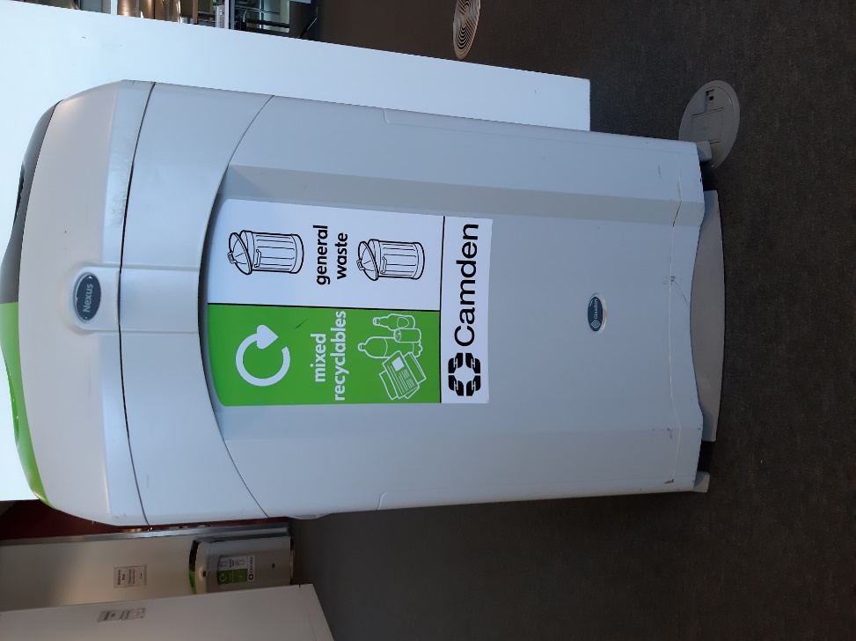 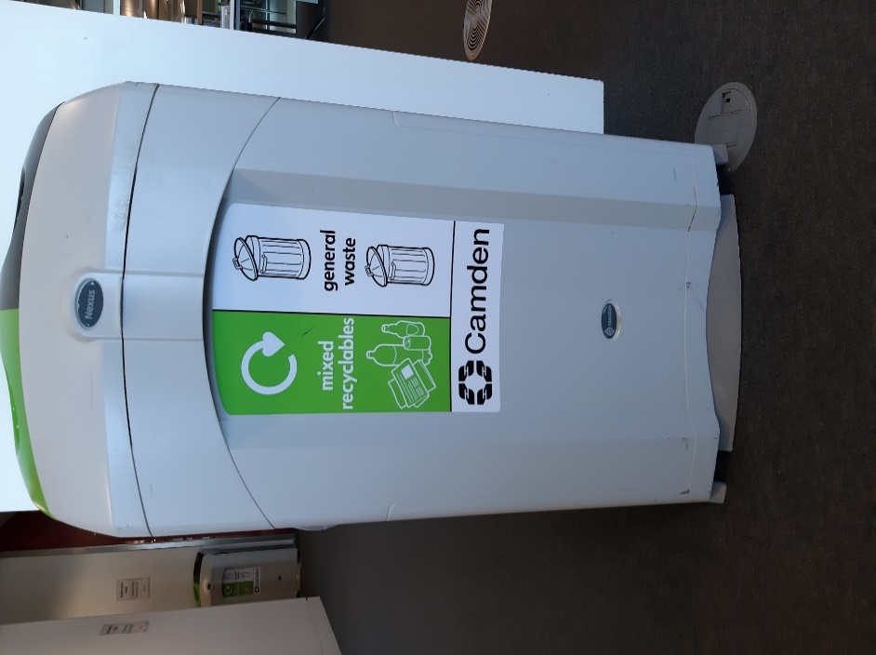

**Waste Generation**

Guidance in the following documents has been applied when defining the Waste Management Plan:

* Camden Planning Guidance, March 2019;
* Camden's Environment Service technical guidance for recycling and waste; and
* BS 5906:2005 Waste management in buildings – a code of practice.

1 week / 5/7 day or Two-day waste generation for commercial use has been calculated to comply with best practice and allow for contingency.

The equipment required can be seen in the example equipment specifications.

**Commercial Waste Generation**

Based on the estimated two-day waste generation is 2.34m³ as shown in Table 2.

*Table 2 - Two-day waste generation*

|  |  |
| --- | --- |
| **Proposed Development - Two Day Waste or 5/7 day 1 week Generation (m³)** | |
| Waste Stream | CSC |
| Residual | **0.47** |
| Combined Recycling | **1.87** |
| Total | 2.34 |

(to be reviewed after occupation of the building when in operation)

**Commercial Waste Storage**

The Proposed Development requires a waste store, for the CSC, sized at 13.65m2. Waste stores have been sized to accommodate two days’ storage of commercial waste. The equipment required is shown in Table 3.

The above mentioned waste segregation strategy ensures the highest quality of recycled materials, however the internal strategy for the different building functions will be developed and designed later, prior to occupation.

*Table 3 - CSC waste storage equipment*

|  |  |  |
| --- | --- | --- |
| **CSC – Waste Storage Equipment** | | |
| Waste Type | Waste Container | Number Required |
| Residual | 1,100 litre bin | 1 |
| Mixed Recycling | 1,100 litre bin | 1 |
| Total | - | 2 |

Storing the waste for the CSC will require the provision of:

* 1 No. 1,100 litre Eurobins for the storage of residual waste;
* 1 No. 1,100 litre wheelie bin for the storage of mixed recycling

The above mentioned waste segregation strategy ensures the appropriate approach of recycled materials, and will be developed and designed whilst in use to establish any new regimes after occupation.

**Waste Storage**

Hazardous Waste

It is assumed that the following wastes, which are classified as hazardous, will be kept to a minimum and contained in COSHH locked cabinet:

* Gas Canisters
* Glues /plastic cement
* Pipe Grease

A specific request should be sent to the Camden FM team for the collection of hazardous waste. Upon collection, College of North West London Technician will take it to the general waste store prior to collection by a waste contractor.

See separate document - ***UCG COSHH Arrangement.docx***

Confidential Paper Waste

Confidential waste must be collected in secure bins located around the buildings. To be fully compliant with the Data Protection Act, a written contract with a certified confidential waste company is required. This waste stream will be collected in situ by a specialist contractor and shredded and disposed of off-site.

Photocopier Cartridges

Photocopier and printer cartridges will be collected in boxes located by the photocopiers, which will be periodically collected by the FM team for storage prior to collection by a waste contractor.

Internal Waste Transfer Leaseholder - HS2

The FM team will be responsible for communicating with the tenants CNWL & Camden on the requirements for transferring waste and recycling to the storage facility, including the requirements for bulky and non-standard waste. The waste store and individual zones within the store shall always be labelled clearly.

The office, workshop and communal areas will be provided with waste and recycling stations on each floor for segregating waste. Tenants CNWL & Camden must be aware of and follow their responsibilities under the waste duty of care: Code of Practice (2016)[1] .

**Litter Management**

Litter Picking

Litter picking will be conducted by the cleaner throughout the day to allow for both a safe and clean environment.

External/Surrounding Areas

The cleaning of external areas within the Proposed Development will follow the programme set out in Table 4.

*Table 4 Cleaning schedule*

|  |  |
| --- | --- |
| **Action** | **Frequency** |
| Clear debris, litter from entrances and public areas | Daily |
| Empty waste bins | Daily |
| Clear leaves from all entrances and fire exits | Weekly |
| Clean and wash down external signs | Weekly |

**Waste Collection**

Waste bins will be collected from directly from the waste store and waste collections will be undertaken by the nominated waste carrier. Collections are usually out of hours between, 06:00 and 07:00. Where the distance between the waste store and the waste collection point is more than 10m the marshals will manage waste collections and rotate any full and empty containers. There will be a smooth transfer for the presentation, tipping, and the bins will be removed immediately and transferred back to the storage room.

As it is proposed to present full waste bins, issues associated with fly tipping will be minimised as members of the public will not have general access to the waste bins.

In the event of a missed collection, full waste bins will be returned to the waste store. Storage has been provided to accommodate two days’ waste generation, therefore, missing a single waste collection will not have a detrimental impact on waste storage.

**Example Equipment Specification**

1,100 Litre Eurobin

Length: 1.37m

Width: 1.11m

Height: 1.38m

|  |
| --- |
|  |

240 Litre Wheelie Bin – For storage - recycling on site

Length: 0.72m

Width: 0.55m

Height: 1.15m

|  |
| --- |
|  |

**Waste Management Plan Review**

The success of the strategy as detailed above will be closely monitored by the Construction Operations manager.

Feedback should be provided monthly and as and when required where immediate action is required and dealt with in accordance with this strategy.

The strategy will be updated and amended as appropriate to ensure the development is within the perimeters of what is deemed necessary to maintain a clean and safe environment all year round.

Any changes or deviations to the agreed Waste Management Plan will be made by submission of a change request to planning at LBC. Amendments will be shown in an appendix to the WMP, under version control.

Identifying means of ensuring the provision of information to the Council and provision of a mechanism for monitoring and reviewing as required from time to time.

ENDS

1. <https://www.gov.uk/government/publications/waste-duty-of-care-code-of-practice/waste-duty-of-care-code-of-practice>