Emilios Tsavellas
Development Director
6 Duke Street St James
London
SW1Y 6BN

David McKinstry
Principal Heritage Officer
LB Camden
2nd Floor, 5 Pancras Square
N1C 4AG

Dear David

APPLICATION FOR MVHR ON ROOF
4-6 BEDFORD PLACE

INTRODUCTION

4-6 Bedford Place is a Grade II listed property in the Bloomsbury Conservation Area forming part of the group listed 1-20 (evens) Bedford Place (List Entry: 1244591). As concluded in the previous heritage statement, which supported application ref: 2023/1398/L the building’s significance is principally formed by its uniform front elevation and areas of retained planned form and detailing.

This application seeks to make a changes to following listed building consent and planning permission to house MVHR on roof level as opposed to roof void, as consented.

2023/1398/L – Granted 26 September 2023
Extension to lower ground and ground floor rear closet wings at nos. 5 and 6, erection of new 2 storey rear extension at no. 4, installation of a lift, PV's on the roofs, installation of air source heat pumps and associated enclosures in the rear gardens of nos. 4 and 6, landscaping of front lightwells and rear gardens and associated internal alterations including installation of new bathroom pods and ensuites, changes to partitions at lower ground to 3rd floor levels, bricking up existing opening in rear garden wall of no. 5 and 6 and creation of 2 new openings between gardens of no. 4 and 5 and no.s 5 and 6 as part of refurbishment of the existing hotel.

2023/1315/P – Granted 26 September 2023
Extension to lower ground and ground floor rear closet wings at nos. 5 and 6, erection of new 2 storey rear extension at no. 4, PV's on the roofs, installation of air source heat pumps and associated enclosures in the rear gardens of nos. 4 and 6, landscaping of front lightwells and rear gardens and associated internal alterations to create 7 additional bedrooms as part of refurbishment of the existing hotel.
bedrooms as part of refurbishment of the existing hotel.

Whilst this application is for new full planning permission and listed building consent, it closely relates to the above permissions. The following documents have been submitted:

Proposed Section AA Drawing No. A100.120 Rev P2
Proposed Section BB Drawing No. A100.121 Rev P2
Proposed Roof Plan Drawing No. A100.104 Rev P2
Proposed Detailed Section Drawing No. A100.121B
Noise Assessment

PROPOSED WORKS

The application site has 3x roof level “lightwells” which provide light over the principal stair that runs from ground to second floor. The skylights are in poor condition and due to be refurbished. Each of the lightwells has a timber platform sitting above, as per the photo below, which provide access to the main roof.

The consented scheme under ref: 2023/1315/P and 2023/1398/L administered a new energy and services strategy using air source heat pumps (ASHP’s) to be housed in the rear garden and mechanical ventilation and heat recovery (MVHR) system to be housed in the roof voids above third floor level. This strategy achieves significant environmental enhancements as outlined in the consented energy statement.

It is now proposed to house the MVHR on new platforms that would sit externally in the lightwells. This approach is consistent with the scheme at 21-23 Bedford Place ref:2023/4954/L, which we understand is being supported. The skylights would be refurbished and backlit and the platforms and plant would not be visible from any view – public or private.

The reason for the change is to ensure the equipment can be safely and conveniently accessed for maintenance, to improve acoustic performance within rooms and to improve the fire strategy. The proposal requires no structural interventions. The platforms will not require any structural works to the building and are so completely reversible. The change in strategy also means that the ceilings at third floor do not need to be suspended (as there will not be acoustic or fire issues from the plant sitting in the void) and so can be restored to historic proportions.

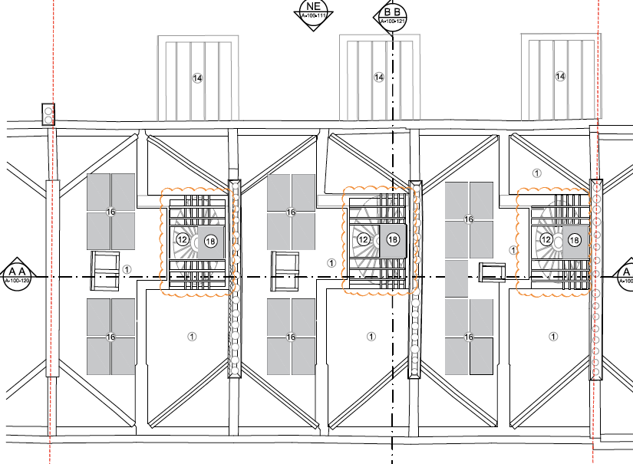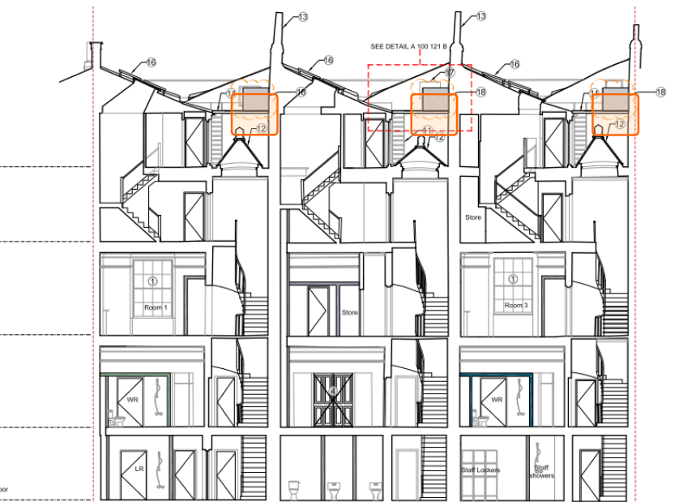
Proposed roof plan and section showing new location of MVHR
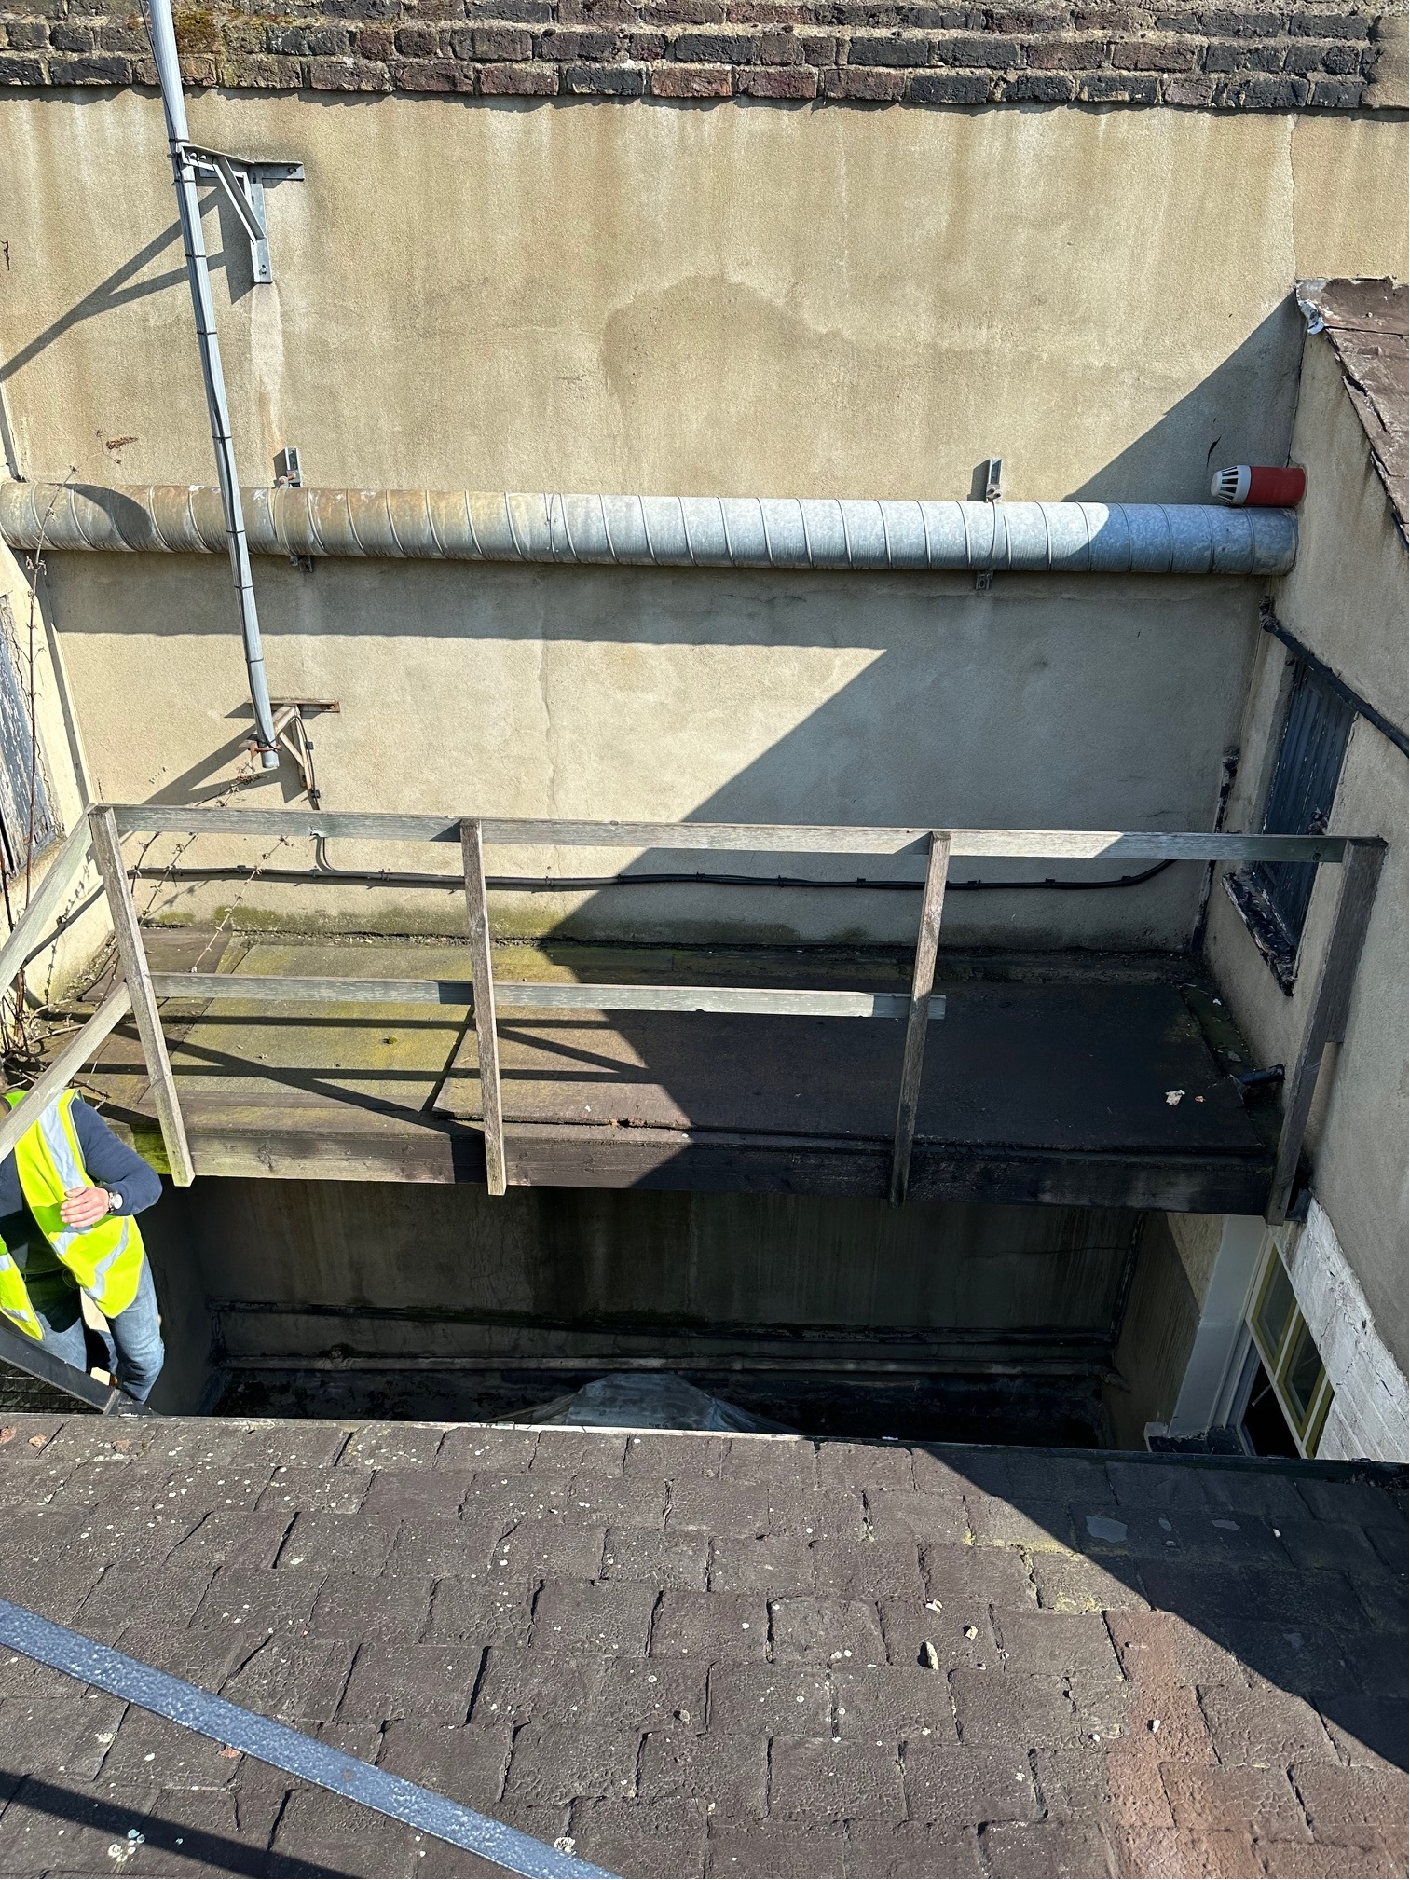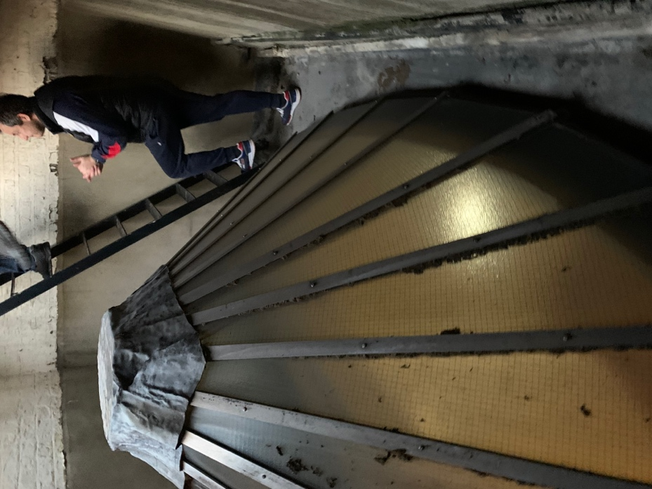
Photo of existing timber platform and skylights to be refurbished

JUSTIFICATION

The heritage benefit is that the change is reversible - it does not require any change to the structure of the roof and the plant is also easier to access and maintain. Furthermore, it means the ceiling at third floor level will not be suspended and so it can be returned to original proportions as there would be no noise generating plant within the void and no rooms above to fire separate. The strategy is consistent with what is being supported at 21-23 Bedford Place. It will not be visible in any public or private viewpoints. It is therefore our view that the historic and architectural significance of the listed buildings will be enhanced and there will be no adverse impact on the character and appearance of the conservation area, consistent with the duties of paying special regard and attention under S66 and S72 of the LBCAA 1990.

In terms of acoustics, internally the performance of the hotel rooms will be enhanced as there will be no plant sitting in the void. The submitted acoustic assessment also confirms that there will be no impact on nearby sensitive receptors. Overall, the proposal is an enhancement to the consented scheme in this respect.

CONCLUSION
The proposal is to rehouse plant on new platforms located within the lightwells at roof level, with the skylights then to be refurbished and backlit. The plant would not be visible internally or externally and the change requires no structural interventions and is therefore entirely reversible.
The change brings about a number of benefits to acoustics, fire performance and historic ceiling proportions at third floor level.
It is our opinion that the works preserve the architectural and historic significance of the listed building and preserve the character and appearance of the conservation area.
It is therefore respectfully requested that permission and listed building consent is given accordingly.

Yours sincerely,

Emilios Tsavellas MRTPI
Development Director

