**D E S I G N & ACCESS S T A T E M E N T**

**Well Mount Cottage, Well Road, Hampstead NW3 1LJ**

**Site**

This Design Statement is submitted in conjunction with the Planning Application for the works at Well Mount Cottage, Well Road, Hampstead. Well Road, is located within the Hampstead Conservation Area and is a small road running from the village to the heath between New End Square and East Heath Road. Well Mount Cottage, situated near the junction with Christchurch Hill, is a part brick, part white painted brick Victorian cottage located on the northern side of Well Road, which consists of a mix of Victorian, Edwardian and 20th century houses and cottages, with post war flats (New End Square) close by. There is, as such, no particular period or common design to the properties in the immediate proximity, with its character being derived from its variety.

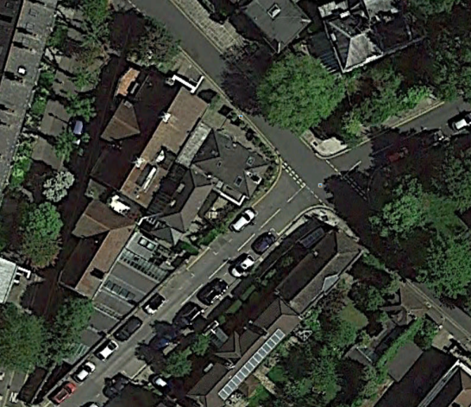 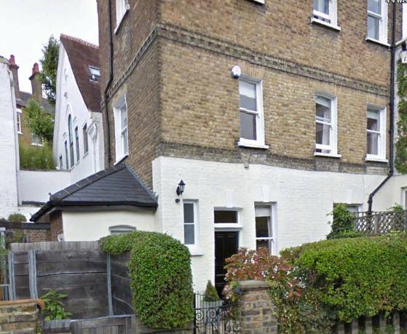

Well Mount Cottage - Aerial view As seen from Well Road

**The proposal**

The application proposes to build a first floor extension above the existing ground floor dining area to the rear (northern side) of the property, set back and therefore hidden from view from Well Road. This will provide much needed width to what is currently very narrow accommodation. In addition, it is proposed to widen the small existing side extension by 800mm (1500mm to the rear) where it meets the boundary with Well Mount Studios. As part of the project, the old and inefficient glazing units are to be replaced on a like for like basis. This will mean an upgrading of the fenestration with traditional timber framed double glazed sashes, in keeping with the Article 4 directive.

**Design & Building materials**

Although Well Road itself reflects a variety of styles as well as materials, the Victorian preference for building with stock bricks is clear to see within the Hampstead Conservation Area. For this reason the extension walls are to be constructed in yellow stock brick, matching the walls on the main cottage, the southern Well Road boundary and those of many of the properties in the immediate vicinity. At ground floor level and to the rear of the property facing Christchurch Hill, the brickwork will remain painted, thus ensuring a maximum of light reflection in these areas. The new hipped roof to the rear is designed with a low pitch, again to maximize light, and finished with slate and dark grey ridging to match the main and side roofs.

**Access**

Access to the site is solely from Well Road on the southern side of the property. The proposed construction will have no implications with regard to access.

**Conclusion**

This proposal takes into account the history of the area and in particular the character of the Hampstead Conservation Area. In modestly increasing the proportions of this property, the choice of stock bricks and slated roofwork establishes a link with the character of the area and along with the proposed upgrade of the timber sashes provides an improvement to the visual appearance of the facade as well as the amenities of the property.