**Information for removal of LBC Conditions 3 & 4**

**Application ref: 2021/3955/L**

**DECISION**

**Planning (Listed Building and Conservation Areas) Act 1990 Listed Building Consent Granted**

**Address: Chestnut Lodge Squire's Mount London NW3 1EG**

**Proposal: Replacing deteriorated bricks and pointing. Drawing Nos: 1.500 Chestnut Lodge Site Plan, 1.1250 Chestnut Lodge Site Plan, LBC Chestnut Lodge Hampstead (including Design and Access and Heritage Statements and methodology).**

**Conditions**

3 All new work and work of making good shall be carried out to match the existing adjacent work as closely as possible in materials and detailed execution. Reason: In order to safeguard the special architectural and historic interest of the building in accordance with the requirements of policy D2 of the Camden Local Plan 2017.

4 A sample panel of the brickwork shall be erected on site, showing the proposed bricks, which shall match the existing, and pointing which shall be lime based with a slightly recessed joint. this shall be viewed by the LPA and approved in writing before the relevant part of the work is begun:

**Overview**

As previously discussed via telephone the original scope of work has been reduced to just undertaking essential repairs using like for like materials. The areas of most concern are the heads sash window arches on the second floor, water is entering internally through cracks/gaps in the pointing during periods of heavy rain.

Over the telephone a site to view the bricks and mortar samples. You mentioned that because it was a like for like repair, we should apply through the correct channels to have the conditions discharged.

Please find below an overview of the work (see figure 1 - 5), and details of the proposed like for like materials.

Second floor arches that require repointing and isolated brick replacement

Figure1 Front elevation of the house, identifying the brick arches where water ingress is present

Figure 2 Illustrating the cementitious pointing and cracked joints to the brick arches on the second-floor windows

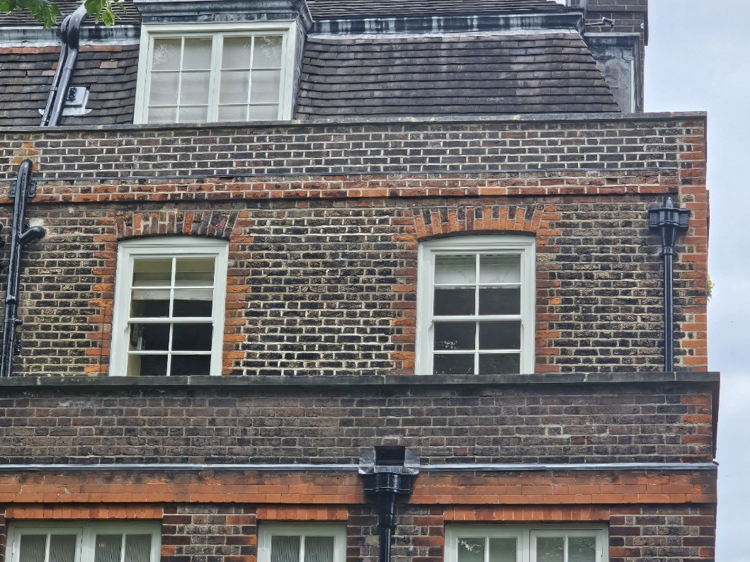

Figure 3 Close up view of the brick arches

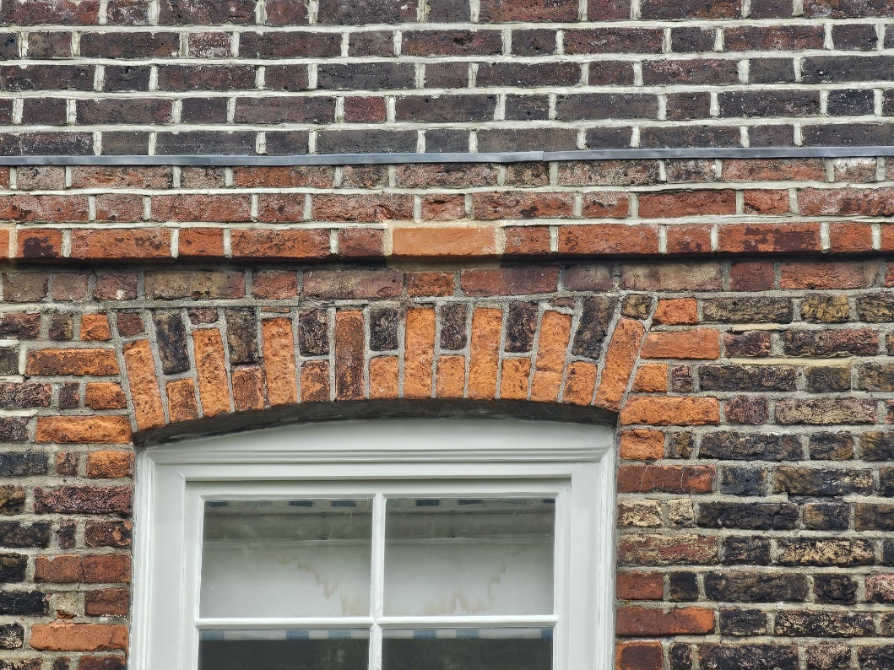

Figure 4 Illustrating the cementitious over pointing

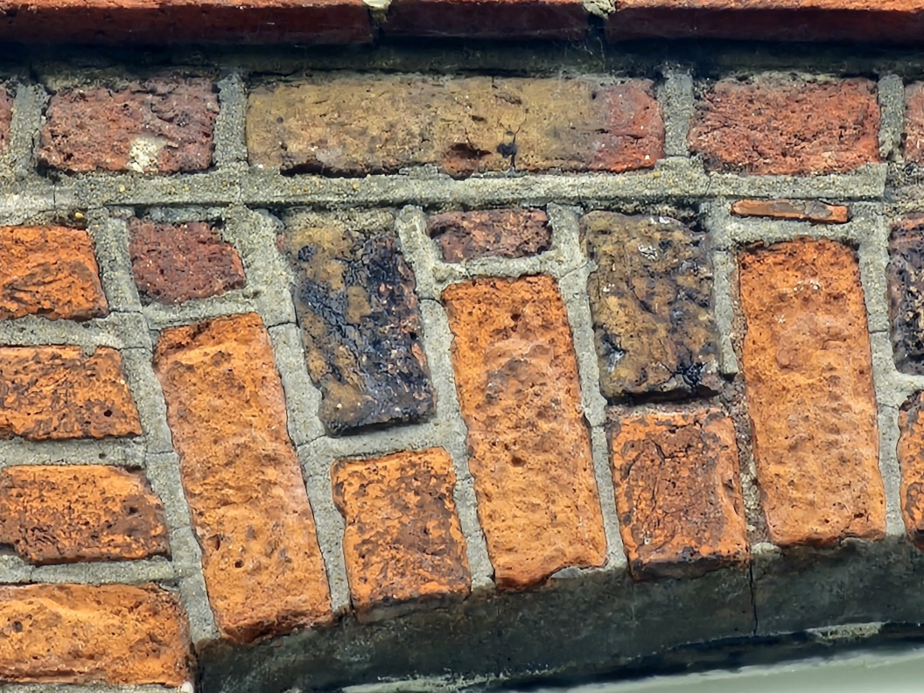

Figure 5 Illustrating hairline cracks in the cementitious mortar and open mortar joints providing entry points for driving rain.

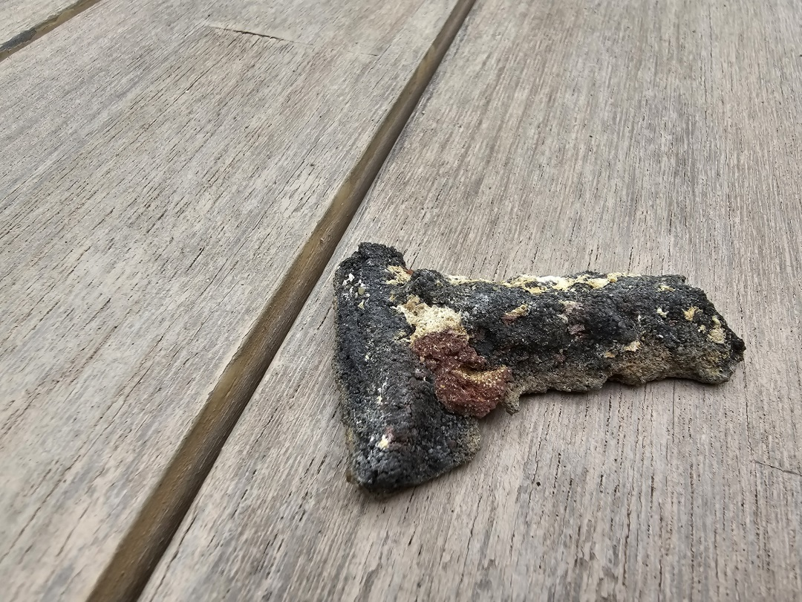

The original pigment colour at the rear of the mortar plug and the lighter bleached mortar at the front

Figure 6 A sample of the original cementitious mortar, the original black colour can be seen on the reverse, the front however has been bleached by the sun

**New mortar**

As can been seen from the previous images the existing mortar varies in colour across the elevation, see figures 4 & 5. The arches concerened have all been pointed with a cementitious mortar that has cracked or failed, resulting in water ingress. The mortar used is cementitious with a pigment added. As can be seen from figure 6 the original colour at the reverse of the sample would have been black oxide, however the sun has bleached the mortar to light grey on the surface. The replacement mortar is to be lime mortar that has been coloured with natural earth pigments to match the surrounding cementitious mortar when it dries.

Several mortar biscuits were made to try and replicate the colour, see figure 7. The most suitable mortar mix was;

* 3 Parts Grove fine washed building sand
* 1 part NHL 2 Lime
* I small cup of black oxide pigment
* 1 small cup of raw umber pigment

The mortar mixed used has been designed to reach its optimum colour after two years of weathering.

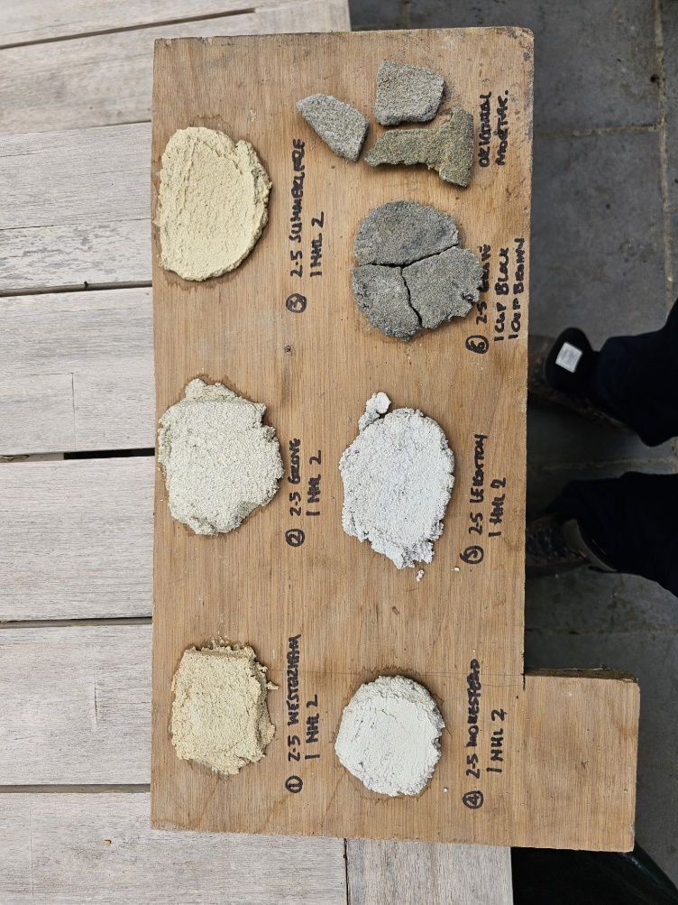

Sample of original mortar

Figure 7 Illustrating the various mortar biscuits that were made to develop a match mortar

**Bricks**

The bricks are a soft red handmade brick. They vary in colour across the elevation, due to the level/degree of pollutants attached to the surface, see figures 8 and 9. The new replacement bricks are made by HG Mathes of Chesham and are a like for like replacement in size, colour and texture.

Figure 8 Showing the replacement handmade bricks against the original brickwork

Figure 9 Another example of the new handmade bricks

To soften the appearance of the isolated brick replacements they will be tinted, where the need arises. The level and degree of tinting will be based on the degree of pollutants present in the surrounding area. The philosophy is to create isolated brick repairs that sit harmoniously with the existing historic brickwork.

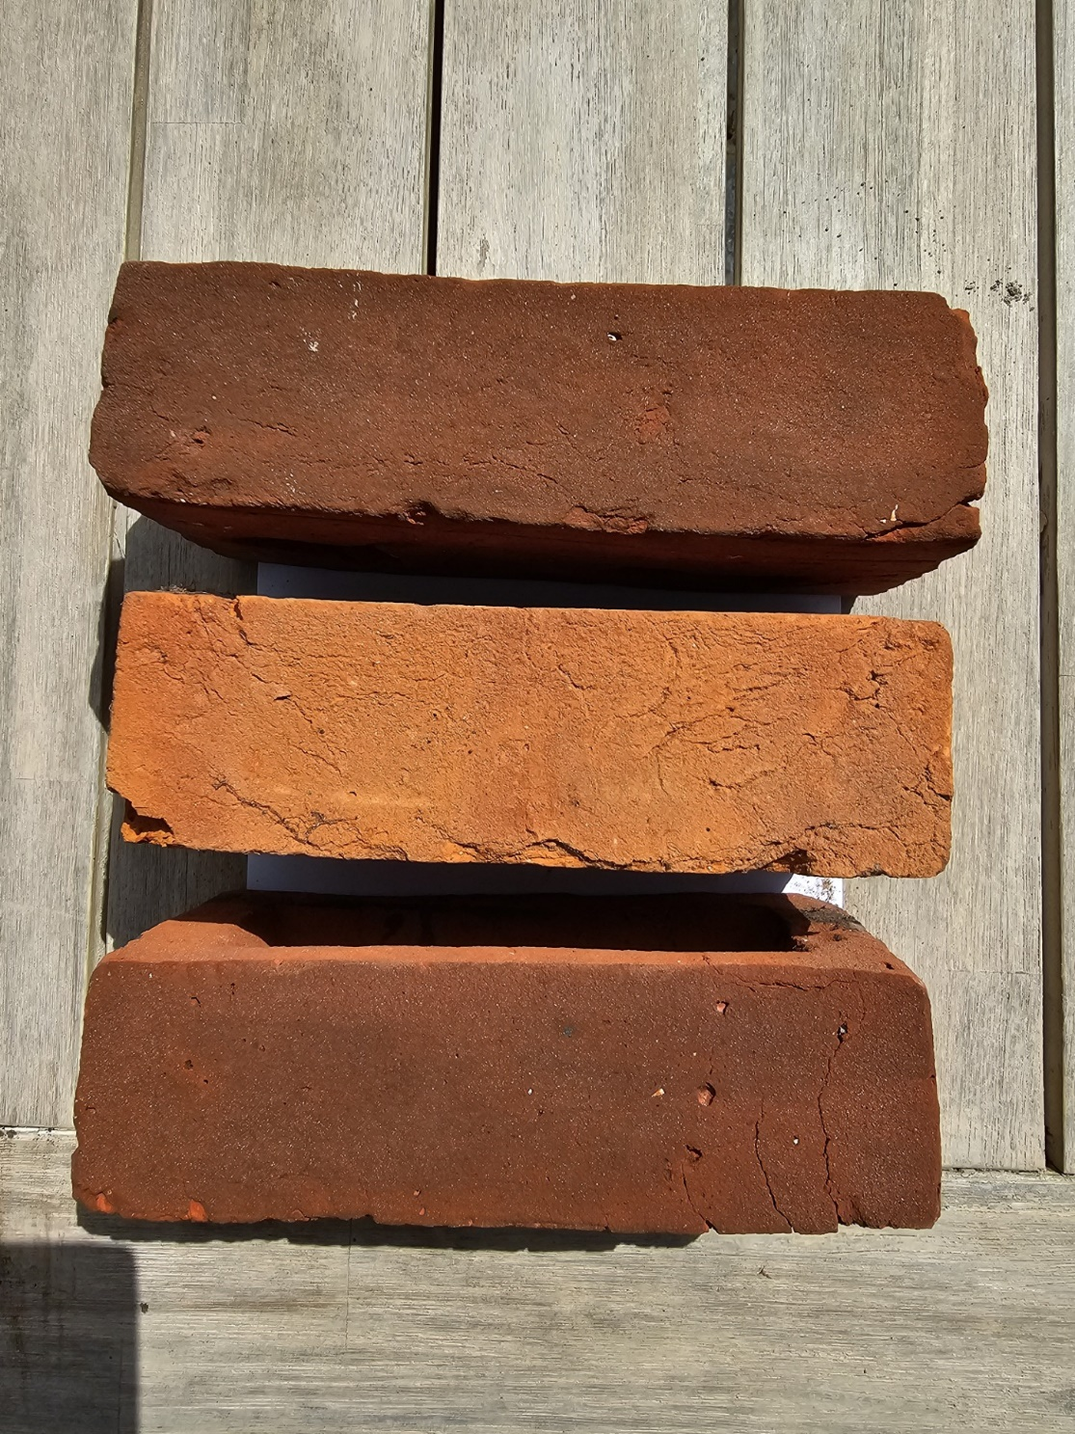

Figure 10 Illustrating tinting of the new handmade bricks to soften the effect of the new replacement bricks

Should you have any questions please do hesitate to contact me.

Best wishers,

David Pope

Ernest Barnes Ltd

Mob: 07802 741269 Email: ernestbarnesltd@sky.com