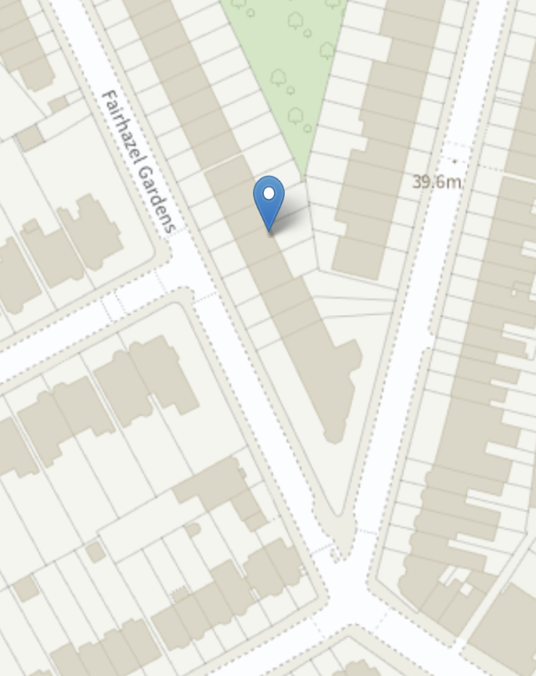

The Tree is situated in the rear garden of 22a Fairhazel Gardens and is near 20 and 24 Fairhazel Gardens and 76 Goldhurst Terrace. Please see image to right for info a visual display of the relationship between the tree and surrounding area. Please note photograph was taken in February.