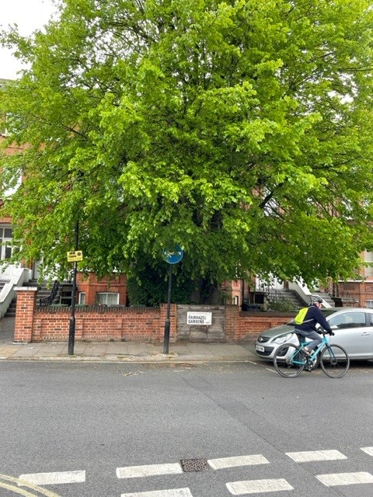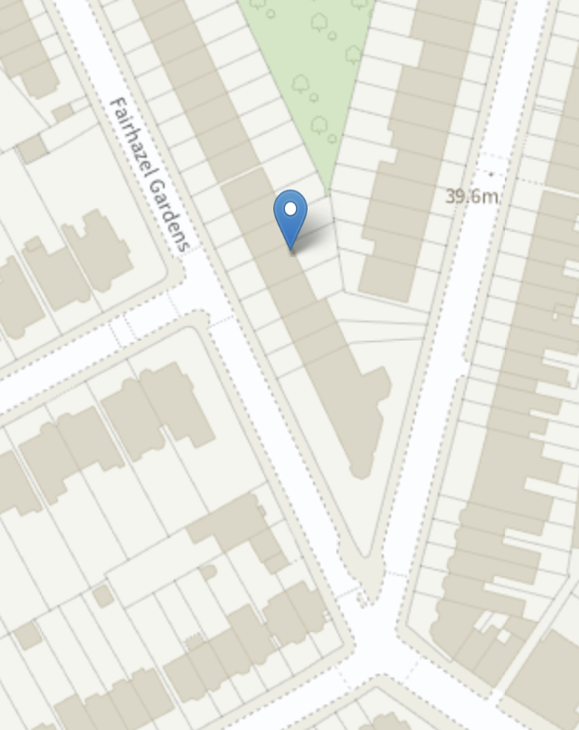

The Tree is situated in the front garden of 22a Fairhazel Gardens. Please see image to right for info a visual display of the relationship between the tree, the property and the road.