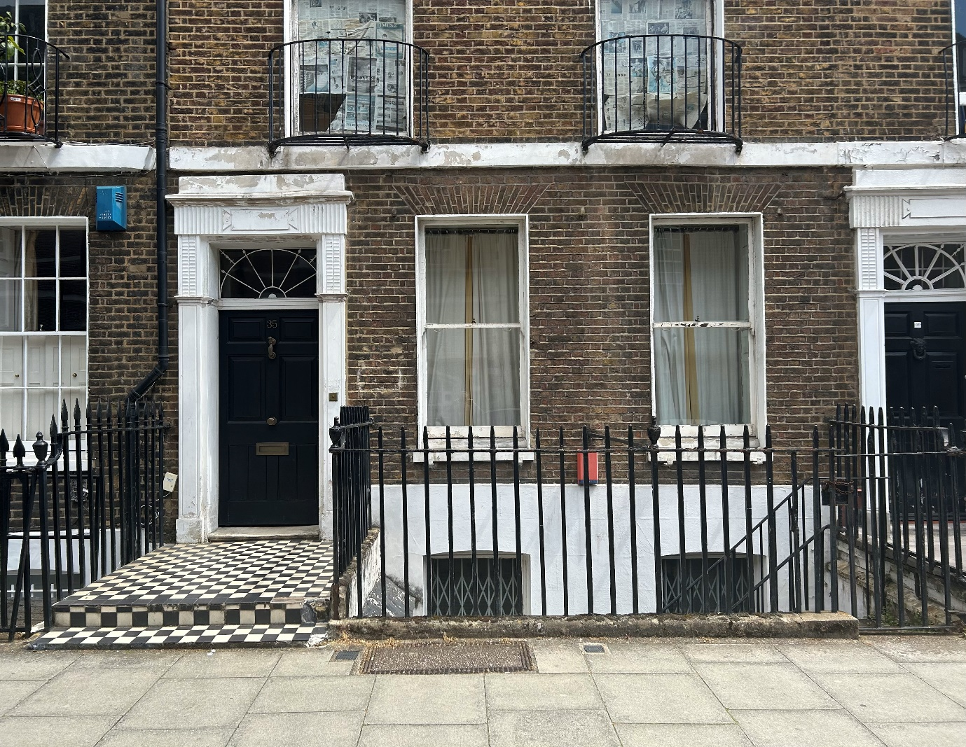

HERITAGE STATEMENT
FOR REFURBISHMENT OF FRONT STEPS AND GROUND AND FIRST FLOOR RAILINGS
AT
35 DOUGHTY STREET WC1N 2AA

Introduction

35 Doughty Street is a grade II listed, five storey, terrace house in single occupancy.
The property has been subject to a series of planning applications, the last being 2022/2907L relating to the lowering of a window cill on the rear outrigger.
This new application now proposes to do work which will enhance the appearance of the frontage by restoring the front steps and threshold, and the ground and first floor railings.

Description, appearance and impact on the Heritage asset.
The existing front steps are in a poor state of repair and leaking badly into the basement. The ground floor railings are in need of refurbishment and the first floor railings are seriously corroded near the point of attachment to the wall.
The front steps will be restored to their former Portland stone finish, the adjacent railings will be removed, refurbished and reinstated and the remaining railings will be repaired and reinstated. The upstand to the right of the steps will disappear. The upstand along the pavement will be removed in line with the frontage of number 34.
The first floor railings are in need of extensive repair and will be removed, repaired and re-instated.
The heritage appearance of the property will be enhanced as a result of this restoration.

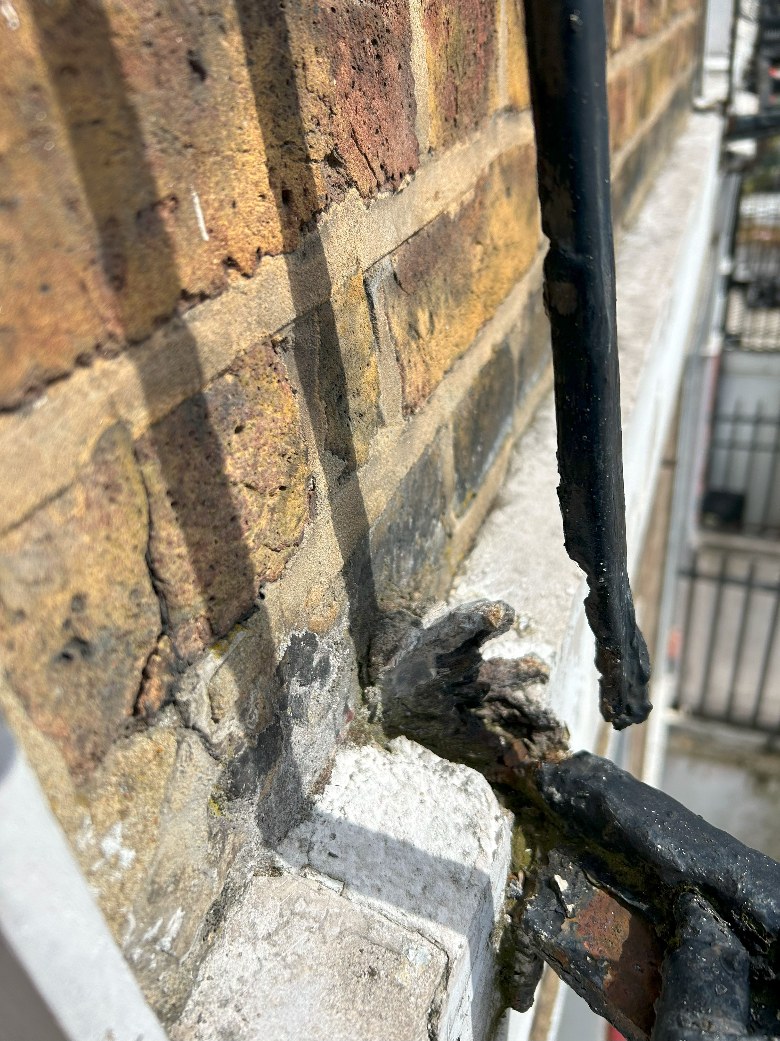
Serious corrosion on first floor railings

