

# To London Borough of Camden, Planning Department

**Planning Ref:** 2024/1103/P

**Address:** Flat A 42 Denning Road NW3 1SU

**Case Officer:** Brendan Versluys

**Date**: 06.06.2024

This application for a rear extension appears to indicate that little more rear garden loss will occur than losing the existing hard-standing patio. It is not clear on the plans however how access to the garden will be made without losing more garden. As no garden plans have been submitted, we need to know whether the garden level is to be lowered and whether the cracked rear curved retaining wall by the steps has already been removed, as has been done at the front. If the garden is being planned to be dug out, removing most of the soil altogether, our concern is that plants will then be in pots and the garden entirely paved over. While the bay tree gained consent for removal with [2018/4215/T](https://planningrecords.camden.gov.uk/NECSWS/PlanningExplorer/Generic/StdDetails.aspx?PT=Planning%20Applications%20On-Line&TYPE=PL/PlanningPK.xml&PARAM0=485238&XSLT=/NECSWS/PlanningExplorer/SiteFiles/Skins/camden/xslt/PL/PLDetails.xslt&FT=Planning%20Application%20Details&PUBLIC=Y&XMLSIDE=&DAURI=PLANNING) this was not done within the 2-year consent, but after March 2024 when estate agent photographs show it was still existing:

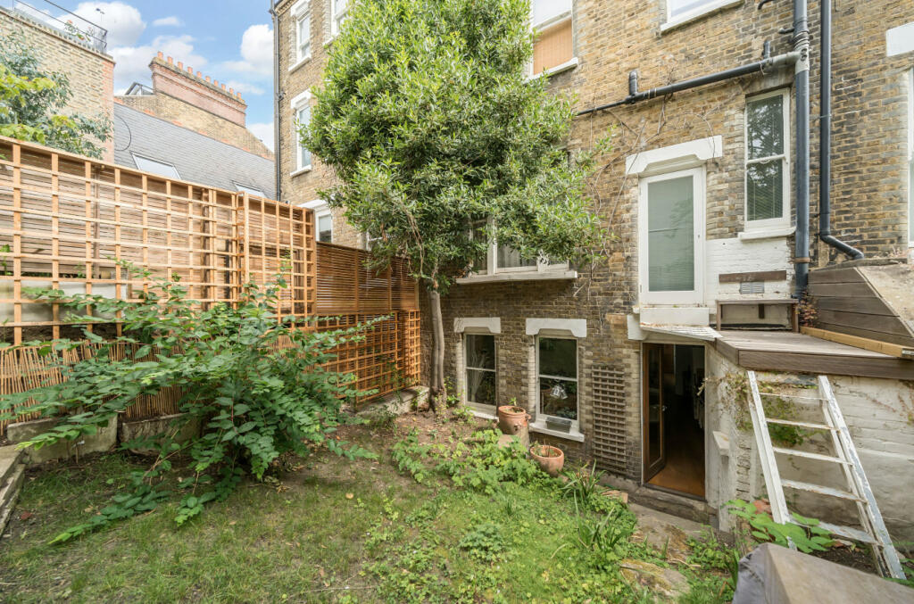 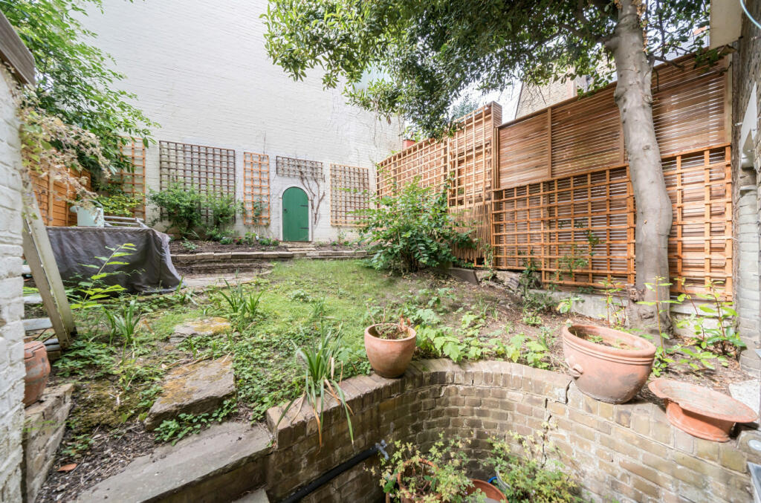

While this approach would mean the current step access is no longer needed, it does mean an awful lot of both soil and vegetation will be lost. This is a significant volume of soil ‘sponge’ for rainfall; when it has gone, there will be an increase in run-off to the sewers at a time when flooding of South End Green is now a more frequent and disturbing occurrence.

There will also be uninterrupted echo from any new hard surfaces of the garden as well as the 3-storey white side wall of 31 Pilgrim's Lane at the rear. Holding parties in such a garden will be a nightmare for many neighbours in the vicinity and for wildlife that will have lost a significant amount of habitat, shelter and means for moving around safely within and between the rear gardens here. The 3-storey white wall with no tree canopy or shrubs. plus any hard standing over the garden will cause unbearable heat reflection, making use of the rear garden during the day unbearable for much of the summer, and this heat sink will add to the heat discomfort of all the other occupants in 42 Denning Road and its neighbours 24 hours a day during any sunny and hot periods.

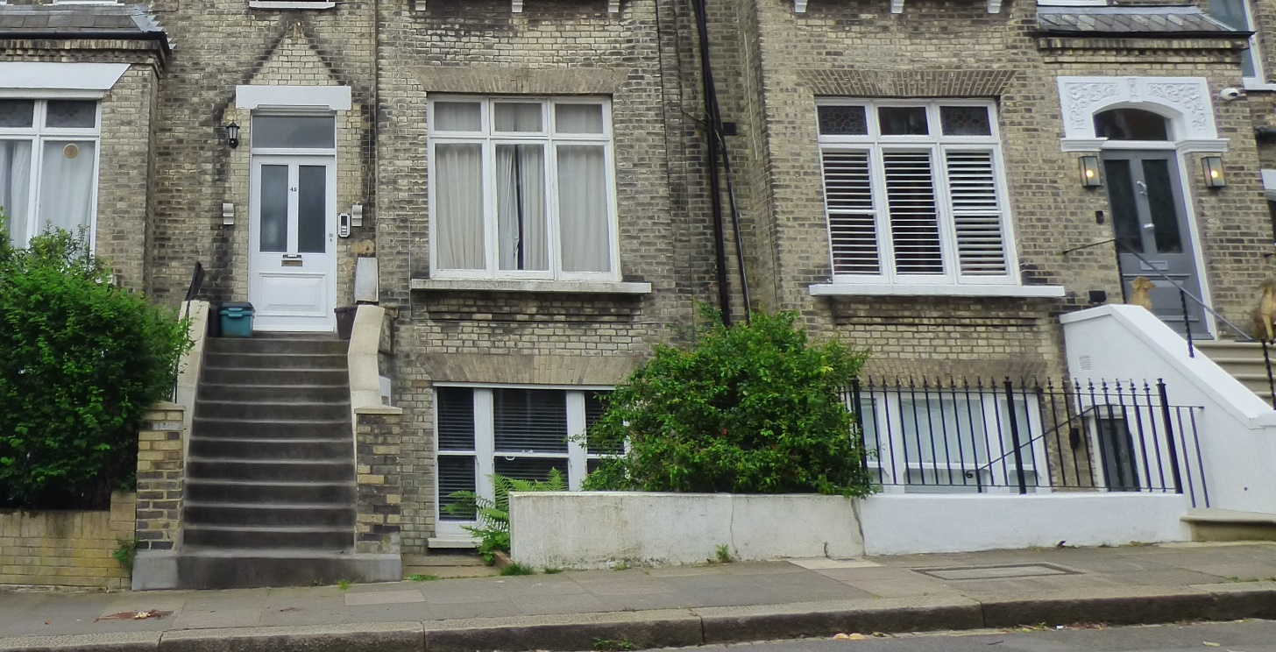

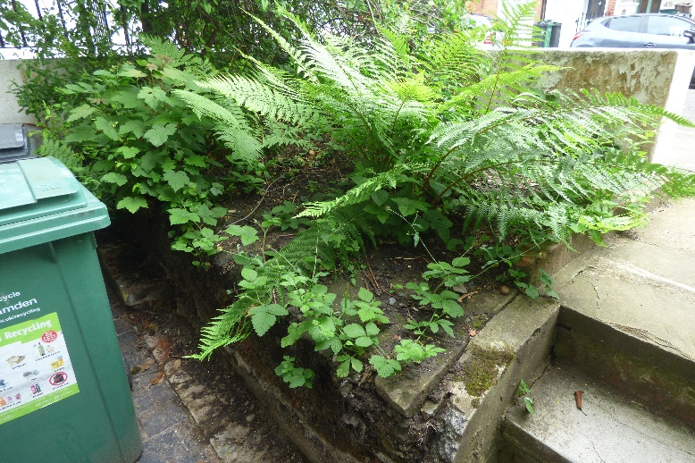 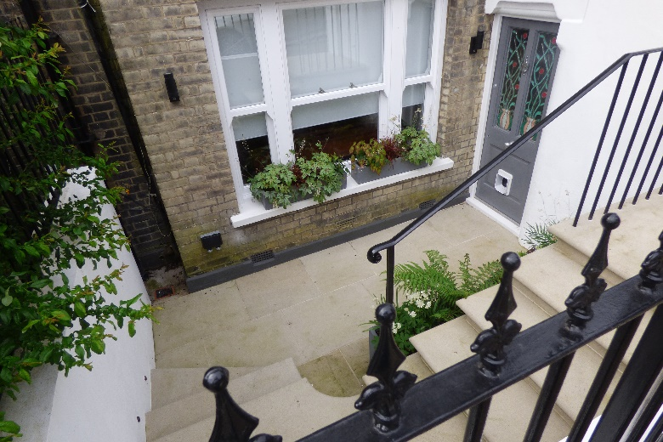

A retaining wall in the front garden behind the shrubbery (photo on left) has already been removed and we are concerned that the plan is for the shrubbery and the entire bed here, including all its soil, to be removed and entirely paved over, with shrubs in pots as has been done to its semi-detached neighbour at 40 Denning Road (photo on right).

If these are planned for this development, then the owner and Camden need to consider the emerging Draft Camden Local Plan 2024 and emerging revision of the Hampstead Neighbourhood Plan (eHNPR) that has completed its public consultation and health check by planning examiner. Both of these were in the public domain before this application was submitted and require that

1) Garden reduction takes into account eHNPR Policy NE1: ‘Supporting biodiversity and mitigating climate change’ particularly in relation to BNG:

1. The Plan supports development that provides a minimum of 10% Biodiversity Net Gain (BNG). The following should be included as part of the design of the scheme where feasible:

a) Increasing canopy cover and volume as part of any landscaping scheme.

b) Increasing biomass through the planting of hedges and shrubs and necromass through establishing wood piles and other dead plant life.

e) The protection or enhancement of the status or population of priority habitats, species, and wildlife movement.

f) Increasing the area of permeable surfaces, particularly those that include biodiversity-enhancing features, and reducing the area of impermeable surfaces, including artificial grass.

2) Landscaping of the front and rear gardens is done according to eHNPR Policy DH3 Sustainable development Policy 3c:

'Maintaining, restoring, and where possible, increasing permeable surface areas.

Applicants should slow water run-off, using a sustainable drainage system where appropriate, such as attenuation tanks.’

and para 3.39:

'Developments that remove soil, as for foundations for extensions, basements, etc., should mitigate for loss of water absorption by use of attenuation tanks and/or by removing hardstanding elsewhere on site.'

This means that an existing and proposed landscape plan are recommended (currently missing), indicating how they are going to increase BNG and permeable surfaces, and fit in a storm water attenuation tank.

We would also be concerned that the character of the front and rear gardens with their brick walls, including the curved rear garden retaining wall are lost to the Conservation Area if these are not rebuilt as before:

Hampstead Conservation Area Statement page 57: FRONT BOUNDARIES/OPEN SPACE

Alterations to the front boundaries between the pavement and properties can dramatically affect and harm the character of the Conservation Area. Brick walls and piers, railings and hedges are enormously important to the streetscape and there is a rich variety of detail and materials in the area. There are a number of styles of front boundaries referred to in the text and these distinctive and attractive features should be retained and restored where they have been lost. A number of front gardens have been turned into parking areas and what should be a soft landscape with a path, possibly tiled, becomes a hard surface. The principle is not acceptable and further loss will be resisted.

While it seems that there is some precedent for garden removal along this side of the road, now that Climate Change is upon us with both storm flooding and periods of very high temperatures, as well as a huge loss in Biodiversity and Environmental degradation, the National Planning Policy Framework, Environment Act 2021, the Camden Local Plan, the Hampstead Neighbourhood Plan - and the Heath & Hampstead Society - now support a more environmentally-sustainable and climate-resilient approach to development.

We request that Camden require some further plans to indicate how the applicant plans to consider these factors in this development.

David Castle, Chair of Planning Sub-Committee, Heath & Hampstead Society