Dickinson House, 46 Highgate West Hill, LONDON N6 6DB
Application Number: 2024/1258L
Application Registered: 29-04-2024

Heritage Statement – Section 3: photographic back up

DH1
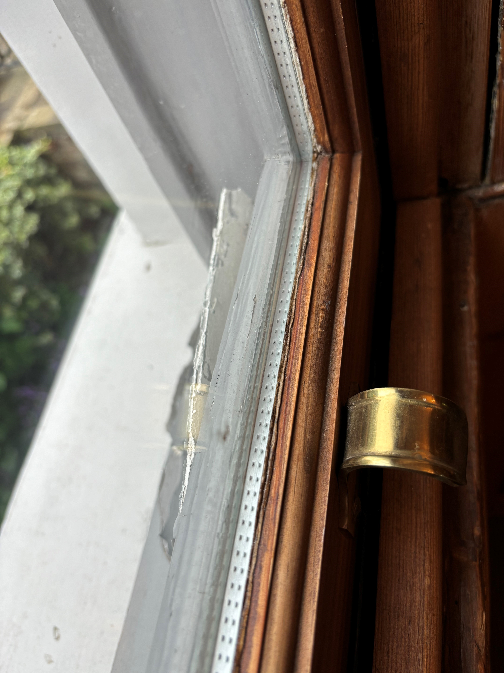

DH2 and DH3 [below]
