**HERITAGE STATEMENT**

**THE BRITISH LIBRARY**

**96 EUSTON ROAD**

**LONDON NW1 2DB**

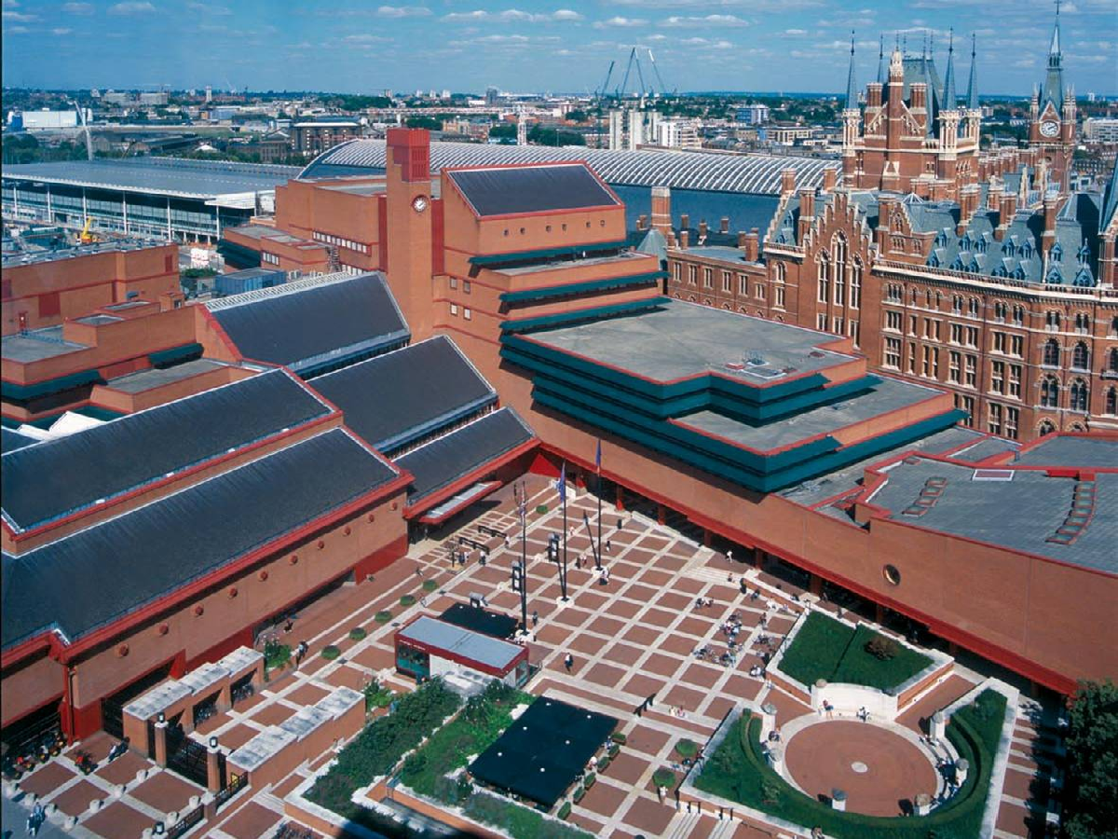

**Prepared by:**

**MALCOLM WOODS**

**Grad Dipl Cons (AA)**

**IHBC (ret’d)**

**March2024**

**INTRODUCTION**

This statement has been drawn up to consider the heritage impact of proposals to upgrade telecommunications equipment on the building on Euston Road in London that is home to The British Library.

The author is Malcolm Woods Grad Dipl Cons AA IHBC(ret’d). For 23 years until early retirement in 2012, he was an Historic Buildings and Areas Adviser in the London Region of English Heritage (now Historic England) dealing with a wide range of proposals affecting principally Grade I and Grade II* listed buildings and developments affecting conservation areas. He is conservation adviser to the Royal Greenwich Heritage Trust and is a member of the Trust’s Capital Works Committee; he currently chairs Chelmsford Diocesan Advisory Committee; and he is the heritage adviser to the Southern Historic Churches Committee of the Roman Catholic Church.

Using the National Planning Policy Framework as a guide, this document seeks to assess the potential impact of the proposals upon this designated heritage asset and any other designated heritage assets in the vicinity.

## THE SITE

## The British Library is housed in a purpose designed building that stands on the north side of Euston Road between Ossulston Street and Midland Road. The building was designed by (Sir) Colin St John Wilson, with M.J.Long, Douglas Lanham, John Collier, John Honer and many more and was completed in 1999 having opened two years earlier. Along with St Pancras Station and Kings Cross Station, the British Library building forms a trio of major public buildings along this stretch of Euston Road. The British Library, piazza, boundary wall and railings to Ossulston Street, Euston Road and Midland Road was added to the National Heritage List for England at Grade I on 31st July 2015. However, it is not in a conservation area although the boundary of the Kings Cross/St Pancras Conservation Area runs down the centreline of Midland Road.

**THE PROPOSAL**

The proposal is to upgrade the existing telecommunications installation.

**HERITAGE ASSESSMENT**

‘Conservation Principles, Policies and Guidance for the sustainable management of the historic environment’ (English Heritage, April 2008) describes a number of ‘heritage values’ that may be present in a ‘significant place’. These are evidential, historical, aesthetic and communal value. ‘Heritage significance’ and ‘heritage values’ are assumed to be conceptually equivalent to each other, and both to the statutory term the ‘special architectural or historic interest’ of listed buildings or conservation areas. The heritage significance of the site and its surroundings.

As the most important public building in this country in the last quarter of the 20th century, the British Library has evident special architectural and historic interest. Sir Colin St John Wilson’s stately yet accessible design incorporates fine materials and a generous display of public art. The Library’s dramatic and carefully considered interiors achieve its ultimate goal: of creating a space to inspire thought and learning. The building clearly has significant aesthetic value and its very function as the national library of the United Kingdom means that it has significant communal value.

**THE POLICY CONTEXT**

In considering the impact of proposals upon designated heritage assets including listed buildings and conservation areas, paragraphs 206 to 208 (inclusive) the National Planning Policy Framework (NPPF) as revised in December 2023 has this to say about how any such impacts should be assessed:

***206.****Any harm to, or loss of, the significance of a designated heritage asset (from its alteration or destruction, or from development within its setting), should require clear and convincing justification. Substantial harm to or loss of:*

*(a) grade II listed buildings, or grade II registered parks or gardens, should be exceptional;*

*(b) assets of the highest significance, notably scheduled monuments, protected wreck sites, registered battlefields, grade I and II* listed buildings, grade I and II* registered parks and gardens, and World Heritage Sites, should be wholly exceptional.*

***207.****Where a proposed development will lead to substantial harm to (or total loss of significance of) a designated heritage asset, local planning authorities should refuse consent, unless it can be demonstrated that the substantial harm or total loss is necessary to achieve substantial public benefits that outweigh that harm or loss, or all of the following apply:*

*(a) the nature of the heritage asset prevents all reasonable uses of the site; and*

*(b) no viable use of the heritage asset itself can be found in the medium term through appropriate marketing that will enable its conservation; and*

*(c) conservation by grant-funding or some form of not for profit, charitable or public ownership is demonstrably not possible; and*

*(d) the harm or loss is outweighed by the benefit of bringing the site back into use.*

***208.****Where a development proposal will lead to less than substantial harm to the significance of a designated heritage asset, this harm should be weighed against the public benefits of the proposal including, where appropriate, securing its optimum viable use.*

In addition, Section 10 of the NPPF sets out the government’s policy with regard to “Supporting high quality communications” and it opens with this statement, ***“****Advanced, high quality and reliable communications infrastructure is essential for economic growth and social well-being. Planning policies and decisions should support the expansion of electronic communications networks, including next generation mobile technology (such as 5G) and full fibre broadband connections.”*

The London Borough of Camden’s Local Plan was adopted on 3rd July 2017 and Section 7 of the plan relates specifically to Design and Heritage, the latter being covered under Policy D2, which very much reflects the Government’s own policy as set out in the NPPF, opens as follows:

“*Designated heritage assets ~ Designated heritage assets include conservation areas and listed buildings. The Council will not permit the loss of or substantial harm to a designated heritage asset, including conservation areas and Listed Buildings, unless it can be demonstrated that the substantial harm or loss is necessary to achieve substantial public benefits that outweigh that harm or loss, or all of the following apply: a. the nature of the heritage asset prevents all reasonable uses of the site; b. no viable use of the heritage asset itself can be found in the medium term through appropriate marketing that will enable its conservation; c. conservation by grant-funding or some form of charitable or public ownership is demonstrably not possible; and d. the harm or loss is outweighed by the benefit of bringing the site back into use.*

*The Council will not permit development that results in harm that is less than substantial to the significance of a designated heritage asset unless the public benefits of the proposal convincingly outweigh that harm.”*

Policy D2 has a section specifically devoted to listed buildings as follows:

*Listed Buildings - Listed buildings are designated heritage assets and this section should be read in conjunction with the section above headed ‘designated heritage assets’. To preserve or enhance the borough’s listed buildings, the Council will:*

*\* resist the total or substantial demolition of a listed building;*

*\* resist proposals for a change of use or alterations and extensions to a listed building where this would cause harm to the special architectural and historic interest of the building; and*

*\* resist development that would cause harm to significance of a listed building through an effect on its setting*

Finally, in March 2018, Camden Council issued a planning guidance note entitled “Digital Infrastructure. This note contains the follow guidance with regard to telecommunications equipment:

*Proposals for the installation of telecommunications equipment such as masts, cabinet boxes and satellite dishes, erecting antennae or other such structures will be determined in accordance with the National Planning Policy Framework (NPPF) Section 5 – Supporting high quality infrastructure (paragraphs 42 to 46).*

*In line with the NPPF, the Council will support the expansion of electronic communications networks, including telecommunications and high speed broadband. Camden Planning Guidance: Digital Infrastructure 5*

*In particular, the Council will aim to keep the numbers of radio and telecommunications masts and the sites for such installations to a minimum consistent with the efficient operation of the network. Existing masts, buildings and other structures should be used unless the need for a new site has been demonstrated to the satisfaction of the Council. Where new sites are required, equipment should be sympathetically designed and appropriately camouflaged where possible.*

**DISCUSSION**

Given the substantial size of the British Library complex, it is perhaps not surprising that one the high roof areas of the tall northerly blocks facing onto Midland Road (see below, outlined in red) has been used as a site for mobile telecommunications equipment since 2008 – i.e. seven years prior to the building being listed - when an application was approved for 6 antennas in three groups of two. Five years later, in 2013, an upgrade took place to remove the original antennas and replace them with 3 antenna arrays. With the development of technology, it is now time for a further upgrade of the installation to manage 5g signals. It is therefore proposed to remove the existing antennas and replace them with three upgraded antenna arrays in the same locations as the present equipment on three of the four corners of the roof to the rear block of the library. The other rooftop equipment cabinets etc will also be updated.

**The area of roof upon which the existing equipment is located**

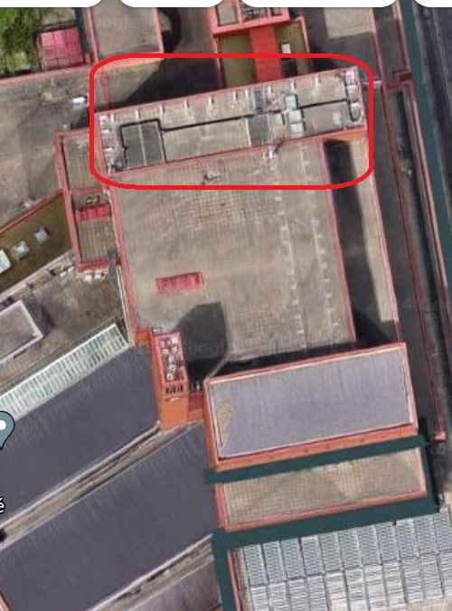

Given that the original installation of telecommunications equipment pre-dates the listing of the building, it follows that the equipment that is there now is part of the listed building by virtue of Section 1(5) of The Planning (Listed Buildings and Conservation Areas) Act 1990, vis **“***In this Act “listed building” means a building which is for the time being included in a list compiled or approved by the Secretary of State under this section; and for the purposes of this Act – (a) any object or structure fixed to the building.”* Clearly, to upgrade the installation again, listed building consent is required since this constitutes an alteration to the listed building. However, the impact of this upgrade upon the character and appearance of the designated heritage asset us minimal since the proposal calls for simply substituting one set of aerial arrays for another. There will inevitably be a change in shape and size (in the case of the latter a modest increase in size) but given the bulk and massing of the host building, these changes will be hardly discernible from the public domain in and around the site given the height of the roof to which the equipment is fixed. It is reasonable to conclude therefore that the impact of the changes proposed will cause significantly less than substantial harm to the designated heritage asset, a level of harm that will be significantly outweighed by delivery reliable 5g signals to this part of the borough.

**CONCLUSION**

As the Government’s advice in its *Factsheet 6: 5g* published on 24 November 2020 points out, “The UK is one of the most technologically advanced countries in the world, and 5G is the natural next step in progressing our society’s digital journey. The increased connectivity and capacity offered by 5G is opening up the potential for new, innovative services for individuals and industry.” In addition, the NPPF positively encourages local planning authorities to support the provision of the next generation of mobile technology. To this end, Camden’s guidance specifically encourages, “Existing masts, buildings and other structures should be used” for the installation of telecommunications equipment. This application to upgrade an existing installation is part of that process and whilst it involves work to a grade I listed building, the impact of these necessary works upon the character and appearance of the designated heritage asset will be so slight as to effectively be neutral.

Malcolm Woods

March 2024

**THE BRITISH LIBRARY – LIST DESCRIPTION**

Public Library, the present design based on that of 1975-8, built 1982-99, though opened in 1997; architect (Sir) Colin St John Wilson, with M.J.Long, Douglas Lanham, John Collier, John Honer and many more. The structural engineers were Ove Arup and Partners, with mechanical engineering services from Steensen Varming and Mulcahy and quantity surveyors Davis Langdon and Everest. William Lam advised on lighting.  
  
The Conservation Centre: although attached to the rear north elevation (Long and Kentish, 2006), the centre is a separate building and very recent in date. It is not part of the special interest of the Library.  
  
Works of art: some significant internal and external works of art associated with the design of the library, contemporary with its completion and opening, and supported by outside sponsorship are of special interest and included in the listing. Where this is the case, these are specifically mentioned in the List entry. Other free-standing or ‘curated’ works are not included.  
  
STRUCTURE AND MATERIALS  
  
The building has a concrete frame, based on 7.8m x 7.8m column centres, clad inside and out in red brick (hand-made, sand-faced dark Victorian Reds from Leicestershire) laid in stretcher bond, chosen because they were made of the same clay as those used for the adjoining St Pancras Station and Hotel immediately to the east. In a contrasting red to the brick there are metal sills and cornice bands, and cladding to the columns, the latter with stylized classical motifs, and dark green metal fascias to the science rooms, colours inspired by the adjacent St Pancras Station and Hotel. Special stainless steel wall ties allow vertical movement between the series of sub-frames and the brick skin. There is a granite plinth to the Midland Road elevation, with plaster and panelling contrasted with brick and tile within; external columns are clad in steel. The stepped roofs are slate-covered, again akin to St Pancras Hotel, contrasting with the steel screens shielding the clerestory glazing. The brick and stone paviours to the forecourt are continued within the building.  
  
Interior joinery throughout is in American White Oak, with maple used only in the Conference Centre. The floor and wall finishes are of Travertine, Portland Whitbed, and Purbeck limestone, with contrasting Travertine and brick paviours on the ground floor of the atrium. In general the door furniture and stair handrails are in brass, the latter over bound with leather, with a bronze structure to the King’s Library.  
  
PLAN  
  
The building comprises two main blocks of libraries above ground, linked by a central entrance range, with a large piazza over four tiers of basement stacks on piled foundations, and small additions to the rear. The basement is divided by the tunnels of the Northern and Victoria Lines, with resilient bearings separating the conference centre structure from the Hammersmith and City/Circle Lines. The frontage parallel to Euston Road contains the main entrance and atrium, with the King’s Library and restaurants behind; to the west (left) are the humanities, rare books and music libraries; to the east (right) the science and patent libraries adjoin the conference centre (with its own entrance) parallel to Midland Road, making an acute angle, with a vertical clock tower containing service shafts between the west block and entrance range. Additional public and staff entrances are along Midland Road.  
  
EXTERIOR  
  
The south elevation facing the piazza includes the main ENTRANCE. Steps lead to the sliding entrance doors, set at grade under a canopy with a display window to the gift shop to the left; the ramp to the right of the steps was constructed in 2014. To the left (west) of the entrance, each panel of the five-bay, four-storey frontage (housing internally the exhibition rooms and shop), has two metal roundels, above which is an additional step and clerestory to the roof. The western block is itself divided into two six-bay blocks, each of six bays, to the west with double-stepped pitched roofs, and a flat roof to the raised set-back block in between.  
  
A ten-bay block to the east (right) rises to six main storeys with staff facilities behind, its height determined in relation to the hotel and station across the road to the east; panels of brushed metal sun shields are repeated on the east and west elevations. The CLOCK TOWER rises above the junction between the east block and the stepped roofscape of the entrance. The clock near to the apex faces south with stepped brick and red metal detailing above. Feature spotlighting added to the base of the clock tower in 2014 is not of special interest.  
  
The CONFERENCE CENTRE adjoins seamlessly to the south, its entrance at the forecourt elevation, with a large porthole opening above to light the stairs within, and its raked pent roof-line presenting a bold face to Euston Road, broken by two bands of projecting triple-glazed fenestration with sun screens at the south-east corner. To Euston Road, a modest kiosk café and an undercover ramp (added in 2010) that leads through to the piazza are not of special interest. On the Midland Road elevation a colonnade, with metal railings in between, rises from a Royken granite plinth and supports the projecting and stepped east wing above with long strip windows defined by louvred metal sun screens and interrupted by a projecting ‘V’-shaped staircase ‘oriel’ window; the soffit is coffered. The north elevation has landscaped roof terraces incorporating a circular pergola and a projecting stair tower.  
  
The rear (north) elevation was intended by Wilson to allow for further phases of building (see history above). It has a series of stepped terraces repeating the same idiom of brick panels and paviours, with planters and a square-patterned trellis and balustrade somewhat reminiscent of Frank Lloyd Wright. There is a broad public terrace with planting boxes leading out from the large staff restaurant, which has a fully-glazed facade shielded by metal screens; above it is an enclosed terrace, including a circular pergola surrounding fixed wooden seating.  
  
The west elevation (to Ossulston Street) and rear elevation of the western block is supported on red columns with deep bracketed eaves and has a stepped roof; an external circular escape stair for the humanities reading room, constructed with radial bricks, is attached to the rear.  
  
Despite the contrast of square and diagonal, the structure of the two blocks is on a strong square grid, reminiscent of that which governs Wilson’s nos. 2 and 2a Granchester Road, Cambridge (a pair of houses of 1961-64, one of which with a studio for himself, listed at Grade II, NHLE ref 1392069), and which appears in details such as coffering, doors and screens, the supports of the uplighters, glazing, grilles and trellises. Common ingredients are set out in Stonehouse (2007).  
  
PIAZZA, PORTICO AND EXTERNAL ARTWORKS  
  
To the south (front) of the main entrance is a forecourt known as the piazza with brick paviours set within a grid of limestone slabs that includes steps, raised levels and a rotunda defined by walls topped with granite boulders at the entrances; Sir Antony Gormley’s ‘Planets’ installation of 2002, noted but at the time of the inspection (2015) but is not part of the special interest of the building. There are flag poles and a temporary, free-standing café on the piazza; neither the café here* nor other cafes* within the building’s envelope, or the flagpoles* are included in the listing. DDA compliant handrails have been added in a number of places and are not of special interest. A raised plinth at the point of intersection between the main south and angled, ramped south-eastern entrance incorporates Eduardo Paolozzi’s Newton (after Blake), installed in 1995, an integral part of Wilson’s composition and made by the Morris Singer Foundry with raised planting behind. Feature lighting for Newton, with an associated plinth made by East Coast Casting, was added in 2014 and is not part of the special interest of the building. To the south on the Euston Road entrance, the square brick entrance gateway, known as the Portico, forms a rectangular frame to an angled entrance, with a stone panel incised with the name ‘The British Library’ repeated in the pattern of the iron gates and their high overthrow, by David Kindersley and Lida Cardozo. The bronze chair, Witness, by Sir Antony Gormley, installed in 2011, is noted but is not part of the special interest of the building.  
  
INTERIOR  
  
The interior of the Library combines quiet, top-lit reading rooms in the west and east blocks joined centrally by a complex space of multiple entrance concourses arranged in terraces organised with the King’s Library at the core.  
  
Freestanding furniture throughout is noted because it was designed by the architects (with Reading Room chairs by Ron Carter) but cannot be included in the listing. Fixed furniture is included in the listing unless stated otherwise.  
  
Interior artworks: the British Library retains numerous works of art as part of their collections, some of which are displayed within the building. However, for ease of their curation, and in recognition that they may be donated items, these works of art* are not included in the listing, although purpose-built architectural elements for housing them may be included and will be specified.  
  
PUBLIC REALM  
  
Entrance and catering areas: bronze sliding and double entrance doors lead to a low vestibule with shop and exhibition halls to the west (left), from which stairs rise to an atrium on four main levels with galleries reached off dog-leg stairs to left, a ramp and a more dramatic spiral stair to right, set behind stairs to the lower ground and a low fountain. Travertine columns contrast with Portland limestone floors in two colours; internal porthole openings light the spaces to the right. The cyma curve roof incorporates clerestory glazing with top lighting to the rear and inset spots; the hanging lights are by Juha Leviska. The central control desk divides access to this main space into two. The main foyer at ground level is defined by built-in seating and balustrading of travertine, with plant troughs. A bronze chair* by Gormley, was installed on the ground floor c.2012 but is not part of the special interest of the building.  
  
The lower ground floor has travertine columns, beams, dado and lift surrounds (as repeated in the rest of the building), limestone and brick paviour floors. The cloakroom has a sinuous counter * and banks of oak lockers* are attached to the walls; these are not included in the listing. Access to offices lie through double doors to the left. Fixed sculptures integral with the building are Anne Frank by Doreen Kern was installed in this location in 2003 and is not of special interest. Paradoxymoron is a painting of 1996 by Patrick Hughes. The reconfigured education space* on this floor is not included in the listing.  
  
To the centre of the ground floor are sets of escalators next to the stairs of limestone with Travertine balustrades leading to the Upper Ground Level and Level 1; handrails – like the door handles – here and through the building are wrapped in leather with brass curves, inspired by those of Gunnar Asplund and Alvar Aalto. In the lift lobby at Upper Ground Level is a model * of the Library set on a plinth*, cut to reveal the basement stacks below the piazza, which is not included in the listing.  
  
There is much art on display in the entrance atrium. A wall tapestry, conceived as part of Wilson’s original design, based on R. B. Kitaj’s If Not, Not, made by Edinburgh Weavers was moved to the side of the front entrance in 2013. A statue of Shakespeare* (a replica based on that by Roubiliac 1758) stands to the left of the stairs to the west wing above a stepped, inscribed plinth marking the opening of the Library by Queen Elizabeth II on 25 June 1998. On the west wall of the atrium, four busts* in red steel roundels of the donors to the collections (Sir Thomas Grenville, Joesph Banks, Sir Robert Cotton and Sir Hans Sloane) are also replicas. The statue of Shakespeare* and busts of the donors* are noted because of their prominence in the atrium but are replicas and are not included in the listing although their architectural plinths are included.  
  
Banks of lifts serve the two sets of reading rooms either side of the atrium, the lobbies of which have travertine detailing and limestone borders to the carpeted floors. All carpet* is of standard contract range and not included in the listing. All lifts* in the library are utilitarian and are not included in the listing. Other balustrading is formed of simple steel uprights with a brass top rail. There is built-in bench seating within travertine walls, and black fossil limestone paving to the rear gallery serving the cafe at Upper Ground Level, with kitchen and staff restaurants behind on Level 1, separated by oak doors and louvres. The fixtures* and fittings* of all catering areas, restaurants and lounges for both public and staff use, including seating*, counters*, vending equipment and kitchen equipment*, are not included in the listing.  
  
A belvedere at Level 1 gives views across the foyer. Two more floors above this level have walkways and balconies at the rear over the entrance to the servery. A corridor, with a built-in travertine seat, leads to the staff restaurant and outside terraces for staff and public, including the pergola garden. Limestone floors also serve the lower restaurant area, the stair to which has a built-in travertine handrail and inset lights; there are travertine stall risers to the servery.  
  
Exhibitions: at the Upper Ground floor of the western range, beneath the Rare Books Library, is the Sir John Ritblat Gallery, a permanent display of the ‘Treasures of the British Library’, with a central service core and concrete columns with afromosia veneer coating. Here there is a combination of free standing temporary cases which not of special interest and, attached to the enclosing walls, permanent cases contemporary with the building. Stairs lead down to the Paccar Gallery for temporary exhibitions, which partly underlies the ‘Treasures’ exhibition, with access points from both the Ground and Lower Ground floors; the wall partitions in the Paccar exhibition and the stairs between the Paccar and Treasures exhibition spaces* are functional and do not form part of the listing. The adjacent exhibition workshops* are classed as office areas and are not included in the listing. Stairs with travertine risers and steel and brass handrails lead down from the ground floor to the Paccar Exhibition space but beyond this point the exhibition partition walls*, fixtures* and fittings* are temporary, not fixed and not included in the listing. At the Upper Ground floor, to the rear of the foyer, is a temporary exhibition area, again with free standing fittings, masking the view of the King’s Library at this point; the exhibition panels* and structure* are not included in the listing because of their temporary nature.  
  
Shop and Box office: flanking each side of the atrium’s ground floor, both the shop* and box office* have C21 shop fronts* and fittings* and are not included in the listing.  
  
Reader Registration* is a remodelled office area at Upper Ground level which is not included in the listing. Toilets* for staff and public throughout the building are utilitarian and are not included in the listing.  
  
READING ROOMS AND THE KING'S LIBRARY  
  
There are 11 reading rooms in total, divided broadly into humanities on Levels 1 to 3 in the west block, fronting Ossulston Road, and science in the east block on Levels 1 to 3, fronting Midland Road.  
  
King’s Library: rising in the centre of the building behind the foyer, the King’s Library is accessed from a bridge over a narrow ‘moat’ at the Upper Ground floor through heavy bronze double doors. It is a six-storey glazed casket, served by an internal lift and escape stairs, with an independent structure comprising a bronze framed curtain wall set within a trough or moat, travertine walled with a glass balustrade and black marble base. Wilson described it (1998, references below) as ‘an object in its own right … simultaneously a celebration of beautifully bound books, a towering gesture that announces the invisible presence of treasures housed below and a hard-working sources of material studied in presence of treasures houses below and a hard-working source of material studied the Rare Book Reading Room opposite: the symbolic is at one with the use’. The books are placed on outward-facing shelving as close to the glass as is feasible, on stacks which move inwards while allowing air movement for the preservation of the books, so that the bindings can be enjoyed. Subtle lighting within alternate mullions inside the cases highlights the bindings. At the centre are fixed stacks. There is a bust of George III* by Peter Turnerelli,1812 on a black marble plinth, of note, but not included in the listing.  
  
Humanities Reading Room: access to the Humanities Reading Room is at level 1 in the west block. This lofty, triple-height and essentially square space, receives generous daylight through rooflights and clerestories with a coved ceiling sweeping up to the top-floor clerestory. Inserted on two sides are the two projecting and stepped upper floors, enclosed by giant square piers accessed by internal timber-lined stairs; the third being the map room. The piers are panelled to shoulder height in American White Oak incised with delicate lines, imitating fluting; all timber detailing used for the balustrades, desks and wall shelving and joinery is American White Oak. The pierced oak balustrading to the upper floors has elongated stanchions, repeated as a vertical motif in the cornice that makes a feature of the air ducts and lighting troughs below, and countered by the multiple vertical shafts of the up-lighters; the built-in oak desks have square patterns incorporating lights and sockets, and brushed black steel built-in lights. Other finishes are in impact-resistant, glass reinforced gypsum (GRG) rather than plaster, for ease of maintenance, plain or sparely detailed with stylized classical motifs with Japanese overtones. All these square and vertical patterns have sources in Frank Lloyd Wright, whose Robie House Wilson particularly admired. This plan form derives from that of Leslie Martin’s Law Library at St Cross, Oxford, designed in association with Wilson and built in 1959-63. The Control and issue desks match the American White Oak panelling and shelving of the walls, and like the desks and chairs are by the architects. The chairs are not fixed, thus are ineligible for listing, but the reading desks, with leather tops, mostly are; some are modified for DDA compliance, others altered to take computer processor units with additional electrical supply for lap-tops.  
  
Adjacent to Humanities is the Rare Books and Music Reading Room, with the Manuscript Reading Room on the single balcony above. The details here are repeated on a more modest scale, with conoid-topped columns and flatter slopes to the ceiling. Carrels or sound booths against the perimeter wall are built in to the music library, originally, it is said to accommodate those wishing to use portable type writers; the film reader room is alongside. Doors throughout the reading rooms are of American White Oak with brass and bound leather handles, glazed to the booths and film-reader room.  
  
Science Reading Rooms: the eastern block housing the science and social science collections is on three floors, topped by a coffered ceiling that is upswept to the top of the main windows, with a balustrade protecting the ducting below. On the other side are two stepped back galleries with broad timber ledges topped by brass handrails. To the street (Midland Road) it has large, continuous side windows, with in between carrels, desks and a connecting stair with glass balustrades. There are more bookcases for material on open shelves than is found in the humanities libraries; those in freestanding, moveable units* are not included in the listing. There are broad timber ledges to the balconies. Control and issue desks match the oak panelling and shelving of the walls, and like the tables and chairs (not fixed, and the same as those in the humanities reading rooms and not included in the listing) are designed by the architects. Some additional internal glass partitioning was added in 2012 and is not of special interest.  
  
Business and IP Centre: on Level 1 of the east block, formerly a science reading room, the Business and IP Centre has a modernised entrance foyer and inserted glass meeting rooms; the foyer and meeting room partitions* are not included in the listing. The high windows are over-built in shelving and a single gallery whose balustrade is lined in timber (former Science North reading room), linked by a spiral stair (also with a timber balustrade) and with shelving on both levels. Ducts form a cornice, the square columns are timber lined to dado height, and there are built-in desks, not all with reading lamps; the wall shelving is lit with downlights.  
  
Newsroom: on Level 2 in the east block, the newsroom created from a former science reading room in 2014, has a reconfigured foyer* and renewed fixtures* and fittings* and a digital screen* installed. It is not included in the listing.  
  
Asian and African Studies Reading Room: on Level 3 in the east block, formerly the Indian Office Library, is a double-height space so that the historic picture collection can be hung. The fittings are similar to those in the other Reading Rooms.  
  
OFFICES AND BASEMENT  
  
The staff offices are located to the rear of the east and central blocks, the principal entrance being the staff entrance gate (gate 8) from Midland Road. The offices* are adaptable spaces with standard furniture*, fixtures* and fittings* and are not included in the listing with the exception of the 4th Floor Executive office which is included in the listing as a representative example.  
  
Access to the reading rooms and public realm is via stairs to the rear and lifts; there are no notable fixtures and fittings here except for the carved, timber war memorial to all Library Association librarians from the Commonwealth lost in the First and Second World Wars which is fixed to the wall opposite the main lifts to the science reading rooms and is included in the listing. At the rear also is the staff restaurant with timber dado repeated in the maple battens fixed to the bases of circular columns and hanging lights by Louis Poulsen. On Level 4 of the east block is the Board room and its adjacent Executive Office suite, a ‘staff’ area with meticulous travertine and American White Oak finishes; the Board room furniture is by Ron Carter and where fixed is included in the listing.  
  
Beneath the piazza are four vast basement floors* with overpainted brick walls, mechanical and motorised stacking and secure pens for rare and valuable items. On Basement level two is the control room for the Mechanical Book Handling System (MBHS), a bespoke conveyor belt system transporting items in trays to and from the basement to the reading rooms’ service desks via lifts. As part of the integral design of the Library the basements and MBHS are noted here, but none of the basement levels*, their fixtures and fittings* are included in the listing. Collection item storage areas* on other floors, including large areas of the Lower Ground Floor, Manuscripts and Philatelic Storage Rooms are not included in the listing.  
  
Loading bays*, plantrooms*, cores*, lift-shafts*, and other utility and service areas* are not of special interest and are not included in the listing.  
  
CONFERENCE CENTRE  
  
Refurbished in 2010, the centre serves the Library and external functions and is entered from the forecourt through bronze doors, with lower and upper foyers, served by a travertine lined stair well, the treads in Purbeck marble and Portland stone. The lift wall and dado are in travertine with limestone floors and maple joinery. There is a 250-seat auditorium accessed on two levels (seating recovered in 2010) and four seminar rooms seating 20-65 people, of these only the double-height Elliott Room is of special interest; the others have standard fixtures* and fittings*. A large foyer with a bar is reached by a broad travertine-lined stair incorporating built-in seating, and leather-bound brass handrails, dubbed the ‘Spanish Steps’ by Wilson to denote his intention that they be a meeting and conversation place. The toilets* and cloakroom* are not included in the listing.  
  
SUBSIDIARY FEATURES  
  
The entrance adjoins walls to Euston Road and Ossulston Street; the latter has two pairs of set-back gates, the first into the forecourt, the second to the rear of the western wing, and railings set on a low, stone-capped wall with brick piers. The semi-circular planters* to the Euston Road frontage and railings between and including Gate 10 and Gate 9* fronting Midland Road (installed in 2008) are not included in the listing.