DESIGN AND ACCESS
- Site Details

Site Name: | Somers Town | Site Address: | The British Library  St. Pancras  96 Euston Road  London  NW1 2DB
National Grid Reference: | E: 530008 N: 182927
Site Ref Number: | Cornerstone 13656331 | Site Type: | Macro

- Pre Application Check List

Site Selection

Was a local planning authority mast register available to check for suitable sites by the operator or the local planning authority? |  | No
If no explain why:

After a phone call to the LPA it was established the council do not hold this information.

Were industry site databases checked for suitable sites by the operator: | Yes
If no explain why:

Site Specific Pre-application consultation with local planning authority

Was there pre-application contact: | Yes
Date of pre-application contact: | 08/02/2024
Name of contact: | The Director of Planning
Summary of outcome/Main issues raised:

Prior to the submission of this application the applicant-initiated pre-consultation discussions with the local planning authority. This provides an opportunity for the LPA to discuss development proposals and identify site specific issues.

No comments were received in respect to the consultation submitted at the time of submission.
Annual area wide information to planning authority

Has annual area wide information been provided? | No
If no explain why:

Summary issues raised:

Cornerstones commercial relationship with VMO2 has changed, effectively increasing our independence to work with other companies in the deployment of mobile infrastructure. It means we no longer have visibility of VMO2’s full update plan. However, Cornerstone is fully committed to working closely with Local Planning Authorities and following best practice guidance.

We aim to engage and work with the planning department at the earliest opportunity from when we are instructed to deliver new infrastructure within your Local Authority area and often conduct strategic pre-rollout engagement meetings to discuss our wider rollout. If your Local Authority would like a meeting to discuss wider Cornerstone rollout plans then please advise. We recognise the importance of developing long term partnerships and will always work with you to deliver improved mobile connectivity.

Community Consultation

Rating of Site under Traffic Light Model: |  |  | Green
Outline of consultation carried out:
Consultation with the local Ward Councillors for St Pancras & Somers Town Ward (Councillors Shah Miah, Edmund Frondigoun and Samata Khatoon)

Summary of outcome/main issues raised:

No site-specific responses had been received at the time of submission.

School/College

Location of site in relation to school/college:

There are no schools in close proximity as defined by the search criteria within the CoP.
Outline of consultation carried out with school/college:

N/A

Summary of outcome/main issues raised:

N/A
Civil Aviation Authority/Secretary of State for Defence/Aerodrome
Operator consultation

Will the structure be within 3km of an aerodrome or airfield? |  | No
Has the Civil Aviation Authority/Secretary of State for Defence/Aerodrome Operator been notified? |  | No
Details of response:

N/A

Site Provider Letter

Copy of Site Providers Letter enclosed? |  | Yes
Date served: | 08/03/2024 & 26/04/2024

- Proposed Development

The proposed site:
The current roof equipment at The British Library is being upgraded with limited visual impact but significant connectivity benefits. The existing site can be seen below in Figures 1&2 and is located on the rooftop of The British Library, St. Pancras, 96 Euston Road, London, NW1 2DB.

Proposed upgrade consists of the Proposed removal of existing 6No. Antennas and the Proposed installation of 9No. Antennas on proposed tripod support poles, 1No. GPS module, 2No. 300ᴓ dishes and associated ancillary works. This is a minor upgrade to an existing rooftop telecommunications installation that will provide significantly increased wireless connectivity to this area of London.

The existing telecoms site is located at St. Pancras, a vibrant and historically significant area in the heart of London. It is home to various landmarks and attractions, including St. Pancras International, a major railway station known for its stunning Victorian architecture and access to the Eurostar service; King's Cross Station and London Euston Station, important transportation hubs, connecting London to various destinations across the UK; The British Library, one of the world's largest libraries, housing a vast collection of books, manuscripts, and historical documents; Regent's Park which offers greenery and recreational spaces, including beautiful gardens, sports facilities and London Zoo and Camden Town which is just a short walk away home to wide-ranging markets, live music venues, and vibrant nightlife, attracting visitors from around the world. The St. Pancras area is bustling with activity, offering a blend of historic charm, cultural landmarks, and modern amenities, making it a lively and energetic part of London to live work and visit.

The Existing telecoms installation is located on the rooftop of The British Library opposite St Pancreas International Station on Euston Road. The British Library boasts 14 floors and is home to over 170million books and items. This tall building provides an ideal location to house the telecoms equipment to provide VMo2 coverage to this area of London.

As this area of London is a hub for travel; local and international, the area attracts many visitors throughout the year. A robust and reliable telecommunications network is essential for the smooth functioning of local businesses and the everyday lives of visitors and commuters in this area of London, with a greater demand for a wide range of telecommunication services. The proposed upgrade will ensure this infrastructure is upheld.

The surrounding area comprises of a mix of residential, commercial, and industrial spaces. While the site is located opposite St. Pancras International station and is close to King's Cross and London Euston stations, there are also residential pockets nearby. The closest residential properties are situated on Ossulston Street to the west of The British Library. Views of the installation from these properties will be restricted as the equipment is located on the northeastern rooftop of the library. Street-level views of the installation from surrounding streets will also be limited due to the minor upgrade and the similar positioning of the equipment compared to the existing setup.

Whilst the existing site does not lie within a conservation area, The British Library sits adjacent to the Kings Cross St Pancreas Conservation area. Views of the installation from the North along Midland Road from within the Conservation area, will remain minimal and in keeping with the existing rooftop furniture visible from here. Views of the rooftop installation from the East within the Conservation area will remain invisible from streetview, buildings and structures for example St Pancreas Station building provide screening of the installation. From the South of Midland Road the rooftop installation is visible to a degree. The installation assimilates well with the skyline ensuring minimal visual intrusion.

Views of the installation from the Northwest and Southeast will appear less cluttered on the rooftop whilst there will be minimal changes to the views from the Northeast and Southwest. The minimal street views are evidenced within the accompanying photomontage.

As previously stated, the proposed is an upgrade to an established rooftop telecommunication installation. This submission is purely to upgrade the existing site with new equipment to facilitate significantly increased coverage that will benefit residents, businesses and visitors to this area of London.

Figure 1:
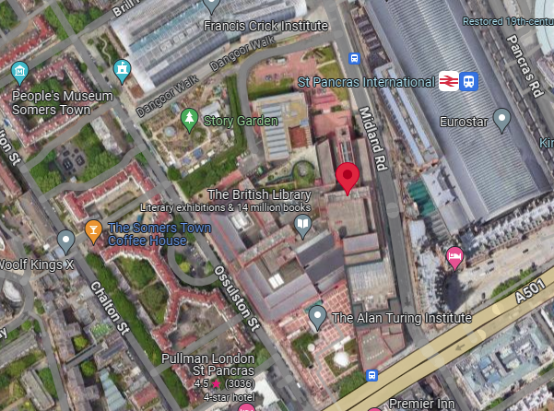

Figure 2:
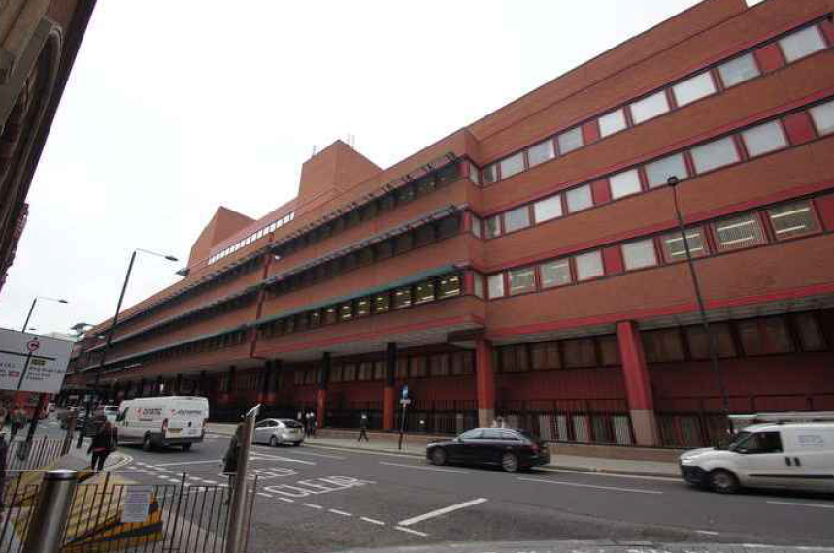

Figure 3
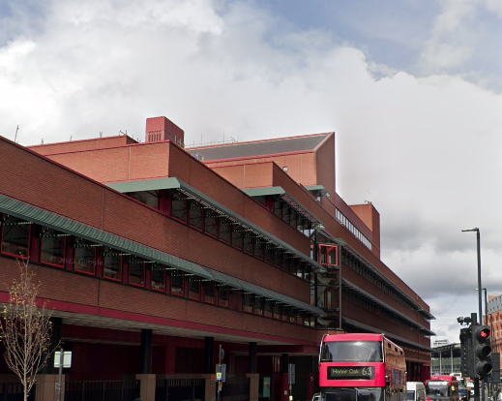

Heritage Information
This heritage section has been prepared as part of the planning application for an upgrade to the telecommunication site at The British Library which includes the removal of existing 6No. Antennas and the installation of proposed of 9No. Antennas on proposed tripod support poles, 1No. GPS module, 2No. 300ᴓ dishes and associated ancillary works.

The purpose of this section is to provide an assessment of the heritage significance of the site and its surroundings, and to demonstrate how the proposed development will respond to and preserve this significance. The site is located The British Library Grade I Listed Building and has a rich and varied history. As such, it is an important part of the local heritage and cultural fabric, with features and characteristics that contribute to the unique and distinct character of the area.

This heritage section will provide a detailed overview of the site's historical and cultural significance, including a description of its architectural features and design elements. It will also assess the potential impact of the proposed development on the site's heritage significance and set out the measures that will be taken to mitigate any negative impacts and ensure that the site's heritage value is preserved. Finally, this section will demonstrate how the proposed development will contribute to the ongoing preservation and enhancement of the area's heritage significance, and how it will align with relevant local and national heritage policies and guidelines."

In particular:

- Considerations of design and layout are informed by the context, having regard not just to any immediate neighbouring buildings but the townscape and landscape of the wider locality. The local pattern of streets and spaces, building traditions, materials and ecology all help to determine the character and identity of the development.

- The scale, massing and height of proposed development have been considered in relation to that of adjoining buildings; the topography, the general pattern of heights in the area; and views, vistas and landmarks.

The following general design principles have been taken into account in respect of this proposed telecommunications development:

- A proper assessment of the character of the area concerned.
- That the design shows an appreciation of context;
Site Conditions, Technical Constraints, Landscape Features and Capacity Requirements

Introduction
It needs to be borne in mind that the proposed development is for an upgrade for an existing rooftop telecommunications installation. Access is deliberately restricted, where appropriate, for the security of the installation.
The British Library Listed building

The British Library is a public library, built 1982-99 and opened in 1997.

The British Library, located in London, is one of the largest and most prestigious libraries in the world. The Library houses a vast and diverse collection of over 170 million items, including books, manuscripts, maps, newspapers, magazines, prints, drawings, and music scores.
The British Library's main building, located near St. Pancras station, is a striking piece of modern architecture. Designed by architect Colin St. John Wilson, it features a distinctive red brick exterior and a spacious interior with high ceilings and natural light. The brickwork is interspersed with large rectangular windows, creating a visually interesting facade. Steel beams and structures are integrated into the facade, adding a modern touch and providing structural support to the building. These steel elements complement the red brickwork, creating a harmonious contrast between traditional and contemporary architectural elements. The external architecture of the British Library features clean lines and geometric shapes, reflecting a modernist design. Cubic forms and angular details contribute to the building's visual appeal and help define its architectural identity.

Reasons for designation
The Library was designated as a Grade I Listed Building in July 2015 for its:
Architectural interest: its stately yet accessible modernist design;
Materials used and level of craftsmanship and skilful handling of a range of materials externally and internally;
Interior, well-planned interior spaces; its Historic Interest incorporating the King’s Library, given to the nation by George III;
Architect: designed by Sir Colin St John Wilson and his architectural partner, M.J. Long. Wilson;
Artistic interest, for the fusion of art with architecture as a component of the design ethos, exemplified by Paolozzi’s Newton in the piazza;
and Group Value with the Grade I St Pancras Hotel, Grade II Camden Town Hall and Grade II housing on Ossulston Street in close proximity.

Design Component
The proposed rooftop installation is an upgrade to the existing rooftop installation at the British Library.
Whilst it is appreciated that the installation will be visible from some viewpoints within the locality, the proposed design is considered to be the least visually intrusive option. The equipment is to be located in a similar position to the existing equipment, to ensure minimal change to the views of the installation and visual amenity of the area. The height of the proposed antennas is not increasing from the existing equipment and whilst there is an addition of 3No. antennas views of the installation from the Northwest and Southeast will appear less cluttered on the rooftop and there will be minimal changes to the views from the Northeast and Southwest. The rooftop telecommunication site avoids street scene clutter and minimalizes visual disruption in the streetscape, whilst providing optimum coverage for the area. Enhancing the wireless connectivity and telecommunication infrastructure in this area of London.

It is recognised that these works may be considered to cause some harm to the character of The British Library Grade I Listed Building, however due to the minimal visual change this harm is considered to be less than substantial and is outweighed by public benefit that will be derived by the provision of a reliable telecoms infrastructure.

Conclusion

When considering the installation of a mobile phone installation located on a Listed Building, it is important to ensure that the proposed infrastructure does not negatively impact the area's heritage significance. This can be achieved by following some key guidelines: 1. Siting and design: The mobile phone installation should be sited in a location that has minimal impact on the surrounding historic fabric, and the design of the installation should be sympathetic to the character of the area. 2. Disguising or camouflaging the installation: To minimize the visual impact of the installation, it may be possible to disguise it or incorporate it into surroundings. This could include painting it a colour that matches surrounding buildings, or adopting a design that mimics the form and character of nearby structures. 3. Engaging with the local community: Engaging with the local community can help to ensure that the proposed installation is sensitive to the area's unique character and heritage. This could involve consulting with local residents, heritage groups, and other stakeholders to gain their input and feedback on the proposed design and location of the installation. 4. Providing information and education: Providing information and education about the proposed installation and its benefits can help to alleviate concerns and foster greater understanding and acceptance among local residents. This could involve hosting public meetings, providing educational materials, or engaging with local schools and community organizations. Overall, by following these guidelines, it is possible for a mobile phone installation to be installed on the rooftop of a Listed Building while still preserving the area's heritage significance. The key is to ensure that the installation is sited and designed in a way that is sensitive to the unique character of the area. All of the above key areas have been undertaken and thus we believe the proposal both preserves and enhances the area.
We consider the development complies with both central government and local planning policy guidance where the underlying aim is to provide an efficient and competitive telecommunication system for the benefit of the community while minimising visual impact.

Taking into account the factors of technical constraints, available sites and planning constraints we consider that this site and design clearly represents the optimum environmental solution.

On the basis of a recognised need to expand and promote telecommunications networks across the region, it is considered that the proposal fully accords with the requirements of the National Planning Policy Framework and the Council’s Local Plan Policies.

Enclose map showing the cell centre and adjoining cells if appropriate:
This can be emailed to the LPA on request.

Type of Structure :

Description:
Proposed removal of existing 6No. Antennas. Proposed installation of 9No. Antennas on proposed tripod support poles, 1No. GPS module, 2No. 300ᴓ dishes and associated ancillary works. Existing equipment room to be upgraded internally.

Overall Height:
+42.2m AGL
Height of existing building: |  | Main Roof level 38.5m  Top of tower 47m
Equipment Housing:
Depth: |  | N/A
Width: |  | N/A
Height: |  | N/A
Materials :
Tower/mast etc – type of material and external colour: | Galvanised
Equipment housing – type of material and external colour: | Grey

Reasons for choice of design:
Cornerstone is the UK's leading mobile infrastructure services company. We acquire, manage and own over 20,000 sites and are committed to enabling best in class mobile connectivity for over half of all the country's mobile customers. We oversee works on behalf of telecommunications providers and wherever possible aim to:

• promote shared infrastructure
• maximise opportunities to consolidate the number of base stations
• significantly reduce the environmental impact of network development

The proposed facility will provide improved coverage for VMo2 customers. This is fully in line with national guidance which supports the use of high-quality communications infrastructure and states that local planning authorities should support the expansion of electronic networks.

The existing rooftop installation sets the president for a telecommunication development in this location. The applicant appreciates that The British Library building is a Grade I listed building, the design of the proposed equipment has therefore been selected as it is considered to be the least visually intrusive option available and would not detract from the character of the area in which the proposal sits, preserving the Listed Building. Any other proposal to satisfy the identified requirement may result in the addition of a separate installation in close proximity to the existing equipment. In our opinion, such a proposal would, in this instance be unnecessary and would result in a greater visual impact.

Central Government attaches great importance to the design of the built environment and outlines this within Section 12 (para. 131) of the 2023 National Planning Policy Framework. It states:

“Good design is a key aspect of sustainable development, creates better places in which to live and work and helps make development acceptable to communities.”

In keeping with the 2023 National Planning Policy Framework (NPPF). guidelines of using: “high quality communications” (Section 10), the proposed design has been selected to minimise visual impact upon the street scene by replicating as much as possible the existing equipment that is an established accepted skyline presence.

Although it is accepted that there will be a slight increase in the number of antennas, it is felt that such a minor increase would not detract from the character of the area in which the proposal sits. This increase is necessary to achieve the required coverage for this area. Whilst there is a slight increase in the number of antennas on the rooftop, the height of the antennas will not change.

By using tripod support poles the equipment can be kept at a minimum height to ensure the preservation of the character of this Listed building whilst enhancing the wireless connectivity of the area. An alternative solution might be a stub tower to house the telecoms equipment, this installation would not be appropriate in this location as it would be very prominent in this sensitive area.

Rooftop telecommunication sites benefit from avoiding street scene clutter whilst providing optimum coverage for the area. Physical objects such as the tall surrounding buildings can obstruct radio signals causing a reduction in signal strength and coverage. Rooftop sites lend themselves to eliminating this.

The design of the proposed upgrade to this existing rooftop installation is minor and it is considered that the upgrade will continue to be located in positions where no significant architectural features would be affected. The equipment continues to respect the scale of the building and nearby buildings and achieves a high level of visual integration with the Library and that whilst the antennas would continue to be located at the highest point of the building, they will not break the skyline or result in visual clutter.

Health and Safety
International Commission on Non-Ionizing Radiation Protection Declaration enclosed.

International Commission on Non-Ionizing Radiation Protection public compliance is determined by mathematical calculation and implemented by careful location of antennas, access restrictions and/or barriers and signage as necessary. Members of the public cannot unknowingly enter areas close to the antennas where exposure may exceed the relevant guidelines.

When determining compliance, the emissions from all mobile phone network operators on or near to the site are taken into account.

In order to minimise interference within its own network and with other radio networks, Cornerstone’ operates its network in such a way the radio frequency power outputs are kept to the lowest levels commensurate with effective service provision

The radio base station that is the subject of this application will be configured to operate in this way.

All operators of radio transmitters are under a legal obligation to operate those transmitters in accordance with the conditions of their licence. Operation of the transmitter in accordance with the conditions of the licence fulfils the legal obligations in respect of interference to other radio systems, other electrical equipment, instrumentation, or air traffic systems. The conditions of the licence are mandated by Ofcom, an agency of national government, who are responsible for the regulation of the civilian radio spectrum. The remit of Ofcom also includes investigation and remedy of any reported significant interference.

The telecommunications infrastructure the subject of this application accords with all relevant legislation and as such will not cause significant and irremediable interference with other electrical equipment, air traffic services or instrumentation operated in the national interest.

ICNIRP Compliance

The addition of new technologies and mast sharing affects ICNIRP compliance – a higher minimum mast height is required in some cases.

- Technical Justification

Reason(s) why site required

When planning cellular telecommunications networks it is important for engineers to predict, with a high degree of confidence, the behaviour of cellular transmissions. This then enables the operator to calculate how many cell sites are needed to provide the level of coverage required by the services they offer under the terms of their licence.

The strength of radio signals detected at a receiving device naturally reduces the further away it is from the transmitter. In general the reduction (or decay) in signal power is affected by a number of variables. The main factors are

• frequency,
• distance (from transmitter),
• terrain (such as hills),
• clutter (such as buildings, foliage, vehicles, and water)
• and atmospheric conditions (such as rain).

A reduction in the strength of the radio signal increases the likelihood of dropped calls and reduced data rates for internet browsing, for example.

Customers will inadvertently be aware of this by finding that sometimes they need to go near windows, a higher floor of a building or even outside in order to achieve a stronger signal for their mobile devices.

Network Changes

Over time the topography and clutter in an area is subject to change. For example, building developments, housing and tree growth can all change. As a consequence, the signals received from local phone masts can degrade, as they are dependent on these factors. These reasons along with customer complaints, network consolidation (mast sharing) and new technologies (5G) require a re-evaluation of a network operator’s telecommunications infrastructure.

There is a specific requirement for a rooftop upgrade at this location to increase 2G, 3G and 4G capacity in and around this area of London whilst also providing the latest 4G technology and new 5G service provision to the local area. This ensures high quality indoor service provision is maintained.

- Site Selection Process

Alternative sites considered and not chosen:

If no alternative site options have been investigated, please explain why:
This is an upgrade to an existing site thus no other standalone new facilities have been investigated. A new additional mast to facilitate the upgrade would not be in line with NPPF. By upgrading the current facility the most sequentially preferable option has been progressed.

Land use planning designations:

Site Ref: | 13656331 | Site Address: | The British Library, 96 Euston Road, St. Pancras, London, NW1 2DB

Local Planning Authority: LB Camden Council

Development Plan: Camden Local Plan (2017)

Fig.1: LP Plan Extract (Reference Only):

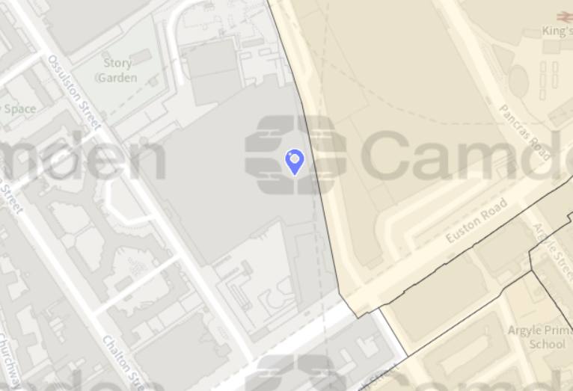

Site and its surrounds

Policy Relevant to the Development Site:

The site is designated as being within the settlement boundary, with urban uses to the north, east, south, and west. The site is a Listed Building. The site designation is a material consideration.

This is an existing telecommunications site.

The LB Camden Council does not have a specific telecoms policy, although para. 5.10 of the Local Plan is relevant. This, together with the NPPF is of relevance. The National Planning Policy section of this supporting statement goes into detailed analysis of why this site is in compliance with the NPPF.

Policy Analysis:

Para. 5.10 reads:

“Digital infrastructure

5.10 The Council recognises the importance of digital infrastructure in enterprise
development and expects electronic communication networks, including
telecommunications and high-speed broadband, to be provided in business
premises.”

Policy D2 reads:

“Heritage

The Council will preserve and, where appropriate, enhance Camden’s rich and diverse heritage assets and their settings, including conservation areas, listed buildings, archaeological remains, scheduled ancient monuments and historic parks and gardens and locally listed heritage assets.

Designated heritage assets

Designed heritage assets include conservation areas and listed buildings.

The Council will not permit the loss of or substantial harm to a designated heritage asset, including conservation areas and Listed Buildings, unless it can be demonstrated that the substantial harm or loss is necessary to achieve substantial public benefits that outweigh that harm or loss, or all of the following apply:

a. the nature of the heritage asset prevents all reasonable uses of the site;
b. no viable use of the heritage asset itself can be found in the medium term through appropriate marketing that will enable its conservation;
c. conservation by grant-funding or some form of charitable or public ownership is demonstrably not possible; and
d. the harm or loss is outweighed by the benefit of bringing the site back into use.

The Council will not permit development that results in harm that is less than substantial to the significance of a designated heritage asset unless the public benefits of the proposal convincingly outweigh that harm.

Conservation areas

Conservation areas are designated heritage assets and this section should be read in conjunction with the section above headed ‘designated heritage assets’. In order to maintain the character of Camden’s conservation areas, the Council will take account of conservation area statements, appraisals and management strategies when assessing applications within conservation areas.

The Council will:

e. require that development within conservation areas preserves or, where possible, enhances the character or appearance of the area;
f. resist the total or substantial demolition of an unlisted building that makes a positive contribution to the character or appearance of a conservation area;
g. resist development outside of a conservation area that causes harm to the character or appearance of that conservation area; and
h. preserve trees and garden spaces which contribute to the character and appearance of a conservation area or which provide a setting for Camden’s architectural heritage.

Listed Buildings

Listed buildings are designated heritage assets and this section should be read in conjunction with the section above headed ‘designated heritage assets’. To preserve or enhance the borough’s listed buildings, the Council will:

i. resist the total or substantial demolition of a listed building;
j. resist proposals for a change of use or alterations and extensions to a listed building where this would cause harm to the special architectural and historic interest of the building; and
k. resist development that would cause harm to significance of a listed building through an effect on its setting.”

The proposed development at this existing site is required to deliver the requisite level of electronic communication service on a single site and seeks to minimise its visual impact and change to the character of this location, and will continue to maintain and respect the integrity of the building (the site remaining as physically distant from lines of sight from residential uses as possible in this part of the Borough / positioned in the same location as the existing installation). The form and design of the proposed configuration would not appear out of context in this location (appearing in the comparable context of the existing roof top infrastructure / ladders / existing antenna to be changed etc.), so according with wider Development Plan policy and would ensure the integrity, character and setting of the area is fully maintained.

The public benefits of a greatly enhanced communications network for businesses, residents and visitors alike in this location would qualify as a substantial benefit with near benign change or impact on amenity.

Any harm to the character and setting of the heritage asset (and neighbouring heritage assets) would qualify as less than substantial, and the public benefits would be considerable, and materially outweigh harm.

The enhanced digital service would very much accord with the objectives of the Development Plan policy.

The proposed installation fully accords with the requirements of the NPPF providing reliable communications infrastructure to ensure continued economic growth and social well-being. The proposed upgraded equipment is of minimal visual change to the existing installation and further promotes the NPPF. The benefits of the proposed development will significantly outweigh any perceived potential harm.

The London Plan

The London Plan is a strategic planning document that sets out an integrated framework for the development of London. It is prepared by the Mayor of London and provides a long-term vision and policies for land use, transport, housing, economy, environment, and social infrastructure within the city.

The London Plan guides the spatial development of the city, taking into account factors such as population growth, housing needs, transportation requirements, and environmental sustainability. It aims to shape the city's physical and social fabric, promoting economic growth, social inclusion, and quality of life for Londoners.

The plan covers various aspects of urban development, including:

Housing: The London Plan addresses the need for affordable housing, setting targets for the provision of new homes and promoting mixed-use developments that incorporate affordable housing.

Transport: It outlines policies to improve transportation networks, reduce congestion, and promote sustainable modes of transport, such as walking, cycling, and public transport. It also emphasizes the integration of transport with land use planning.

Economy: The plan supports economic growth by identifying areas for business development, encouraging innovation and entrepreneurship, and protecting employment land.

Environment: It promotes environmental sustainability by addressing climate change, promoting energy efficiency, protecting green spaces, and enhancing biodiversity.

Social infrastructure: The plan considers the provision of social infrastructure, such as schools, healthcare facilities, cultural amenities, and community spaces, to support the needs of London's residents.

The foreword sets the scene regarding the importance of digital connectivity setting out the aim of ‘making London a … pioneering smart city with world-class digital connectivity supporting more digital devices to improve the lives of Londoners and enable businesses to thrive.’

This theme is developed within paragraph 1.1.4 under ‘Building Strong & Inclusive Communities’ stating ‘… social, physical and environmental infrastructure that meets London’s diverse needs is essential if London is to maintain and develop strong and inclusive communities.’

Chapter 2 of the London Pan 2021 deals with ‘Spatial Development Patterns’. Paragraph 2.0.4 notes that infrastructure is key to this delivery, with ‘proper planning of utilities and communications capacity and the social infrastructure that supports the day-to-day lives of Londoners’.

Paragraph 2.0.7 goes on to state that ‘Growth and change have not always benefited Londoners equally’…. ‘To address this, it is important that there is a strong focus on sustainable and inclusive regeneration in these areas, with boroughs, the Mayor and other partners working closely…’

Paragraph 6.8.1 states ‘The Mayor wants London to continue to provide the best environment in the world in which to do business, so that businesses of all different sizes and sectors can reach their growth potential. This includes supporting business and employment across all sectors of the economy and capitalising on new growth opportunities in emerging sectors:

• tech and digital sector – which supports the growth and evolution of all sectors in the economy. Planning should ensure that new developments have the digital connectivity required to support London’s global competitiveness (see Policy SI 6 Digital connectivity infrastructure). …The Mayor will support the growth of the tech and digital sector across all of London.”

The London Plan 2021 further emphasises the importance of digital infrastructure in terms of supporting growth and ensuring global competitiveness within the provisions of Policy SI 6 Digital Connectivity Infrastructure stating:

A. To ensure London’s global competitiveness now and in the future, development proposals should: 1. ensure that sufficient ducting space for full fibre connectivity infrastructure is provided to all end users within new developments, unless an affordable alternative 1GB/s-capable connection is made available to all end users

2. meet expected demand for mobile connectivity generated by the development

3. take appropriate measures to avoid reducing mobile connectivity in surrounding areas; where that is not possible, any potential reduction would require mitigation

4. support the effective use of rooftops and the public realm (such as street furniture and bins) to accommodate well-designed and suitably located mobile digital infrastructure.

B. Development Plans should support the delivery of full-fibre or equivalent digital infrastructure, with particular focus on areas with gaps in connectivity and barriers to digital access.

Policy SI 6 relates to ‘Digital Connectivity Infrastructure’ and A (3) specifically seeks to avoid the loss of sites due to redevelopment, requiring developers to work with the operators, with the policy stating ‘To ensure London’s global competitiveness now and in the future, development proposals should:

A.3 “take appropriate measures to avoid reducing mobile connectivity in surrounding areas; where that is not possible, any potential reduction would require mitigation”

The role of digital connectivity in raising London’s global competitiveness now and in the future receives more prominence and importance in the London Plan 2021. Paragraphs 9.6.1 – 9.6.9 encourage the delivery of high-quality / world-class digital infrastructure with paragraph 9.6.1 of the justification for Policy SI 6 stating:

Fast, reliable digital connectivity is essential in today’s economy and especially for digital technology and creative companies. It supports every aspect of how people work and take part in modern society, helps smart innovation and facilitates regeneration.

Paragraph 9.6.8 states ‘The Mayor will work with network operators, developers, councils and Government to develop guidance and share good practice to increase awareness and capability amongst boroughs and developers of the effective provision of digital connectivity and to support the delivery of policy requirements. The Mayor will also help to identify spatial gaps in connectivity and overcome barriers to delivery to address this form of digital exclusion, in particular through his Connected London work. Boroughs should encourage the delivery of high-quality / world-class digital infrastructure as part of their Development Plans’.

Policy D2 – Infrastructure Requirements for Sustainable Densities includes relevant policy aspect B:

B. Where there is currently insufficient capacity of existing infrastructure to support proposed densities (including the impact of cumulative development), boroughs should work with applicants and infrastructure providers to ensure that sufficient capacity will exist at the appropriate time. This may mean that if the development is contingent on the provision of new infrastructure, including public transport services, it will be appropriate that the development is phased accordingly.

Policy GG1 Building strong and inclusive communities states:

Good growth is inclusive growth. To build on the city’s tradition of openness, diversity and equality, and help deliver strong and inclusive communities, those involved in planning and development must:

- Encourage early and inclusive engagement with stakeholders, including local communities, in the development of proposals, policies and area-based strategies
- Seek to ensure changes to the physical environment to achieve an overall positive contribution to London
- Provide access to good quality community spaces, services, amenities and infrastructure that accommodate, encourage and strengthen communities, increasing active participation and social integration, and addressing social isolation
- Seek to ensure that London continues to generate a wide range of economic and other opportunities, and that everyone is able to benefit from these to ensure that London is a fairer, more inclusive and more equal city
- Ensure that streets and public spaces are consistently planned for people to move around and spend time in comfort and safety, creating places where everyone is welcome, which foster a sense of belonging, which encourage community buy-in, and where communities can develop and thrive
- Promote the crucial role town centres have in the social, civic, cultural and economic lives of Londoners, and plan for places that provide important opportunities for building relationships during the daytime, evening and night-time
- Ensure that new buildings and the spaces they create are designed to reinforce or enhance the identity, legibility, permeability, and inclusivity of neighbourhoods, and are resilient and adaptable to changing community requirements
- Support and promote the creation of a London where all Londoners, including children and young people, older people, disabled people, and people with young children, as well as people with other protected characteristics, can move around with ease and enjoy the opportunities the city provides, creating a welcoming environment that everyone can use confidently, independently, and with choice and dignity, avoiding separation or segregation.

Policy GG5 Growing a good economy states:

To conserve and enhance London’s global economic competitiveness and ensure that economic success is shared amongst all Londoners, those involved in planning and development must:
- Promote the strength and potential of the wider city region
- Seek to ensure that London’s economy diversifies and that the benefits of economic success are shared more equitably across London
- Plan for sufficient employment and industrial space in the right locations to support economic development and regeneration
- Ensure that sufficient high-quality and affordable housing, as well as physical and social infrastructure is provided to support London’s growth
- Ensure that London continues to provide leadership in innovation, research, policy and ideas, supporting its role as an international incubator and centre for learning
- Promote and support London’s rich heritage and cultural assets, and its role as a 24-hour city
- Make the fullest use of London’s existing and future public transport, walking and cycling network, as well as its network of town centres, to support agglomeration and economic activity
- Recognise and promote the benefits of a transition to a low carbon circular economy to strengthen London’s economic success

Policy SI 6 Digital connectivity infrastructure states:

- To ensure London’s global competitiveness now and in the future, development proposals should:
- ensure that sufficient ducting space for full fibre connectivity infrastructure is provided to all end users within new developments, unless an affordable alternative 1GB/s-capable connection is made available to all end users
- meet expected demand for mobile connectivity generated by the development
- take appropriate measures to avoid reducing mobile connectivity in surrounding areas; where that is not possible, any potential reduction would require mitigation
- support the effective use of rooftops and the public realm (such as street furniture and bins) to accommodate well-designed and suitably located mobile digital infrastructure.
- Development Plans should support the delivery of full-fibre or equivalent digital infrastructure, with particular focus on areas with gaps in connectivity and barriers to digital access

In accordance with the requirements of Policies GG1, GG5, and SI 6 the proposal will deliver reliable critical mobile digital infrastructure in the form of improved coverage and capacity. It is essential to note that without the proposed upgrade the Operator will not be able to deliver the required essential coverage and capacity within this key mixed commercial and residential district.

The proposed upgrade will help promote the London Plan by enhancing connectivity, supporting sustainable development, enabling smart city infrastructure, and fostering economic growth, aligning with the plan's objectives of creating a connected, sustainable, and prosperous city.

The UK Wireless Infrastructure Strategy

The UK Wireless Infrastructure Strategy is a new policy framework to drive deployment and adoption of 5G and advanced wireless connectivity; and the government's 6G strategy for the UK.
It highlights the importance of connectivity to the UK and recognises that the UK needs world-class wireless connectivity:

“Connectivity has brought benefits for British households and British business, boosting
growth, productivity, and opportunity for all. And change shows no sign of stopping. In fact, we find ourselves on the brink of a new revolution which promises to transform
the world once more.
5G will be the cornerstone of our digital economy. With higher capacity and lower latency, standalone 5G will drive growth in the industries of today and tomorrow including in emerging sectors like artificial intelligence where Britain leads the world. Just take smart ports, where 5G-enabled remote operation can help us to move containers more quickly, efficiently, and safely, boosting our international competitiveness. 5G can improve our public services, too, in everything from education to social care. In transport, for example, we can use 5G to power forward
progress in everything from real time travel information to augmented reality
navigation and self-driving buses and taxis.”

Which is why the time is right to turn our sights to mobile connectivity, where the same sense of mission is needed to deliver the kind of wireless infrastructure that will transform how we live our lives and run our economy. This is not simply a matter of
improving download speeds as people browse the internet on their phones or dial into work calls. It is far more transformative than that.

The power of 5G and future telecoms advances will unlock new solutions in everything from industry to healthcare. Falling behind in coverage will mean falling behind in international competitiveness when it comes to the technologies of tomorrow, and failing to provide British people with innovative, life-enhancing services on secure, resilient networks.”

The proposed telecommunication equipment will help promote The UK Wireless Infrastructure Strategy by improving coverage and capacity, supporting digital inclusion, facilitating economic growth, and enabling future-proof infrastructure including 5G that will ensure the area doesn’t fall behind in coverage and international competitiveness. The proposed development will provide significant public benefit with greater capacity and wireless connectivity for local businesses, residents and visitors to the area.

Additional relevant information:

Siting

We have considered the detailed siting and design carefully to ensure that the scheme has a limited impact on the locality, and general visual amenity.

Visual appearance

We would repeat that we have carefully placed and designed the scheme to ensure the principles of good siting and appearance are adhered to. The overall impact of the installation on the environment and building is very limited.

Consultation

In accordance with the industry ’10 commitments’ and the Code of Best Practice, consultation has been attempted with the planning department prior to submission of this proposal.

Education

The relationship between 5G and education is evolving at a massive rate with educators exploring the relevance of Virtual Reality (VR) technologies for education and training. Crucially, VR can support remote learning, allowing students a presence in the classroom even when working elsewhere.
5G’s ability to deliver real-time information (low latency), ultra-fast speeds (critical for high definition images and video), increased capacity and heightened security will also allow learning on the job, thanks to technologies such as Augmented Reality (AR) goggles, which can give engineers real-time instructions on how to fix a machine on a production line, for example.

Health

Patients across the country are now becoming accustomed to relying on remote healthcare services such as NHS 111, virtual GP appointments, and ordering online deliveries of essential medical supplies.
5G will prove critical in providing the infrastructure required to deliver remote health services over the next decade. By design, 5G’s ability to deliver real-time information (low latency), ultra-fast speeds (critical for high definition images and video), increased capacity and heightened security are going to be fundamental in scaling the patient benefits of remote healthcare and keeping medical records secure and private. For instance, trials have shown that connecting ambulance crews to expert resources using 5G allows paramedics to work with doctors and conduct specialist procedures in real time whilst on the road.

Conclusion

We consider the development complies with both central government and local planning policy guidance where the underlying aim is to provide an efficient and competitive telecommunication system for the benefit of the community while minimising visual impact.

Taking into account the factors of technical constraints, available sites and planning constraints we consider that this site and design clearly represents the optimum environmental solution.

On the basis of a recognised need to expand and promote telecommunications networks across the region, it is considered that the proposal fully accords with the requirements of the National Planning Policy Framework and the Council’s Local Plan Policies.

Confirmation that submitted drawings have been checked for accuracy

Name: (Agent) | Susannah Help | Telephone: | On request
Company: | Cornerstone
Company Address: | WHP Telecoms Ltd  1a Station Court  Station Road  Guiseley  Leeds  LS20 8EY | Email Address: | s.help@whptelecoms.com
Signed: |  | Date: | 27th April 2024
Position: | Planner | (on behalf of Cornerstone)

Macro or Micro

