Location Plan & Photos
Flat 1, Ground Floor
142 Goldhurst Terrace
West Hampstead
London
NW6 3HP

Tree Location Plan
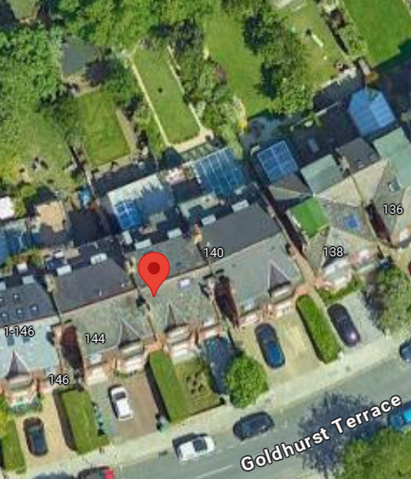
The tree is located within the rear garden, has limited views from neighbouring properties and is causing an actionable nuisance in root trespass
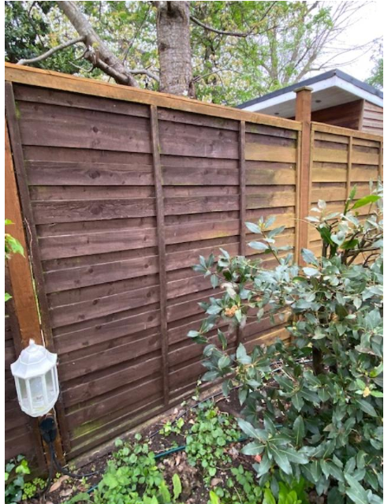
Tree location viewed from neighbour’s property

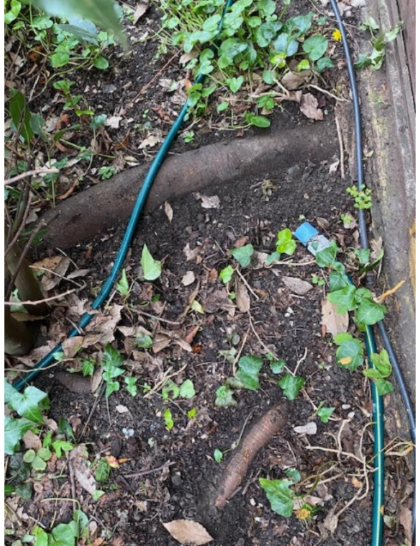
Root trespass beneath boundary and damage to concrete gravel board

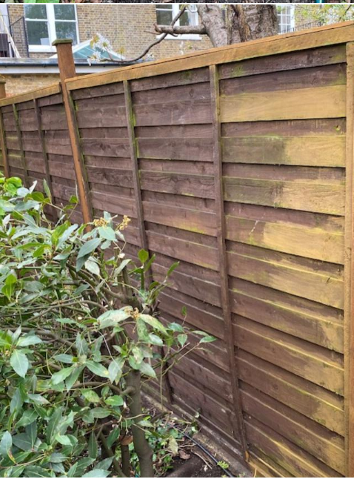
Tree as viewed from neighbour’s land

