21 Mornington Crescent, NW1 7RG

Design & Access Statement

April 2024

Prepared by **MM Planning and Architecture**

# Contents

Contents 2

1.1 EXECUTIVE SUMMARY 2

1.2 INTRODUCTION 2

1.3 PREVIOUS PLANNING APPLICATION 3

2.1 SITE ANALYSIS 3

2.2 PLANNING POLICIES 3

2.3 EXISTING PHOTOS 4

3.1 DESIGN PRINCIPLES 5

3.2 USE 5

3.3 AMOUNT 5

3.4 OVERLOOKING/PRIVACY 5

3.5 SCALE 5

3.6 LAYOUT 5

3.7 DAYLIGHT/SUNLIGHT ASSESSMENT 6

3.8 LANDSCAPING 6

3.9 APPEARANCE AND MATERIALS 6

3.10 ACCESS 6

4. PLANNING & POLICY COMPLIANCE 6

## 1.1 EXECUTIVE SUMMARY

This design and access statement has been prepared on behalf of our client Xuelin Bates and is in-line with the existing householder application that is to be considered with the Architectural work prepared. The application concerns is intended to support a planning and listed building application for 21 Mornington Crescent.

## 1.2 INTRODUCTION

The property is in a current state of disrepair, and a major renovation project is being undertaken as part of the project. The garden is currently in a state of substantial neglect, where it has been disused for a number of years and has been used as a place to throw unused furniture and refuse.

The proposed works consist of:

* Outbuilding at the rear of the garden
* Associated landscaping works

This householder application is for the erection of a new outbuilding to the rear of the garden. We believe that an outbuilding works well with the existing garden space, as the current garden depth is 22m. The outbuilding will be built at ground level on an existing levelled garden (flat garden).

This Design & Access Statemen is accompanied by the following documents:

- Duly Completed Application Form.

- Full Set of Existing Drawings.

- Full Set of Proposed Drawings.

## 1.3 PREVIOUS PLANNING APPLICATION

The previous planning application dated 21-02-2023 had been rejected on the basis that the outbuilding would be built on a raised. This assumption is incorrect and was an error/mistake on the surveyor/architects part when undertaking the works. The error stemmed from the temporary rubbish that was at the garden. Since then the rubbish has been cleared (please see Figure 3)and the garden is in its former state of being levelled. The proposal will be on the **levelled garden** and not on a raised platform.

## 2.1 SITE ANALYSIS

The property is situated in 21 Mornington Crescent NW1 7RG, and forms part of the crescent of terraces along Mornington Crescent, all of which are Grade II Listed. In the wider context, Mornington Crescent intersects Hampstead Road to the east, with Mornington Crescent Station being located 150m from the property.

The rear garden is situated at ground level, with the exception of the stairs leading to the basement adjacent to the existing property. The current access into the garden is from the ground floor via a single leaf door. The door leads onto a bridge link, which is situated above a lowered courtyard. The lowered courtyard acts as an access area for the basement into the garden. The current access from ground floor is through a narrow door, through the bridge into the garden.

The current garden area has been cleared out of the waste and is currently in a decent state. Previously the garden had been used as a place for disused pieces of furniture, general waste and over gown vegetation. Since then, this waste has been cleared and additionally the garden is very deep, equating to almost 22m in depth and around 7m in width and therefore can be put to much better use.

## 2.2 PLANNING POLICIES

The property lies in the London Borough of Camden and falls within the Camden Town Conservation Area. The history of the building has also been taken into account, its past configuration as an open plan ground floor, and the previous outbuilding attached to the rear of the property.

Relevant planning policies considered:

* SPD - Design Quality (Adopted 2006)
* Camden Local Plan (September 2017)
* London Plan (2021)
* Camden Town Conservation Area
* Camden Planning Guidance
* Supplementary Planning Document
* Design Guidelines for House Extensions & External Alterations

The client wishes to have an office space where she will be able to work from home, and due to the significant depth of the garden, we believe that this proposal is acceptable, as the space will be put to better use, including a more considered landscape and planting approach where the garden and heritage asset will be more appreciated. The proposed outbuilding and associated landscaping will improve and enhance the appearance of the heritage asset, as well as improving local biodiversity and landscaping.

## 2.3 EXISTING PHOTOS

Figure 1 – Block Plan for Concerned Property

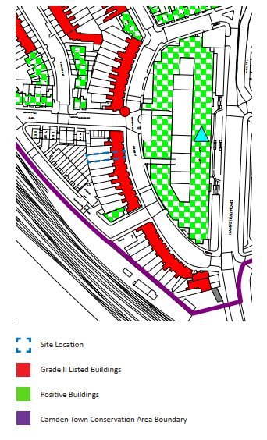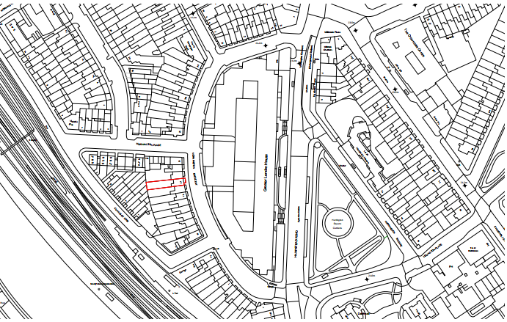

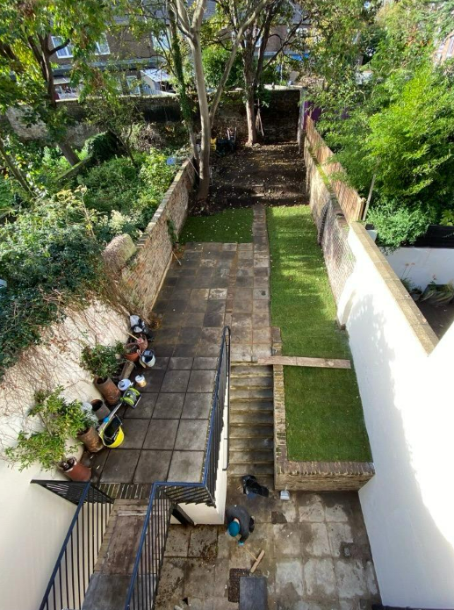

Figure 3 –Front View of the Existing Garden (Subsequent to removal of Waste)

Figure 2 –Conservation Area and Grade II Listed Buildings

## 3.1 DESIGN PRINCIPLES

The proposal seeks to introduce an outbuilding to the rear of the garden. The proposed outbuilding maintains a 600mm gap on the left hand-side (No.20) and 150mm gap to the right hand-side (No.22). The proposed height of the outbuilding (ridge) is 2.5m.

The external materiality is proposed to be charred timber cladding. The main design feature is the use of glazing to enable framing and unobstructed views of the landscaping of the garden.

The proposal also seeks to increase the height of the garden fence with adjoining neighbour no.20 and introduce a timber fence to improve privacy. Currently, the garden fence in some areas is as low as 950mm.

The proposal seeks to maintain the existing landscape levels, which enables a series of plant beds along the pathway towards the main entrance of the outbuilding.

## 3.2 USE

There is no change of use proposals to the current property, the use class will remain a C3 Use Class.

## 3.3 AMOUNT

The proposal covers most of the width of the garden (approx. 5.5m in width), however the size of the outbuilding is viably subordinate to the existing house. It is important to note that the proposed outbuilding is also significantly less than 50% of the garden area.

## 3.4 OVERLOOKING/PRIVACY

The proposal ensures that there are no issues pertaining to overlooking and privacy.

## 3.5 SCALE

The proposals have been sensitively conceived and formulated to be respectful to the character of the listed building and the wider terrace. The proposed outbuilding is modest in scale and would be visually subordinate to the host building. Its sympathetic form and materials would complement the character of the listed building, whilst its clean, robust and simple contemporary design is clearly of its time.

The ceiling height of the proposal is 2.3m high from the levelled ground floor to the ceiling and 2.5m high to the ridge of the roof from the levelled ground. The proposal also utilises a 100mm parapet wall and the total height from the ground floor to the ridge of the parapet wall is 2.6m.

The proposal also utilises a green roof that also improves the aesthetic of the outbuilding as it would go well with the proposed landscaping.

## 3.6 LAYOUT

The internal layout is primarily for the use as an office space/studio. Due to the significant distance to the house, the client also wishes to introduce a small shower room where she will be able to spend extended hours of the day working.

The outbuilding has generous views out towards the proposed landscaping and has been designed with views of the landscaping in mind.

## 3.7 DAYLIGHT/SUNLIGHT ASSESSMENT

Daylight is not specific to a particular direction, as it is received from the dome to the sky. It is therefore necessary to consider all residential properties within the vicinity and facing the reference property.

The proposed outbuilding will have adequate sunlight and lighting within the outbuilding. We have used Autodesk Revit to assess the sunlight and daylight and we are confident that no adverse effect has occurred.

This report confirms that the proposed daylight and sunlight standards to the neighbouring properties, because of the proposed development, adequately satisfy the BRE guide to good practice and Camden Council’s Adopted UDP, for properties in this location.

Our calculations have shown that the new development will cause no significant loss of sunlight to the neighbouring residential properties. We therefore conclude that, in our opinion, there will be no adverse effect to the neighbouring properties in this context.

## 3.8 LANDSCAPING

There will be minimal reduction of green space, as the current area of the garden has a significant area of hard landscaping, a bridge, stairs and a disused and neglected garden bed.

## 3.9 APPEARANCE AND MATERIALS

New planned elements will be constructed utilising modern construction methods with more than required thermal and acoustic insulation built in the new floors, external walls, roof structure and the slab. Sustainable materials such as timber will be used for the cladding and construction of the outbuilding. The interior of the outbuilding will be lined in veneered plywood. Modern materials and techniques will guarantee high quality of build is provided, with minimal building time to ensure minimal discomfort to the neighbours. Furthermore, the design team will comply with current Building Regulations and other required standards.

## 3.10 ACCESS

There are no alterations to the access of the property in this proposal. Access to the proposed outbuilding is through a series of stone pavers, which will be in compliance with Building Regulations approved documents.

# 4. PLANNING & POLICY COMPLIANCE

In addition to National Planning Policy, the proposal has also been assessed using the Local Plan Policy D1 (Design) and Policy D2 (Heritage).

Policy D1 refers to general design principles and requires development to be of high quality, which respects local context and character and preserves or enhances heritage assets. Policy D2 relates specifically to proposals which affect listed buildings and conservation areas and requires that development preserves and where appropriate enhances these designated heritage assets. The Council will resist proposals that cause harm to the special architectural and historic interest of listed buildings or their settings. The current proposals are considered to fully comply with policies D1 and D2.