Brendan Versluys
London Borough of Camden
Camden Town Hall
Judd Street
WC1H 9JE.

By email only: planning@camden.gov.uk

Re: Objection to Planning Application 2024/1055/P (Centenary House 96-98 Camden High Street London NW1 0LQ) for the change of use of second and third floors from office (Use Class E) to residential use (Class C3), including a roof extension to provide 6 x new residential units (3 x one bedroom flats, 2 x two bedroom flats, 1 x three bedroom flat) and refurbishment of building exterior, alterations to Pratt Street communal entry, installation of new cycle facilities.

Dear Mr. Versluys,

- We write to you as the owner and operator of The Blues Kitchen, Camden at 111-113 Camden High Street, London NEW1 7JN.

- We wish to make the following comments in relation to Planning Application No. 2024/1055/P (Application) and ask the Council to consider the following when deciding the Application:

- Protection of The Blues Kitchen (and other live music venues in the area) should be secured through appropriate conditions and/or section 106 planning obligations, given the importance of cultural venues in the Camden Local Plan (Local Plan).

- Regarding the Agent of Change principle, it is critical that any future occupiers (given the permanent nature of the accommodation proposed) of the development are 1) aware of the existing Blues Kitchen and other the live music venues in the area and 2) noise attenuation measures are maintained throughout the life of the development. This should be secured through a section 106 agreement.

- We would like to see further detail in the Noise Assessment that has been prepared, especially consideration of noise in relation to The Blues Kitchen and other live music venues.

- Per Policy A4 of the Local Plan, there is a requirement for a construction management plan to show how the Applicant intends to deal with noise and vibration during construction. We say that this should be prepared prior to a decision being made and then secured via a section 106 obligation.

- We elaborate on these matters below.

Background

- The application site contains a 4-storey building on Camden High Street, comprised of a ground floor and first floor office (currently operating as a financial unit (Halifax)), with two additional storeys of vacant office space. The current application seeks to convert the vacant office space at the second and third floor to residential flats, with the addition of a fourth floor flat. In total there are six flats - two at second floor, three at third floor and a larger three-bedroom flat at fourth floor.

- As noted in the Planning Statement submitted with the Application, neighbouring premises consist of The Blues Kitchen, as seen from the below cadastral (The Blues Kitchen (marked with the blue pin and the Application site shaded black)):

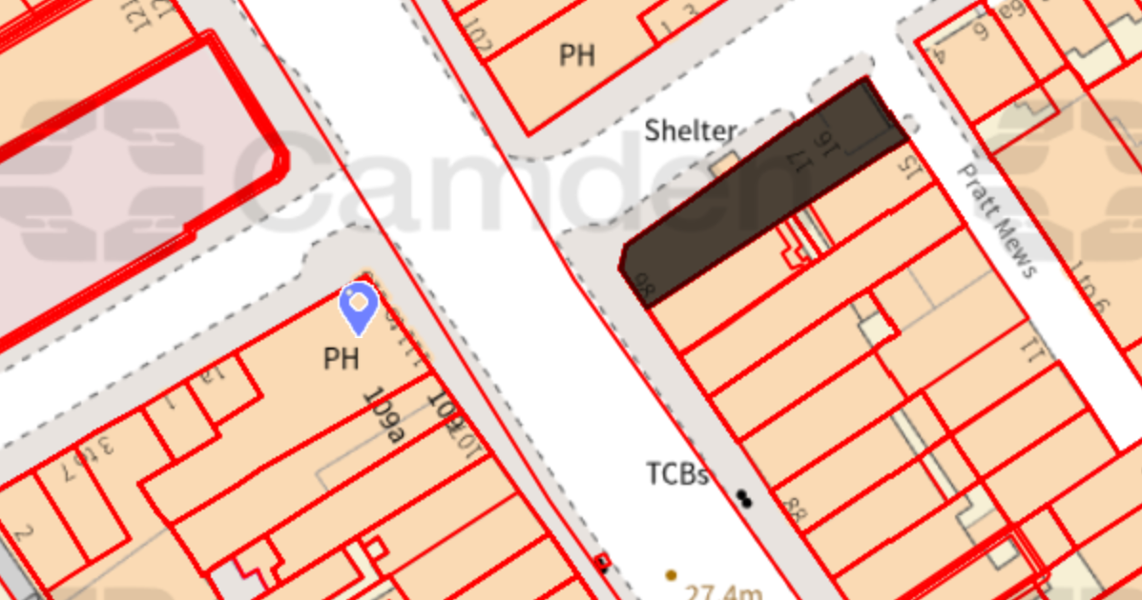

- Given the proximity of the Application site to our operation, we wish to make the below points.

Importance of cultural facilities within the Local Plan

- We are wanting to protect our business and as such, wish to highlight to the Council the specific local policies that the Council must consider when deciding this Application.

- We draw the Council’s attention to Policy C3 in their Local Plan which provides for protection of cultural and leisure facilities.

“Protection of cultural and leisure facilities

The Council will seek to protect cultural and leisure facilities and manage the impact of adjoining uses where this is likely to impact their continued operation.”

- We note at paragraphs 4.59 and 4.60 of the Local Plan provide that:

“4.59 Cultural and leisure facilities are seen as being under particular threat in London
due to rising property values and their siting in prominent locations. There are a wide range of facilities we wish to see protected, in particular affordable accommodation as this is becoming increasingly scarce in inner London. Certain facilities are particularly valuable due to their significance in helping to define Camden’s cultural and leisure offer.

4.60 The Council wants to ensure that existing cultural and leisure attractions are sustained and enhanced. It is important that noise sensitive uses, such as residential, built adjacent to an established facility, do not affect the ability for cultural and leisure premises to continue operating successfully, e.g. live music venues. Policy A4 Noise and vibration provides further advice on this matter.”

- It is established that the Blues Kitchen is a cultural attraction and well renowned as a live music venue both at a local and national level. It is important this cultural facility is protected during the construction phase, and it is also important that the development, given it is brining more permanent residents to the area, does not create conflict with our continual operation once complete.

The Agent of Change principle

- We note the importance of the Agent of Change Principle in protecting the existing use of The Blues Kitchen and other live music venues in the area. Paragraph 193 of the National Planning Policy Framework (NPPF) provides as follows:

“193. Planning policies and decisions should ensure that new development can be integrated effectively with existing businesses and community facilities (such as places of worship, pubs, music venues and sports clubs). Existing businesses and facilities should not have unreasonable restrictions placed on them as a result of development permitted after they were established. Where the operation of an existing business or community facility could have a significant adverse effect on new development (including changes of use) in its vicinity, the applicant (or ‘agent of change’) should be required to provide suitable mitigation before the development has been completed.”

- The Local Plan provides at paragraph 6.93:

“In cases where noise sensitive development is proposed in close proximity to an existing noise generating use (such as music venues and pubs) the Council will determine whether the introduction of the sensitive use will be harmful to the existing premises continued operation. In some cases the Council may require the developer to be responsible for future costs of soundproofing (known as the “agent of change” principle), secured by a legal agreement.”

- In accordance with the Local Plan and paragraph 193 of the NPPF, the Agent of Change principle should be secured by way of an obligation in a section 106 Agreement. Our preference would be for an agent of change obligation within the section 106 Agreement that contained the following:

- The owner must provide information to any occupier or potential occupier of the development that they are situated near a music and night time entertainment venue;
- The appropriate sound-proofing within the development, as assessed by the Council, must be retained for the lifetime of the development; and
- The developer and/or owner be responsible for future costs of sound-proofing if required.

Noise mitigation measures during construction and on completion of the development

- To protect existing cultural venues such as The Blues Kitchen, the Application needs to provide for noise mitigation measures to achieve this.

- In terms of the documentation material currently before the Council, we note that there is a Noise Impact Assessment prepared by KR Associates (Assessment). The Assessment concludes that the following proposed acoustic measures are required:

- Acoustic glazing with a minimum performance or Rw 40 dB e.g. 6.8mm – 12mm argon filled airgap – 6.0mm toughened. Manufacturer to provide verified test certificate. Total thickness of 25mm.
- No trickle type vents within the façade of the building.
- MVHR whole house ventilation system with additional cooling or design to ensure windows do not need to be opened to control over-heating. The system will need to provide an over performance of Rw 45 dB or more which could be achieved with standard 1,800mm long attenuators.
- Additional cooling unit to the MVHR ventilation system to ensure that windows never need to be opened to control over-heating.

- In our opinion, as we have stated at paragraph 13, these need to be secured via a section 106 agreement to ensure these measures (and any further measures Council consider appropriate to mitigate noise) are maintained for the life of the development.

- We also note that the Assessment does not consider The Blues Kitchen and only considers the traffic noise on Camden High Street, Halifax mechanical services (the first floor flat) and music practice rooms on Pratt St. In our opinion, the Assessment should also consider the live music venues and other hospitality venues in the area, including The Blues Kitchen, as a potential source of noise. The Assessment also does not consider noise during the construction period, however, we note that this could be dealt with through a Construction Management Plan (see paragraphs 19-21).

- In our view, before any decision is made, the Applicant should submit a revised Assessment that deals with The Blues Kitchen (and any other relevant live music/hospitality venues) and to determine whether further noise mitigation measures are required.

- At Policy A4 of the Local Plan it is stated:

“…will only grant permission for noise generating development, including any plant and machinery, if it can be operated without causing harm to amenity. We will also seek to minimise the impact on local amenity from deliveries and from the demolition and construction phases of development.”

- We note at paragraph 6.94 of the commentary in the Noise and Vibration Policy (A4) in the Local Plan:

“The Council will also consider the impact of attenuation measures on the character and appearance of the building and locality (see Policy D1 Design and associated supplementary planning document Camden Planning Guidance on design). Measures to mitigate the impacts of noise and vibration associated with demolition and construction will be secured by legal agreement through Construction Management Plans (Policy A1 Managing the impact of development).”

- Given the above, we say that Construction Management Plan secured through a section 106 Agreement is required by Policy A4. To date, it does not appear that a Construction Management Plan has been submitted with the Application. Our view is this should be made available for review prior to a decision being made so that interested persons can provide any comment on the proposed noise mitigation measures in the Construction Management Plan.

Conclusion

- We hope that above is clear in relation to our concerns and suggestions in relation to the Application. If you have any queries, please do not hesitate to contact the undersigned.

Yours sincerely

Steven Ball
CEO
Blues Kitchen Ltd.

