**Design & Access Statement**

**First Floor Flat 4, 1 Rosecroft Avenue NW3 7QA**

**To accompany an application for the removal of two windows in the north elevation and the addition of one in the east elevation**

Prepared by Murray John Architects Ltd for Purfleet Limited.

**Contents**

Introduction

1 Description

2 Reason for the work

3 History of the flat

4 Planning Considerations

5 Design and materials

6 Access

7 Conclusion.

**1 Description**

This planning application is for the removal of two windows in the north elevation and the addition of one in the east elevation as shown on the attached drawings.

The new window is to match, in appearance, exactly that of the adjacent window but formed using slim-line double glazed windows with leaded came on one face.

Brickwork will be neatly resolved into the Flemish bond of the existing brickwork and be carried out exactly according to the drawings attached to this application.

**2 Reason for the works**

The owner and occupant of the flat, Ms Nancy Bodson, wishes to improve the light, the view and most significantly, the heat loss from the room. The bedroom at present is around 14 sq m in area and is relatively tall.  There are presently three large ill-fitting windows that co-date the original construction. The overall area of the flat is 46.3 sqm.

Consequently, the bedroom, is particularly cold in winter.

Present 2no north facing windows to be removed are each 1.8 sqm and the 1no east window is 1.92 sqm.  This makes a total of 5.52 sq m of single glazing - 39% of the floor area! It is proposed to upgrade the existing east window to match the proposed new one. Therefore the total area of windows proposed shall be 3.84 sqm, reducing the area of windows in that room to 27.4%.

Furthermore the north window structural openings shall be infilled with plasterboard, then 100 insulation set into a stud work frame, and a further 50 layer of insulation to be set behind painted render board as shown in our detail drawing 806_06.

Single glazing has a U value of around 5.2 W/m²K.  Slimlite double glazing can achieve 1.6 W/m²K.  We are proposing further that the new windows be appropriately draught sealed, trickle vented, and set in thermally broken frames to avoid cold bridging.  Therefore, the proposed new east windows and insulated infilled north windows shall substantially improve the energy efficiency of the flat and reduce heating load and comfort levels.

**3 History of the flat**

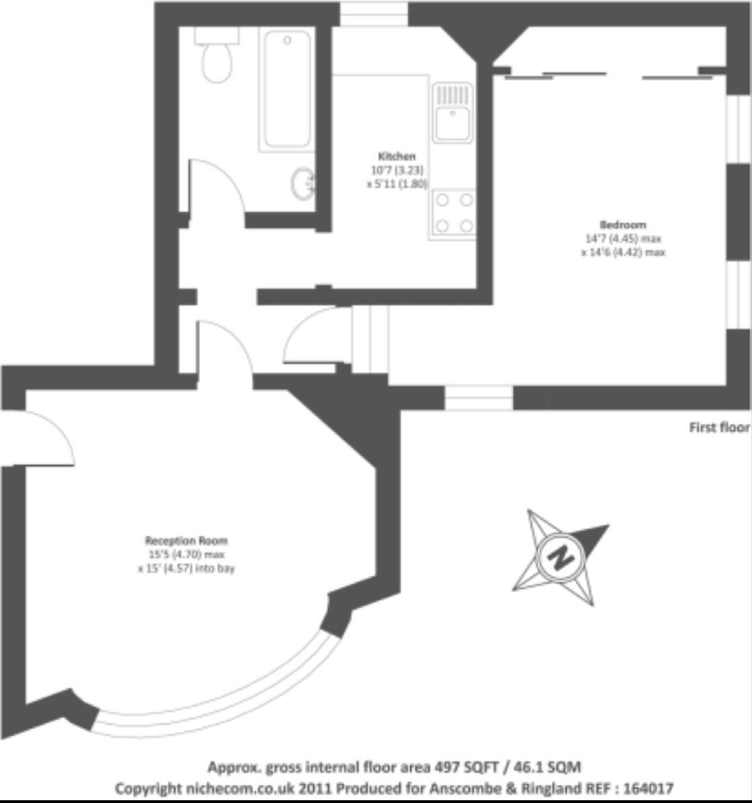 *Plan of Flat 4 showing bedroom r.h.s and living room to the left. It is part of the larger house, part of a north wing.*

The flat is part of a group known locally as “The crofts”- Hollycroft, Ferncroft and Rosecroft Avenues and is in the Redington/Frognal Conservation Area. The area is near the West Heath and part of an adjacent farm until the late C19th.

The houses were laid out by developer George Hart (daughters Rose, Holly and Fern) in 1896 and some were designed by notable architect C.H.B. Quennell. Three houses are listed in the street but none of these are visible from No 1.

Whilst No 1 is not perhaps as remarkable as those listed, it has, none the less, considerable character and personality consistent with the greater group. This includes the bay windows, irregular roofscapes, variations in the brickwork and height and shape of windows, divided panes, leaded lights, turrets and a generally *managed irregularity*. They fall into the style category of *Queen Anne Revival*.

The house, No 1 Rosecroft Avenue, is on the junction of Hollycroft Avenue and is subdivided into five flats, two on each of the ground and first floors and one in the attic and also a garden flat. In the 1980s there were garages in the garden to the north of the house and these were replaced with a modest house known as No 1A. Now the bedroom of Flat 3 overlooks the roof-scape of this house.

It is inconceivable that the use of the house will be reversed in the future because the building has been developed to a great extent and original rooms are lost. However, the character of the building remains and is to be respected

**4 Planning considerations**

The principal considerations are that there is reference to the

* Conservation Area Appraisal,
* Camden’s Core Strategy, especially Policy CS14 Promoting high quality laces and conserving our heritage
* Camden’s Energy Efficiency Planning Guidance in Conservation Areas.

Policy DP25 states that the Council will only permit development within the conservation area that preserves the area’s character and appearance

As this is a minor application and upgrading two windows to

Policy DP 24 expects development to be of the highest standard with regards to the site, it’s context and the character and proportions of the building and the use of high quality materials

Therefore, regarding these two policies, the alterations are eminently acceptable in design terms.

Camden’s advice regarding improving energy efficiency is that heritage and improved energy efficiency are both important. Improvements should seek to conserve heritage value in a manner appropriate to its significance.

**5 Design and Materials**

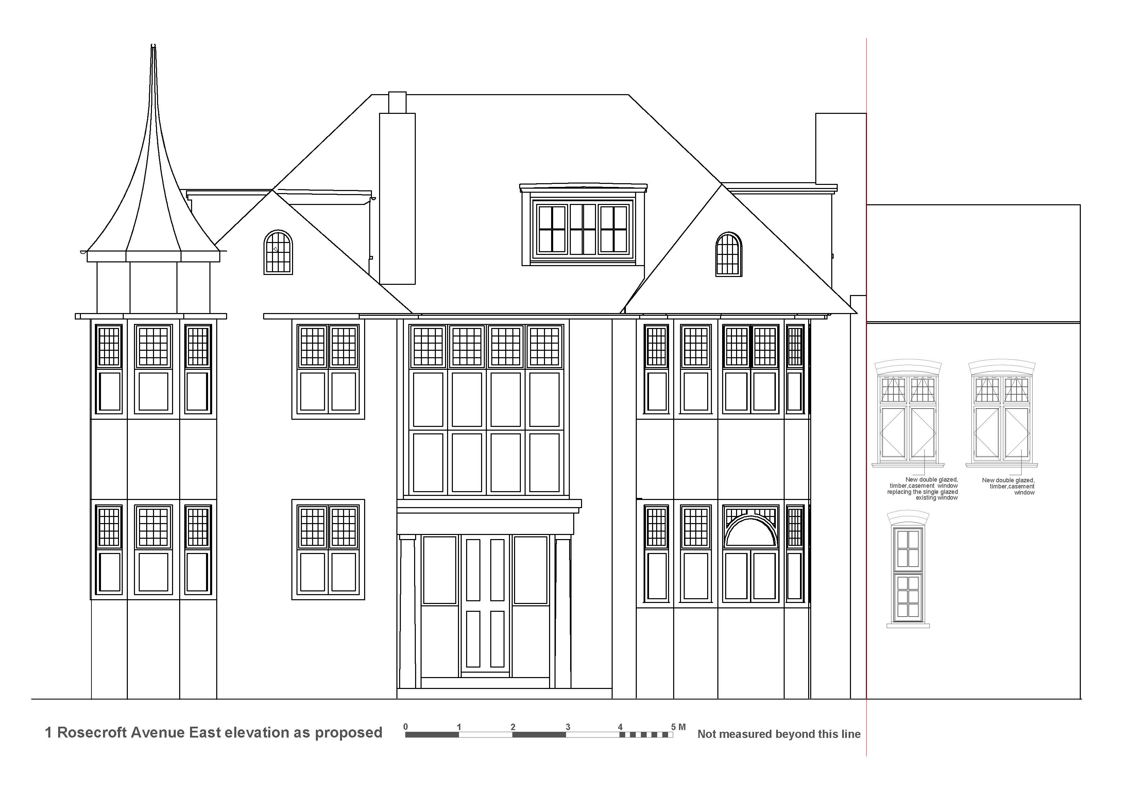

**NEW WINDOW**

The proposal is a suitable response to the circumstances. It considers the form of the house, its appearance as well as the history of the building and the subsequent alterations during its lifetime.

The windows’ materials used shall be white painted timber, glass and lead came applied to both sides on the outer sheet of glass. Brickwork is to match exactly the existing with bond brought to order with the Flemish work adjacent and pointed to match. The stone cill shall match adjacent also.

Where north windows, partly concealed by the adjacent 1980s building, are removed, they are to be recessed and painted leaving the outline of the brickwork visible and reversible.

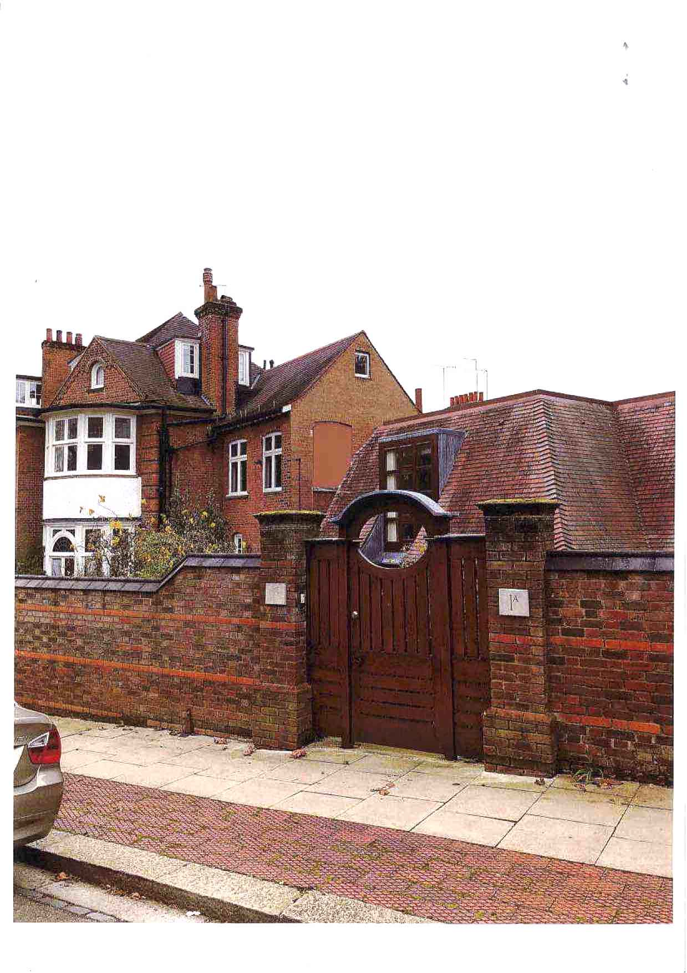*Treatment of infilled North windows as proposed – note these will be faced in matching brick slips*

**6 Access**

Access to the building is generally unchanged. There is no additional area removed or added so no change in occupancy.

Access within the building is unchanged.

It is not feasible to install lifts or other access arrangements, especially as there would need to be such facilities on the shared stair hall and also a lift in the very narrow corridor within the bedroom.

**7 Conclusion**

The design of a pair of windows is comfortably placed on the wall and entirely at a scale, type and location of other comparable windows or groups of windows in the conservation area.

Therefore the new window and upgraded matching window is appropriate to the heritage significance of the building and the conservation area.

Murray John

29th Nov 2023

Rev 10th April 2024