REDINGTON FROGNAL ASSOCIATION
Umbrella body for residents groups in the Redington Frognal Conservation Area

25 March 2024

Dear Mr. Campbell,

2024/0030/P: 99 Frognal - objection

Redington Frognal Association is the umbrella organisation for streets within the Conservation Area and adjacent. In particular, it strives to protect and enhance the landscape character as well as the architectural heritage.

While elements of the redevelopment proposal are welcomed, on balance we consider that it will cause material harm to the setting of the listed building, which is not offset by any public benefit. The additional housing units will not be placed on the open market and we speculate that they will be used as recording studios or guest accommodation.

The harm is due to the following:

- over-development of the site and a consequent failure to maximise the biodiversity gain
- increasing the likelihood and extent of flooding from groundwater and surface water, both at surrounding properties and further downstream of the lost River Westbourne
- unwelcome light pollution at a sensitive site, adjacent to Branch Hill, Branch Hill Pond and situated in a local ecological network, where soprano and pipistrelle bats and barn owls forage and commute.

A preliminary ecological appraisal is essential before the application progresses further.

We also draw attention to the biodiversity net gain of over 41%, which is targeted further down Frognal (application 2033/5366/P), and should be taken as an absolute minimum for a large site in this location, virtually abutting Hampstead Heath.

The Biodiversity metric calculation for application 2023/5366/P is also copied below and the value of 41% could easily be exceeded at 99 Frognal by incorporating a natural wildlife pond. A wildlife pond would additionally help with rainwater and groundwater attenuation, as at Branch Hill Pond: https://www.redfrogassociation.org/?s=groundwater

DEFRA ECOLOGY_BIODIVERSITY METRIC TOOL - Result for UCS Planning Application 2023/5366/P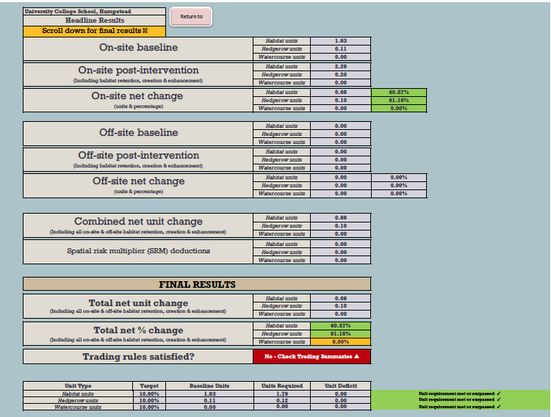

Copious evidence of the importance of the area to wildlife can be found in the Evidence Base to the Redington Frognal Neighbourhood Plan (https://www.redfrogforum.org/evidence-base/):

- (52) BGI 1 Gardens and Ecology – bat reports and other sightings
- (52 i) Ecology Network May 2016 Redington Frognal BAT_Redacted
- (52 ii) Gardens advice from The Ecology Network
- (52 xxix) Heysham Lane & Firecrest Woodland-Sightings and Nests
- (52 xxx) Firecrest sightings, June 2016_Redacted
- (52 xxxi) GiGL RedFrogSummary data, March 2019
- (52 xxxii) GiGL RedFrog_Factsheet, March 2019.

The presence of bats will have been increased through the wildlife pond which was recently re-introduced metres away at Branch Hill: a map of recordings, taken on 23.8.22 with an Echometer, is shown below.

Bat flight path recordings beginning at Branch Hill Pond, 23.8.22
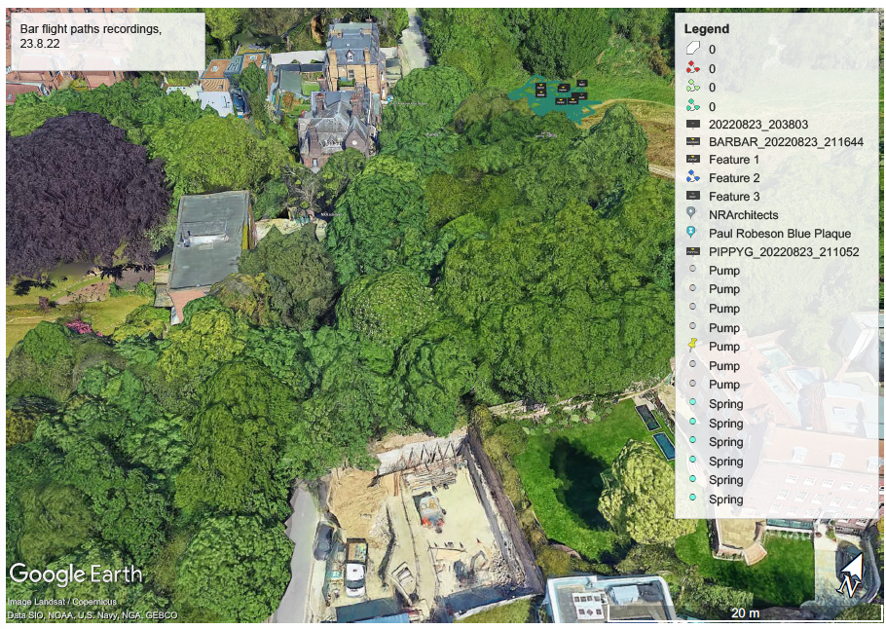

Excavation to a depth of 7 metres will have severe ramifications for sub surface water. The BIA was carried out in dry weather and has not taken account of varying rainfall conditions. The planned excavations are contrary to both the Hampstead Neighbourhood Plan and Camden’s Local Plan.

The risk of surface water flooding can be seen at: https://check-long-term-flood-risk.service.gov.uk/map?easting=526118.81&northing=185807.19&map=SurfaceWater

The current proposal represents an inappropriate over-development of the site, which will harm the setting of this historic house and cause negative externalities through light pollution and interference with the water table and underground water.

Yours sincerely,

Nancy Mayo

Secretary

Redington Frognal Association

http://www.redfrogassociation.org

