To whom it may concern,

I would like to apply for the permission to build a garden room used for indoor golf simulation. The sole purpose of this room is to house golf launch monitor, projector, and screen canvas where I can practice golf.

Indoor golf simulator technology has advanced a lot in the past decade. With correct setup it offers opportunity for enthusiastics like me and my farther to practice and play indoor. A typical setup is shown in the following picture, quoted from Trackman (<https://www.trackman.com/> leading manufacturer of launch monitors used by professional golfer and baseball players).

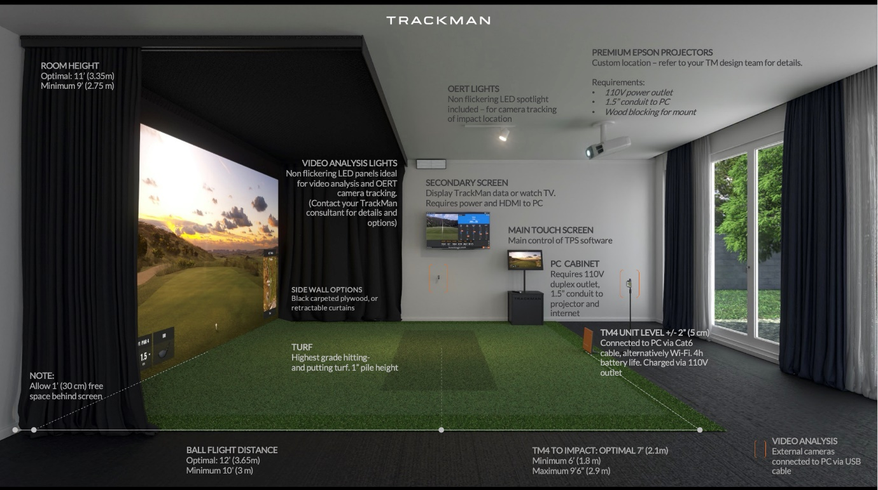

There is a minimum size requirement for the room, in order for the simulator to function optimally. A guideline interior dimension is 5.5 meters deep, 4.5 meters wide, and 2.9 meters high. The provided drawing shows a room built to have sufficient interior space for this setup. We are aware of the maximum limit of 2.5 meters height of the outbuilding and proposed to excavate internally 0.5 meters to offer sufficient height, so that my golf clubs won’t hit the ceiling. My architect and I worked on the drawing so that the outlook of the building complies with the rule and is not intrusive to the surroundings.

I will out source the interior design job to Golf Swing Systems (<https://www.golfswingsystems.co.uk>), who are professionals in designing and building golf simulator rooms. If needed they will be willing to offer more information regarding the specs of the simulator room. Some example photos of their past projects are included in this file.

I’m looking forward to the planning permission, and we are more than happy to work together with the council in the process!

