1. Front (East) Elevation

1. North (side) Elevation

1. North (side) Elevation

1. Bathroom

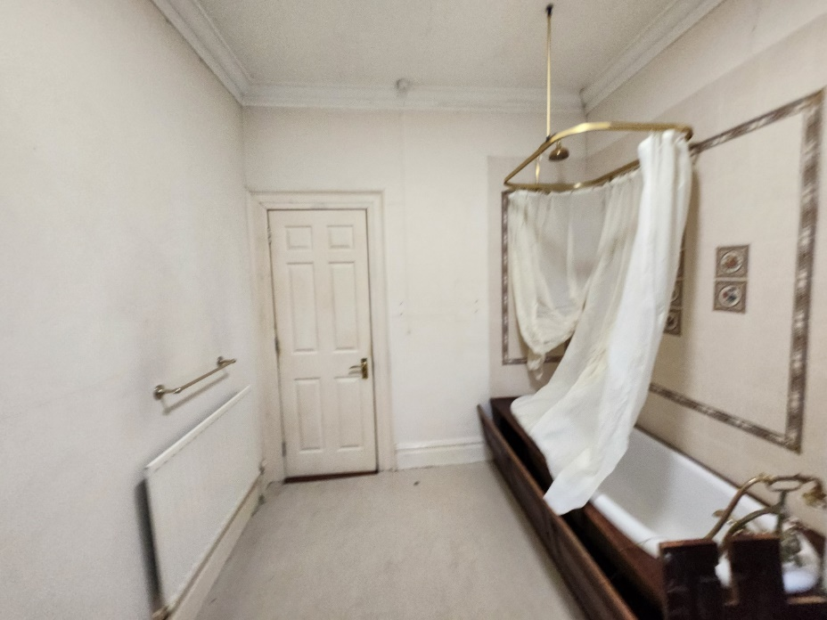

1. Bathroom

1. Hallway

1. Bedroom

1. Bedroom

1. Living Room

1. Living Room

1. Kitchen

1. Hallway with Common part entrance door