**259 GOLDHURST TERRACE, LONDON NW6 3EP**

Development Management,

Regeneration and Planning,

Culture and Environment Directorate,

Camden Town Hall,

Judd Street,

WC1H 8ND

**BY POST**

**BY EMAIL TO: [planning@camden.gov.uk](mailto:planning@camden.gov.uk)**

**BY UPLOAD TO THE COUNCIL’S PLANNING WEBSITE**

23 February, 2024

Dear Sirs/Madams,

We are writing to you regarding planning application with reference number **2024/0012/P-194 Goldhurst Terrace**. We are the owners of 259 and 259 A&B Goldhurst Terrace, which are located right opposite 194 Goldhurst Terrace. We thought that it is a legal requirement for the council to publicise planning application. However, we did not see any notices affixed adjacent to the site and we were only notified the planning application today by our neighbour. As such, Camden council should at least extend public consultation period to allow notices to be affixed near the site.

After reviewing the submitted documents, we would like to take this opportunity to object the planning application in concern. Below are the reasons for your consideration:

1. Camden council recently updated its planning guidance in Jan 2021. Policy A5 states that the siting, location, scale and design of basements must have minimal impact on and be subordinate to, the host building and property. CPG Basements clearly explains all the criteria. The proposed plan in the above mentioned planning application does not follow a few of the rules set out in the guidance.
   * CPG Basements clearly states that “basement should extend into the garden no further than 50% of the depth of the host building.” Point j in the guidance shows how the depth of the building should be measured. Bay windows and original rear projections are not included within this measurement – please see screenshot below or see page 13 of the guidance.

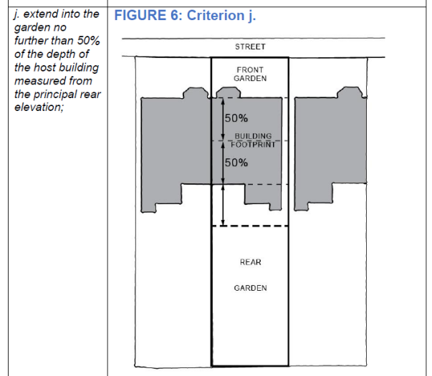

In the planning application concerned citing the original plan from its submitted document, the host building is highlighted by the curly red pen below. The buildings to be demolished and dismantled are all either rear projections/outriggers or garage. They should not form as part of the host building. As such, basement proposal within the application far exceeds the dimensions allowed in the point j, especially the basement proposal under the garage, which clearly extends further than 50% depth of the host building.

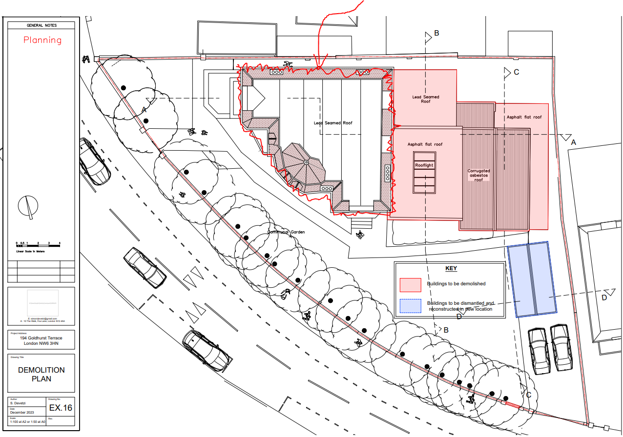

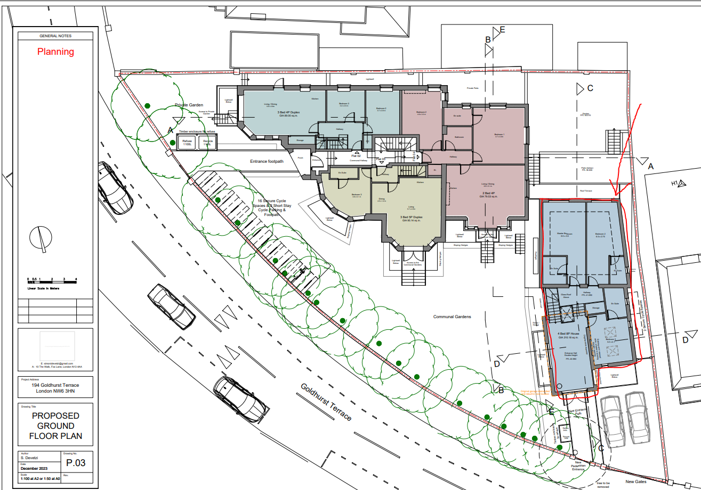

* + CPG Basements point k also states that basement should not extend into or underneath the garden further than 50% of the depth of the garden. The proposed basement under existing garage area extends almost to the boundary of the rear garden, which clearly does not follow policy A5’s guideline if measured from the boundary of host building instead of the outrigger/extension. (clearly demonstrated in the illustration of point k on page 14 of CPG: Basements.)

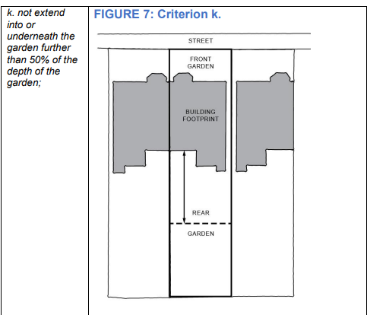

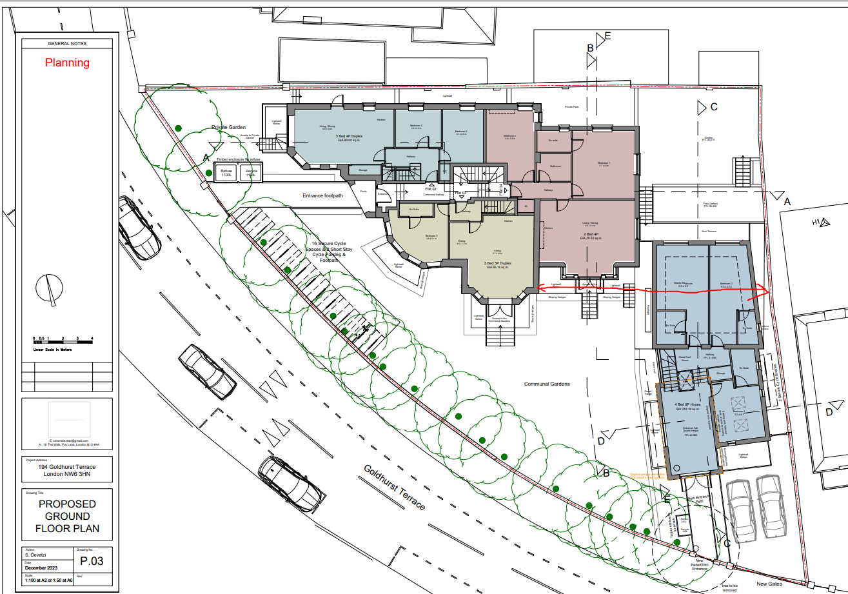

1. The planning application in concern also proposes to have 3 story rear extensions at current extension location. This has no precedent in the South Hampstead conservation area, not to mention along the road of Goldhurst Terrace. We believe the intended scheme conflicts with the overall planning policies of the Council. Specifically, the design, appearance and materials of the proposed dwelling to the east of host building is absolutely not of a design in keeping with the scale, character, or historical heritage of other dwellings on Goldhurst Terrace. The road sits within the local SHCA: in order to preserve its essential character, any new buildings and associated landscaping should be developed in a manner that is fully in sympathy with the other dwellings in the area. In particular, we object both to the proposed external staircases (unique, we believe, to the area), and to the misaligned windows in the new extension, both of which will be extremely visually unappealing and entirely out of character with the neighbouring properties.

Overall, we believe the proposed rear extension and basement are not subordinate to the host building and they are significantly harmful to the amenity of neighbouring occupiers and to the character of the host building and pattern of development.

We are most grateful for your kind consideration, and hope that these very real concerns are all clear (but would be happy if necessary to elaborate further if necessary). We would ask, please, that you confirm to us that they, together with any additional objections raised by other local residents, will all be fully taken into account and properly reflected in the Council’s decision regarding the application. We have not been notified of the date of any meeting for the application to be formally considered but would ask that we are informed of this so that we can seek to attend if appropriate.

Kind Regards,

Xinchen Gao